SATIP – SAP Cloud ALM

Integration Data Cluster
Schema design — tip_calm_* tables for TIP_Platform_dev
VoltusWave Technologies
Confidential — Engineering Design Document

1. Purpose & scope
This document specifies the data cluster that connects SATIP to SAP Cloud ALM (CALM). It is designed to slot into the existing TIP_Platform_dev schema, matching its established conventions exactly so the new tables sit naturally alongside the ~130 tip_* tables already in place.
The cluster captures three things the existing schema does not yet model: (1) CALM tenant/connection configuration including the outbound OAuth client reference and the inbound provider-endpoint registration; (2) the binding and reconciliation layer that maps SATIP test artifacts to CALM entities via a canonical key and lifecycle state; and (3) result/defect projection plus a transactional outbox for the Phase 2 outbound path.
Design stance, carried from the integration architecture: CALM remains the authoritative system of record for traceability and compliance. SATIP enriches CALM; it never forks it. Accordingly these tables track projection and sync STATE rather than re-owning CALM's data. The provider-side test-automation API is inbound (CALM calls SATIP); results flow back to CALM by executionhistory pull, so the projection tables record what was exposed and its acknowledgement state, not a second copy of the verdict CALM stores.

2. Conventions matched
Every table follows the conventions confirmed directly from the live core tables (tip_test_case, tip_test_case_execution, tip_test_run, tip_defect, tip_sap_system, tip_tenant_config):
- Primary key: char(36) UUID named <table>_id.
- Tenancy triple on every table: account_id char(36) NOT NULL, workspace_id char(36) NOT NULL, control_unit_id char(36) NULL.
- Audit quad: created_by, created_at, updated_by, updated_at (CURRENT_TIMESTAMP defaults; updated_at ON UPDATE).
- Soft-delete triple on lifecycle tables: deleted_at, deleted_by, delete_reason_id.
- Lookups as _master tables with tinyint PK; junctions as _xref; flexible payloads as json columns; paired varchar status + *_id tinyint where applicable.

3. Cluster overview
Nineteen tables: eight master lookups, two configuration tables, one CALM-entity reference cache, two binding tables, three projection tables, one transactional outbox, one sync log, and one versioned field-mapping table.
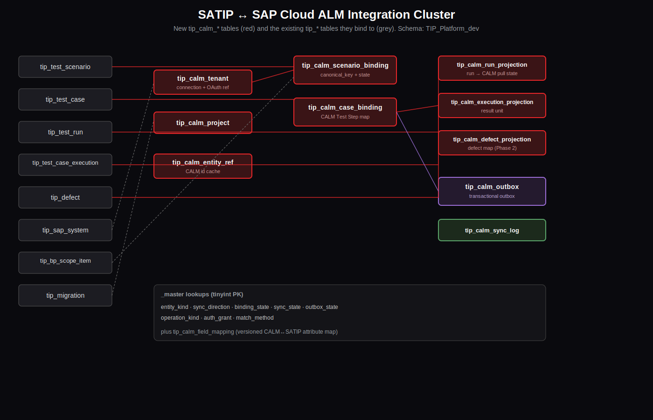
Figure 1 — CALM cluster and its bindings into existing tip_* tables

4. Table-by-table

4.1 Configuration
Table | Role
tip_calm_tenant | One row per registered CALM tenant. Holds CALM host/region/API base, the inbound provider endpoint registered in CALM LMS, and the outbound OAuth client (id + secret reference + scopes). Secrets stored by reference only.
tip_calm_project | CALM projects under a tenant; caches CALM project global id and optional link to a SATIP migration.

4.2 Entity reference cache
Table | Role
tip_calm_entity_ref | Single internal handle for any CALM-side entity SATIP references (Process, Requirement, Feature, CALM Test Case, Test Plan, Defect). Bindings and projections FK here instead of scattering raw CALM ids.

4.3 Binding / reconciliation
The vocabulary bridge is explicit: a CALM “Test Case” corresponds to a SATIP test scenario, and a CALM “Test Step” corresponds to a SATIP test case. Two binding tables capture both levels.
Table | Role
tip_calm_scenario_binding | Binds tip_test_scenario to a CALM Test Case. Carries canonical_key = hash(project, scope, processGlobalId, surface-signature), binding state (PRE_GENERATED → CALM_REQUESTED → BOUND → READY, plus STALE/RETIRED), match method, scope linkage (bp_scope_item, business_process, CALM process/requirement refs), and the is_write_back_enabled gate.
tip_calm_case_binding | Binds tip_test_case to a CALM Test Step under a scenario binding. test_case_id is preserved across regeneration so CALM history stays continuous.

4.4 Projection / sync state
Table | Role
tip_calm_run_projection | Per (run, tenant): what SATIP exposed for a test run and the CALM pull/ack state, including the CALM-issued execute job id and last executionhistory pull served.
tip_calm_execution_projection | Per (execution, tenant): the unit CALM consumes as a result. Maps a SATIP execution to its scenario binding with a mapped CALM verdict and evidence references.
tip_calm_defect_projection | Per (defect, tenant): maps a tip_defect to a CALM defect entity (Phase 2).

4.5 Outbox & observability
Table | Role
tip_calm_outbox | Transactional outbox. Each intended outbound CALM mutation is written in the same DB transaction as the domain change, with an idempotency key (e.g. satip-def-{runId}), then dispatched by a worker with backoff. Poll index on (outbox_state_id, next_attempt_at).
tip_calm_sync_log | Append-only history of every CALM interaction (inbound served + outbound sent) for diagnostics, audit, and replay. Not the source of truth for state.
tip_calm_field_mapping | Versioned, declarative CALM↔SATIP attribute map referenced by bindings, so mapping can evolve without code changes.

5. Master tables (seed values)
Master | Values
entity_kind | PROCESS, REQUIREMENT, FEATURE, USER_STORY, TEST_CASE, TEST_STEP, TEST_PLAN, DEFECT, SCOPE
sync_direction | INBOUND, OUTBOUND, BIDIRECTIONAL
binding_state | PRE_GENERATED, CALM_REQUESTED, BOUND, READY, STALE, RETIRED
sync_state | PENDING, IN_PROGRESS, SUCCEEDED, FAILED, SKIPPED, DEAD_LETTER
outbox_state | NEW, CLAIMED, DISPATCHED, CONFIRMED, FAILED, DEAD_LETTER
operation_kind | RAISE_DEFECT, UPDATE_DEFECT, UPDATE_REQUIREMENT_STATUS, ATTACH_EVIDENCE, UPDATE_TASK_STATUS
auth_grant | CLIENT_CREDENTIALS, AUTH_CODE
match_method | CANONICAL_KEY, CALM_ID, MANUAL, HEURISTIC

6. Foreign keys into existing tables
All FK targets were verified against the live schema; column types match exactly.
CALM column | References
tip_calm_tenant.sap_system_id | tip_sap_system.sap_system_id
tip_calm_project.migration_id | tip_migration.migration_id
tip_calm_scenario_binding.test_scenario_id | tip_test_scenario.test_scenario_id
tip_calm_scenario_binding.bp_scope_item_id | tip_bp_scope_item.bp_scope_item_id
tip_calm_scenario_binding.business_process_id | tip_business_process_master.business_process_id
tip_calm_case_binding.test_case_id | tip_test_case.test_case_id
tip_calm_run_projection.run_id | tip_test_run.run_id
tip_calm_execution_projection.execution_id | tip_test_case_execution.execution_id
tip_calm_defect_projection.defect_id | tip_defect.defect_id

7. Operational notes
- Secrets: oauth_client_secret_ref and inbound_auth_secret_ref hold a handle into the secret manager, never the secret itself — consistent with not storing credentials in plaintext.
- Write-back gate: only bindings in BOUND/READY with is_write_back_enabled = 1 should project to CALM; SATIP retains all runs, but only bound-case runs are exposed.
- Idempotency: the outbox unique key (calm_tenant_id, operation_kind_id, idempotency_key) guarantees at-least-once dispatch without duplicates.
- Soft-delete-aware uniqueness: unique keys include deleted_at so a soft-deleted row does not block a new active binding; this is deliberate MySQL NULL-distinct behavior.
- Apply order: master tables first (Section 1), then config, entity_ref, bindings, projections, outbox, log, field_mapping — the file is already ordered this way and seeds masters at the end.
- The MCP connection is read-only; this DDL is delivered as a migration file for the team to apply.

