HEALTHCARE INSURANCE DATA ANALYSIS USING EDA, LINEAR REGRESSION AND LOGISTIC REGRESSION

Submitted By
S. Jhansi Lakshmi Sambhana
B.Tech CSE (AI & ML)
Anil Neerukonda Institute of Technology and Sciences (ANITS)

ABSTRACT
Healthcare insurance companies require efficient methods to estimate medical expenses and identify high-risk customers. This project performs Exploratory Data Analysis (EDA) on a healthcare insurance dataset to understand relationships among customer attributes and insurance charges. Linear Regression is used to predict insurance charges, while Logistic Regression is used to classify customers into risk categories. The results demonstrate that factors such as smoking habits, age, and BMI significantly influence insurance costs.
1. INTRODUCTION
Healthcare insurance data contains valuable information about customers and their medical expenses. Analyzing this data helps insurance companies understand risk factors and estimate future costs.
The objectives of this project are:
- Perform Exploratory Data Analysis (EDA)
- Predict insurance charges using Linear Regression
- Classify customers into risk categories using Logistic Regression
- Evaluate model performance using standard metrics

2. DATASET DESCRIPTION
The dataset contains healthcare insurance records with the following attributes:
Feature | Description
age | Age of the customer
sex | Gender
bmi | Body Mass Index
children | Number of children
smoker | Smoking status
region | Residential region
charges | Medical insurance charges
Dataset Information
- Total Records: 1338
- Total Features: 7
Data Cleaning
- Missing Values: None
- Duplicate Records Found: 1
- Duplicate Record Removed
Final Dataset Shape:
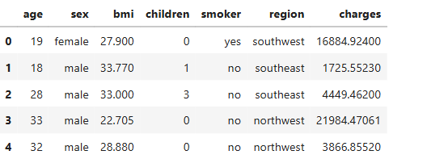
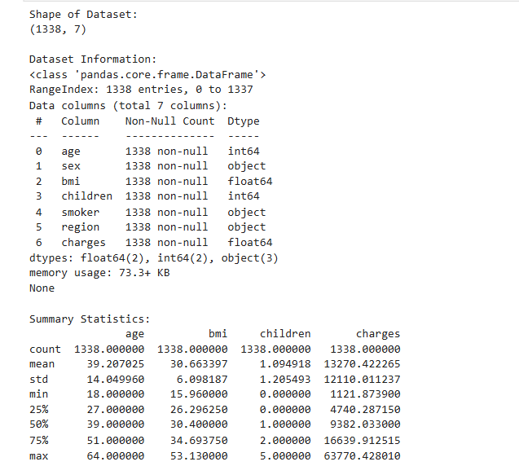

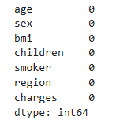

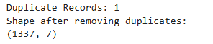

3. EXPLORATORY DATA ANALYSIS
3.1 Age Distribution
The age distribution shows that most customers fall between 20 and 50 years of age.
Observation: Most customers are between 20 and 50 years.
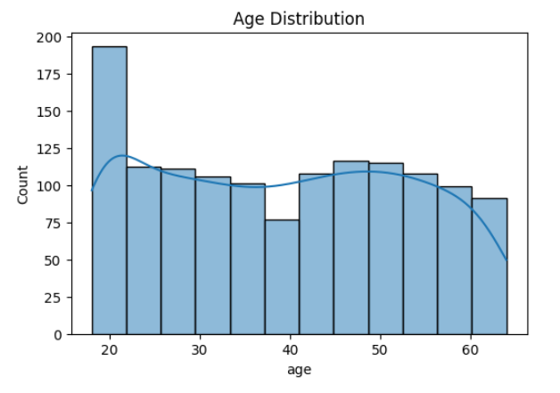
3.2 BMI Distribution
The BMI distribution is approximately centered around values between 25 and 35.
Observation: BMI values are mainly concentrated around 25–35.
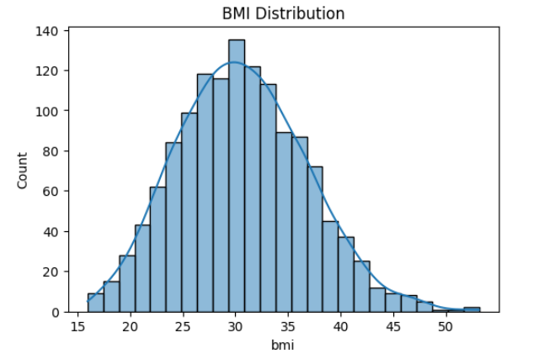

3.3 Insurance Charges Distribution
The distribution of insurance charges is positively skewed, indicating that most customers have lower charges while a few customers incur very high expenses.
Observation: Most customers have lower charges, while a few customers have very high charges.
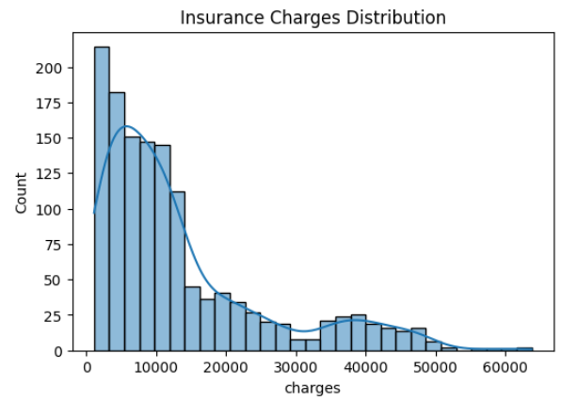

3.4 Age vs Charges
The scatter plot indicates that insurance charges generally increase with age.
Observation: Medical expenses tend to increase as age increases.
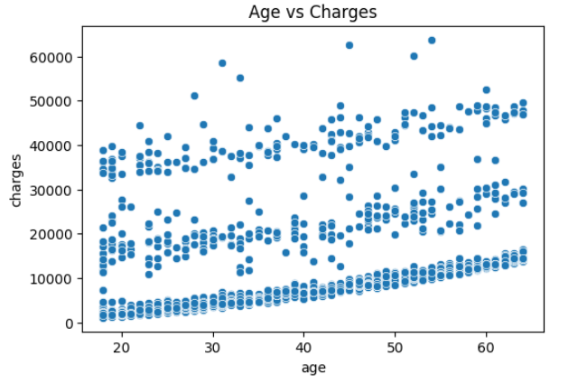

3.5 BMI vs Charges
The plot shows a positive relationship between BMI and insurance charges.
Observation: Higher BMI tends to increase medical expenses.
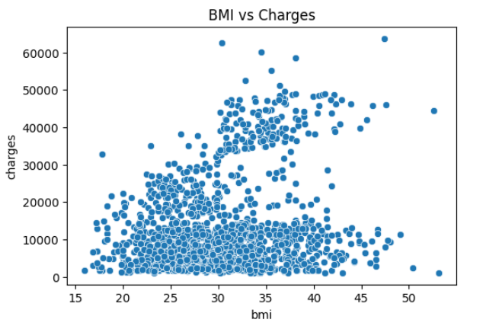
3.6 Smoking Status vs Charges
The boxplot clearly indicates that smokers incur significantly higher insurance charges compared to non-smokers.
Observation: Smokers have much higher medical expenses than non-smokers.
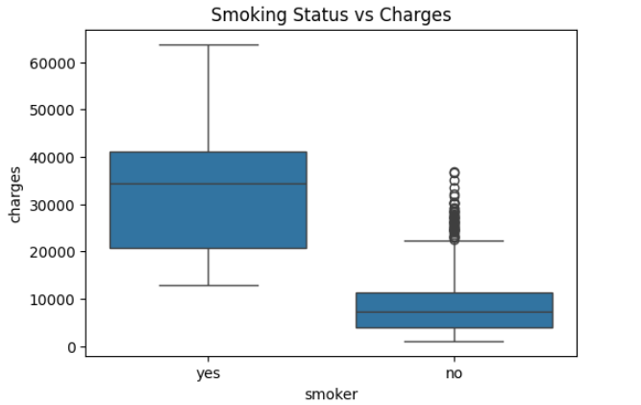

3.7 Gender vs Charges
The distribution of charges among males and females appears similar.
Observation: Male and female charges are relatively similar.
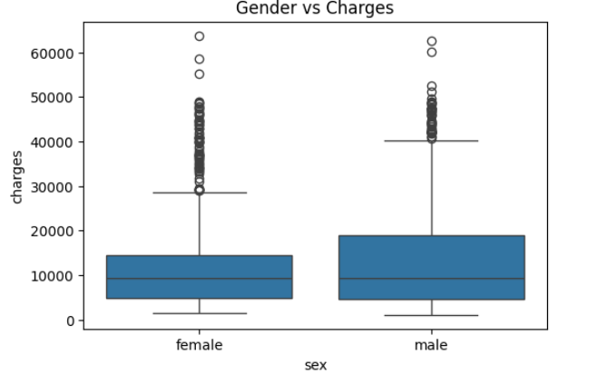
3.8 Correlation Matrix
Correlation analysis helps identify relationships between variables.
The strongest positive correlation is observed between:
- Smoker Status and Charges (0.79)
This indicates smoking is a major factor influencing insurance charges.
Observation: Smoking status has the highest impact on insurance charges.
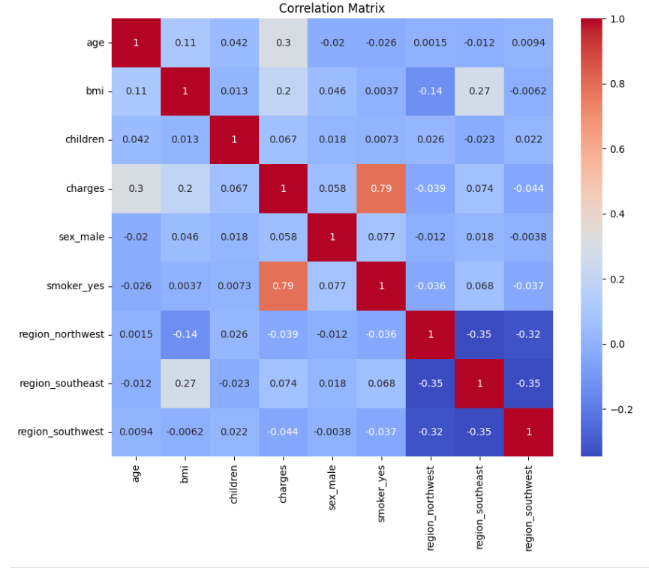
4. LINEAR REGRESSION
Objective
To predict healthcare insurance charges based on customer attributes.
Model Training
Linear Regression was trained using the processed dataset after encoding categorical variables.
Evaluation Metrics
Metric | Value
MAE | 4177.05
MSE | 35478020.68
RMSE | 5956.34
R² Score | 0.8069
Interpretation
The R² Score of approximately 0.81 indicates that the model explains around 81% of the variation in insurance charges, demonstrating strong predictive capability.
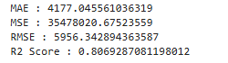
Actual vs Predicted Charges
The scatter plot compares actual charges against predicted charges.
Observation: Predicted values closely follow actual values, indicating good model performance.
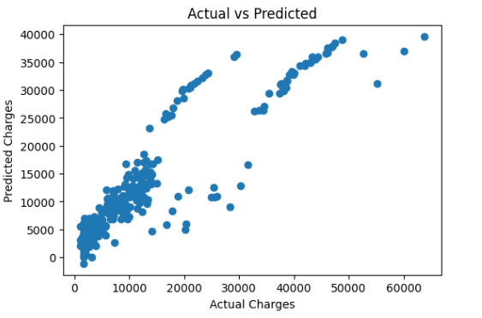
5. LOGISTIC REGRESSION
Objective
To classify customers into:
- Low Risk (0)
- High Risk (1)
A new risk category was created using the median insurance charge value.
Model Performance
Metric | Value
Accuracy | 0.9104
Precision | 0.8944
Recall | 0.9338
F1 Score | 0.9137
Interpretation
The Logistic Regression model achieved over 91% accuracy, indicating excellent classification performance.
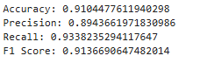
Classification Report
Class | Precision | Recall | F1-Score
0 | 0.93 | 0.89 | 0.91
1 | 0.89 | 0.93 | 0.91
Overall Accuracy: 91%

Observation: The model performs consistently across both classes.
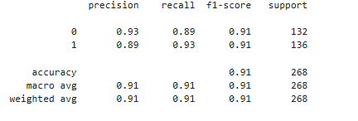
Confusion Matrix
Actual / Predicted | 0 | 1
0 | 117 | 15
1 | 9 | 127
Interpretation
- Correctly Classified Low-Risk Customers: 117
- Correctly Classified High-Risk Customers: 127
- Misclassified Low-Risk Customers: 15
- Misclassified High-Risk Customers: 9
Observation: The model makes very few classification errors and demonstrates strong predictive accuracy.
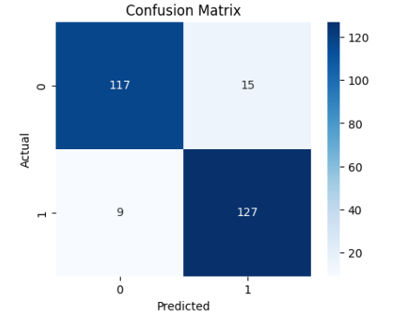

6. KEY FINDINGS
- Smoking status has the strongest influence on insurance charges.
- Insurance costs increase with age.
- Higher BMI generally leads to higher medical expenses.
- Gender has relatively little effect on insurance charges.
- Linear Regression predicts insurance charges with good accuracy.
- Logistic Regression classifies customer risk levels with over 91% accuracy.

8. Future Enhancements
- Random Forest Regression can be used to improve prediction accuracy.
- Decision Tree Models can help capture non-linear relationships in the data.
- XGBoost Implementation can provide better predictive performance.
- Hyperparameter Tuning can be used to optimize model parameters.
- Feature Engineering can be performed to create more informative features.
- Streamlit or Flask Deployment can be used to convert the model into a web application for real-world usage.
7. CONCLUSION
This project successfully analyzed healthcare insurance data using Exploratory Data Analysis, Linear Regression, and Logistic Regression.
EDA revealed that age, BMI, and smoking status significantly affect insurance charges. Linear Regression achieved an R² score of approximately 80.69%, demonstrating effective prediction of medical expenses. Logistic Regression achieved an accuracy of approximately 91%, effectively classifying customers into risk categories.
The project highlights the usefulness of machine learning techniques in healthcare insurance analytics and risk assessment.

