Objective: Identify phishing characteristics in a suspicious email sample.
Tools: Email client or saved email file (text), free online header analyzer.
Deliverables: A report listing phishing indicators found
I took example of Phishing mail from sources

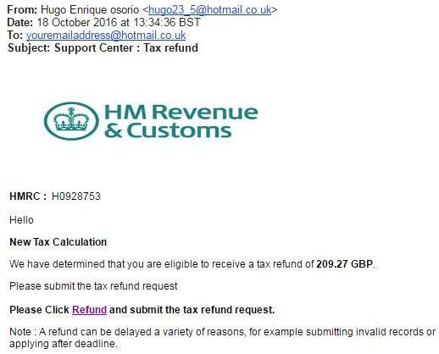

1. Email Overview
- Sender Name: Hugo Enrique Osorio
- Sender Email: hugo23_5@hotmail.co.uk
- Subject: Support Center: Tax refund
- Claimed Organization: HM Revenue & Customs (HMRC)
- Date Received: 18 October 2016

2. Indicators of Phishing
A. Suspicious Sender Address
- HMRC never emails users from personal email services like Hotmail.
- Legit government emails come from official domains (e.g., @hmrc.gov.uk).
B. Generic & Urgent Subject
- Uses “Tax refund” to trigger urgency.
- Scammers often use financial refunds to lure victims.
C. Impersonation of HMRC
- Email uses the HMRC logo to appear legitimate.
- This is a common social engineering tactic.
D. Fake Reference Number
- The ID H0928753 is used to create a false sense of authenticity.
E. Suspicious Link
- Contains a hyperlinked word: “Refund”.
- Likely leads to a phishing website designed to collect:
  - personal data
  - banking information
  - login credentials
F. Poor Grammar & Formatting
- Multiple grammatical errors and incomplete sentences:
  - “Please submit the tax refund request”
  - Awkward spacing and punctuation
- Legit emails from HMRC are professionally written.
G. Generic Greeting
- Only “Hello” used.
- HMRC always addresses recipients by full legal name.
H. Unusual Email Content
- Promises a refund of 209.27 GBP — scammers often use precise amounts to appear real.
3. Summary of Phishing Traits
The email exhibits the following phishing indicators:
- ❌ Sender domain mismatch (Hotmail instead of .gov.uk)
- ❌ Impersonation of a government agency
- ❌ Suspicious refund link
- ❌ Urgent language encouraging immediate action
- ❌ Poor writing quality
- ❌ No personalization
- ❌ Fake reference number
4. Conclusion
- This email is a confirmed phishing attempt designed to steal personal and financial information under the guise of a tax refund.
The user should not click any links, not provide any details, and report the email to the appropriate security team or authority.

