Error 1: nv40b_monolith_resource_metrics.class
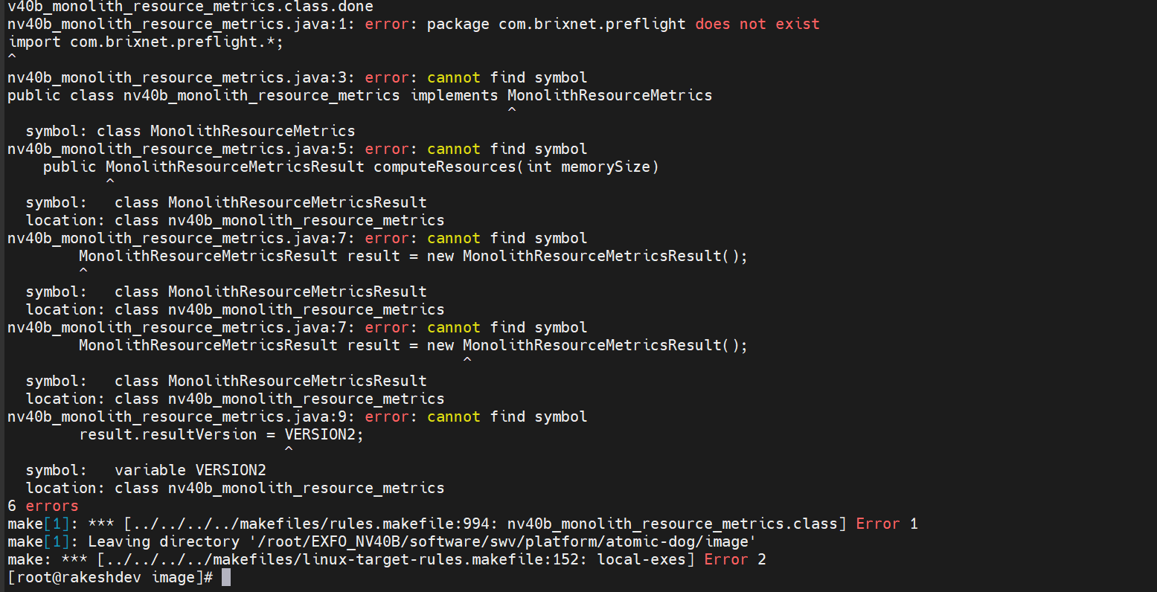
Error 2: bvm-verifier-agent
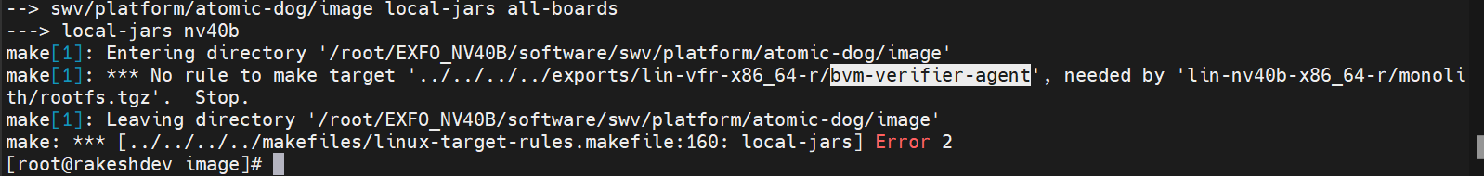
Eror 3: swv Directory
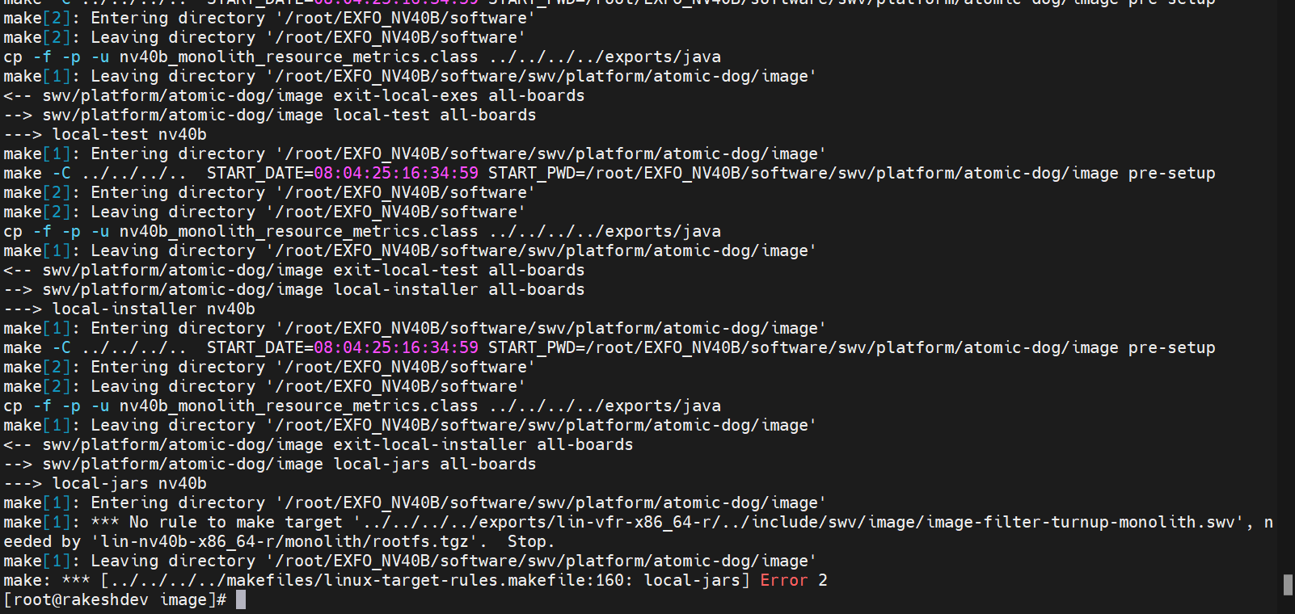
Error 4: so files apart from below 4 .so files
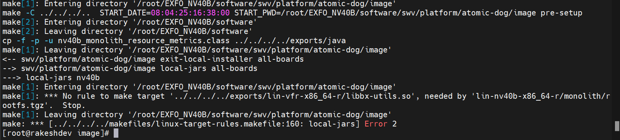
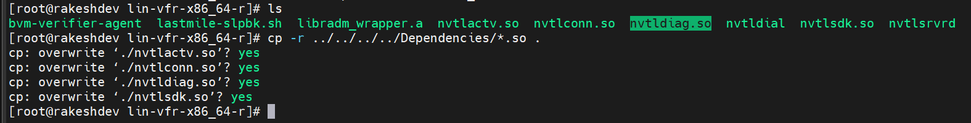
Error 5: exfo-memtool
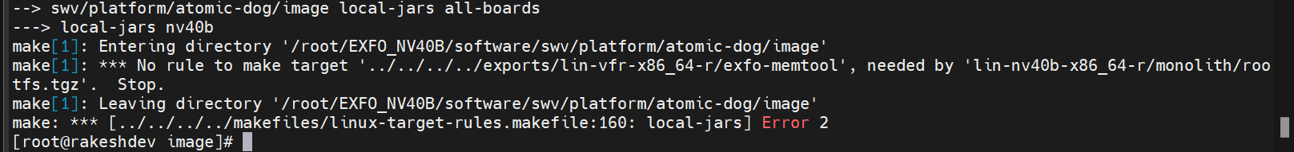
Error 6: sshd'
Error 7: scp
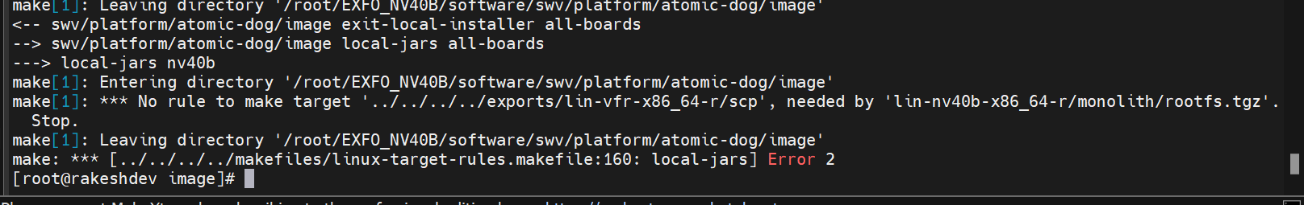
Error 7: ssh-keygen
Error 8: Linux-lastmile from d to r
Error 9: lastmile-dma

Error 10: lastmile-rawcardtool
Error 10: lastmile-ethtool
Error 10: lastmile-triumph
Error 11: lastmile-turnup
Error 12: lastmile-timesvc
Error 13: lastmile-version
Error 14: exfo-pci-control
Error 15: diags-eth-bvm
Error 16: diags-fcc-ethernet-bvm
Error 17: verifier-nv40b
Error 18: we copied lin-nv40b-x86_64-r
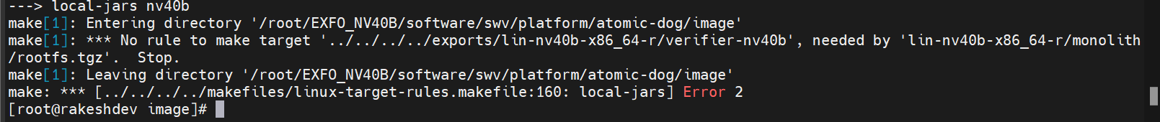
Error 19: lin-gcc4-x86_64
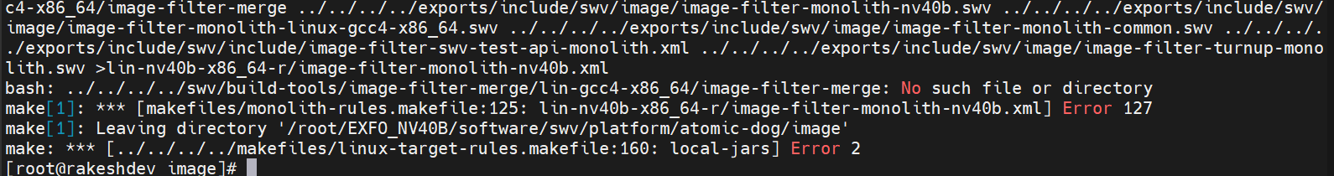
Error 20:
Copied 710011644928.vkr file
Error 21:
Encrypt-vkr

