HPE DL360 monolith compilation
Approach Document
Version 1.0



Customer Restricted - Information that is intended for a restricted set of employees with the right / need to know principle relating to a specific Account engagement where information owned by the client but managed by Capgemini or information related to customers and their environments (both Technology and Business related) is being handled. This classification must be used for Capgemini documentation and systems where information is being shared with the client.

Editing
Verification
Validation

Monitoring developments
Version | Date | Editor | Description
V1.0 | 06-3-2025 | Capgemini Engineering Team | Monolith compilation and monolith.raw testing.
Table 1: Change history

Distribution
Name | Function | Organization
EXFO Engineering Team | Engineering | EXFO
CG Engineering Team | Engineering | Capgemini
Table 2: Distribution list

Content
1 Introduction 4
1.1 Purpose of the document 4
1.2 Scope 4
2 Procedure followed to generate monolith.vmdk for nv40b verifier 5
3 Stakeholder 7

Introduction

Purpose of the document
This document outlines the process and issues faced while compiling the kernel and root filesystem (rootfs) in an initial development environment and compilation issues faced with newly cloned source code. It has compilation procedures under different debug configurations (YES & NO) .

Scope
The document focuses on compiling the kernel and rootfs in an initial development environment and testing different debug configurations(YES & NO). It also covers build errors faced in newly cloned source code.

Procedure followed to generate monolith.vmdk for nv40b verifier
- We automated all steps from cloning the source code to monolith.raw image generation
- Get the script from http://10.16.128.175/dependencies.sh
wget http://10.16.128.175/dependencies.sh
- Give executable permissions to the script
chmod +x dependencies.sh
- Run the script to generate monolith.vmdk and monolith.raw
./dependencies.sh
- Tested monolith.vmdk in Virtual Machine

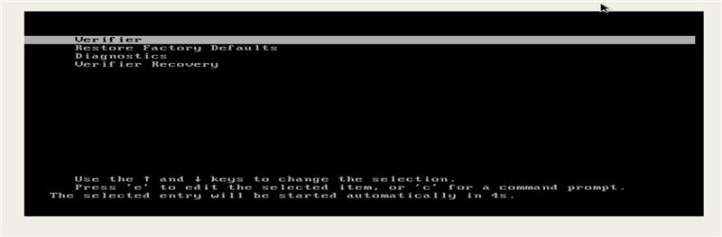

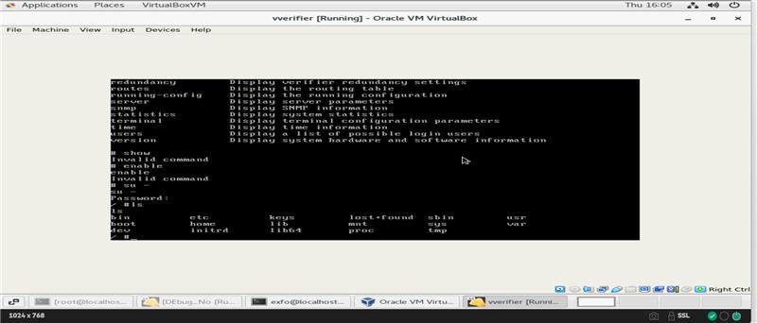

- Also tested monolith.raw in server
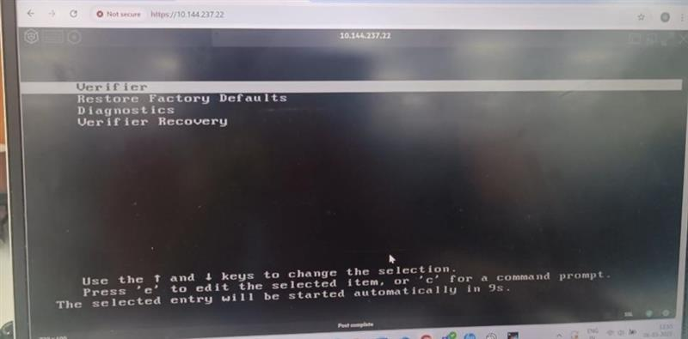

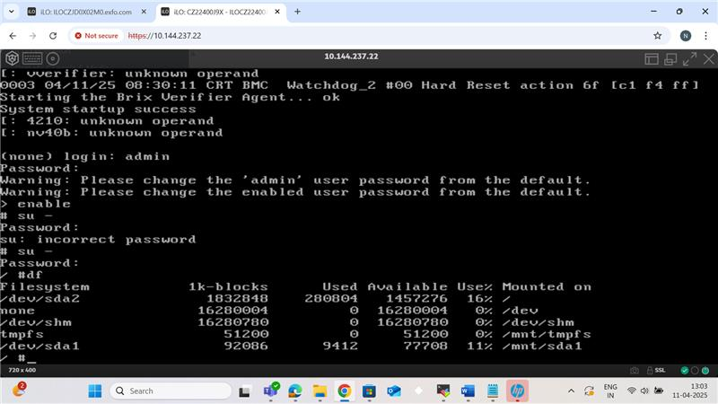

3 Stakeholder

Name | Function | Title
Kesavan Nivetha | Project Manager | Project Manager
Vijayan Bharathi | Delivery Manager | Director
Suresh Kalidasan | Architect | Architect
Navyashree N.V | Software Developer | Engineer
Jhansi Vaddipalli | Software Developer | Engineer

About Capgemini Engineering
Capgemini Engineering combines, under one brand, a unique set of strengths from across the Capgemini Group: the world leading engineering and R&D services of Altran – acquired by Capgemini in 2020 - and Capgemini’s digital manufacturing expertise. With broad industry knowledge and cutting-edge technologies in digital and software, Capgemini Engineering supports the convergence of the physical and digital worlds. Combined with the capabilities of the rest of the Group, it helps clients to accelerate their journey towards Intelligent Industry. Capgemini Engineering has more than 52,000 engineer and scientist team members in over 30 countries across sectors including aeronautics, automotive, railways, communications, energy, life sciences, semiconductors, software & internet, space & defence, and consumer products.
Capgemini Engineering is an integral part of the Capgemini Group, a global leader in partnering with companies to transform and manage their business by harnessing the power of technology. The Group is guided every day by its purpose of unleashing human energy through technology for an inclusive and sustainable future. It is a responsible and diverse organization of 270,000 team members in nearly 50 countries. With its strong 50-year heritage and deep industry expertise, Capgemini is trusted by its clients to address the entire breadth of their business needs, from strategy and design to operations, fueled by the fast evolving and innovative world of cloud, data, AI, connectivity, software, digital engineering and platforms. The Group reported in 2020 global revenues of €16 billion.
Get the Future You Want | www.capgemini.com





This document contains information that may be privileged
or confidential and is the property of the Capgemini Group.
Copyright © 2022 Capgemini. All rights reserved.

