HOW TO COMPILE AND CREATE VMDK AND RAW IMAGE
- Compile kernel
- make kernel-all
- compile Rootfs
- cd ~/root/ Navya_Monolith27-02/software/swv/platform/atomic-dog/image
- make CPU=x86_64 DEBUG=no BOARDS=nv40b
NOTE: In newly cloned repository, we copied all required dependencies. Copied vmlinuz-3.18.12 from /software/exports/lin-vfr-x86_64-d to /software/exports/lin-vfr-x86_64-r.
- cd ~/root/software/swv/platform/atomic-dog/image/lin-nv40b-x86_64-r
- cp ~/710011644928.vkr.
NOTE: Changed LABEL names in bvm-mkimg.sh from rootfs to rootfs1 and rootfs2 at line numbers 430 &441.
Also, changed LABEL of root path in grub.cfg from /dev/sda2 to root=LABEL=rootfs1 & from /dev/sda3 to root=LABEL=rootfs2 at line numbers 526 &544.
- sudo PATH=$PATH:/root/Navya_Monolith27-02/software/exports/lin-vfr-x86_64-r/ ../rootfs/boot/install-tools/bvm-mkimg.sh -m monolith-nv40b-x86_64.jar -p nv40b -o monolith.vmdk -vkr 710011644928.vkr
3.Tested vmdk in VM
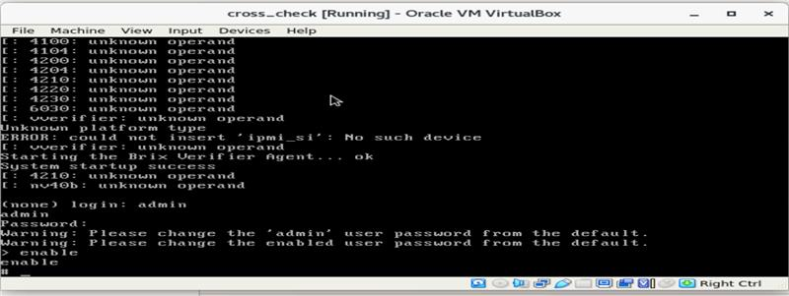
Login : admin
Password: admin
>enable
#show ?

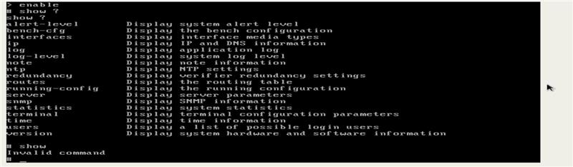

su –
Password: bluebunny
#ls

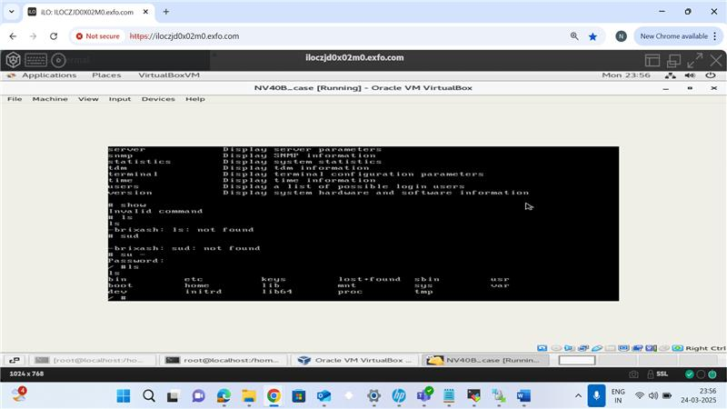

- qemu-img convert monolith.vmdk -O raw ~/monolith.raw

Need to check in server.

Task -2 (Added an executable to Rootfs compiled it and build it and we are able to see the script post booting of vmdk in the path /test/sample.sh)
464#echo "Current directory: $(pwd)"
465 #echo "Listing current directory contents:"
466 #ls -l
467 echo "Checking test/ directory:"
468 ls -l test/ 2>/dev/null || echo "Directory test/ does not exist"
469
470 SCRIPT_PATH="./test/sample.sh"
471
472 echo -n "Unpack the primary root file system files... "
473 tar zxvf ${TMPDIR}/monolith/rootfs.tgz -C /mnt/loop2p2 >/dev/null 2>&1
474
475
476 if [ $? != 0 ]; then
477 echo fail
478 bvm_cleanup
479 rm -rf $TMPDIR
480 exit 1
481 fi
482 mkdir -p /mnt/loop2p2/test
483 if [ -f "$SCRIPT_PATH" ]; then
484 cp "$SCRIPT_PATH" /mnt/loop2p2/test/
485 chmod +x /mnt/loop2p2/test/sample.sh
486 else
487 echo "Error: $SCRIPT_PATH not found!"
488 exit 1
489 fi
Above lines of code we added to add a directory called test in which we have an executable sample.sh
so after untaring the rootfs and mounting it on /mnt/loop2p2 we created a directory test on /mnt/roop2p2 and gave executable permissions to the sample.sh file packed along with the rootfs so it will be packed along with rootfs when vmdk is created.
Issue resolved regarding the losetup by following steps :
1️dentify Mounted Partitions on /dev/loop2
Check which locations are using /dev/loop2:
mount | grep loop2
Example Output:
/dev/loop2p1 on /mnt/efi type vfat (rw,...)
/dev/loop2p2 on /mnt type ext4 (rw,...)
/dev/loop2p1 on /mnt/boot/efi type vfat (rw,...)
This confirms that partitions of /dev/loop2 are mounted.

2️Unmount All Mounted Partitions
Use the following commands to unmount the partitions:
sudo umount /mnt/efi
sudo umount /mnt
sudo umount /mnt/boot/efi
Now, verify that they are unmounted:
mount | grep loop2
If nothing appears, the partitions are successfully unmounted.

3️Detach the Loop Device
Once unmounted, detach /dev/loop2 using:
sudo losetup -d /dev/loop2
Check if it is removed:
losetup -a
If /dev/loop2 does not appear, it has been successfully released. 🎉

