How to boot CentOS 7 using UEFI with Secure Boot

Contents
- Check Secure Boot status.
- Backup existing certificates from the UEFI.
- Write your own certificates.
- Sign your own grub / kernel / initrd.
- Configure your grub.cfg to only load signed kernel and initrd.
- Add a password protection to GRUB2.
Dependencies
- Install sbsigntools.
- Install efitools.
Install sbsigntools and efitools
- Create a work directory and install repositories in it :
- $ mkdir -p secu-os/install
Use git clone or wget to download dependencies :
$ cd secu-os/install/
$ git clone https://git.kernel.org/pub/scm/linux/kernel/git/jejb/sbsigntools.git
$ git clone https://git.kernel.org/pub/scm/linux/kernel/git/jejb/efitools.git
Proceed installations :
$ cd sbsigntools/
$ ./autogen.sh
$ ./configure
$ make check
$ make install
$ make installcheck
$ cd ../efitools/
$ make
$ make install

Prerequisite
- A Linux distribution installed and booting with UEFI on a PC.
- Disable Secure Boot in your BIOS.

Check Secure Boot status
To verify if your computer has booted with Secure Boot, type the following command :
$ bootctl status
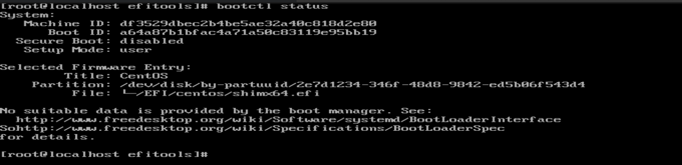

Backup existing certificates from the UEFI
In this section, we will backup the public keys / certificates from the UEFI keystore :
- The Platform Key (PK) is a variable where the public key given by the hardware vendor (ex : Dell, HP, Asus, ...) is stored.
- The Key Exchange Key (KEK) is a variable which can contains one or more public keys. Usually, Microsoft store his public key here.
- The Database (db) is a variable containing a signature database commonly filled with public keys. It is used as a boot executable whitelist.
- The Database Blacklist (dbx) is a variable similar to the db, but it contains the boot executable blacklist, also called "revoked keys/signatures".
These variables are used to control the Secure Boot process.
- Prepare the backup directory and give it only root access:
- $ mkdir -p secu-os/backup
- $ chmod -v 700 secu-os/
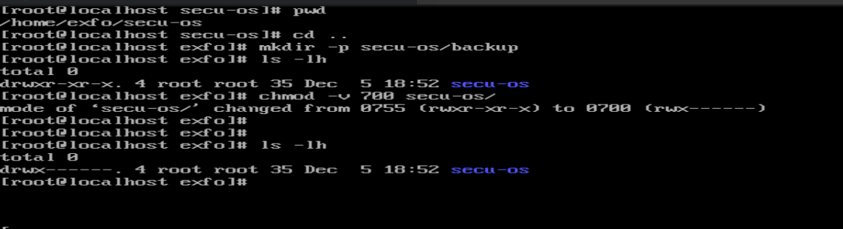

- $ cd secu-os/backup/
- Backup actual efi keys :
- $ efi-readvar -v PK -o old_PK.esl
- $ efi-readvar -v KEK -o old_KEK.esl
- $ efi-readvar -v db -o old_db.esl
- $ efi-readvar -v dbx -o old_dbx.esl
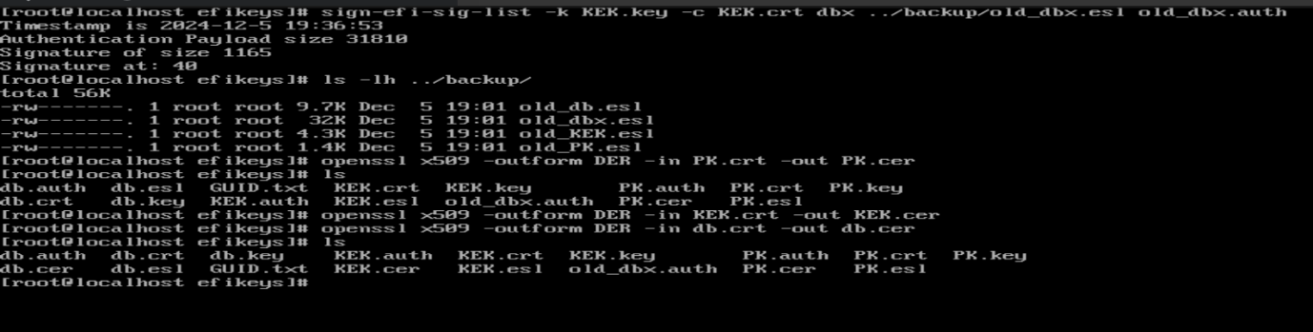

Warning : don't forget the -o option or your variable will be dumped as text and you wont be able to reload them.
Write your own certificates
Now we will create a new PK, KEK and kernel-signing keypair (db) with openssl.
Keys characteristics (source):
- X.509 certificate format for the public key.
- RSA asymmetric cryptosystem, with a 2048 bit key length.
- Have 10 years (3650 days) to run until expiry.
- Use SHA-256 as the public key's message digest.
- Prepare the efikeys directory :
- $ cd secu-os/
- $ mkdir efikeys
- $ cd efikeys/
- Create the keys with openssl :
- $ openssl req -new -x509 -newkey rsa:2048 -subj "/CN=tutorial's platform key/" -keyout PK.key -out PK.crt -days 3650 -nodes -sha256
- $ openssl req -new -x509 -newkey rsa:2048 -subj "/CN=tutorial's key-exchange-key/" -keyout KEK.key -out KEK.crt -days 3650 -nodes -sha256
- $ openssl req -new -x509 -newkey rsa:2048 -subj "/CN=tutorial's kernel-signing key/" -keyout db.key -out db.crt -days 3650 -nodes -sha256


Each commands provide a private key and a certificates.
- Make the private key readable only by root:
- $ chmod -v 400 *.key
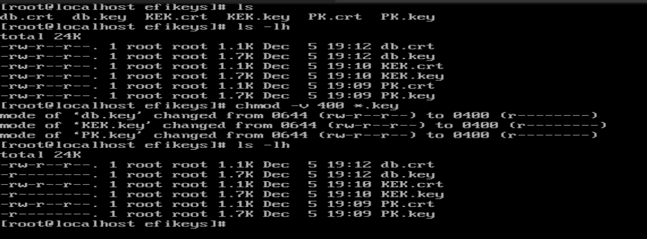

Sign your own grub / kernel / initrd
Update UEFI keystore with our own keys
Before signing our grub, kernel or initrd, we need to update the UEFI keystore variables with the keys that we have just created.
Some informations about keys format (source):
- .key PEM format private keys for EFI binary and EFI signature list signing.
- .crt PEM format certificates for sbsign.
- .cer DER format certificates for firmware.
- .esl Certificates in EFI Signature List for KeyTool and/or firmware.
- .auth Certificates in EFI Signature List with authentication header (i.e. a signed certificate update file) for KeyTool and/or firmware.
- Create a GUID for owner identification :
- $ cd secu-os/efikeys/
- $ uuidgen --random > GUID.txt
- Prepare PK for installation in EFI :
- $ cert-to-efi-sig-list -g "$(< GUID.txt)" PK.crt PK.esl
- $ sign-efi-sig-list -g "$(< GUID.txt)" -k PK.key -c PK.crt PK PK.esl PK.auth
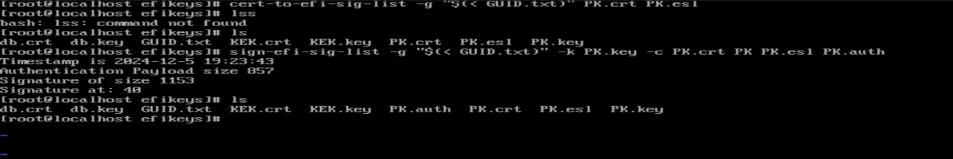
The first command converts a certificate into a EFI signature list.
The second one sign the EFI signature list. In this case, we sign it with the PK private key.
- Prepare KEK for installation in EFI :
- $ cert-to-efi-sig-list -g "$(< GUID.txt)" KEK.crt KEK.esl
- $ sign-efi-sig-list -g "$(< GUID.txt)" -a -k PK.key -c PK.crt KEK KEK.esl KEK.auth
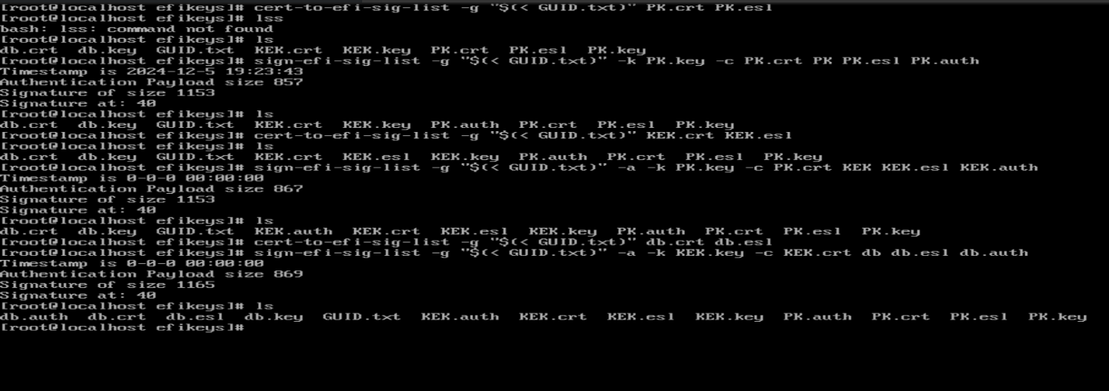

We add -a option to append to the file instead of replace it.
We use PK private key to sign the signature list.
- Prepare db for installation in EFI :
- $ cert-to-efi-sig-list -g "$(< GUID.txt)" db.crt db.esl
- $ sign-efi-sig-list -g "$(< GUID.txt)" -a -k KEK.key -c KEK.crt db db.esl db.auth


Same, we use here -a option.
We use KEK private key to sign the signature list.
- Prepare dbx for installation in EFI :
- $ sign-efi-sig-list -k KEK.key -c KEK.crt dbx ../backup/old_dbx.esl old_dbx.auth
- For the dbx, we just restore the old one and sign it with the KEK private key.
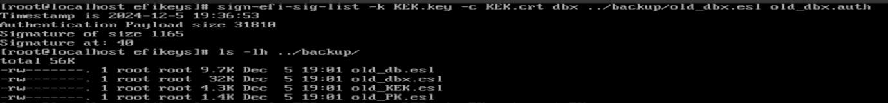

- Crete DER version of our 3 public keys (certificates) :
- $ openssl x509 -outform DER -in PK.crt -out PK.cer
- $ openssl x509 -outform DER -in KEK.crt -out KEK.cer
- $ openssl x509 -outform DER -in db.crt -out db.cer
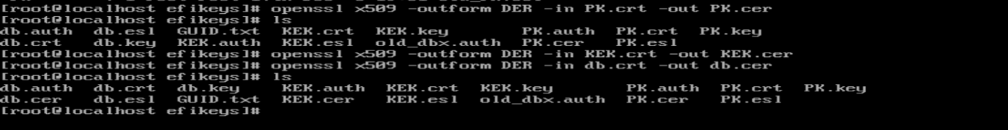

- For dual boot, compound (old+new) in order to save Microsoft signatures:
- $ cat old_KEK.esl KEK.esl > compound_KEK.esl
- $ cat old_db.esl db.esl > compound_db.esl
- $ sign-efi-sig-list -k PK.key -c PK.crt KEK compound_KEK.esl compound_KEK.auth
- $ sign-efi-sig-list -k KEK.key -c KEK.crt db compound_db.esl compound_db.auth
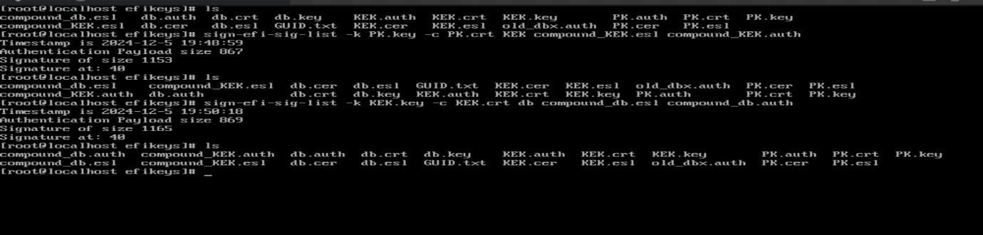

Entering setup mode (clearing keystore)
- To enter in setup mode, first reboot the machine :
- $ reboot
- Then, enter in your BIOS and perform :
  - Clear UEFI secure boot variable
  - Save changes
  - Restart your machine
Note : in some computers you will have to enable custom keys in your BIOS.
Installing new keys into the keystore
- Verify that the secure boot variables are cleared :
- $ efi-readvar
Expected output:
Variable PK has no entries
Variable KEK has no entries
Variable db has no entries
Variable dbx has no entries
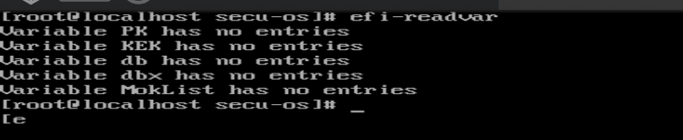
- Return to your efikeys directory and update keystore with your own signatures:
- $ cd secu-os/efikeys/
- $ efi-updatevar -e -f ../backup/old_dbx.esl dbx
- $ efi-updatevar -e -f db.esl db
- $ efi-updatevar -e -f KEK.esl KEK
- $ efi-updatevar -f PK.esl PK updated with $ efi-updatevar -f PK.auth PK

The -e option specifies that an EFI signature list file have to be loaded.
The -f option precise the filename.
Note : for dual boot user replace db.esl, KEK.esl by compound_db.esl, compound_KEK.esl.
- Backup your installed certificates :
- $ cd ../backup/
- $ efi-readvar -v PK -o new_PK.esl
- $ efi-readvar -v KEK -o new_KEK.esl
- $ efi-readvar -v db -o new_db.esl
- $ efi-readvar -v dbx -o new_dbx.esl
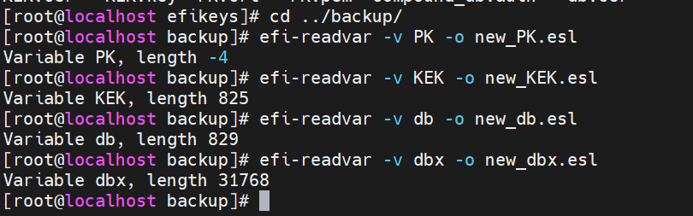

- Verify the content of installed variables :
- $ efi-readvar
Sign your grub bootloader
- Backup your grub bootloader :
- $ su root
- $ cd secu-os/backup/
- $ cp /boot/efi/EFI/centos/grubx64.efi grubx64.efi.bak
- Sign the grub bootloader :
- $ cd secu-os/efikeys/
- $ sbsign --key db.key --cert db.crt --output /boot/efi/EFI/centos/grubx64.efi /boot/efi/EFI/centos/grubx64.efi
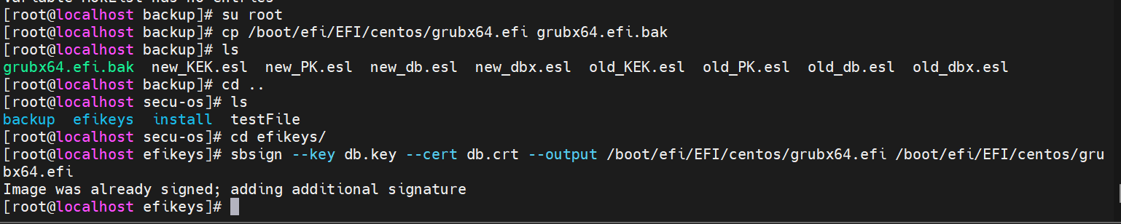

Sign your kernel
- Backup your kernel :
- $ su root
- $ cd secu-os/backup/
- $ cp /boot/vmlinuz-xxx vmlinuz-xxx.bak
- Sign the kernel :
- $ cd secu-os/efikeys/
- $ sbsign --key db.key --cert db.crt --output /boot/vmlinuz-xxx /boot/vmlinuz-xxx
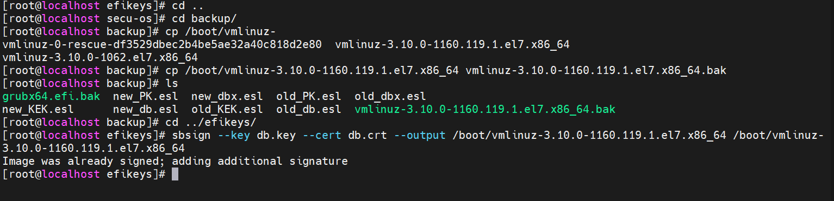

Sign your initrd
- Backup your initrd :
- $ su root
- $ cd secu-os/backup/
- $ cp /boot/initramfs-xxx initramfs-xxx.bak
- At the point, sbsigntools don't provide the possibility to sign the initrd. So we will use an other tool named gpg :
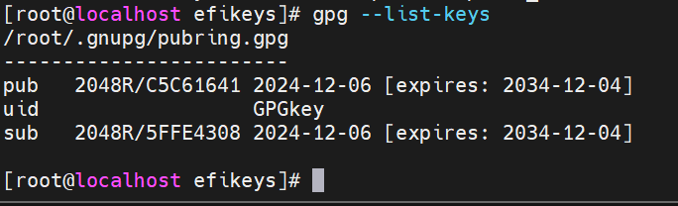

$ gpg --default-key GPG.key --detach-sign /boot/initramfs-xxx.img
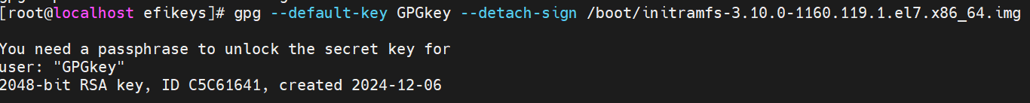
GRUB only load signed kernel
- Backup your grub.cfg :
- $ su root
- $ cd secu-os/backup/
- $ cp /boot/efi/EFI/centos/grub.cfg grub.cfg.bak
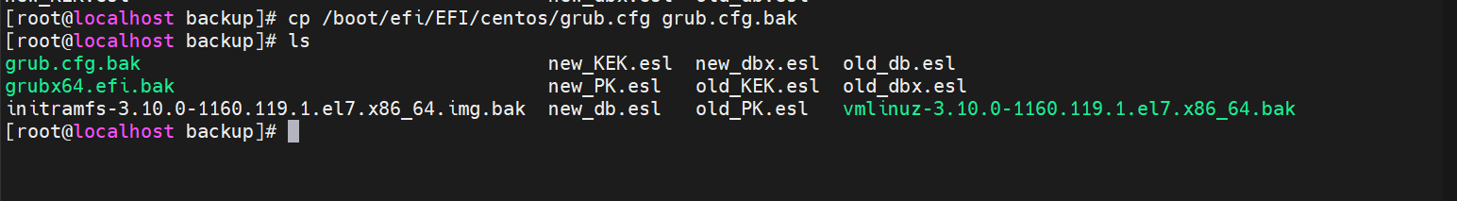

- Edit your grub.cfg and add this at the top of the file :
- set check_signatures=enfore
- export check_signatures
