- make CPU=x86_64 DEBUG=no BOARDS=nv40b
below error
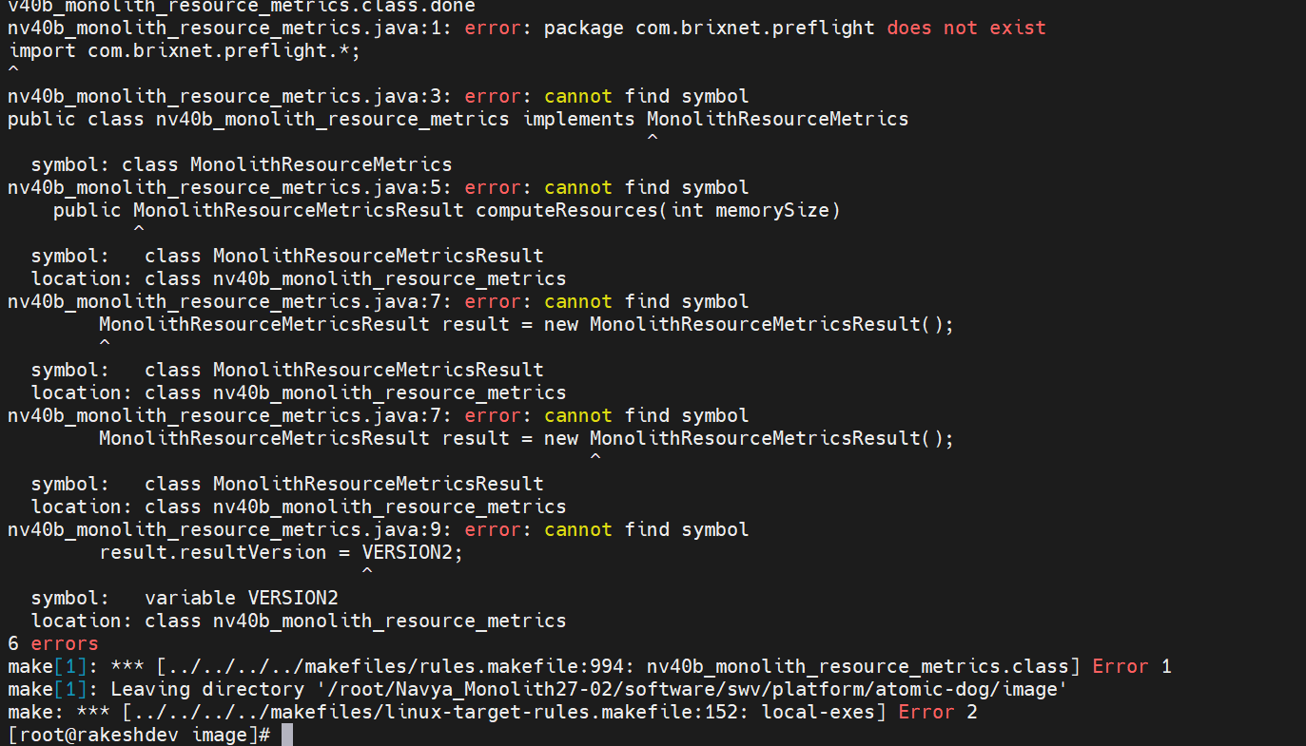
To resolve this we copied all files and com directory from /exports/java
- make CPU=x86_64 DEBUG=no BOARDS=nv40b
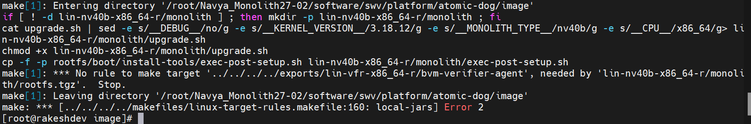
we just checked is any script file related to kernel-all
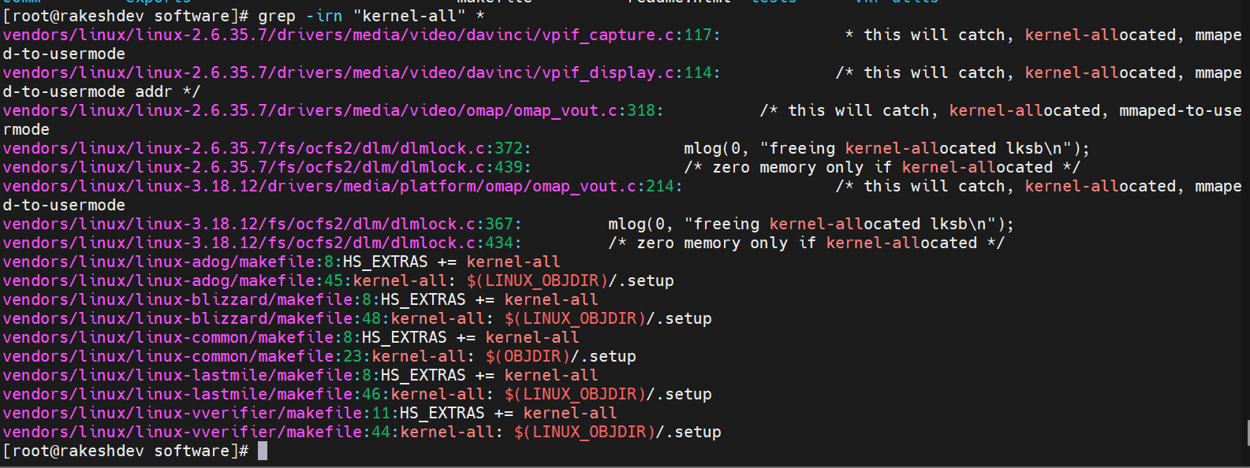
According to kernel, make files OBJDIR is lin-vfr-x86_64-r or lin-vfr-x86_64-d.
37. LINUX_EXPORTS=$(PWD)/$(TOP)/exports/$(OBJDIR)/linux-lastmile
under vi vendors/linux/linux-lastmile/makefile.
According to rootfs OBJDIR is monolith-(BOARD_NICKNAME)-$(CPU).jar
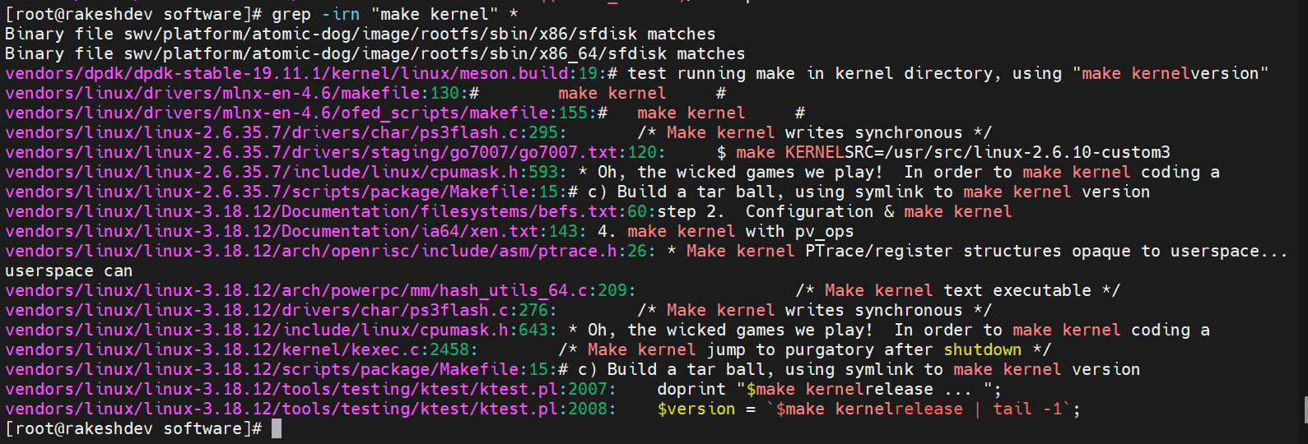

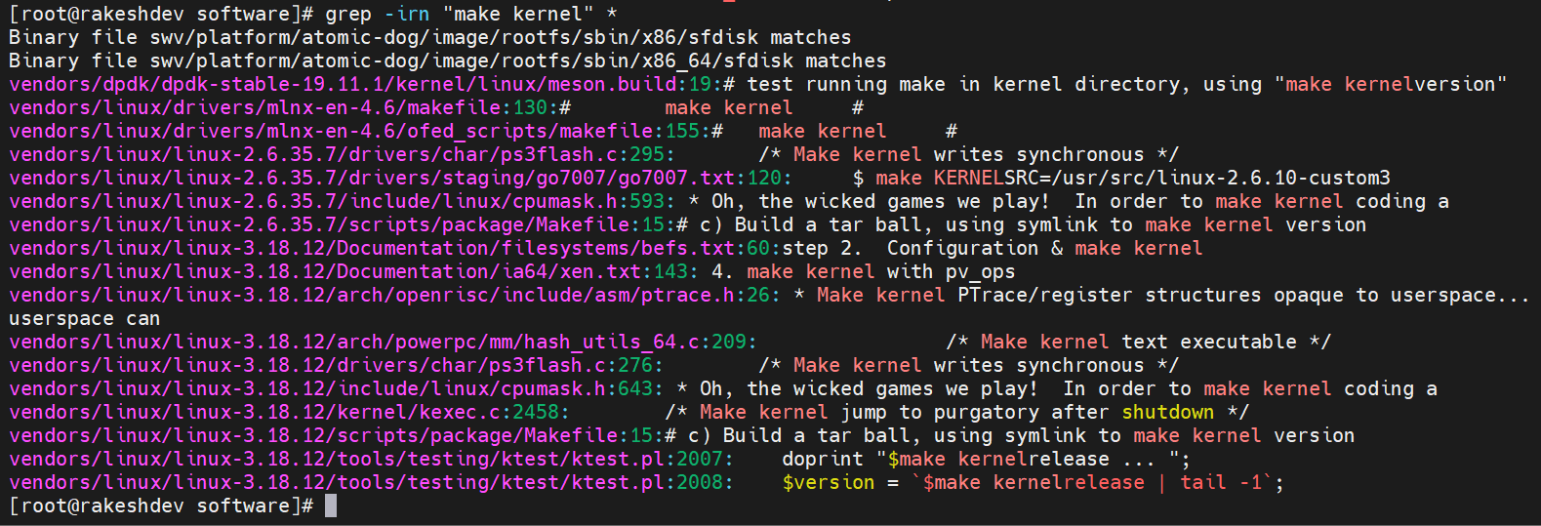

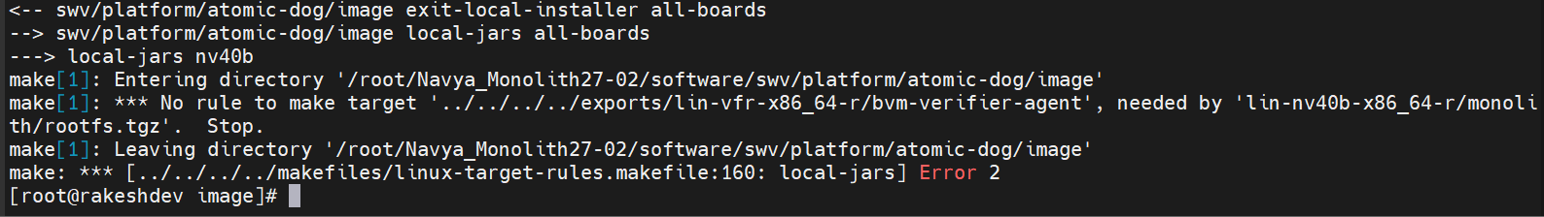
For this error we check under /exports/lin-vfr-x86_64-r. we have only these files.
After marc step make exports/lin-vfr-x86_64-r created.
We copied bvm-verifier-agent and compiled.
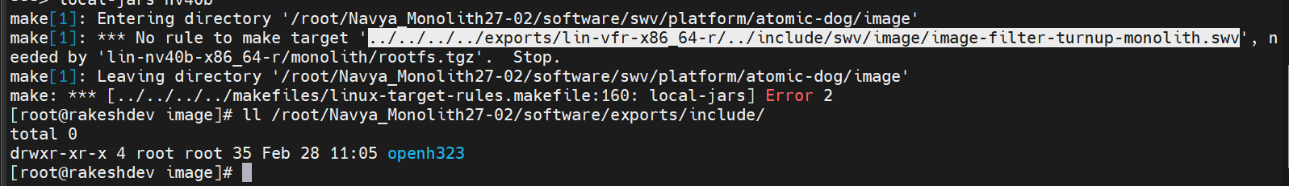
We don’t have SWV directory inside it image directory.
Here we copies image-monolith-filter-turnup-monolith.swv. under /exports/include
make again
Make error libswv-logger.so
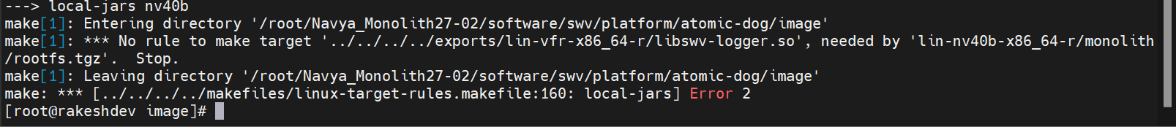
We copied all .so files except nvtl 4
We copied exfo-*
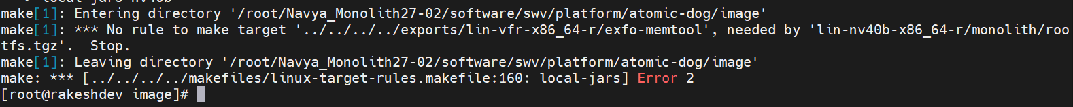
We copied ssh-*, ssh,sshd.
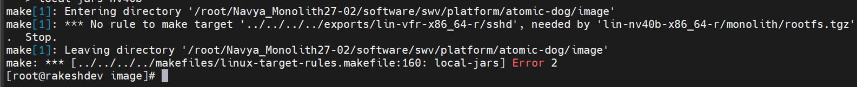
Scp
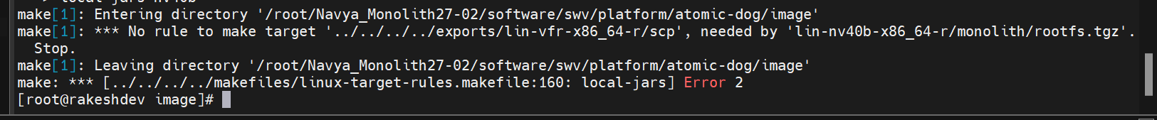
Lastmile.ko
