Python Activity-Based Learning
1.
Progressive Electricity Billing: Calculate household bills using multiple consumption slabs, fixed charges, surcharges, and rebates, then compare bills across several months and identify unusual increases.
Sol:
Problem statement
Calculate an electricity bill using progressive slabs: first 100 units at Rs. 1.50/unit, next 100 at Rs. 2.50/unit, and units above 200 at Rs. 4.00/unit. Add a fixed charge of Rs. 50.
Objectives
- Practice input, conditional statements, arithmetic, and progressive slab calculations.
- Calculate energy charge based on consumption slabs.
- Add fixed charges and display the final electricity bill.
Assumptions
- Units consumed cannot be negative.
- Slab rates apply only to the units within each slab.
- The fixed charge of Rs. 50 is added once.
Algorithm
1. Start.
2. Read units consumed.
3. If units are negative, display invalid units.
4. If units are at most 100, charge all units at Rs. 1.50.
5. If units are 101 to 200, charge the first 100 at Rs. 1.50 and the remainder at Rs. 2.50.
6. If units exceed 200, charge the first 100 at Rs. 1.50, the next 100 at Rs. 2.50, and the rest at Rs. 4.00.
7. Add Rs. 50 fixed charge, display the bill, and stop.
Flowchart
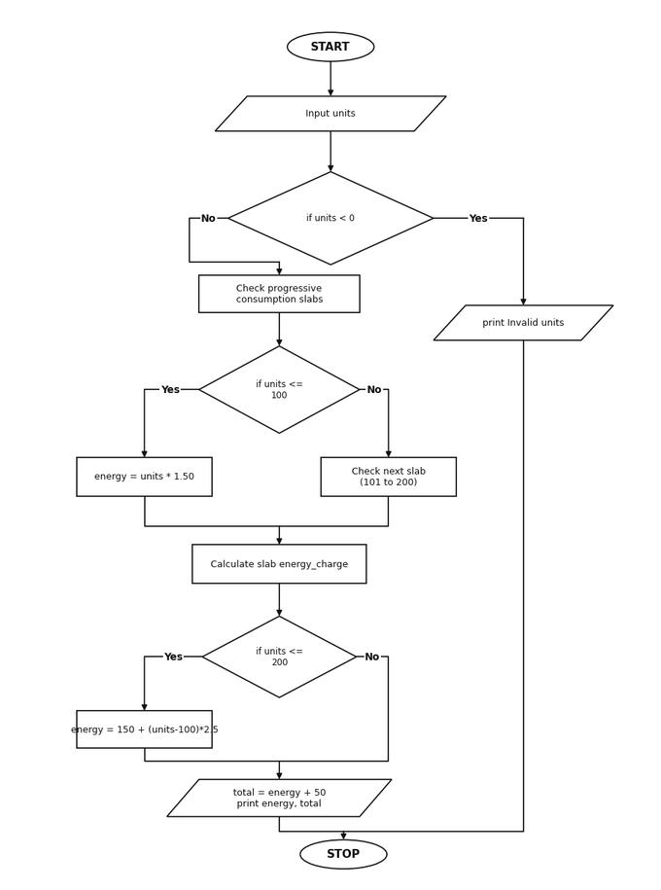
Pseudocode
START
INPUT units
IF units < 0
PRINT "Invalid units"
ELSE
IF units <= 100
energy_charge = units * 1.50
ELSE IF units <= 200
energy_charge = 100 * 1.50 + (units - 100) * 2.50
ELSE
energy_charge = 100 * 1.50 + 100 * 2.50 + (units - 200) * 4.00
total_bill = energy_charge + 50
PRINT energy_charge, total_bill
STOP
Source Code
units = float(input("Enter units consumed: "))
if units < 0:
print("Invalid units")
else:
if units <= 100:
energy_charge = units * 1.50
elif units <= 200:
energy_charge = 100 * 1.50 + (units - 100) * 2.50
else:
energy_charge = 100 * 1.50 + 100 * 2.50 + (units - 200) * 4.00
total_bill = energy_charge + 50
print("Energy charge: Rs.", round(energy_charge, 2))
print("Total bill: Rs.", round(total_bill, 2))
Test Cases
1. Enter units consumed: 50
Output:
Energy charge: Rs. 75.0
Total bill: Rs. 125.0
2. Enter units consumed: 150
Output:
Energy charge: Rs. 275.0
Total bill: Rs. 325.0
Output
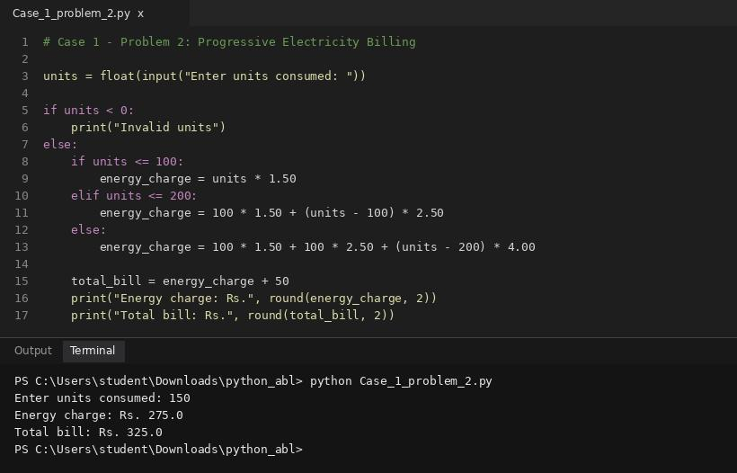
Conclusion
The program calculates the electricity bill by applying each rate only to the units in its slab.
2.
Hospital Billing and Patient Classification: Process consultation, diagnostic, and treatment charges, apply conditional concessions, validate billing constraints, and classify patients according to a supplied payment policy.
Sol:
Problem statement
Calculate a patient's hospital bill from room charges, consultation fee, and medicine cost. Classify the bill as Low (below Rs. 5,000), Moderate (Rs. 5,000 to Rs. 15,000), or High (above Rs. 15,000).
Objectives
- Use arithmetic and if-elif-else conditions to calculate and classify a hospital bill.
- Validate that entered hospital charges are non-negative.
- Display total hospital bill and patient category.
Assumptions
- All entered charges must be zero or positive.
- The classification uses the final total bill amount.
Algorithm
1. Start.
2. Read room, consultation, and medicine charges.
3. Reject any negative charge.
4. Add all charges to compute total.
5. Classify the total into Low, Moderate, or High.
6. Display total and classification.
7. Stop.
Flowchart
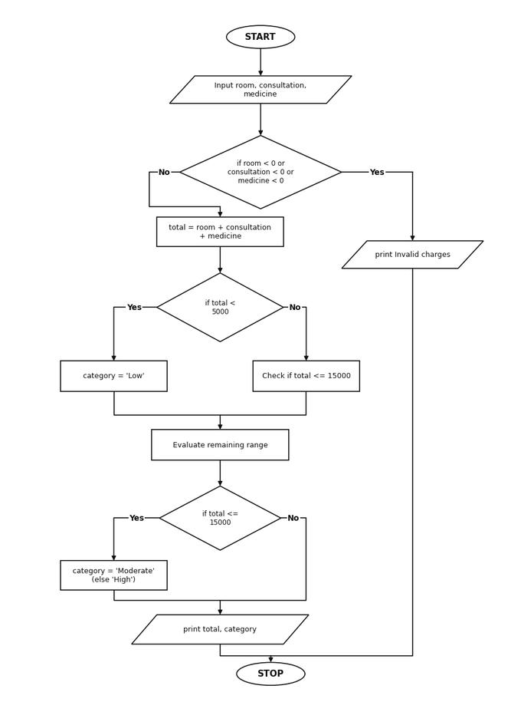
Pseudocode
START
INPUT room, consultation, medicine
IF room < 0 OR consultation < 0 OR medicine < 0
PRINT "Invalid charges"
ELSE
total = room + consultation + medicine
IF total < 5000
category = "Low"
ELSE IF total <= 15000
category = "Moderate"
ELSE
category = "High"
PRINT total, category
STOP
Source Code
room = float(input("Enter room charges: "))
consultation = float(input("Enter consultation fee: "))
medicine = float(input("Enter medicine cost: "))
if room < 0 or consultation < 0 or medicine < 0:
print("Invalid charges")
else:
total = room + consultation + medicine
if total < 5000:
category = "Low"
elif total <= 15000:
category = "Moderate"
else:
category = "High"
print("Total hospital bill: Rs.", round(total, 2))
print("Patient bill category:", category)
Test Cases
1. Enter room charges: 1000
Enter consultation fee: 500
Enter medicine cost: 700
Output:
Total hospital bill: Rs. 2200.0
Patient bill category: Low
2. Enter room charges: 3000
Enter consultation fee: 1000
Enter medicine cost: 2000
Output:
Total hospital bill: Rs. 6000.0
Patient bill category: Moderate
Output
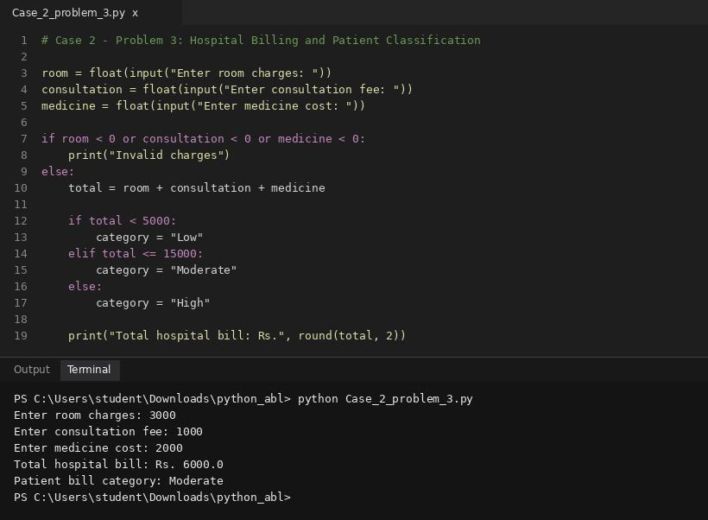
Conclusion
The program totals hospital expenses and assigns a category based on the final amount.
3.
Examination Result and Grace-Mark Validation: Process marks across multiple subjects, apply subject-wise pass criteria and a specified grace-mark policy, and generate final classifications without exceeding maximum marks.
Sol:
Problem statement
Read marks for five subjects, each out of 100. A student passes if every subject has at least 35 marks. If exactly one subject has 30 to 34 marks and all other subjects are passed, allow up to 5 grace marks to bring that subject to 35.
Objectives
- Apply loops, validation, conditions, and simple result processing.
- Identify subjects below the passing threshold of 35 marks.
- Apply the grace-mark rule when exactly one subject is between 30 and 34.
Assumptions
- Marks must be integers from 0 to 100.
- Grace marks are applied to only one subject and are limited to the number needed, up to 5.
Algorithm
1. Start.
2. Read five subject marks and validate each mark.
3. Find subjects with marks below 35.
4. If none are below 35, declare PASS.
5. If exactly one subject has 30 to 34 and the other four passed, add the required grace marks.
6. Otherwise declare FAIL and display final marks and result.
7. Stop.
Flowchart
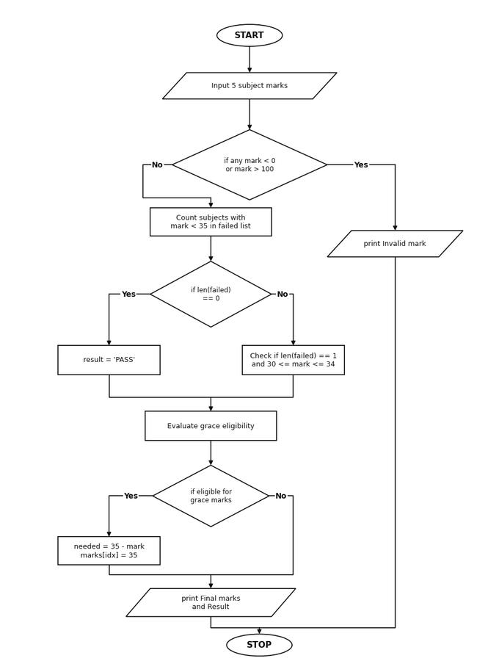
Pseudocode
START
INPUT 5 subject marks into marks list
IF any mark < 0 OR mark > 100
PRINT "Invalid mark"
ELSE
Find indices of marks < 35 in failed list
IF len(failed) == 0
result = "PASS"
ELSE IF len(failed) == 1 AND 30 <= marks[failed[0]] <= 34
needed = 35 - marks[failed[0]]
marks[failed[0]] = 35
result = "PASS WITH GRACE MARKS"
ELSE
result = "FAIL"
PRINT marks, result
STOP
Source Code
marks = []
valid = True
for i in range(5):
mark = int(input("Enter marks for subject " + str(i + 1) + ": "))
if mark < 0 or mark > 100:
print("Invalid mark. Marks must be 0 to 100.")
valid = False
break
marks.append(mark)
if valid:
failed = []
for i in range(5):
if marks[i] < 35:
failed.append(i)
if len(failed) == 0:
result = "PASS"
elif len(failed) == 1 and 30 <= marks[failed[0]] <= 34:
index = failed[0]
needed = 35 - marks[index]
marks[index] = marks[index] + needed
result = "PASS WITH " + str(needed) + " GRACE MARKS"
else:
result = "FAIL"
print("Final marks:", marks)
print("Result:", result)
Test Cases
1. Enter marks for 5 subjects: 70, 65, 32, 80, 50
Output:
Final marks: [70, 65, 35, 80, 50]
Result: PASS WITH 3 GRACE MARKS
2. Enter marks for 5 subjects: 70, 25, 32, 80, 50
Output:
Final marks: [70, 25, 32, 80, 50]
Result: FAIL
Output
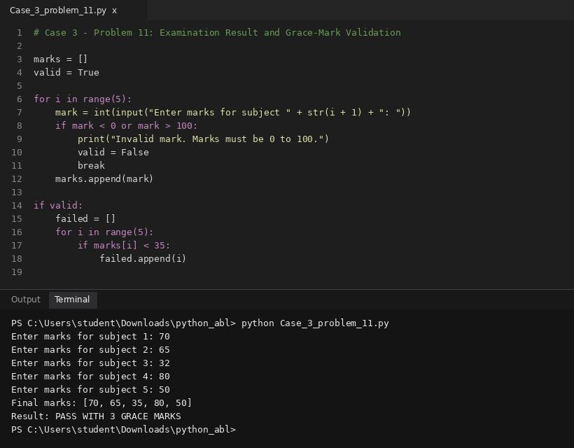
Conclusion
The program validates marks and applies grace marks only when the eligibility rule is satisfied.
4.
Food Waste Monitoring System: Compare prepared meals, meals served, and leftovers across several days; calculate wastage percentages and identify days exceeding acceptable limits.
Sol:
Problem statement
Record food prepared and food wasted for three meals. Calculate total prepared food, total waste, waste percentage, and classify waste as Low (below 10%), Moderate (10% to 25%), or High (above 25%).
Objectives
- Use loops, totals, and conditional classification to monitor food waste.
- Validate that wasted food does not exceed prepared food.
- Calculate overall waste percentage and classify the waste level.
Assumptions
- Quantities are in kilograms and cannot be negative.
- Wasted quantity cannot exceed prepared quantity for any meal.
Algorithm
1. Start.
2. For each of three meals, input prepared and wasted kilograms.
3. Validate the quantities.
4. Add prepared and wasted amounts to totals.
5. Calculate waste percentage as (waste_total / prepared_total) * 100.
6. Classify and display the results.
7. Stop.
Flowchart
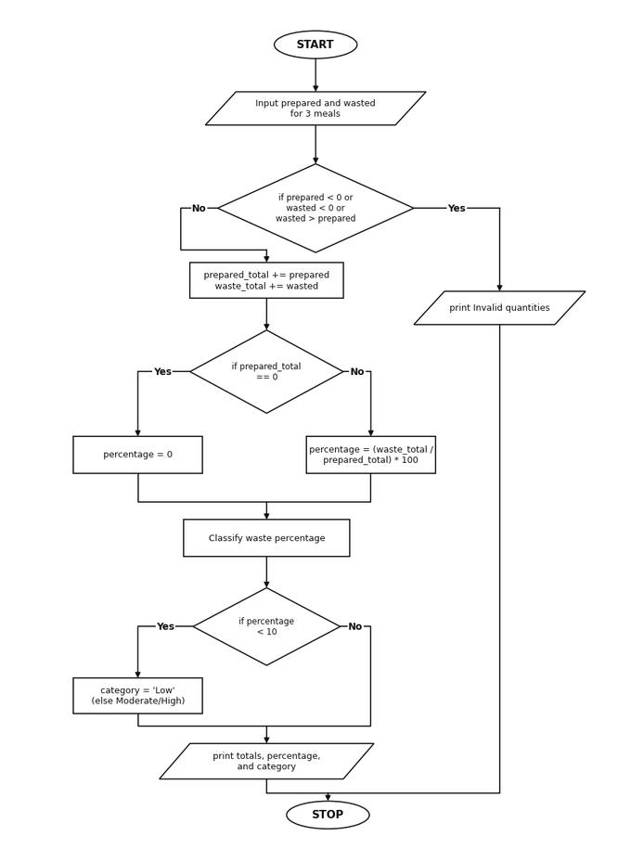
Pseudocode
START
SET prepared_total = 0, waste_total = 0
FOR each meal IN ["Breakfast", "Lunch", "Dinner"]
INPUT prepared, wasted
IF prepared < 0 OR wasted < 0 OR wasted > prepared
PRINT "Invalid quantities"
STOP
prepared_total = prepared_total + prepared
waste_total = waste_total + wasted
percentage = (waste_total / prepared_total) * 100
CLASSIFY percentage into Low, Moderate, or High
PRINT prepared_total, waste_total, percentage, category
STOP
Source Code
prepared_total = 0.0
waste_total = 0.0
valid = True
meals = ["Breakfast", "Lunch", "Dinner"]
for meal in meals:
prepared = float(input(meal + " prepared (kg): "))
wasted = float(input(meal + " wasted (kg): "))
if prepared < 0 or wasted < 0 or wasted > prepared:
print("Invalid quantities")
valid = False
break
prepared_total = prepared_total + prepared
waste_total = waste_total + wasted
if valid:
if prepared_total == 0:
percentage = 0.0
else:
percentage = (waste_total / prepared_total) * 100
if percentage < 10:
category = "Low"
elif percentage <= 25:
category = "Moderate"
else:
category = "High"
print("Total prepared:", round(prepared_total, 2), "kg")
print("Total wasted:", round(waste_total, 2), "kg")
print("Waste percentage:", round(percentage, 2), "%")
print("Waste level:", category)
Test Cases
1. Breakfast: 30 kg / 2 kg, Lunch: 45 kg / 6 kg, Dinner: 25 kg / 4 kg
Output:
Total prepared: 100.0 kg
Total wasted: 12.0 kg
Waste percentage: 12.0 %
Waste level: Moderate
2. Total prepared: 100.0 kg, Total wasted: 5.0 kg
Output:
Waste percentage: 5.0 %
Waste level: Low
Output
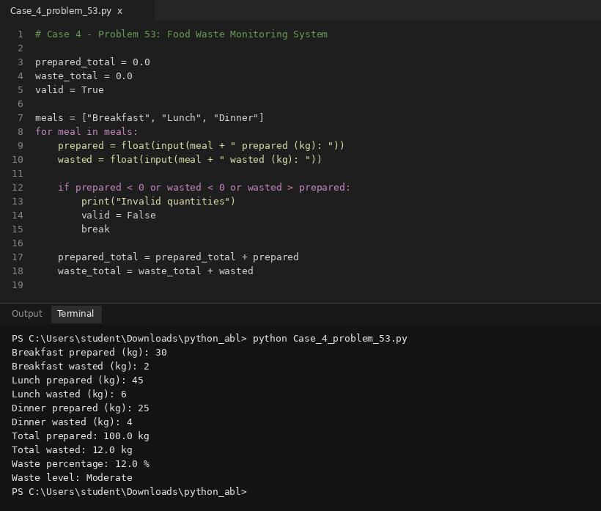
Conclusion
The system summarizes food waste and provides a category to support waste reduction.
5.
Traffic Violation Penalty Calculator: Process multiple violations using vehicle category, offence type, repeat-offence status, and predefined fine rules; calculate the final penalty and identify disqualification conditions.
Sol:
Problem statement
Calculate penalties from a list of traffic violations. Sample fines: no helmet Rs. 1,000; signal jump Rs. 2,000; overspeeding Rs. 1,500. Add a 20% surcharge when the total base fine exceeds Rs. 3,000.
Objectives
- Use loops, lists, validation, and conditional calculations.
- Validate each violation name and accumulate the base fine.
- Apply a 20% surcharge when the base fine exceeds Rs. 3,000.
Assumptions
- Only the three listed violation names are accepted.
- Each occurrence is counted separately.
- Surcharge of 20% applies only when base fine > Rs. 3,000.
Algorithm
1. Start.
2. Read the number of violations.
3. For each violation, read the violation name and validate it.
4. Add its fine (1000, 2000, or 1500) to the base total.
5. If base total exceeds Rs. 3,000, calculate a 20% surcharge.
6. Display base total, surcharge, and final total.
7. Stop.
Flowchart
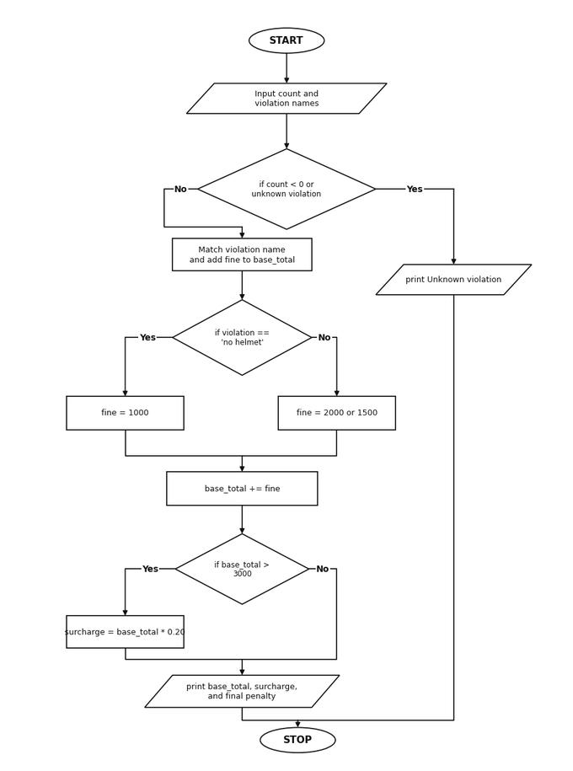
Pseudocode
START
INPUT count
SET base_total = 0
FOR i = 1 TO count
INPUT violation
IF violation == "no helmet"
fine = 1000
ELSE IF violation == "signal jump"
fine = 2000
ELSE IF violation == "overspeeding"
fine = 1500
ELSE
PRINT "Unknown violation" and STOP
base_total = base_total + fine
IF base_total > 3000
surcharge = base_total * 0.20
ELSE
surcharge = 0
PRINT base_total, surcharge, base_total + surcharge
STOP
Source Code
count = int(input("How many violations? "))
base_total = 0
valid = count >= 0
for i in range(count):
violation = input("Enter violation (no helmet/signal jump/overspeeding): ").strip().lower()
if violation == "no helmet":
fine = 1000
elif violation == "signal jump":
fine = 2000
elif violation == "overspeeding":
fine = 1500
else:
print("Unknown violation:", violation)
valid = False
break
print("Fine: Rs.", fine)
base_total = base_total + fine
if valid:
if base_total > 3000:
surcharge = base_total * 0.20
else:
surcharge = 0.0
final_penalty = base_total + surcharge
print("Base fine: Rs.", round(base_total, 2))
print("Surcharge: Rs.", round(surcharge, 2))
print("Final penalty: Rs.", round(final_penalty, 2))
Test Cases
1. How many violations? 2 (no helmet, signal jump)
Output:
Base fine: Rs. 3000
Surcharge: Rs. 0.0
Final penalty: Rs. 3000.0
2. How many violations? 3 (no helmet, signal jump, overspeeding)
Output:
Base fine: Rs. 4500
Surcharge: Rs. 900.0
Final penalty: Rs. 5400.0
Output
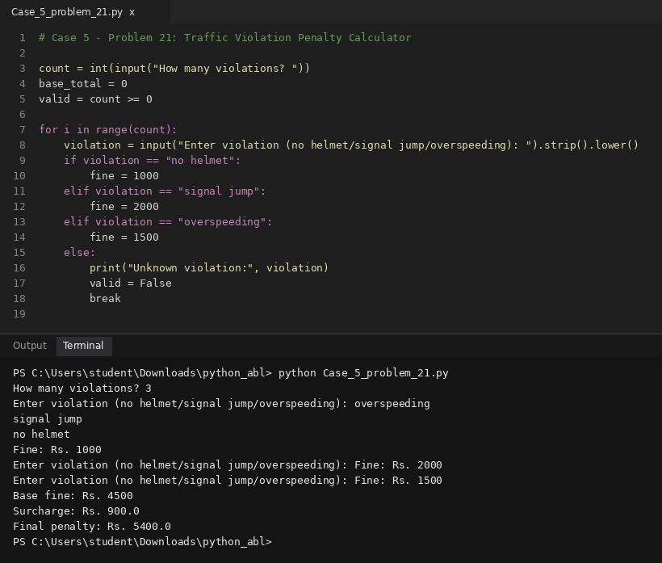
Conclusion
The calculator totals violations and applies the surcharge only when the base fine exceeds Rs. 3,000.
6.
Student Timetable Conflict Detection: Compare course schedules represented by strings and tuples, detect overlapping periods, identify unavailable rooms, and validate a proposed timetable.
Sol:
Problem statement
Given class records with day, start time, end time, and subject, detect whether any two classes overlap on the same day.
Objectives
- Practice lists, tuples, nested loops, comparisons, and validation.
- Validate that class start and end hours fall within 0 to 24 with start < end.
- Detect and report overlapping classes scheduled on the same day.
Assumptions
- Times are entered as integer hours in 24-hour format.
- Each class has start < end.
- Two classes overlap if start1 < end2 and start2 < end1 on the same day.
Algorithm
1. Start.
2. Read the number of classes and each class record.
3. Validate start and end times.
4. Compare each pair of classes using nested loops.
5. If two classes occur on the same day and their intervals overlap, report a conflict.
6. If no pair overlaps, report no conflicts and stop.
Flowchart
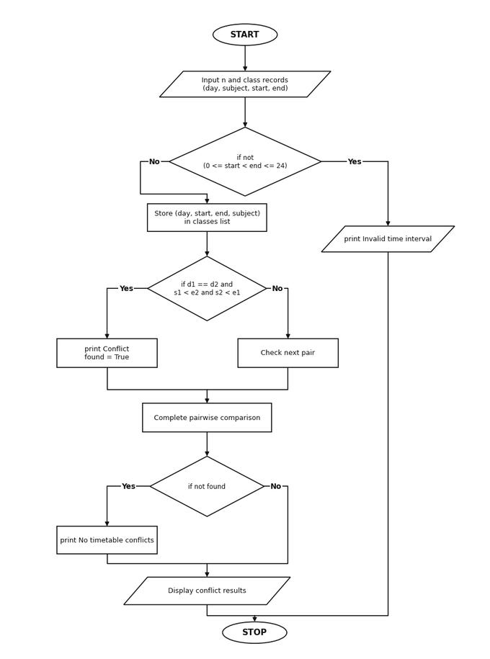
Pseudocode
START
INPUT n class records (day, start, end, subject)
VALIDATE 0 <= start < end <= 24
conflict = False
FOR i FROM 0 TO n - 1
FOR j FROM i + 1 TO n - 1
IF same day AND start_i < end_j AND start_j < end_i
PRINT conflict
conflict = True
IF NOT conflict
PRINT "No timetable conflicts"
STOP
Source Code
classes = []
n = int(input("Enter number of classes: "))
valid = n >= 0
for i in range(n):
print("Class", i + 1)
day = input("Day: ").strip().lower()
subject = input("Subject: ").strip()
start = int(input("Start hour (0-23): "))
end = int(input("End hour (1-24): "))
if not (0 <= start < end <= 24):
print("Invalid time interval")
valid = False
break
classes.append((day, start, end, subject))
if valid:
found = False
for i in range(n):
for j in range(i + 1, n):
d1, s1, e1, sub1 = classes[i]
d2, s2, e2, sub2 = classes[j]
if d1 == d2 and s1 < e2 and s2 < e1:
print("Conflict:", sub1, "and", sub2, "on", d1)
found = True
if not found:
print("No timetable conflicts")
Test Cases
1. Class 1: mon, Maths, 9 to 11 | Class 2: mon, Python, 10 to 12
Output:
Conflict: Maths and Python on mon
2. Class 1: mon, Maths, 9 to 10 | Class 2: mon, Python, 10 to 11
Output:
No timetable conflicts
Output
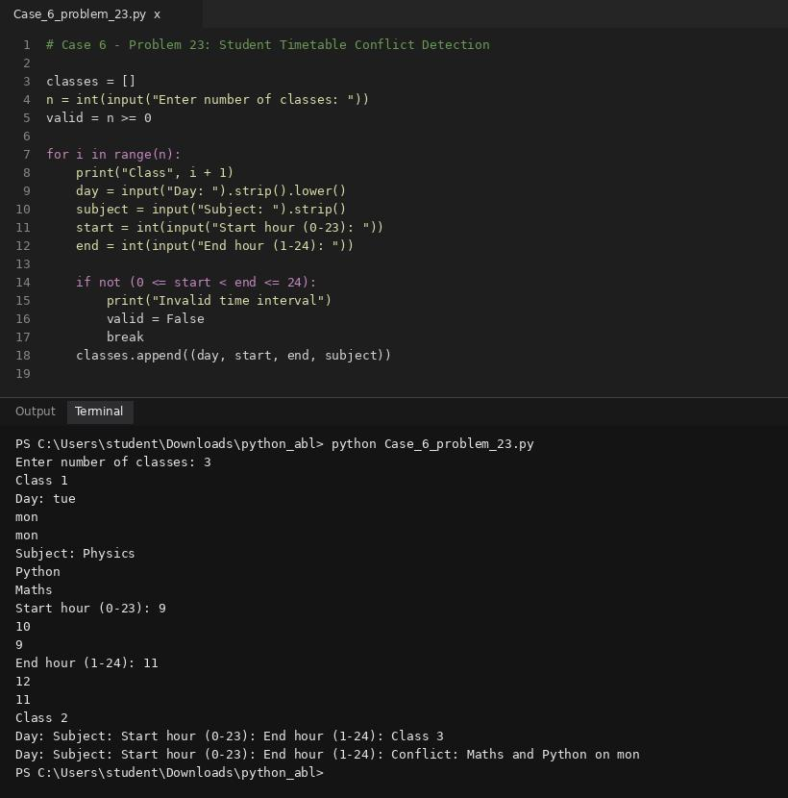
Conclusion
The program compares pairs of class intervals and reports overlapping classes on the same day.
7.
Library Borrowing and Fine Reconciliation: Analyse tuples representing book identifiers, borrowing periods, and return delays; calculate fines, identify overdue records, and reconcile book availability.
Sol:
Problem statement
For each returned book, calculate a late fine of Rs. 2 per day for the first 5 late days and Rs. 5 per day for each additional late day. Sum fines for all books.
Objectives
- Use loops, conditional calculations, and accumulated totals.
- Validate that late days are non-negative integers.
- Calculate book-wise fines and the total library fine.
Assumptions
- Late days are non-negative whole numbers.
- No fine is charged when a book is returned on time (0 late days).
Algorithm
1. Start.
2. Read the number of returned books.
3. For each book, read late days and validate.
4. Charge Rs. 2 per day for up to 5 days; for days beyond 5, charge Rs. 5 per extra day.
5. Add each book's fine to the total.
6. Display individual and total fines, then stop.
Flowchart
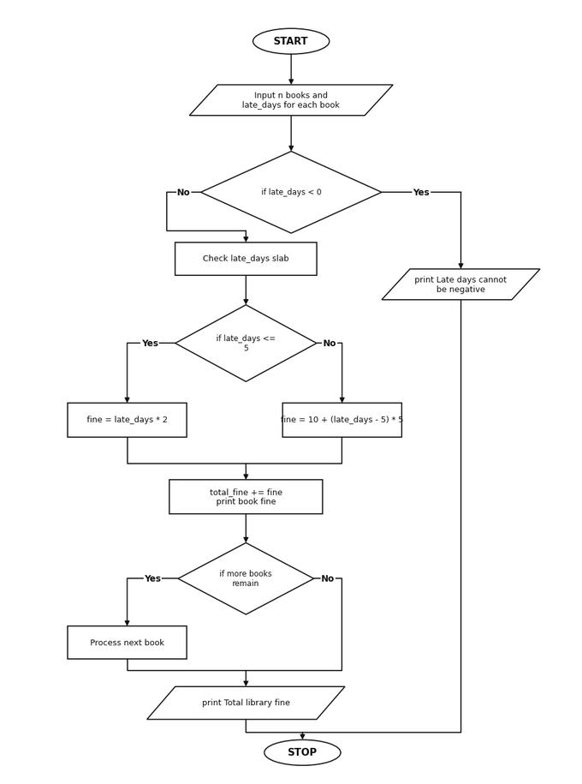
Pseudocode
START
INPUT number_of_books
SET total_fine = 0
FOR each book
INPUT late_days
IF late_days < 0
PRINT "Late days cannot be negative" and STOP
ELSE IF late_days <= 5
fine = late_days * 2
ELSE
fine = 5 * 2 + (late_days - 5) * 5
total_fine = total_fine + fine
PRINT fine
PRINT total_fine
STOP
Source Code
n = int(input("Number of returned books: "))
total_fine = 0
valid = n >= 0
for i in range(n):
late_days = int(input("Late days for book " + str(i + 1) + ": "))
if late_days < 0:
print("Late days cannot be negative")
valid = False
break
elif late_days <= 5:
fine = late_days * 2
else:
fine = 5 * 2 + (late_days - 5) * 5
print("Fine for book " + str(i + 1) + ": Rs.", fine)
total_fine = total_fine + fine
if valid:
print("Total library fine: Rs.", total_fine)
Test Cases
1. Number of returned books: 2 | Book 1: 4 late days | Book 2: 8 late days
Output:
Fine for book 1: Rs. 8
Fine for book 2: Rs. 25
Total library fine: Rs. 33
2. Number of returned books: 1 | Book 1: 0 late days
Output:
Fine for book 1: Rs. 0
Total library fine: Rs. 0
Output
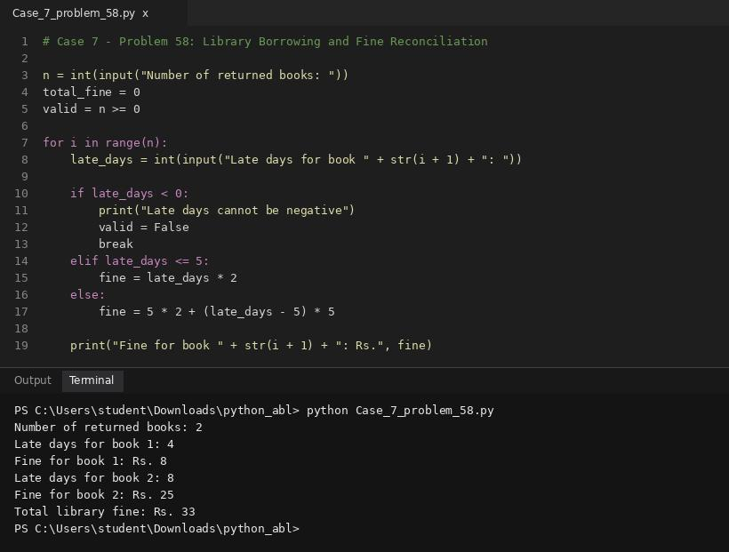
Conclusion
The program calculates progressive fines for each book and reconciles them into one total.
8.
Tuple-Based Course Registration Validation: Represent course registrations as tuples, identify duplicate registrations and invalid course combinations, and determine students whose selections violate supplied rules.
Sol:
Problem statement
Store course registrations as tuples containing student ID, course code, and credits. Check for duplicate student-course registrations and calculate total credits for each student.
Objectives
- Use tuples, lists, loops, and duplicate detection.
- Validate student ID, course code, and positive credit values.
- Detect duplicate student-course pairs and sum credits per student.
Assumptions
- Each record has a non-empty student ID and course code, and credits must be positive integers.
- A student may register for different courses but not the same course twice.
Algorithm
1. Start.
2. Read the number of registration records.
3. Store each valid record as a tuple (student, course, credits).
4. Compare records to detect repeated (student, course) pairs.
5. Accumulate valid credits per student using lists.
6. Display duplicate status and credit totals per student, then stop.
Flowchart
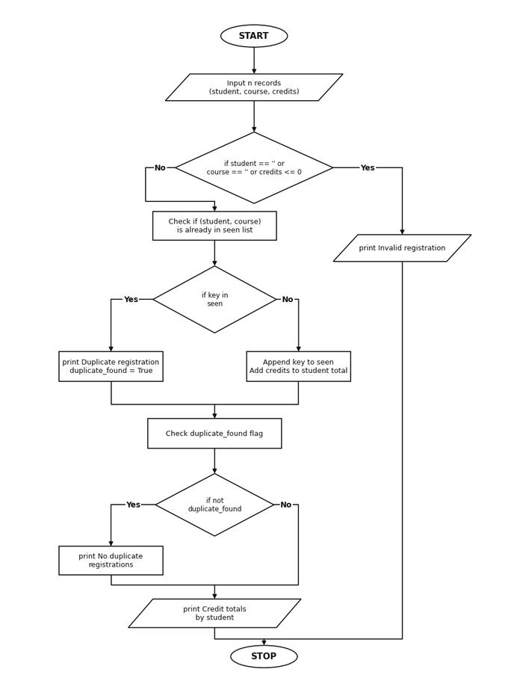
Pseudocode
START
INPUT n records (student_id, course_code, credits)
VALIDATE fields
seen = empty list
FOR each (student, course, credits) IN registrations
key = (student, course)
IF key IN seen
PRINT "Duplicate registration"
ELSE
Append key to seen
Add credits to student total
PRINT duplicate status and credit totals
STOP
Source Code
registrations = []
n = int(input("Number of registration records: "))
valid = n >= 0
for i in range(n):
student = input("Student ID: ").strip()
course = input("Course code: ").strip().upper()
credits = int(input("Credits: "))
if student == "" or course == "" or credits <= 0:
print("Invalid registration")
valid = False
break
registrations.append((student, course, credits))
if valid:
seen = []
student_ids = []
student_credits = []
duplicate_found = False
for rec in registrations:
student, course, credits = rec
key = (student, course)
if key in seen:
print("Duplicate registration:", student, "-", course)
duplicate_found = True
else:
seen.append(key)
if student not in student_ids:
student_ids.append(student)
student_credits.append(credits)
else:
idx = student_ids.index(student)
student_credits[idx] = student_credits[idx] + credits
if not duplicate_found:
print("No duplicate registrations")
print("Credit totals by student:")
for i in range(len(student_ids)):
print(student_ids[i], ":", student_credits[i])
Test Cases
1. Records: (S01, CS101, 3), (S01, MA101, 4), (S01, CS101, 3)
Output:
Duplicate registration: S01 - CS101
Credit totals by student:
S01 : 7
2. Records: (S01, CS101, 3), (S01, MA101, 4)
Output:
No duplicate registrations
Credit totals by student:
S01 : 7
Output
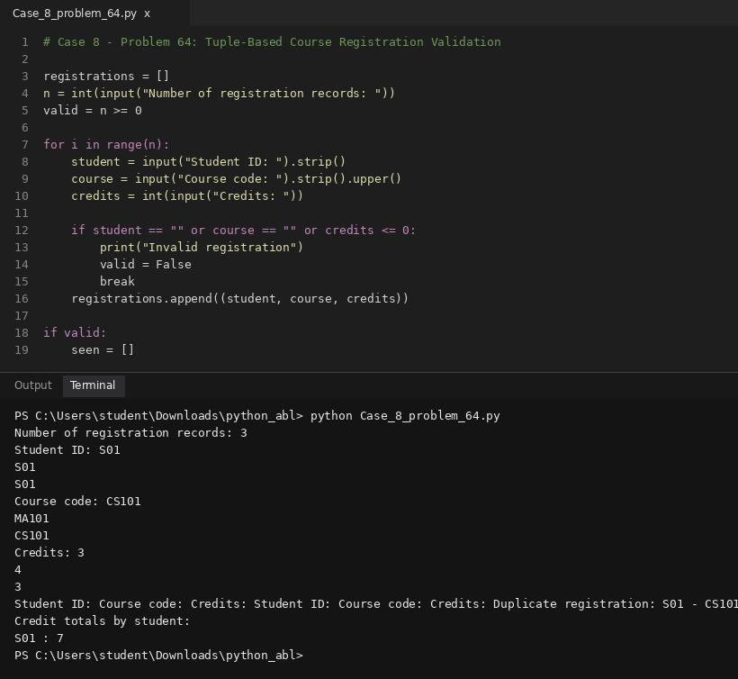
Conclusion
The program uses tuples to represent registrations and detects duplicate entries while calculating credit totals.
9.
University Scholarship Allocation: Design a system that evaluates applicants using aggregate marks, subject-wise minimum scores, attendance, and income criteria, ranks eligible students, and resolves ties using predefined rules.
Sol:
Problem statement
Allocate a limited number of scholarships to eligible students. Eligibility requires marks of at least 85 and family income no greater than Rs. 300,000. Rank eligible students by marks descending, then lower income ascending, then student ID alphabetically, and award scholarships up to available seats.
Objectives
- Combine record handling, eligibility rules, sorting, tie-breaking, and constrained allocation.
- Filter eligible students meeting marks >= 85 and income <= 300,000.
- Rank candidates and allocate scholarships up to the seat limit.
Assumptions
- Each student record contains ID, marks, and annual family income.
- Marks must be 0 to 100 and income must be non-negative.
Algorithm
1. Start.
2. Read scholarship seats and student records.
3. Validate all inputs.
4. Keep students meeting both eligibility conditions (marks >= 85 and income <= 300,000).
5. Sort eligible students by marks descending, income ascending, and ID ascending.
6. Award scholarships to the top candidates up to available seats.
7. Display ranking, award status, and unfilled seats, then stop.
Flowchart
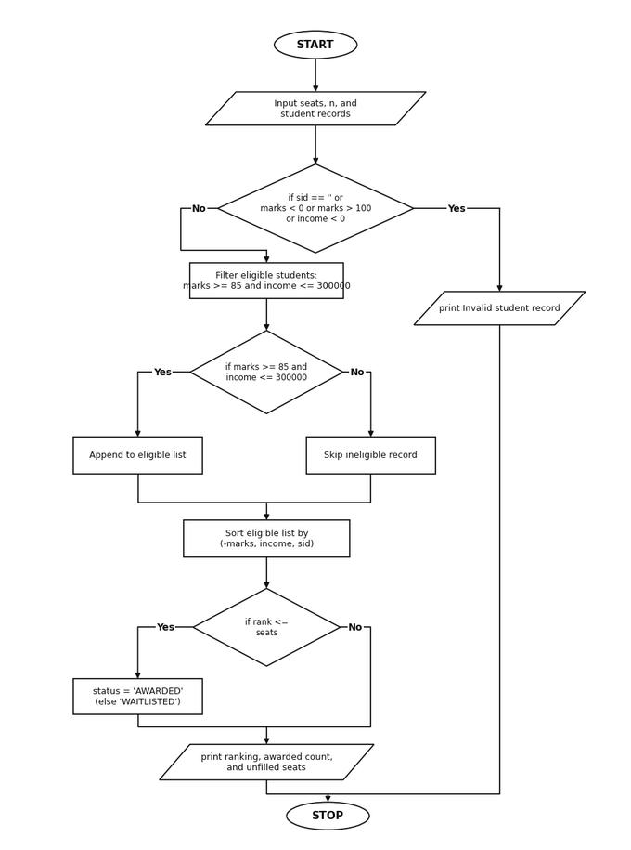
Pseudocode
START
INPUT seats and n student records (sid, marks, income)
VALIDATE records
eligible = students with marks >= 85 AND income <= 300000
SORT eligible by (-marks, income, sid)
FOR rank FROM 1 TO len(eligible)
IF rank <= seats
status = "AWARDED"
ELSE
status = "WAITLISTED / NOT AWARDED"
PRINT rank, sid, marks, income, status
PRINT awarded count and unfilled seats
STOP
Source Code
seats = int(input("Number of scholarships available: "))
n = int(input("Number of students: "))
students = []
valid = seats >= 0 and n >= 0
for i in range(n):
sid = input("Student ID: ").strip()
marks = float(input("Marks (0-100): "))
income = float(input("Annual family income: "))
if sid == "" or not (0 <= marks <= 100) or income < 0:
print("Invalid student record")
valid = False
break
students.append((sid, marks, income))
if valid:
eligible = []
for s in students:
sid, marks, income = s
if marks >= 85 and income <= 300000:
eligible.append((-marks, income, sid, marks))
eligible.sort()
print("Scholarship ranking:")
rank = 1
awarded_count = 0
for item in eligible:
neg_m, income, sid, marks = item
if rank <= seats:
status = "AWARDED"
awarded_count = awarded_count + 1
else:
status = "WAITLISTED / NOT AWARDED"
print(rank, sid, marks, "Rs.", round(income, 2), status)
rank = rank + 1
if seats > awarded_count:
unfilled = seats - awarded_count
else:
unfilled = 0
print("Scholarships awarded:", awarded_count)
print("Unfilled seats:", unfilled)
Test Cases
1. Seats: 2 | Students: A (90, 250000), B (95, 290000), C (88, 200000)
Output:
1 B 95.0 Rs. 290000.0 AWARDED
2 A 90.0 Rs. 250000.0 AWARDED
3 C 88.0 Rs. 200000.0 WAITLISTED / NOT AWARDED
Scholarships awarded: 2
Unfilled seats: 0
Output
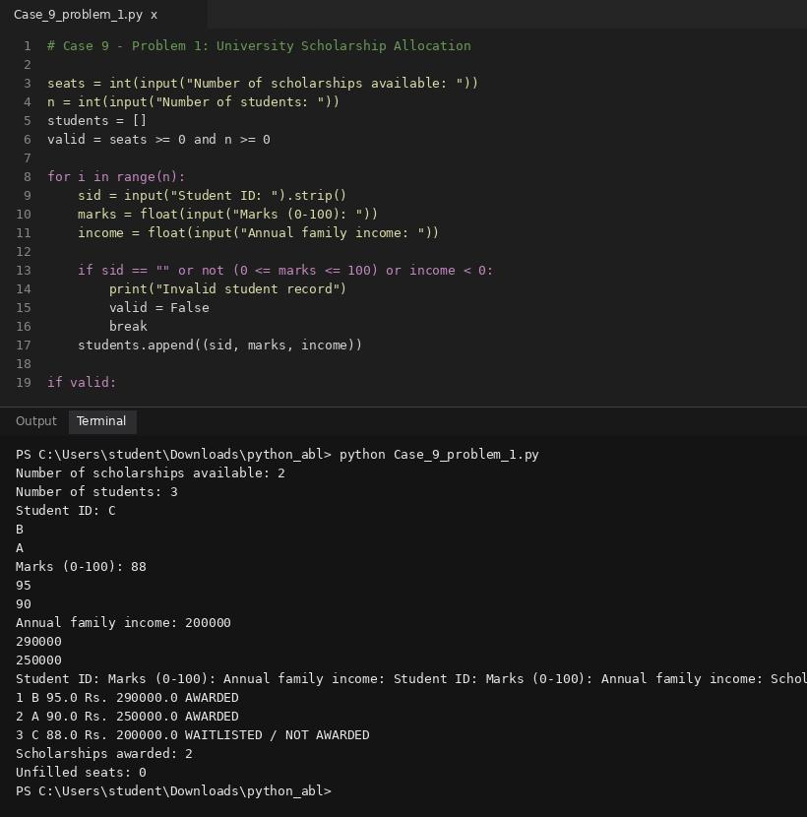
Conclusion
The program applies eligibility rules and deterministic tie-breaking to allocate a limited number of scholarships.
10.
University Admission Decision Engine: Evaluate candidates using subject eligibility, aggregate marks, course-specific thresholds, and tie-breaking criteria; generate a ranked list of eligible applicants.
Sol:
Problem statement
Determine admission eligibility using entrance score, qualifying-exam percentage, and available seats. A candidate is eligible if entrance score is at least 70 and qualifying percentage is at least 60. Rank eligible candidates by entrance score descending, qualifying percentage descending, then application ID ascending, and admit candidates up to the seat limit.
Objectives
- Integrate input validation, filtering, multi-key ranking, and limited-seat allocation.
- Filter applicants meeting entrance >= 70 and qualifying >= 60.
- Rank eligible candidates and assign ADMITTED or WAITLISTED status.
Assumptions
- Scores are from 0 to 100 and seat count is non-negative.
- Ties in entrance score are broken by qualifying percentage descending, then ID ascending.
Algorithm
1. Start.
2. Read seat capacity and candidate records.
3. Validate IDs, scores, and percentages.
4. Filter candidates meeting both minimum criteria.
5. Sort by entrance score descending, qualifying percentage descending, and ID ascending.
6. Admit candidates up to seat capacity.
7. Display each eligible candidate's rank and decision, then stop.
Flowchart
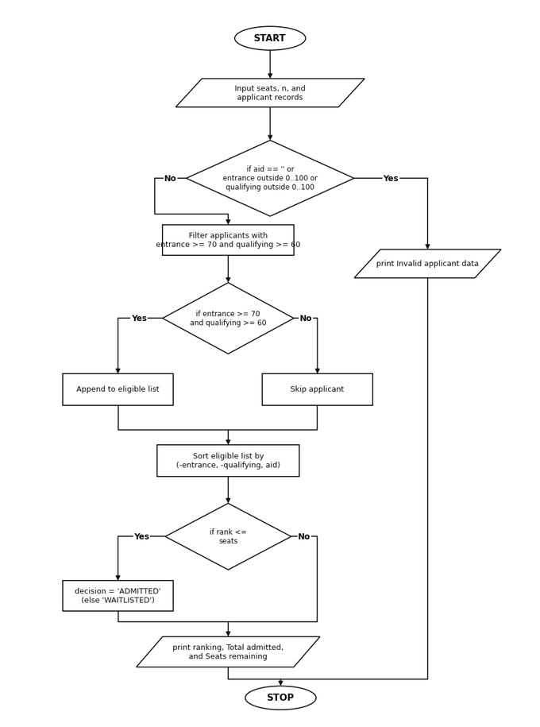
Pseudocode
START
INPUT seats and n candidate records (aid, entrance, qualifying)
VALIDATE records
eligible = candidates where entrance >= 70 AND qualifying >= 60
SORT eligible by (-entrance, -qualifying, aid)
FOR rank FROM 1 TO len(eligible)
IF rank <= seats
decision = "ADMITTED"
ELSE
decision = "WAITLISTED"
PRINT rank, aid, entrance, qualifying, decision
PRINT total admitted and seats remaining
STOP
Source Code
seats = int(input("Available seats: "))
n = int(input("Number of applicants: "))
applicants = []
valid = seats >= 0 and n >= 0
for i in range(n):
aid = input("Application ID: ").strip()
entrance = float(input("Entrance score (0-100): "))
qualifying = float(input("Qualifying percentage (0-100): "))
if aid == "" or not (0 <= entrance <= 100) or not (0 <= qualifying <= 100):
print("Invalid applicant data")
valid = False
break
applicants.append((aid, entrance, qualifying))
if valid:
eligible = []
for a in applicants:
aid, entrance, qualifying = a
if entrance >= 70 and qualifying >= 60:
eligible.append((-entrance, -qualifying, aid, entrance, qualifying))
eligible.sort()
print("Admission results:")
rank = 1
admitted_count = 0
for item in eligible:
neg_e, neg_q, aid, entrance, qualifying = item
if rank <= seats:
decision = "ADMITTED"
admitted_count = admitted_count + 1
else:
decision = "WAITLISTED"
print(rank, aid, entrance, qualifying, decision)
rank = rank + 1
if seats > admitted_count:
rem_seats = seats - admitted_count
else:
rem_seats = 0
print("Total admitted:", admitted_count)
print("Seats remaining:", rem_seats)
Test Cases
1. Seats: 2 | Applicants: A (80, 80), B (90, 70), C (85, 90)
Output:
1 B 90.0 70.0 ADMITTED
2 C 85.0 90.0 ADMITTED
3 A 80.0 80.0 WAITLISTED
Total admitted: 2
Seats remaining: 0
Output
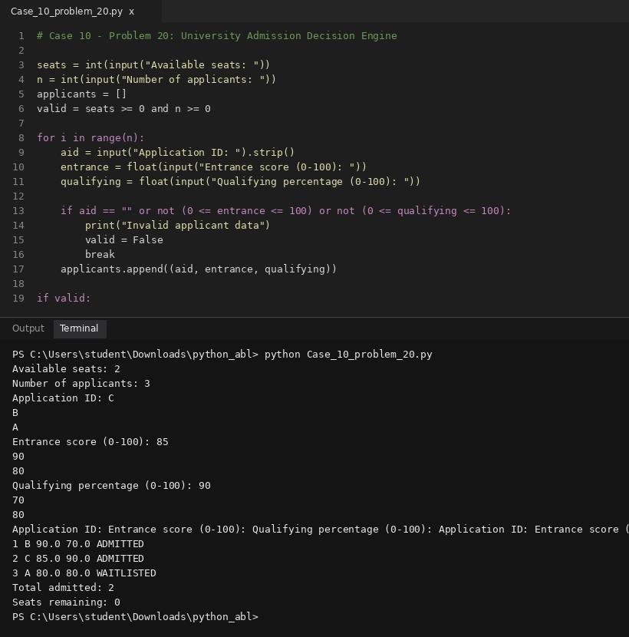
Conclusion
The system filters candidates, ranks them consistently, and respects the available seat limit.

