STANDARD OPERATING PROCEDURE
Recording the Kiln Video for Biochar Volume
Use: one slow video per biochar-filled kiln Time: ~1 minute per kiln For: Field data collectors
1. Why this matters
The video is turned by software into a 3-D model of the biochar, and that model is used to measure the volume. A slow, steady, complete video gives an accurate volume. A fast, shaky, or half-finished video gives a wrong number — or no result at all. Please follow every step exactly.
2. When to record
- Record after the biochar is fully quenched (cooled with water) and the surface has settled.
- Record before unloading — while all the biochar is still inside the kiln.
- Record in good daylight. Never at night.
- Make sure the surface is clear — no foam, smoke, or standing water hiding the biochar.
3. What you need
- A smartphone with a working camera and enough free storage for a short video.
- A clean camera lens — wipe it first (ash or dust blurs everything).
- Recommended: a 1-metre stick or measuring tape to lay across the rim as a size reference (see Section 8).
4. Get ready (before you record)
- Move people, tools, hoses and buckets away from the kiln — nothing should block it or move during the video.
- Stand so the sun is behind you, not facing the camera.
- Open the camera, switch to Video, and set the quality to 1080p or 4K if your phone allows.
- Keep the zoom at 1× — do not zoom at any time.
5. The technique — the slow circle
1. Stand at the edge (rim) of the kiln.
2. Tilt the phone down about 50–60° so you look into the kiln — you must see the black biochar surface AND the full round rim.
3. Walk slowly all the way around the kiln — a complete circle — keeping the biochar and the whole rim in view the entire time.
4. Take about 30–40 seconds for one full circle. Slow and smooth.
5. Keep the kiln filling most of the screen.
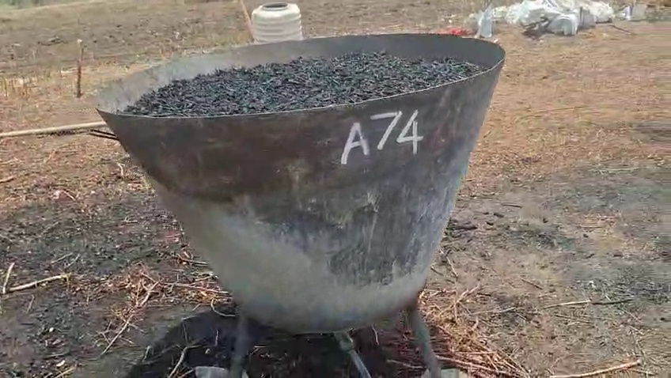
Example: the kiln fills the frame with the rim and biochar visible. (Tilt a little more downward than this to see the surface better.)
6. The 6 golden rules
1 · Go slow  Move at a slow walk. Fast movement = blur = the software fails. | 2 · Full circle  Go all the way around (360°). Do not stop halfway.
3 · Look down into it  Tilt ~50–60° down. See the black surface, not just the side. | 4 · Keep the whole rim in view  The rim is the ruler that sets the real size. Never cut it off.
5 · Hold steady  Two hands. Move your feet smoothly — no jerks or swings. | 6 · One take, no zoom  Record in one continuous take. Never zoom in or out.
7. How to record — step by step
1. Wipe the lens. Open the camera, switch to Video, set 1080p/4K, zoom at 1×.
2. Stand at the rim and tilt down ~50–60°. Check you can see the biochar + the full rim.
3. Press record and hold still for 2 seconds before you start moving.
4. Walk slowly all the way around (~30–40 seconds), keeping the surface and full rim in frame the whole time.
5. Optional but better: do a second slow loop at a slightly different height.
6. Stop recording. Play it back and check it against Section 9.
7. Record 2 videos of the same kiln, in case one comes out shaky.
8. Add a size reference (recommended)
Before recording, lay a 1-metre stick or an open measuring tape across the rim, so it is clearly visible in the video. This gives the software an exact, known size and makes the volume more reliable. If you have none, the software can use the kiln's rim instead — but a 1-metre marker is strongly recommended for the most accurate result.
9. Check before you submit (must pass EVERY point)
☐ | You recorded a full circle — all the way around the kiln.
☐ | The whole round rim is visible for the entire video.
☐ | All the black biochar surface is visible (not hidden behind the rim).
☐ | The video is smooth and sharp — not shaky, not blurry.
☐ | Bright daylight — no deep shadow and no strong glare on the biochar.
☐ | You did not zoom, and it is one continuous take.
☐ | (If used) the 1-metre reference is visible in the video.
If any point fails — delete it and record again.
10. Do & Don't
Situation | DO | DON'T
Speed | Move at a slow, steady walk | Rush or swing the phone (causes blur)
Coverage | Complete a full 360° circle | Stop halfway or skip a side
Angle | Tilt down ~50–60° into the kiln | Shoot flat from the side (rim hides biochar)
The rim | Keep the whole rim in view always | Let any part of the rim leave the frame
Zoom | Keep zoom fixed at 1× | Zoom in or out during the video
Light | Daylight, sun behind you | Night, deep shadow, or facing the sun
Scene | One kiln, nothing moving | People/tools moving through the shot
11. Common mistakes and how to fix them
Mistake | Why it's wrong | Fix
Moved too fast | Frames are blurry — 3-D model fails | Slow down; 30–40 s for one circle
Did not go all the way around | Part of the surface is never seen | Always complete the full circle
Rim went out of frame | No size reference — size becomes wrong | Step back; keep the full rim visible
Zoomed during the video | Confuses the 3-D software | Keep zoom at 1× the whole time
Shot from the side | Rim hides the biochar surface | Stand higher and tilt down into the kiln
Too dark / glare | Biochar not clearly visible | Record in daylight, sun behind you
Record one good video for every biochar-filled kiln, following this procedure. A correct video takes about a minute and gives an accurate biochar volume. Questions? Contact your supervisor. · SOP-KILN-VIDEO-01 v1.0

