JHANVI JOSHI

160470107025

Information And Network Security

Table of Contents

PRACTICAL:1 2

## PRACTICAL:1

# **Aim: Introduction to Information And Network Security**

**What is Cryptography?**

Human being from ages had two inherent needs − (a) to communicate and share information and (b) to communicate selectively. These two needs gave rise to the art of coding the messages in such a way that only the intended people could have access to the information. Unauthorized people could not extract any information, even if the scrambled messages fell in their hand.

*The art and science of concealing the messages to introduce secrecy in information security is recognized as cryptography.*

The word ‘cryptography’ was coined by combining two Greek words, ‘Krypto’ meaning hidden and ‘graphene’ meaning writing.

Cryptography involves creating written or generated codes that allow information to be kept secret. Cryptography converts data into a format that is unreadable for an unauthorized user, allowing it to be transmitted without unauthorized entities decoding it back into a readable format, thus compromising the data.

Information security uses cryptography on several levels. The information cannot be read without a key to decrypt it. The information maintains its integrity during transit and while being stored. Cryptography also aids in nonrepudiation. This means that the sender and the delivery of a message can be verified.

Cryptography is also known as cryptology.

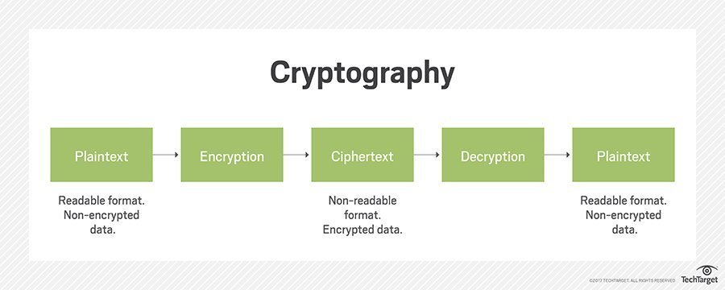

**Security Services of Cryptography**

The primary objective of using cryptography is to provide the following four fundamental information security services. Let us now see the possible goals intended to be fulfilled by cryptography.

**Confidentiality**

Confidentiality is the fundamental security service provided by cryptography. It is a security service that keeps the information from an unauthorized person. It is sometimes referred to as **privacy** or **secrecy**.

Confidentiality can be achieved through numerous means starting from physical securing to the use of mathematical algorithms for data encryption.

**Data Integrity**

It is security service that deals with identifying any alteration to the data. The data may get modified by an unauthorized entity intentionally or accidently. Integrity service confirms that whether data is intact or not since it was last created, transmitted, or stored by an authorized user.

Data integrity cannot prevent the alteration of data, but provides a means for detecting whether data has been manipulated in an unauthorized manner.

**Authentication**

Authentication provides the identification of the originator. It confirms to the receiver that the data received has been sent only by an identified and verified sender.

Authentication service has two variants −

* **Message authentication** identifies the originator of the message without any regard router or system that has sent the message.
* **Entity authentication** is assurance that data has been received from a specific entity, say a particular website.

Apart from the originator, authentication may also provide assurance about other parameters related to data such as the date and time of creation/transmission.

**Non-repudiation**

It is a security service that ensures that an entity cannot refuse the ownership of a previous commitment or an action. It is an assurance that the original creator of the data cannot deny the creation or transmission of the said data to a recipient or third party.

Non-repudiation is a property that is most desirable in situations where there are chances of a dispute over the exchange of data. For example, once an order is placed electronically, a purchaser cannot deny the purchase order, if non-repudiation service was enabled in this transaction.

**What is Symmetric Cryptography and Asymmetric Cryptography?**

**Symmetric Key Encryption**

The encryption process where **same keys are used for encrypting and decrypting** the information is known as Symmetric Key Encryption.

The study of symmetric cryptosystems is referred to as **symmetric cryptography**. Symmetric cryptosystems are also sometimes referred to as **secret key cryptosystems**.

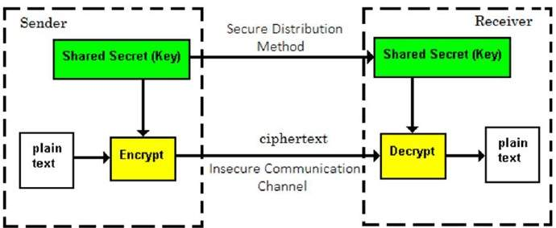

The salient features of cryptosystem based on symmetric key encryption are −

* Persons using symmetric key encryption must share a common key prior to exchange of information.
* Keys are recommended to be changed regularly to prevent any attack on the system.
* A robust mechanism needs to exist to exchange the key between the communicating parties. As keys are required to be changed regularly, this mechanism becomes expensive and cumbersome.
* Length of Key (number of bits) in this encryption is smaller and hence, process of encryption-decryption is faster than asymmetric key encryption.

**Challenge of Symmetric Key Cryptosystem**

There are two restrictive challenges of employing symmetric key cryptography.

* **Key establishment** − Before any communication, both the sender and the receiver need to agree on a secret symmetric key. It requires a secure key establishment mechanism in place.
* **Trust Issue** − Since the sender and the receiver use the same symmetric key, there is an implicit requirement that the sender and the receiver ‘trust’ each other. For example, it may happen that the receiver has lost the key to an attacker and the sender is not informed.

These two challenges are highly restraining for modern day communication. Today, people need to exchange information with non-familiar and non-trusted parties. For example, a communication between online seller and customer. These limitations of symmetric key encryption gave rise to asymmetric key encryption schemes.

**Asymmetric Key Encryption**

The encryption process where **different keys are used for encrypting and decrypting the information** is known as Asymmetric Key Encryption. Though the keys are different, they are mathematically related and hence, retrieving the plaintext by decrypting ciphertext is feasible. The process is depicted in the following illustration −

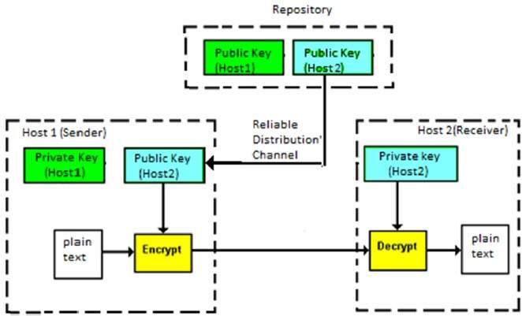

The salient features of this encryption scheme are as follows −

* Every user in this system needs to have a pair of dissimilar keys, **private key** and **public key**. These keys are mathematically related − when one key is used for encryption, the other can decrypt the ciphertext back to the original plaintext.
* It requires to put the public key in public repository and the private key as a well-guarded secret. Hence, this scheme of encryption is also called **Public Key Encryption**.
* Though public and private keys of the user are related, it is computationally not feasible to find one from another. This is a strength of this scheme.
* When *Host1* needs to send data to *Host2,* he obtains the public key of *Host2* from repository, encrypts the data, and transmits.
* *Host2* uses his private key to extract the plaintext.
* Length of Keys (number of bits) in this encryption is large and hence, the process of encryption-decryption is slower than symmetric key encryption.
* Processing power of computer system required to run asymmetric algorithm is higher.

Symmetric cryptosystems are a natural concept. In contrast, public-key cryptosystems are quite difficult to comprehend.

**Relation between Encryption Schemes**

A summary of basic key properties of two types of cryptosystems is given below −

|  |  |  |
| --- | --- | --- |
|  | Symmetric Cryptosystems | Public Key Cryptosystems |
| **Relation between Keys** | Same | Different, but mathematically related |
| Encryption Key | Symmetric | Public |
| Decryption Key | Symmetric | Private |

Due to the advantages and disadvantage of both the systems, symmetric key and public-key cryptosystems are often used together in the practical information security systems.

**Difference Between Symmetric and Asymmetric Encryption**

* Symmetric encryption uses a single key that needs to be shared among the people who need to receive the message while asymmetrical encryption uses a pair of public key and a private key to encrypt and decrypt messages when communicating.
* Symmetric encryption is an old technique while asymmetric encryption is relatively new.
* Asymmetric encryption was introduced to complement the inherent problem of the need to share the key in symmetrical encryption model, eliminating the need to share the key by using a pair of public-private keys.
* Asymmetric encryption takes relatively more time than the symmetric encryption.

**References:**

* <https://www.ssl2buy.com/wiki/symmetric-vs-asymmetric-encryption-what-are-differences>
* <https://www.tutorialspoint.com/cryptography/cryptosystems.htm>
* <https://www.tutorialspoint.com/cryptography/origin_of_cryptography.htm>
* <https://www.techopedia.com/definition/1770/cryptography>