STATISTICAL ANALYSIS ON

GLOBAL INNOVATION INDEX



Submitted By:
Naina Singh Rao (2024BTECH203)
Akshara Kumawat (2024BTECH192)
Jharna Saxena (2024BTECH200)

FACULTY GUIDE:
Dr. Umesh Gupta
Professor, JK Lakshmipat University,
Mahindra SEZ, Jaipur, Rajasthan-302026

Table of Contents
ABSTRACT 4
INTRODUCTION 5
LITERATURE REVIEW 6
OBJECTIVE 7
PROBLEM STATEMENTS: 7
DATA DESCRIPTION 8
Abbreviations used: 8
Formulas and Concepts: 8
METHODOLOGY 11
DATA COLLECTION 14
2014 14
2015 15
2016 16
2017 17
2018 18
2019 19
2020 20
2021 21
2022 22
2023 23
2024 24
RESULTS 26
Problem Statement 1 26
Calculation of IEI 26
Table: IEI for G20 countries for years 2015-2019 26
Table: IEI for G20 countries for years 2020-2024: 27
Table: Mean Innovation efficiency index for G20 countries for years 2015-2024 in descending order 28
Figure: Bar graph depicting the country ranking mean (mean IEI) for years 2015-2024 of the G20 nations. 29
Classification of countries 29
Hypothesis Testing 30
Final Interpretation 32
Problem Statement 3 37
Significance 37
Methodology 37
Graphs 38
India’s Innovation vs G20 (2025): GAP & Z-Score 40
Conclusion 43

ABSTRACT:
This report studies the global innovation index (GII) for G20 countries from 2015 to 2024. It majorly focuses on three things which includes How well developed and developing nations turn their innovation inputs into real results, is there any relationship between GDP and GII and to check whether India is catching up in innovation. It also identifies the important areas where India is still not close to G20 average.
To find this, the report uses descriptive statistics, two-sample t-tests, correlation analysis and the innovation efficiency index(IEI). Different graphs like bar charts, line charts, scatter plots, and box plots were used to show patterns clearly.
The results show that the developed and developing countries do not have any much difference in their innovation efficiency. India, however, shows a strong positive relationship between GDP and GII which supports the idea that India is catching up. At the same time the study finds that India particularly lags in Business Sophistication and human capital & research when compared to other G20 countries.
Overall, In simple terms, India is improving well but it still needs to strengthen these weak areas to close the gap with global innovators.

INTRODUCTION:
Innovation has become one of the most important factors for shaping a country economically, socially, and have contributed to its technological and cultural progress. It's the overall ability of a country to convert its idea into real world outcome and have an impact Because of this wide scope countries need measurable indicator that can capture how well they are performing in different areas of innovation and accordingly work on themselves to become in more efficient and effective manner.
GII was published by World Intellectual Property Organization. It is one of the most widely used tool for this purpose. It evaluates the country on the basis of seven pillars, out of which five are input and two are output. These pillars do have sub pillars and those sub pillars balance an understanding of how a country is using its resources and how well they are managing and transforming them into innovation. In today’s world, countries differ widely in their resources, economic conditions, policy environment along with different demographics and culture, and development levels. Therefore, understanding how efficiently developed and developing nations use their innovation inputs is important for policy-making and economic planning.
To understand this gap more clearly, our project uses G20 nations as the sample because G20 nation together represent more than 80% of world's total economic output and it include a mix of both developing and developed countries which make them ideal for the comparison. One important measure is in the Innovation Efficiency Index which shows how efficiently a country transforms its innovation input to innovation output. This report focuses on the G20 countries over the year 2015 to 2024 and performs a comparative analysis.
We used three problem statements, each focusing on different aspect of Global Innovation Index, comparing the innovation efficiency of developed and developing countries using G20 nations. Here, innovation efficiency helped us to understand whether the countries are able to transform their innovation into meaningful results, whether the developed nations are truly performing better, whether the developing nations are catching or not.
Second was examining the relationship between GDP per capita and GII and whether India is catching up. GDP per capita often represent the nation's economical strength. This problem statement checks if the countries with better economic strength are automatically performing better in innovation and whether India is narrowing the gap over time.
Lastly, the contribution of the key GII pillars analyzed to India's overall innovation performance, identifying which pillar differs the most from the average G20. This helped in understanding India's strength and weaknesses while comparing each innovation pillar to those of the judgment countries averages.
By studying all this together, the report gives a simple picture of how countries differ in innovation, what factor matter the most, where India stands among the other economies, and how can we improve India's score and the rank over time.
LITERATURE SURVEY:
Innovation plays a vital role in a nation’s growth and it has expanded from purely technology to the social, economic, ethical, and cultural parts[1]. It is widely recognized as a key to national growth and competitiveness. The 5 input pillars and 2 output pillars of the GII show how a country can effectively and efficiently use its resources and transform them into innovation. Innovation relies on many factors such as economic conditions strong policies efficiency of the existing system etc. [4]
The GII was published by World Intellectual Property Organization(WIPO) to evaluate economies in a structured format to understand and analyse their innovation progress through intentional and well- thought pillars. The GII rank is based on technological, social, cultural, economical, and environmental progress. The Institutions pillar includes the effectiveness of the legislative executive and judiciary system, the transparency of government, the efficiency of regulation and supportive policy for entrepreneurship. The second pillar of Human Capital and Research works on education R&D investment and scientific capacity, and quality in educational systems. R&D Infrastructure assesses the availability and reliability of electricity, logistics and internet service besides the sustainability performance of a nation and energy efficiency. Market sophistication pillar assesses startup formation private sector growth trade performance and financial market depth It measures how well a country can use capital, investment, and integrate global innovation parameter Business sophistication pillar is related to factors such as skills in the youth, patents, collaboration between industry and academia, and innovation linkages. Productivity and job creation are considered to be directly related to these factors.[3]
Globally 150 innovation indices exists. Innovation is broader than products or technologies it includes process business models etc innovation cannot be fully assessed through education or health but also the research human capital the income sector the skillset of population etc.Researcher recommeds combining the quantitative indices with qualitative tools like surveys case studies cultural analysis with digital footprints. This apprach gives holistic view of how ideas grow and are implemented and what impact they have.[2]
Finally innovation efficiency if curcial and its interrelated the way a country perform in the inputs plays a crucial role too with high home income countries have bigger efficiency and low income countries have institutional and structural barriers that limits their outcomes to improve performace country should invest in R&D but also resouce utilization educational quality digital footprints and policies should be made amended properly.[5]
Efficient management of resouces is as important as the investment itself.

OBJECTIVE:

A Multi-Criteria approach to the Comparative Analysis of the Global Innovation Index across the G20 nations.

PROBLEM STATEMENTS:

- Comparing the innovation efficiency of developed and developing countries using the G20 countries.
- To examine if there is any relationship between GDP per capita and Global Innovation Index(GII) and to analyze if India is “catching up” in terms of innovation performances compared to global expectations.
- To analyze the contribution of key GII pillars (Human Capital, Institutions, Infrastructure, Market sophistication, Business sophistication) to India’s overall Global Innovation Index performance, and identify which pillars exhibit the largest deviation from G20 averages.

DATA DESCRIPTION
- Source: Global Innovation Index dashboard of 2025
- Total participating countries: 139
- Our sample: G20 nations
- Sampling method: we choose the G20 nations as sample because they have diverse economies, innovation leadership, policies and global economic representation.

Abbreviations used:

GII: Global Innovation Index
GDP: Gross Domestic Product per capita, ppp (constant 2021 international $)
GNI: Gross National Income per capita in current U.S. dollars.
CO: Creative Outputs
Infra: Infrastructure
KTO: Knowledge and technology outputs
MS: Market sophistication
BS: Business sophistication
HCR: Human capital and research
IEI: Innovation Efficiency Index

+89

Formulas and Concepts:

Sample mean ($\overline{x}$):

$\overline{x}$= $\frac{1 }{n}$ $\sum_{i=1}^{n}{x_{i}}$
Median:
If n is odd:
Median = x_{(n+1)/2}
If n is even:
Median = $\frac{{x_{\frac{n}{2} } + x}_{\frac{n}{2}+1 }}{2}$
Where, n = number of elements

Standard Deviation ($σ)$:
$σ=\sqrt{\frac{1}{n-1}\sum_{i=1}^{n}{{(x_{i}-\overline{x)}}^{2}}}$

Variance ($σ$²):
$σ$² = $\frac{1}{n-1}\sum_{i=1}^{n}{{(x_{i}-\overline{x)}}^{2}}$

Skewness: Right skewed or left skewed

Kurtosis: Mesokurtic, Leptokurtic and Platykurtic

Hypothesis Testing
Step 1: Build the Hypothesis and identify the level of significance.
Step 2: Identify the test statistic
Step 3: Identify the criteria for rejection of Null Hypothesis
Step 4: Calculation of Test Statistic
Step 5: Decision based on criteria of rejection.

Null hypothesis (H₀): it is the test to nullify. It is to see whether the hypothesis can be rejected as default assumption.
Alternative hypothesis (H_{a}):

Level of Significance (α): it is the probability of rejecting the null hypothesis when it is true (Type 1 error). It tells us how much risk/error of being wrong are we accepting when there is a significant difference.
Here, we will be using α = 0.05, that is, a 5% error of reject a true null hypothesis is accepted.

T-test for two samples:
Step 1:
Null Hypothesis H₀: µ₁ = µ₂
Alternative Hypothesis: µ1 ≠ µ2 (Two tailed)
Step 2: Test Statistic
$t = \frac{ \overline{x_{1}} - \overline{x_{2}}}{\sqrt{\frac{s_{1}^{2} }{n_{1}} + \frac{s_{2}^{2}}{n_{2}}}}$
If population variance in unknown and n <30:
$t = \frac{ \overline{x_{1}} - \overline{x_{2}}}{S_{p}\sqrt{\frac{1 }{n_{1}} + \frac{1}{n_{2}}}}$

and,
$S_{p}^{2} = \frac{\left(n_{1}-1\right)S_{1}^{2}+ \left(n_{2}-1\right)S_{2}^{2} }{n_{1}+n_{2}-2}$,
Degree of freedom:
$df= n_{1}+n_{2}-2$
Where:
$\overline{x_{1}}$, $\overline{x_{2}}$ = group means,
$S_{1}^{2}$ , $S_{2}^{2}$ = sample variances,
$n_{1}$, $n_{2}$ = group sizes

Reject Null hypothesis(H₀) if:
$|t |> t_{\frac{α}{2},n_{1}+n_{2}-2}$

Input Sub Index(ISI):
These are the GII input pillars which include: Institutions, Human Capital and Research, Infrastructure, Market Sophistication, Business Sophistication. It is calculated by taking the arithmetic mean of all the five input pillars of the GII.

Input Sub-Index = $\frac{I_{1}+I_{2}+I_{3}+I_{4}+I_{5}}{5}$
where:
I₁ = Innovation
I₂ =Human Capital and Research
I₃ =Infrastructure
I₄ = Market Sophistication
I₅ = Business Sophistication

Output Sub-Index(OSI):
These are the GII output pillars which include: (Knowledge and Technology outputs and Creative outputs. It is calculated by taking the arithmetic mean of the two output pillars of the GII.

Output Sub-Index = $\frac{O_{1 }+ O_{2}}{2}$

Where:
$O_{1}$: Knowledge and Technology outputs
$O_{2}$: Creative outputs

Innovation Efficiency Index (IEI):
The Innovation Efficiency Index (IEI) measures how effectively a country utilizes and converts its innovation inputs (Institutions, Human Capital and Research, Infrastructure, Market Sophistication, Business Sophistication) and converts it into meaningful and actual innovation outputs (Knowledge and Technology outputs, Creative outputs).
A higher IEI indicates that the investments in research, education, infrastructure and development are being transformed efficiently into technological and creative outputs.

$IEI$ = $\frac{ Input Sub Index}{Output Sub Index}$
If IEI>1: The country gives more outputs as compared to the inputs
If IEI<1: Country is not efficiently converting inputs into outputs.
Data Cleaning process:
The original dataset was cleaned by filtering out just the G20 countries for years 2014-2024 and removing the missing values, selecting relevant columns and then finally placing them into the final data sheet.

DATA COLLECTION

Economies | Institutions | HCR | Infra | MS | BS | KTO | CO | GII | GNI | GDP
United Kingdom | 88.6 | 60.3 | 60.6 | 81.4 | 50.2 | 56.4 | 56.6 | 62.4 | 44570 | 44570
United States of America | 86.2 | 58.3 | 57.5 | 83.8 | 53.7 | 58.1 | 46.5 | 60.1 | 55080 | 63018.8
Canada | 92.7 | 56.4 | 58.4 | 75.9 | 48 | 43.7 | 48.3 | 56.1 | 52200 | 55723.48
Germany | 82.7 | 56.3 | 56.3 | 60.1 | 46.1 | 53.1 | 50.4 | 56 | 48610 | 59239.34
Republic of Korea | 75.8 | 64.1 | 62.8 | 65.4 | 42.7 | 54.5 | 42.2 | 55.3 | 28160 | 41518.09
Australia | 88.9 | 61.8 | 60.1 | 68.1 | 43.9 | 38.5 | 52.5 | 55 | 65220 | 55288.12
Japan | 84.1 | 54.4 | 58.9 | 66.8 | 46.8 | 47.2 | 38.1 | 52.4 | 44440 | 42674.7
France | 78.6 | 55.9 | 54.7 | 61 | 47.4 | 44.2 | 45.5 | 52.2 | 43470 | 50326.57
China | 48.3 | 43.4 | 45 | 50.5 | 41.8 | 59 | 35.7 | 46.6 | 7600 | 13968.58
Italy | 73.2 | 42.1 | 49.8 | 51 | 40 | 42.7 | 37.5 | 45.7 | 35370 | 46825.65
Saudi Arabia | 60 | 35.6 | 47 | 59 | 37.6 | 25.7 | 45 | 41.6 | 29080 | 58872.27
Russian Federation | 56.4 | 44.5 | 41.1 | 42.5 | 34.3 | 37.6 | 31.4 | 39.1 | 14590 | 35853.25
South Africa | 69.9 | 28.7 | 32.9 | 63.8 | 32.7 | 29.1 | 32.7 | 38.2 | 7230 | 14661.26
Türkiye | 54.9 | 33.3 | 35.6 | 49.1 | 25.4 | 32.3 | 41.2 | 38.2 | 12630 | 24595.7
Brazil | 53.9 | 31.1 | 39.2 | 45.2 | 39.3 | 28.1 | 33.6 | 36.3 | 12280 | 19183.17
Mexico | 61.8 | 32.5 | 39.9 | 46.9 | 29.9 | 26.9 | 32.9 | 36 | 10950 | 21069.77
Argentina | 49.1 | 38.3 | 38 | 37.7 | 32.9 | 25.2 | 36.9 | 35.1 | 12240 | 28200.82
India | 50.8 | 22.7 | 32.1 | 51.2 | 28 | 32.2 | 28.6 | 33.7 | 1540 | 6079.844
Indonesia | 38.1 | 22.8 | 33.1 | 45.3 | 22.8 | 23.2 | 39.2 | 31.8 | 3570 | 10504.39
2014:

2015:
Economies | Institutions | HCR | Infra | MS | BS | KTO | CO | GII | GNI | GDP
United Kingdom | 87.3 | 57.5 | 63 | 74.3 | 53.6 | 54.9 | 60.5 | 62.4 | 44400 | 49983.35
United States of America | 86.8 | 54 | 58.8 | 81.5 | 55.4 | 58 | 47.8 | 60.1 | 56040 | 64359.47
Germany | 83.2 | 56.6 | 56.7 | 59.2 | 49.2 | 53.4 | 52.8 | 57.1 | 46590 | 59699.34
Republic of Korea | 76.1 | 64.8 | 62.4 | 63.3 | 45.2 | 56.7 | 43.6 | 56.3 | 28720 | 42459.9
Canada | 92.7 | 49 | 60.9 | 73.5 | 49.3 | 41.9 | 50.9 | 55.7 | 47580 | 55660.87
Australia | 89.3 | 57 | 63.7 | 66.7 | 47.5 | 34.8 | 56.5 | 55.2 | 60520 | 55691.7
Japan | 86.5 | 55 | 63.1 | 64.3 | 50.4 | 48.6 | 39.6 | 54 | 39380 | 43386.71
France | 81.7 | 55.5 | 60.8 | 59 | 49.3 | 41.1 | 50.8 | 53.6 | 41130 | 50682.9
China | 54 | 43.1 | 50.5 | 49.3 | 44.9 | 58 | 35.1 | 47.5 | 8040 | 14856.78
Italy | 73.8 | 41.3 | 57.6 | 53.6 | 40.6 | 41.2 | 37.6 | 46.4 | 33460 | 47311.83
Saudi Arabia | 60.4 | 39.9 | 50.3 | 50.3 | 35.8 | 25.1 | 42.9 | 40.7 | 26580 | 58498.54
Russian Federation | 56.5 | 47.5 | 40.6 | 43.5 | 38.5 | 36.6 | 30.1 | 39.3 | 11740 | 35037.15
Mexico | 61.5 | 34.4 | 39.5 | 47 | 36.9 | 29.4 | 35 | 38 | 10580 | 21408.93
Türkiye | 55.8 | 35.9 | 41 | 49.5 | 26.3 | 27.3 | 40.6 | 37.8 | 12080 | 25746.43
South Africa | 71.6 | 27.4 | 33.9 | 59.1 | 34 | 28.3 | 31.1 | 37.4 | 6450 | 14559.47
Brazil | 55.8 | 30.1 | 40.1 | 44.3 | 41.6 | 25.4 | 29.6 | 34.9 | 10330 | 18357.07
Argentina | 48 | 37.7 | 38.2 | 35.9 | 36.3 | 22.2 | 36.5 | 34.3 | 12500 | 28669.21
India | 50 | 20 | 34.6 | 46.5 | 26.4 | 30.1 | 25.9 | 31.7 | 1580 | 6488.146
Indonesia | 39.8 | 24.3 | 35.6 | 44.4 | 24.6 | 20.9 | 30.8 | 29.8 | 3390 | 10893.66

2016:
Economies | Institutions | HCR | Infra | MS | BS | KTO | CO | GII | GNI | GDP
United Kingdom | 87.6 | 62.6 | 66.4 | 71.6 | 49.2 | 50.2 | 62.5 | 61.9 | 42960 | 50540.88
United States of America | 85.7 | 57 | 61.7 | 86.6 | 52.4 | 56.5 | 51.6 | 61.4 | 56990 | 65017.66
Germany | 84.1 | 58.9 | 58.5 | 59.7 | 48.3 | 51.6 | 56.3 | 57.9 | 45360 | 60578.29
Republic of Korea | 75.4 | 66.9 | 63.3 | 62 | 50.1 | 54.1 | 47.4 | 57.1 | 29330 | 43538.02
Canada | 91.7 | 52.9 | 62.3 | 73.6 | 46.5 | 40.9 | 47.1 | 54.7 | 43900 | 55606.15
Japan | 87.1 | 57.5 | 64.4 | 68.3 | 52.8 | 46.9 | 39.2 | 54.5 | 38460 | 43736.13
France | 80.4 | 58.9 | 63.7 | 61.9 | 48 | 41.3 | 49.8 | 54 | 39020 | 50984.08
Australia | 88.8 | 59.7 | 65.1 | 65.8 | 45 | 34.3 | 48.2 | 53.1 | 54100 | 56341.52
China | 55.2 | 48.1 | 52 | 56.6 | 53.8 | 53.3 | 42.7 | 50.6 | 8360 | 15772.76
Italy | 72.8 | 46.5 | 59.7 | 53.6 | 37.8 | 38.7 | 41.8 | 47.2 | 32400 | 47987.84
Türkiye | 54.6 | 39.2 | 43.6 | 47.7 | 27.6 | 29.1 | 42 | 39 | 11340 | 26246.49
Russian Federation | 57.9 | 50.4 | 44.5 | 43.1 | 37.5 | 31.9 | 28.7 | 38.5 | 9680 | 35005.45
Saudi Arabia | 57.9 | 44.7 | 51.4 | 49.6 | 31.3 | 22.4 | 34.6 | 37.8 | 23940 | 57308.46
South Africa | 69.1 | 33.1 | 37.4 | 58.7 | 32.2 | 24.7 | 26.5 | 35.8 | 5880 | 14519.03
Mexico | 60.5 | 33.7 | 42.8 | 45.7 | 29.8 | 23.3 | 29.9 | 34.6 | 9740 | 21578.26
India | 50.7 | 32.2 | 37 | 50.3 | 32.2 | 31 | 22.5 | 33.6 | 1670 | 6940.626
Brazil | 55.3 | 32.5 | 44.9 | 43.9 | 37 | 23.7 | 23.6 | 33.2 | 9050 | 17620.93
Argentina | 47.2 | 37.3 | 43.3 | 35.7 | 30.8 | 18 | 25.3 | 30.2 | 12130 | 27802.11
Indonesia | 41.6 | 23.1 | 38.5 | 43.3 | 23.7 | 23 | 25.2 | 29.1 | 3370 | 11319.66

2017:
Economies | Institutions | HCR | Infra | M.S. | B.S. | K.T.O. | CO | GII | GNI | GDP
United States of America | 86.2 | 57.2 | 61 | 83.4 | 56.4 | 54.4 | 53.5 | 61.4 | 59060 | 66155.56
United Kingdom | 88.4 | 63.3 | 67.1 | 70.2 | 52.2 | 46.5 | 60.5 | 60.9 | 41720 | 51601.14
Germany | 83.5 | 60.1 | 61.5 | 60 | 51.4 | 51.1 | 55.9 | 58.4 | 44700 | 61991.5
Republic of Korea | 74.5 | 66.2 | 63.4 | 61.6 | 51.1 | 54.7 | 49.4 | 57.7 | 30290 | 44787.65
Japan | 87.4 | 56.7 | 64.3 | 64.3 | 54.5 | 47.1 | 40.8 | 54.7 | 38930 | 44505.28
France | 80.7 | 58.1 | 63.4 | 64.3 | 50.6 | 38.5 | 51.4 | 54.2 | 38120 | 51895.57
Canada | 91 | 53.3 | 62.1 | 73.7 | 47.8 | 38.7 | 44.8 | 53.7 | 42900 | 56612.33
China | 54.8 | 49.2 | 57.9 | 54.7 | 54.5 | 56.4 | 45.3 | 52.5 | 8830 | 16757.97
Australia | 87.4 | 60.2 | 64.8 | 65.3 | 45.4 | 32.1 | 46.1 | 51.8 | 51480 | 56684.65
Italy | 71.9 | 46.3 | 61.8 | 52.6 | 39.6 | 36.1 | 42.9 | 47 | 31790 | 48849.22
Türkiye | 50.6 | 38.1 | 45.7 | 47.8 | 29.3 | 27.6 | 43.4 | 38.9 | 11090 | 27851.98
Russian Federation | 56.1 | 50 | 47.5 | 47.1 | 40.3 | 27.6 | 31 | 38.8 | 9160 | 35570.39
Saudi Arabia | 52.4 | 46.5 | 53.3 | 49.4 | 35 | 21.6 | 28.4 | 36.2 | 23130 | 57942.55
Mexico | 58.5 | 33.7 | 49.7 | 50 | 30.8 | 21.5 | 32.6 | 35.8 | 9270 | 21777.52
South Africa | 66.3 | 32.8 | 43.4 | 57.4 | 34.4 | 21.5 | 28 | 35.8 | 5850 | 14591.44
India | 51.4 | 32.3 | 44.1 | 51.9 | 34.6 | 30.3 | 25.9 | 35.5 | 1790 | 7326.607
Brazil | 51.8 | 35.9 | 48.3 | 44.2 | 37.2 | 18.9 | 26.6 | 33.1 | 8830 | 17724.48
Argentina | 46.4 | 42.6 | 46.6 | 37.7 | 33.6 | 17.6 | 27.6 | 32 | 13070 | 28334.9
Indonesia | 41.2 | 23 | 42 | 46 | 26.2 | 20.9 | 28.1 | 30.1 | 3490 | 11772.57

2018:

Economies | Institutions | HCR | Infra | MS | BS | KTO | CO | GII | GNI | GDP
United Kingdom | 87.4 | 61.3 | 65.8 | 72 | 53 | 48.2 | 56.5 | 60.1 | 42130 | 52071.27
United States of America | 87.7 | 51.3 | 58.8 | 85.1 | 56.1 | 55.6 | 48 | 59.8 | 63230 | 67719.77
Germany | 85.9 | 58.7 | 60.5 | 58.5 | 52.8 | 52.2 | 53.3 | 58 | 48730 | 62495.5
Republic of Korea | 78.5 | 65.3 | 62.7 | 60.4 | 50.2 | 53.3 | 46.4 | 56.6 | 32740 | 45890.43
Japan | 89.8 | 54.3 | 64 | 65.3 | 53.8 | 48.6 | 40.4 | 55 | 41800 | 44848.49
France | 81.2 | 56.8 | 62.9 | 65 | 50.6 | 41.6 | 49.2 | 54.4 | 40960 | 52560.95
China | 59.4 | 47.8 | 56.8 | 55.6 | 56 | 56.5 | 45.4 | 53.1 | 9720 | 17806.79
Canada | 91.7 | 53.7 | 60.2 | 75.2 | 47.5 | 39.5 | 41.1 | 53 | 45060 | 57337.49
Australia | 88.7 | 65.2 | 62.2 | 67.7 | 44.5 | 31.9 | 44.8 | 52 | 53080 | 57450.38
Italy | 74.9 | 44.9 | 61.5 | 51 | 39.6 | 37.7 | 38.9 | 46.3 | 34120 | 49133.14
Russian Federation | 57.8 | 48.4 | 45.2 | 48.1 | 39.9 | 28.9 | 26.9 | 37.9 | 10180 | 36536.7
Türkiye | 51 | 35.8 | 49.3 | 48.4 | 28.7 | 25.7 | 38.7 | 37.4 | 10650 | 28305.46
Mexico | 62.3 | 33.8 | 48 | 48 | 29.5 | 23.5 | 29.2 | 35.3 | 9560 | 21997.77
India | 55.9 | 32.8 | 40.4 | 53.4 | 30.1 | 30.3 | 25.4 | 35.2 | 1970 | 7714.34
South Africa | 65.6 | 30.5 | 39.4 | 57 | 34.4 | 25.2 | 24.6 | 35.1 | 6250 | 14571.38
Saudi Arabia | 51.9 | 47.7 | 49.4 | 51.7 | 33 | 20.2 | 23.4 | 34.3 | 26570 | 61359.47
Brazil | 55.3 | 34.9 | 45.1 | 43.4 | 38.3 | 22.8 | 24.1 | 33.4 | 9320 | 17917.75
Argentina | 54.7 | 35.5 | 43.4 | 37.8 | 31.4 | 17.9 | 23.6 | 30.7 | 12390 | 27367.12
Indonesia | 50.9 | 21.3 | 39.8 | 47.6 | 25.9 | 17.9 | 27 | 29.8 | 3810 | 12262.23

2019:

Economies | Institutions | HCR | Infra | MS | BS | KTO | CO | GII | GNI | GDP
United States of America | 89.7 | 55.7 | 59.2 | 87 | 62.7 | 59.7 | 45.5 | 61.7 | 66010 | 69112.6
United Kingdom | 87.1 | 59.3 | 64.4 | 76 | 54.3 | 56.6 | 52.2 | 61.3 | 43370 | 52645.54
Germany | 86.4 | 63.2 | 62 | 58.6 | 56.1 | 52.7 | 49.6 | 58.2 | 50310 | 62970.72
Republic of Korea | 79.7 | 66.5 | 61.6 | 64.3 | 57.6 | 50.2 | 44.1 | 56.5 | 33830 | 46757.26
China | 64.1 | 47.6 | 58.7 | 58.6 | 55.4 | 57.2 | 48.3 | 54.8 | 10510 | 18820.51
Japan | 89.9 | 49.1 | 64 | 65.8 | 56.5 | 50.8 | 37.9 | 54.7 | 41970 | 44730.91
France | 83.2 | 55.8 | 62.3 | 62.9 | 53.3 | 45 | 45 | 54.2 | 42720 | 53448.55
Canada | 92.3 | 50.9 | 58.5 | 80.4 | 49.9 | 41.3 | 41.4 | 53.9 | 46580 | 57583.85
Australia | 88.8 | 57.7 | 60.9 | 68.3 | 46.1 | 31.6 | 41.1 | 50.3 | 54890 | 57837.06
Italy | 75.3 | 45.4 | 59.4 | 51.4 | 42.2 | 38.9 | 36.8 | 46.3 | 35030 | 49690.63
Russian Federation | 60.9 | 48.3 | 47.1 | 49.4 | 40 | 27.1 | 25.1 | 37.6 | 11190 | 37319.32
Turkiye | 57.4 | 36.3 | 52.2 | 50.8 | 29.5 | 23 | 34.2 | 36.9 | 9800 | 28132.05
India | 59.5 | 33.5 | 43 | 56.3 | 31 | 33.5 | 23.5 | 36.6 | 2070 | 7930.091
Mexico | 62.8 | 33.4 | 48.3 | 49.9 | 29.4 | 25.5 | 29.2 | 36.1 | 9860 | 21704.19
South Africa | 65.9 | 30.4 | 41.1 | 58.6 | 32.7 | 23.9 | 20.8 | 34 | 6570 | 14370.24
Brazil | 58.9 | 36 | 46.8 | 44.2 | 37.6 | 23 | 22.8 | 33.8 | 9410 | 18018.62
Saudi Arabia | 51.3 | 45.5 | 48.9 | 51.9 | 34.3 | 17 | 21.9 | 32.9 | 29140 | 62647.71
Argentina | 56.7 | 38.7 | 45.8 | 37.9 | 32.6 | 19.2 | 24 | 31.9 | 11210 | 26629.55
Indonesia | 53.2 | 21.3 | 44.2 | 48.8 | 25.7 | 17.6 | 24 | 29.7 | 4020 | 12757.79

2020:
Economies | Institutions | HCR | Infra | MS | BS | KTO | CO | GII | GNI | GDP
United States of America | 88.9 | 56.3 | 54.7 | 81.4 | 62.8 | 56.8 | 47.7 | 60.6 | 69440 | 67342.1
United Kingdom | 86.1 | 58 | 60.3 | 74.4 | 51 | 54.4 | 52.7 | 59.8 | 38950 | 47144.7
Germany | 84.6 | 61.1 | 58 | 56.1 | 53.7 | 51.7 | 49.1 | 56.5 | 48510 | 60342.7
Republic of Korea | 78.4 | 65.2 | 57.7 | 62.5 | 60.3 | 49 | 45.8 | 56.1 | 33040 | 46361.6
France | 83.7 | 56.2 | 57.7 | 59.4 | 50.2 | 45.1 | 46.7 | 53.7 | 39690 | 49311.3
China | 64.6 | 49.4 | 52.1 | 58.5 | 52.9 | 55.1 | 47 | 53.3 | 10740 | 19215.2
Japan | 89.3 | 47.3 | 60 | 64.3 | 57.1 | 46.4 | 37.2 | 52.7 | 40930 | 42992.5
Canada | 90.2 | 51.8 | 53.3 | 78.5 | 50.5 | 39.1 | 40.2 | 52.3 | 43900 | 54092.9
Australia | 88.7 | 59 | 55.8 | 67.1 | 43.6 | 30.4 | 37.3 | 48.4 | 53630 | 57059.7
Italy | 74.6 | 43.7 | 56.6 | 50.5 | 36.7 | 42.3 | 35.9 | 45.7 | 32600 | 45505.1
India | 64.7 | 31.6 | 38.1 | 53.7 | 29.4 | 34.7 | 20.6 | 35.6 | 1900 | 7399.53
Russian Federation | 61.5 | 45.6 | 42.4 | 49.7 | 34 | 26.4 | 22.8 | 35.6 | 10660 | 36376.3
Türkiye | 55.4 | 38.4 | 45 | 54.7 | 28.2 | 23.2 | 27.7 | 34.9 | 9160 | 28378.6
Mexico | 61.3 | 32.1 | 43 | 48.4 | 27.1 | 23.4 | 26.2 | 33.6 | 8920 | 19728.5
South Africa | 66.2 | 29.4 | 37.9 | 60.5 | 30.3 | 21.2 | 19.8 | 32.7 | 5930 | 13266.8
Brazil | 58.5 | 35.8 | 41.8 | 42.7 | 35.8 | 23.3 | 18.6 | 31.9 | 8080 | 17327.5
Saudi Arabia | 53.3 | 43.9 | 43.7 | 51.3 | 30.2 | 14.6 | 20.2 | 30.9 | 26940 | 57420.7
Argentina | 54.3 | 35.9 | 39.5 | 34.6 | 26.9 | 17.2 | 19.6 | 28.3 | 9040 | 23877.1
Indonesia | 51 | 21 | 37.7 | 48.1 | 17.8 | 17.9 | 17.8 | 26.5 | 3850 | 12388.5

2021:
Economies | Institutions | HCR | Infra | MS | BS | KTO | CO | GII | GNI | GDP
United States of America | 87.6 | 58.1 | 55.3 | 81.5 | 63 | 59.2 | 47.8 | 61.3 | 71490 | 71307.4
United Kingdom | 86.6 | 58.2 | 59.7 | 78.1 | 49.7 | 52.3 | 54 | 59.8 | 45580 | 51004.43
Republic of Korea | 79.5 | 67.4 | 59.2 | 60 | 60.1 | 54.5 | 52.1 | 59.3 | 35180 | 48419.64
Germany | 84.3 | 62.7 | 55.6 | 57.8 | 54.5 | 53.3 | 50 | 57.3 | 52750 | 62530.77
France | 83.4 | 55.4 | 57.1 | 61 | 50.4 | 44.3 | 52.6 | 55 | 44300 | 52517.34
China | 64.4 | 50.6 | 54.6 | 61.5 | 54.3 | 58.5 | 46.5 | 54.8 | 12220 | 20843.3
Japan | 88.8 | 50.8 | 59.8 | 62.1 | 57.3 | 48.3 | 42.1 | 54.5 | 43710 | 44355.35
Canada | 90.1 | 52.4 | 53.7 | 84.7 | 50.1 | 38.3 | 41.9 | 53.1 | 49080 | 56995.12
Australia | 88.3 | 57.4 | 55.7 | 66.4 | 43 | 29.1 | 39.6 | 48.3 | 57180 | 58182.34
Italy | 75.5 | 46 | 54.2 | 50.7 | 36.7 | 41.7 | 35.8 | 45.7 | 36760 | 49825.39
Türkiye | 56 | 48.5 | 47 | 49.7 | 30.8 | 25.3 | 35.3 | 38.3 | 10010 | 31338.27
Russian Federation | 63.1 | 47.9 | 42.5 | 48 | 31.8 | 26.7 | 26.4 | 36.6 | 11710 | 38638.43
India | 64.4 | 34.1 | 36.8 | 55.5 | 29.2 | 34.5 | 23.1 | 36.4 | 2170 | 8050.019
Mexico | 61 | 33.2 | 41.8 | 48.8 | 27.2 | 24.8 | 28.5 | 34.5 | 9880 | 20782.59
Brazil | 60.6 | 37.5 | 41.2 | 44.9 | 36 | 25.3 | 23.5 | 34.2 | 8060 | 18075.71
South Africa | 66.8 | 31.4 | 36.3 | 57 | 29.3 | 21.9 | 20.6 | 32.7 | 6330 | 13711.29
Saudi Arabia | 53.3 | 45.7 | 45.1 | 51.9 | 21.1 | 19.6 | 20.9 | 31.8 | 30480 | 62690.5
Argentina | 52.8 | 37 | 42.5 | 37.5 | 26.7 | 18.7 | 21.9 | 29.8 | 10070 | 26300.27
Indonesia | 51.2 | 22.4 | 41.4 | 48.5 | 17.5 | 18.3 | 17.5 | 27.1 | 4130 | 12757.07

2022:
Economies | Institutions | HCR | Infra | MS | BS | KTO | CO | GII | GNI | GDP
United States of America | 80.9 | 59.9 | 58.7 | 80.8 | 64.5 | 60.8 | 48.4 | 61.8 | 77060 | 72679.26
United Kingdom | 74.5 | 61.5 | 62.9 | 67.6 | 51.7 | 55.7 | 55.9 | 59.7 | 49080 | 52982.17
Republic of Korea | 70.5 | 66.4 | 60.3 | 48 | 58 | 54.7 | 55.1 | 57.8 | 36160 | 49777.93
Germany | 76.5 | 64.1 | 57.7 | 53.7 | 52.7 | 54.8 | 52.3 | 57.2 | 54730 | 62931.97
China | 64.8 | 53.1 | 57.5 | 56 | 55.9 | 56.8 | 49.3 | 55.3 | 13170 | 21499.38
France | 77 | 57.3 | 59 | 58 | 53.2 | 45.5 | 52.5 | 55 | 45910 | 53691.62
Japan | 75.8 | 52.7 | 61.3 | 59 | 58.1 | 52.6 | 38.9 | 53.6 | 42640 | 44972.34
Canada | 80.4 | 57.7 | 57 | 65 | 52.3 | 39.3 | 38.7 | 50.8 | 53850 | 58321.06
Australia | 77.2 | 61.7 | 58.8 | 50.1 | 48.6 | 32.2 | 37.8 | 47.1 | 60710 | 59883.65
Italy | 59 | 46.9 | 57.4 | 41.9 | 39.3 | 45.2 | 41.3 | 46.1 | 39060 | 52333.33
Türkiye | 46.8 | 38.9 | 49.2 | 41.6 | 32.5 | 27.4 | 41.5 | 38.1 | 10640 | 32748.32
India | 60.1 | 38.3 | 40.7 | 50.4 | 30.9 | 33.8 | 24.3 | 36.6 | 2390 | 8594.392
Russian Federation | 48.7 | 47 | 44.3 | 37.4 | 35.4 | 26.6 | 25.3 | 34.3 | 12890 | 38214.5
Saudi Arabia | 60.6 | 45.6 | 48 | 47 | 31 | 21 | 19.5 | 33.4 | 35110 | 67178.59
Brazil | 46.7 | 36.2 | 43.9 | 37.2 | 37.9 | 24.9 | 24.5 | 32.5 | 8440 | 18554.05
Mexico | 48.2 | 33.6 | 44.2 | 36.3 | 25.2 | 24.3 | 24.7 | 31 | 10730 | 21392.11
South Africa | 51.9 | 26.9 | 40.7 | 40.4 | 27.6 | 24.7 | 19.5 | 29.8 | 6530 | 13777.19
Argentina | 47.6 | 30.5 | 44 | 24.9 | 31.2 | 19 | 24.2 | 28.6 | 11820 | 27627.96
Indonesia | 55.1 | 22.4 | 43.4 | 41.7 | 22.1 | 18.9 | 18.6 | 27.9 | 4520 | 13334.27

2023:
Economies | Institutions | HCR | Infra | MS | BS | KTO | CO | GII | GNI | GDP
United States of America | 77.4 | 56.5 | 56.7 | 82.9 | 69.9 | 63.7 | 53 | 63.5 | 80710 | 74158.7
United Kingdom | 70.9 | 58.9 | 63.7 | 69.3 | 58.4 | 61.4 | 60 | 62.4 | 48560 | 52502.9
Germany | 71.9 | 61.1 | 57.1 | 56.5 | 56.9 | 55.4 | 58.2 | 58.8 | 54960 | 62686.5
Republic of Korea | 66.7 | 66.9 | 60.9 | 52 | 60.9 | 53.3 | 58.2 | 58.6 | 35490 | 50414.2
France | 70 | 54 | 57.2 | 60.7 | 56.1 | 46.7 | 58.2 | 56 | 45440 | 54017.9
China | 60.2 | 49.8 | 56.4 | 56.7 | 54.1 | 61.5 | 48.9 | 55.3 | 13730 | 22687.1
Japan | 72.3 | 53.8 | 60.3 | 61.9 | 59.9 | 51.1 | 44.1 | 54.6 | 39360 | 45858.7
Canada | 78 | 58.1 | 56 | 68.1 | 56 | 43.9 | 44.7 | 53.8 | 54660 | 57517.4
Australia | 75.6 | 59.5 | 58.8 | 53.7 | 50.7 | 34.9 | 44.6 | 49.7 | 63160 | 60461.2
Italy | 55.4 | 43.7 | 57.2 | 44.3 | 41.3 | 44.3 | 45.3 | 46.6 | 38610 | 52725.7
Türkiye | 36.5 | 37.5 | 46.7 | 45.1 | 33.5 | 31.1 | 43.6 | 38.6 | 11730 | 34282.5
India | 53.  9 | 35.5 | 34.3 | 52.9 | 29.6 | 39.7 | 30.3 | 38.1 | 2580 | 9301.76
Saudi Arabia | 59.2 | 40.6 | 48.3 | 47.5 | 34.4 | 22 | 24.1 | 34.5 | 36330 | 64481.8
Brazil | 38.5 | 33.5 | 43.5 | 38.1 | 37.6 | 26.8 | 31.2 | 33.6 | 9310 | 19079.8
Russian Federation | 34.9 | 47.2 | 38 | 37.7 | 34.7 | 26.4 | 29.9 | 33.3 | 14460 | 39887.3
Mexico | 34.8 | 31.7 | 40.4 | 37.2 | 25.4 | 24.7 | 31.7 | 31 | 12000 | 21905.2
South Africa | 43.7 | 25.8 | 39.3 | 40.4 | 29 | 25 | 25.3 | 30.4 | 6480 | 13690.4
Indonesia | 48.7 | 25.8 | 39.2 | 45 | 25.6 | 23.7 | 23.8 | 30.3 | 4810 | 13890
Argentina | 30.9 | 30 | 39.9 | 25.2 | 30.3 | 19.2 | 30.3 | 28 | 12890 | 27105

2024:
Economies | Institutions | HCR | Infra | MS | BS | KTO | CO | GII | GNI | GDP
United States of America | 74.9 | 56.7 | 52.3 | 81.5 | 70.6 | 60.2 | 54.9 | 62.4 | 83660 | 75491.6
United Kingdom | 69.9 | 60.6 | 55 | 68.7 | 56.4 | 58.7 | 61.3 | 61 | 48610 | 52518
Republic of Korea | 71 | 68.6 | 60.5 | 55.8 | 63.7 | 54.1 | 61.7 | 60.9 | 36624 | 52204
Germany | 73.5 | 61.4 | 52.9 | 56.4 | 55.3 | 53.9 | 58.6 | 58.1 | 54960 | 62829.8
China | 57.6 | 50.3 | 62.4 | 55.8 | 58 | 61.7 | 50 | 56.3 | 13660 | 23845.6
France | 67.5 | 54.4 | 54.9 | 60.9 | 55.5 | 43.6 | 60.8 | 55.4 | 45180 | 54465
Japan | 71.2 | 52.9 | 56.3 | 61.5 | 62.5 | 49.7 | 45.1 | 54.1 | 36030 | 46097.4
Canada | 78.2 | 58.4 | 54.7 | 67.2 | 56.8 | 41.4 | 44.1 | 52.9 | 53340 | 56691.9
Australia | 77 | 58.7 | 55.4 | 53.8 | 48.2 | 33.1 | 42.1 | 48.1 | 62550 | 60082
Italy | 51.2 | 45.4 | 52.5 | 43.1 | 38.7 | 41.4 | 47.5 | 45.3 | 38290 | 53115.1
Türkiye | 33.3 | 40 | 50.2 | 43.4 | 31.1 | 28.6 | 48.3 | 39 | 13150 | 35294.4
India | 51.5 | 34.8 | 39 | 52.3 | 28.1 | 38.8 | 32.1 | 38.3 | 2650 | 9817.07
Saudi Arabia | 64.9 | 43.4 | 46.1 | 48.7 | 23.7 | 20.6 | 24.4 | 33.9 | 35570 | 62676.7
Brazil | 31.8 | 33.9 | 45.5 | 38.2 | 36.2 | 24.5 | 32.3 | 32.7 | 9950 | 19647.9
Indonesia | 59.5 | 25.5 | 41.2 | 44.3 | 24.2 | 19.9 | 24.8 | 30.6 | 4910 | 14470.4
Mexico | 30.9 | 32.2 | 39.3 | 36.2 | 28.6 | 23.1 | 31.8 | 30.4 | 12800 | 22033.3
Russian Federation | 19.1 | 41.1 | 36.9 | 36.1 | 29.8 | 23.7 | 30.1 | 29.7 | 15320 | 41704.7
South Africa | 36.5 | 26.8 | 37.1 | 37.8 | 28.6 | 21.4 | 25.3 | 28.3 | 6100 | 13598.8
Argentina | 21.7 | 33.9 | 36.7 | 23 | 27.7 | 18.6 | 29.9 | 26.4 | 13440 | 26547.1

RESULTS

Problem Statement 1:
To test whether developed and developing countries significantly differ in innovation efficiency.

METHODOLGY:

For this problem statement, we analysed the Innovation Efficiency Index (IEI) of G20 countries to compare the innovation performance of developed and developing nations. First, we collected the data for different input and output innovation pillars indicators from 2015 to 2024 and then we calculated the Input sub-index, the Output sub-index and IEI for every country using simple mean.
Next, the mean GDP per capita of each country was calculated and used the median GDP to divide the G20 nations into developed and developing groups.After that, the mean IEI was calculated for each group.
To compare the two groups we performed a two sample t-test (with unknown variance) using basic statistical steps ( mentioned in the data description ).This helped in checking whether there is a meaningful difference in average innovation efficiency between developed and developing countries. Finally, we interpreted the test results and supported the findings with simple graphs such as line charts bar charts and distribution plots.

Calculation of IEI:
Table: IEI for G20 countries for years 2015-2019:
Year | 2015 | 2016 | 2017 | 2018 | 2019
Economies
Argentina | 0.748343 | 0.557128 | 0.546158 | 0.511588 | 0.510156
Australia | 0.704041 | 0.635789 | 0.605076 | 0.584069 | 0.564792
Brazil | 0.648891 | 0.553605 | 0.523229 | 0.540323 | 0.512304
Canada | 0.712969 | 0.672783 | 0.636627 | 0.613768 | 0.622741
China | 0.962572 | 0.903274 | 0.937846 | 0.924347 | 0.927391
France | 0.750082 | 0.727868 | 0.708767 | 0.71722 | 0.708661
Germany | 0.870777 | 0.871567 | 0.845182 | 0.833597 | 0.783788
India | 0.788732 | 0.66082 | 0.655623 | 0.654986 | 0.638155
Indonesia | 0.766153 | 0.707991 | 0.686659 | 0.605121 | 0.538302
Italy | 0.738104 | 0.744268 | 0.725569 | 0.704303 | 0.69145
Japan | 0.690573 | 0.652075 | 0.671608 | 0.680012 | 0.681678
Mexico | 0.734154 | 0.625882 | 0.607319 | 0.59454 | 0.611037
Russia | 0.735878 | 0.6491 | 0.607884 | 0.582707 | 0.531136
Saudi Arabia | 0.718209 | 0.606641 | 0.528318 | 0.46641 | 0.419362
South Africa | 0.65708 | 0.555315 | 0.528169 | 0.472195 | 0.457054
South Korea | 0.804201 | 0.798709 | 0.821496 | 0.845823 | 0.862017
Turkey | 0.814149 | 0.835684 | 0.839243 | 0.828423 | 0.799602
United Kingdom | 0.859398 | 0.835062 | 0.783998 | 0.7945 | 0.781209
United States | 0.786033 | 0.786983 | 0.783701 | 0.778396 | 0.76144

Table: IEI for G20 countries for years 2020-2024:
Year | 2020 | 2021 | 2022 | 2023 | 2024
Economies
Argentina | 0.481172 | 0.537602 | 0.585498 | 0.658699 | 0.682995
Australia | 0.53867 | 0.58843 | 0.602575 | 0.740925 | 0.727623
Brazil | 0.488117 | 0.542274 | 0.549939 | 0.662365 | 0.625083
Canada | 0.611317 | 0.60574 | 0.6242 | 0.700506 | 0.677926
China | 0.91982 | 0.919762 | 0.923251 | 0.995671 | 0.982929
France | 0.74707 | 0.788318 | 0.804598 | 0.880034 | 0.890177
Germany | 0.803828 | 0.820102 | 0.878733 | 0.93575 | 0.939065
India | 0.635632 | 0.654545 | 0.659029 | 0.848691 | 0.861692
Indonesia | 0.508257 | 0.494475 | 0.50758 | 0.64433 | 0.57396
Italy | 0.745899 | 0.736412 | 0.884458 | 0.926002 | 0.962538
Japan | 0.657233 | 0.708908 | 0.745357 | 0.772226 | 0.778581
Mexico | 0.585182 | 0.628538 | 0.653333 | 0.831858 | 0.820873
Russia | 0.527444 | 0.56901 | 0.609727 | 0.731169 | 0.825153
Saudi Arabia | 0.391187 | 0.466375 | 0.436047 | 0.501087 | 0.496032
South Africa | 0.427156 | 0.481205 | 0.589333 | 0.705668 | 0.69994
South Korea | 0.851186 | 0.816983 | 0.905343 | 0.906799 | 0.90582
Turkey | 0.727009 | 0.653017 | 0.824163 | 0.93703 | 0.97096
United Kingdom | 0.811212 | 0.799729 | 0.876807 | 0.944894 | 0.965873
United States | 0.72872 | 0.77424 | 0.791763 | 0.849592 | 0.856399

Using tables (Table: IEI for G20 countries for years 2015-2019) and (Table: IEI for G20 countries for years 2020-2024), the mean Innovation efficiency Index of the G20 nations was calculated for the period of 10 years(2015-2024):

Table: Mean Innovation efficiency index for G20 countries for years 2015-2024 in descending order:
Economy | Mean IEI
China | 0.9397
Germany | 0.8582
United Kingdom | 0.8446
South Korea | 0.8192
Turkey | 0.7836
United States | 0.7894
Italy | 0.7859
France | 0.7723
India | 0.7058
Japan | 0.7038
Mexico | 0.6693
Canada | 0.6479
Russia | 0.6369
Indonesia | 0.6033
Australia | 0.6083
Argentina | 0.6117
Brazil | 0.5956
South Africa | 0.5711
Saudi Arabia | 0.503
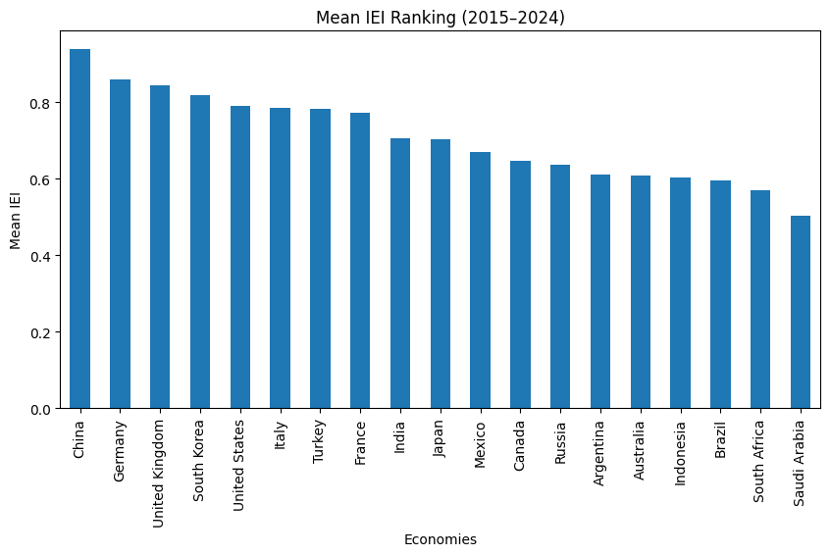

Figure1.1: Bar graph depicting the country ranking mean (mean IEI) for years 2015-2024 of the G20 nations.

Classification of countries :
The G20 countries were divided into 2 groups and then statistical analysis was performed on the two groups: Developed and developing countries.
Since the dataset does not directly label countries in the groups, they were divided by taking the mean GDP per capita, ppp (constant 2021 international $) for each G20 nation from 2015-2024and then median of these mean GDPs which was used as the dividing line.
On calculation:
The median mean GDP = 44548.38 USD
The classification was as follows:
Countries with GDP per capita above the median of G20 were labeled: Developed and,
Countries with GDP per capita below the median of G20 were labeled: Developing.

Table: Classification of Countries based on Mean GDP

Country | Mean GDP | Category
Australia | 57967.41959 | developed
Canada | 56641.90958 | developed
France | 52357.51877 | developed
Germany | 61905.70708 | developed
Italy | 49647.73264 | developed
Japan | 44548.37828 | developed
Republic of Korea | 47061.0641 | developed
Saudi Arabia | 61220.50943 | developed
United Kingdom | 51299.4407 | developed
United States of America | 69334.41065 | developed
Argentina | 27026.02463 | developing
Brazil | 18232.38373 | developing
China | 19210.53523 | developing
India | 7956.25775 | developing
Indonesia | 12584.6213 | developing
Mexico | 21430.83059 | developing
Russian Federation | 37429.03201 | developing
South Africa | 14065.60063 | developing
Türkiye | 29832.44917 | developing

Therefore,
Developed G20 nations include: Australia, Canada, France, Germany, Italy, Japan, South Korea, United Kingdom, United States, China
Developing G20 nations: Argentina, Brazil, India, Indonesia, Mexico, Russia, Saudi Arabia, South Africa, Turkey.
n₁(Developed): 10
n₂(Developing): 9

Hypothesis Testing:
Test of Hypothesis concerning difference of means (Two Populations)
Null hypothesis (H₀):
H₀: $μ_{1 }= μ_{2}$
i.e., there is no significant difference in the IEI of developed vs developing G20 countries.
Here,
$μ_{1}$ = Mean IEI for developed G20 countries
$μ_{2}$ = mean IEI for developing G20 countries

Alternative hypothesis (H_{a}):
H₀: $μ_{D }≠ μ_{d}$
i.e., the mean IEI of the developed and developing G20 countries are not equal.
Level of significance:
α = 0.05
Test statistic:
The population variance is unknown and sample sizes are small (n1<30 And n2<30).
Therefore, t-test for two means with unknown variance is used:
$\overline{x_{1}}$ = 0.73326
$\overline{x_{2}}$ = 0.6797
S₁² = 0.01329
S₁ = 0.1153
S₂² = 0.01379
S₂ = 0.1174
Now,
S_{p}² = 0.01353
S_{p} = 0.1163
And now,
t= 1.003
Degree of freedom:
ν = 10+9-2 = 17
Critical value:
$t_{\frac{α}{2},n_{1}+n_{2}-2}=$_{0.025,17} = 2.110

Step 3: Criteria of Rejection:
On calculation:
|t|< t_{0.025,17}
1.003 < 2.110

Step 5: Decision
We do not reject H₀. There is no significant difference between the mean IEI of developed and developing G20 nations.

Final Interpretation:
Even though developed G20 nations have slightly higher innovation efficiency, the difference is not that large enough to be statistically meaningful. Both groups perform similar in their efficiency to convert their innovation inputs into outputs.

Graphs:

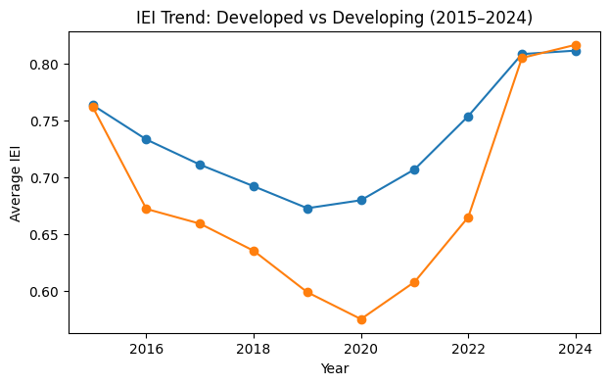
Figure: IEI Trend: Developed vs Developing (2015-2024)
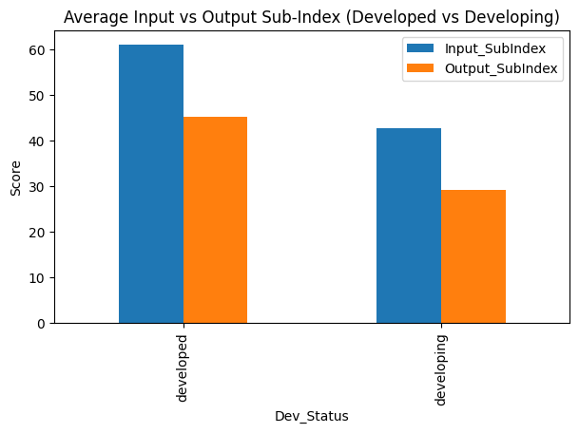
Figure: Average Input vs Output Sub-index (Developed vs Developing)
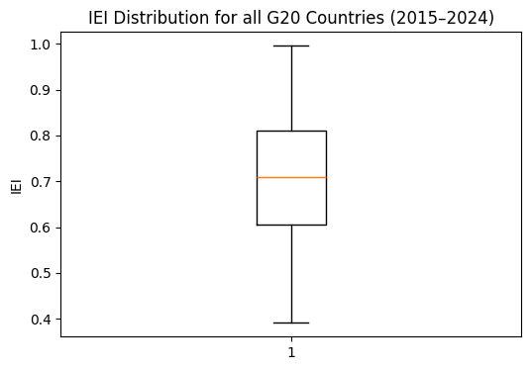
Figure: IEI Distribution for G20 nations(2015-2024)

Problem Statement 2:
To examine if there is any relationship between GDP per capita and Global Innovation Index(GII) and to analyze if India is catching up in terms of innovation performances compared to global expectations.

Relationship Hypothesis
H0(Null): There is no significant relationship between GDP per capita and Global innovation index (GII).
H1(Alternate): There is a significant relationship between GDP per capita and Global innovation index (GII).

Catching Hypothesis
H0(Null): India is not catching up in Innovation over the last decade.
H1(Alternate): India is catching up in Innovation over the last decade.

Methodology:
1. First I collected data for India’s GII (global innovation index) and India’s GDP per capita.
2.⁠ ⁠Then I filtered India’s last 10 years data using python pandas.
3.⁠ ⁠To study the direction of growth, I plotted GDP and GII using line graph.
4.⁠ ⁠To study the relationship between GDP and GII I plotted a scatter plot.
5.⁠ ⁠Then I calculated descriptive statistics, which is mean, median, standard deviation.
6.⁠ ⁠To find the strength of relationship I calculated the Pearson correlation.
7.⁠ ⁠Then at last I analyzed GII whether it is increasing and is India catching up based on correlation and trends.

Visualization
Graph analysis
Graph 1:
Graph 1 shows how the India’s GDP per capita changed over the past decade. The graph shows a clear upward trend which means that India’s Income per person has increased from 2015 to 2024. In 2020, GDP dips a little but after that it continues to grow.
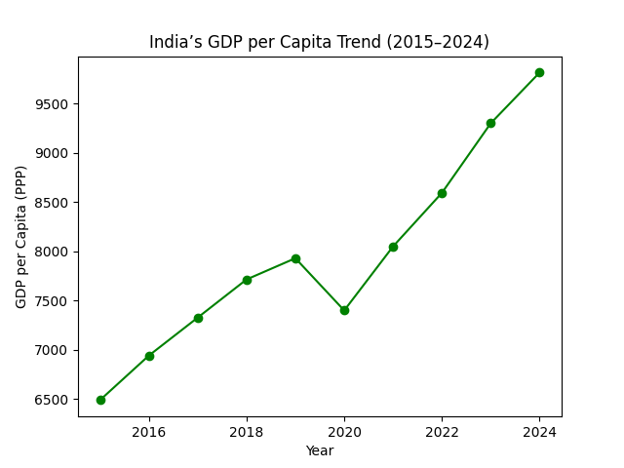

Graph 2:
This graph shows India’s GII score changed over the last decade. Overall, the score only increases from 31.7 in 2015 to 38.3 in 2024, with only slight changes in 2018 and 2020.

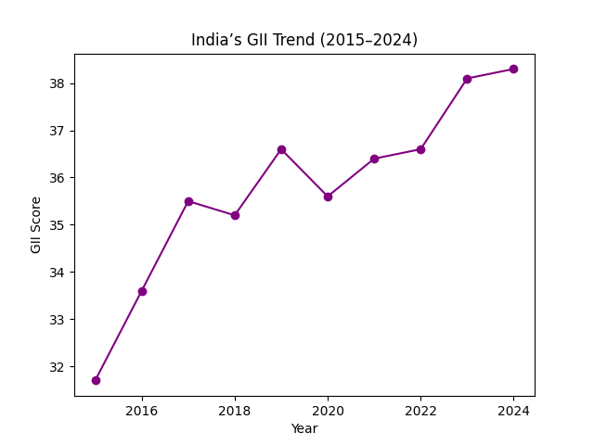

Graph 3:
This scatter plot shows how India’s GDP per capita and GII score are related. Each dot stands for one year. The regression line in the middle shows the overall trend.
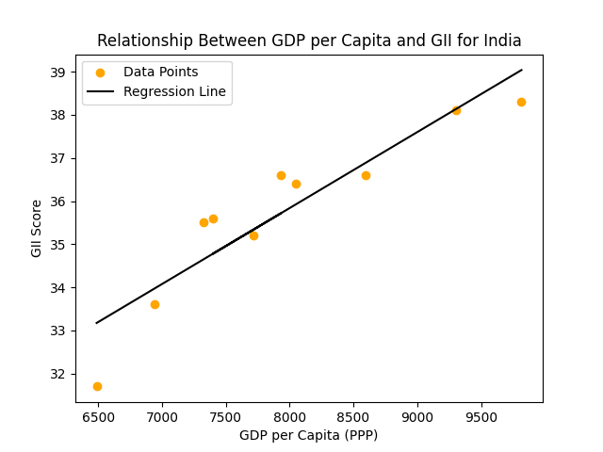

Descriptive Statistics
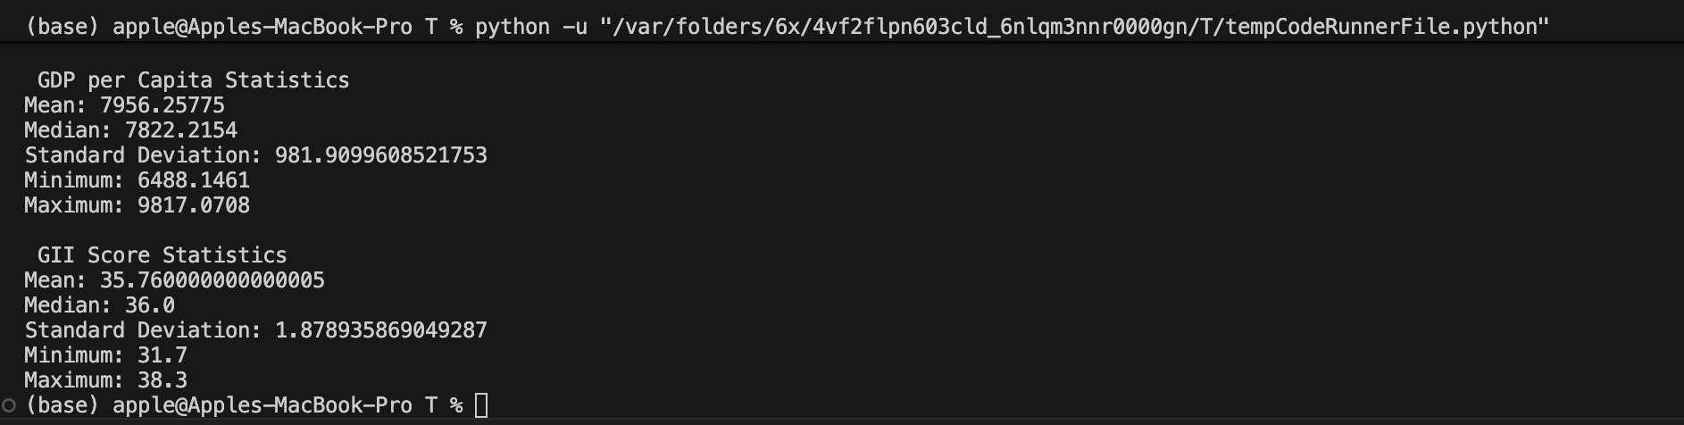

Calculations and Results:
Correlation (GDP vs GII)

Deviation Table
Year | x | y | $$x - \overline{x}$$ | $$y - \overline{y}$$ | $$\left(x - \overline{x}\right)\left(y - \overline{y}\right)$$ | $${\left(x - \overline{x}\right)}^{2}$$ | $${\left(y - \overline{y}\right)}^{2}$$
2015 | 6940.6258 | 31.7 | -1468.11165 | -4.06 | 5959.891 | 2155307.173422 | 16.4836
2016 | 6940.6258 | 33.6 | -1015.63195 | -2.16 | 2193.758 | 1031521.087704 | 4.6656
2017 | 7326.6069 | 35.5 | -629.65335 | -0.26 | 163.709 | 396430.430723 | 0.0676
2018 | 7714.3397 | 35.2 | -241.92030 | -0.56 | 135.474 | 58524.274905 | 0.3136
2019 | 7930.0911 | 36.6 | -26.16890 | 0.84 | - 21.979 | 685.694 | 0.7056
2020 | 7399.5306 | 35.6 | -556.72940 | -0.16 | 89.076 | 309945.819106 | 0.0256
2021 | 8050.0185 | 36.4 | 93.75825 | 0.64 | 59.605 | 8791.006 | 0.4096
2022 | 8594.3919 | 36.6 | 638.75825 | 0.84 | 536.034 | 407217.015 | 0.7056
2023 | 9301.7561 | 38.1 | 1345.49835 | 2.34 | 3148.462 | 1810365.808 | 5.4756
2024 | 9817.0708 | 38.3 | 1860.81305 | 2.54 | 4726.463 | 3462625.207 | 6.4516
sum |  |  |  |  | 14,991.2831 | 9,906,467.7 | 35.3120

Correlation Formula
$$r=\frac{\sum_{ }^{ }{\left(x-\overline{x}\right)\left(y-\overline{y}\right)}}{\sqrt{\sum_{ }^{ }{{\left(x-\overline{x}\right)}^{2}} {\left(y-\overline{y}\right)}^{2}}}$$
On substituting values,

$$r = \frac{2,889570.2 }{\sqrt{\left(37,163,037.4\right)\left(31.44\right)}}$$

$$r = \frac{2,889570.2 }{1,080,127.3}= 0.921$$

Final Correlation Result, r = 0.921
r = 0.921 is a very strong positive correlation, hence we can say that as India’s GDP per capita increases, it’s GII tends to increase strongly.

Year on Year Improvement:
Year | GII
2015 | 31.7
2016 | 33.6
2017 | 35.5
2018 | 35.2
2019 | 36.6
2020 | 35.6
2021 | 36.4
2022 | 36.6
2023 | 38.1
2024 | 38.3

Now we’ll apply this formula
GII of current year – GII of previous year

2016 - 2015 → 33.6 - 31.7 = +1.9
2017 – 2016 → 35.5 - 33.6 = +1.9
2018 – 2017 → 35.2 - 35.5 = -0.3
2019 – 2018 → 36.6 - 35.2 = +1.4
2020 – 2019 → 35.6 - 36.6 = -1.0
2021 – 2020 → 36.4 - 35.6 = +0.8
2022 – 2021 → 36.6 - 36.4 = +0.2
2023 – 2022 → 38.1 - 36.6 = +1.5
2024 – 2023 → 38.3 - 38.1 = +0.2

So, the year on year improvement list is:
[+1.9, +1.9, -0.3, +1.4, -1.0, +0.8, +0.2, +1.5, +0.2 ]
Count: 7 positive changes, 2 negative changes
Total improvement (first $→$last):
$∆decade = y_{2024}- y_{2015}$ = 38.3 - 31.7 = +6.6

Hypothesis Testing:
Hypothesis 1 : Relationship Hypothesis
H0 : p = 0
H1 : p $≠$ 0
Applying test statistic
$$∆r = \frac{r \sqrt{n - 2}}{\sqrt{ 1-r^{2}}}$$
On substituting values,
r = 0.921
n – 2 = 8
1 - $r^{2}$ → 1 - ${\left(0.921\right)}^{2}$ = 1 – 0.848 = 0.152

= $\frac{0.921\sqrt{8}}{\sqrt{0.152}}$
= $\frac{2.604}{0.389}$
$∆r$ = 6.69

Now compare with t-critical
Degree of freedom = 8
For $α$= 0.05 two-tailed $→ t_{0.025,8}$ = 2.306
Decision:
|$∆r$| = 6.69 > 2.306
$→$Reject H0
$→$Significant relationship exists
Hypothesis 2 : Catching up hypothesis
- India’s GII score increased significantly over the decade, rising from 31.7 to 38.3 which in total is +6.6 points of improvement, indicating long-term innovation growth.
- In 9 years, seven shows positive year on year improvement, showing consistent growth rather than random.
- The strong positive correlation (r = 0.921) between GDP and GII shows that there is a close link between economic progress and innovation development.
- The GII trend line shows that India’s innovation inputs gradually increased over time.
- These observations supports the alternative hypothesis (consistent increase in GII, strong statistical evidence)
Decision:
$→$Reject H0
$→$India is catching up

Analysis:
India has started the decade with a lower level of innovation but as years passed, it has improved steadily. The positive link between GII and GDP shows that GII score has been rising almost every year. Some global countries still perform better but the gap between them and India has become much smaller.
Overall, India is catching up and showing that innovation has been getting better year by year.

Problem Statement 3:
To analyze the contribution of all Input GII pillars like Human capital & research , Institutions, Infrastructure and then Business and Market sophistication to overall India’s global innovation index performance and identify which pillar exhibits the largest deviation.
Significance: In this study we tried to understand what affects India’s performance in GII and in what aspects the country is lagging behind as there are several input pillars we choose input pillars the 5 core pillars which affect India’s position and scores we used descriptive statistics Z score and data visualization to realize and conclude which pillar not only affect India’s the most but what are it’s factors too and how can we improve it.
Methodology: The study uses a quantitative approach to analyze the contribution os input pillars and their relation to overall performance of GII. The key pillars we studied were Institutions, Human Capital and Research, Infrastructure, Market Sophistication, and Business Sophistication we left creative output and knowledge output because they are the outputs of these 5 innovation of a country the better these 5 are the better is output We used descriptive stats for mean, mode, median , skewness , kurtosis and then the Z score to understand the patterns we used boxplut and to visualize the gap between India and it’s G20 pillars we used histogram als in Z score the negative values indicate the weaker performance.
Dataset used:
ARG | Argentina | IN.1 | Institutions |  |  | 28.59685 | 120 | W | W | N
ARG | Argentina | IN.2 | Human capital and research |  |  | 33.76381 | 57
ARG | Argentina | IN.3 | Infrastructure |  |  | 38.48586 | 80
ARG | Argentina | IN.4 | Market sophistication |  |  | 28.16042 | 100 |  |  | N
ARG | Argentina | IN.5 | Business sophistication |  |  | 26.63463 | 81 |  |  | N
ARG | Argentina | OUT.6 | Knowledge and technology outputs |  |  | 18.14596 | 79 |  |  | N
ARG | Argentina | OUT.7 | Creative outputs |  |  | 26.70923 | 59 |  |  | N
AUS | Australia | IN.1 | Institutions |  |  | 76.07634 | 13
AUS | Australia | IN.2 | Human capital and research |  |  | 58.57508 | 8 | S |  | N
AUS | Australia | IN.3 | Infrastructure |  |  | 55.66315 | 25 |  |  | N
AUS | Australia | IN.4 | Market sophistication |  |  | 55.39811 | 17
AUS | Australia | IN.5 | Business sophistication |  |  | 45.52978 | 25 |  | W | N
AUS | Australia | OUT.6 | Knowledge and technology outputs |  |  | 33.02535 | 29 |  | W | N
AUS | Australia | OUT.7 | Creative outputs |  |  | 42.50093 | 27 |  | W
BRA | Brazil | IN.1 | Institutions |  |  | 34.20141 | 107 | W |  | N
BRA | Brazil | IN.2 | Human capital and research |  |  | 37.54586 | 48
BRA | Brazil | IN.3 | Infrastructure |  |  | 45.51927 | 60
BRA | Brazil | IN.4 | Market sophistication |  |  | 35.38627 | 71
BRA | Brazil | IN.5 | Business sophistication |  |  | 36.5575 | 39 |  | S | N
BRA | Brazil | OUT.6 | Knowledge and technology outputs |  |  | 25.84225 | 50 |  |  | N
BRA | Brazil | OUT.7 | Creative outputs |  |  | 29.94962 | 50 |  |  | N
CAN | Canada | IN.1 | Institutions |  |  | 75.24707 | 15 |  |  | N
CAN | Canada | IN.2 | Human capital and research |  |  | 58.30246 | 10 | S |  | N
CAN | Canada | IN.3 | Infrastructure |  |  | 55.77613 | 24 |  |  | N
CAN | Canada | IN.4 | Market sophistication |  |  | 59.48775 | 8 | S |  | N
CAN | Canada | IN.5 | Business sophistication |  |  | 49.49099 | 19 |  |  | N
CAN | Canada | OUT.6 | Knowledge and technology outputs |  |  | 40.44135 | 18
CAN | Canada | OUT.7 | Creative outputs |  |  | 44.49431 | 24 |  |  | N
CHN | China | IN.1 | Institutions |  |  | 59.95376 | 44 |  | S
CHN | China | IN.2 | Human capital and research |  |  | 51.9598 | 20 |  | S
CHN | China | IN.3 | Infrastructure |  |  | 64.29572 | 6 |  | S
CHN | China | IN.4 | Market sophistication |  |  | 57.28122 | 13 |  | S | N
CHN | China | IN.5 | Business sophistication |  |  | 55.95859 | 8 |  | S
CHN | China | OUT.6 | Knowledge and technology outputs |  |  | 60.70452 | 1 | S | S
CHN | China | OUT.7 | Creative outputs |  |  | 49.73643 | 14 |  | S | N
DEU | Germany | IN.1 | Institutions |  |  | 70.2094 | 23 |  |  | N
DEU | Germany | IN.2 | Human capital and research |  |  | 61.03583 | 4 | S
DEU | Germany | IN.3 | Infrastructure |  |  | 54.90412 | 28
DEU | Germany | IN.4 | Market sophistication |  |  | 50.82121 | 22 |  |  | N
DEU | Germany | IN.5 | Business sophistication |  |  | 54.47977 | 13 |  |  | N
DEU | Germany | OUT.6 | Knowledge and technology outputs |  |  | 49.64273 | 11 |  |  | N
DEU | Germany | OUT.7 | Creative outputs |  |  | 55.59854 | 8 | S |  | N
FRA | France | IN.1 | Institutions |  |  | 66.81291 | 33 |  |  | N
FRA | France | IN.2 | Human capital and research |  |  | 55.0699 | 15 |  |  | N
FRA | France | IN.3 | Infrastructure |  |  | 57.41305 | 18
FRA | France | IN.4 | Market sophistication |  |  | 57.06097 | 14 |  |  | N
FRA | France | IN.5 | Business sophistication |  |  | 53.36127 | 14
FRA | France | OUT.6 | Knowledge and technology outputs |  |  | 41.80249 | 15 |  |  | N
FRA | France | OUT.7 | Creative outputs |  |  | 55.97299 | 7 | S
IND | India | IN.1 | Institutions |  |  | 53.49016 | 58 |  | S
IND | India | IN.2 | Human capital and research |  |  | 34.72973 | 54 |  | S | N
IND | India | IN.3 | Infrastructure |  |  | 45.2054 | 61 |  | S
IND | India | IN.4 | Market sophistication |  |  | 43.10132 | 38 |  | S | N
IND | India | IN.5 | Business sophistication |  |  | 29.19929 | 64
IND | India | OUT.6 | Knowledge and technology outputs |  |  | 37.81209 | 22 |  | S
IND | India | OUT.7 | Creative outputs |  |  | 32.6968 | 42 |  | S
IDN | Indonesia | IN.1 | Institutions |  |  | 61.6314 | 39 |  | S | N
IDN | Indonesia | IN.2 | Human capital and research |  |  | 24.44101 | 92
IDN | Indonesia | IN.3 | Infrastructure |  |  | 41.56547 | 71
IDN | Indonesia | IN.4 | Market sophistication |  |  | 40.62862 | 50 |  |  | N
IDN | Indonesia | IN.5 | Business sophistication |  |  | 26.523 | 83
IDN | Indonesia | OUT.6 | Knowledge and technology outputs |  |  | 20.57822 | 70
IDN | Indonesia | OUT.7 | Creative outputs |  |  | 26.72606 | 58 |  |  | N
ITA | Italy | IN.1 | Institutions |  |  | 54.24114 | 55 |  |  | N
ITA | Italy | IN.2 | Human capital and research |  |  | 45.09656 | 32 |  |  | N
ITA | Italy | IN.3 | Infrastructure |  |  | 54.90857 | 27 |  |  | N
ITA | Italy | IN.4 | Market sophistication |  |  | 40.43497 | 52
ITA | Italy | IN.5 | Business sophistication |  |  | 40.00422 | 31
ITA | Italy | OUT.6 | Knowledge and technology outputs |  |  | 40.74089 | 17 | S |  | N
ITA | Italy | OUT.7 | Creative outputs |  |  | 45.16389 | 20
JPN | Japan | IN.1 | Institutions |  |  | 70.85528 | 22 |  |  | N
JPN | Japan | IN.2 | Human capital and research |  |  | 53.49742 | 18 |  |  | N
JPN | Japan | IN.3 | Infrastructure |  |  | 57.57589 | 17 |  |  | N
JPN | Japan | IN.4 | Market sophistication |  |  | 59.4082 | 10
JPN | Japan | IN.5 | Business sophistication |  |  | 57.75599 | 6 |  |  | N
JPN | Japan | OUT.6 | Knowledge and technology outputs |  |  | 48.2368 | 12
JPN | Japan | OUT.7 | Creative outputs |  |  | 46.35236 | 18
KOR | Republic of Korea | IN.1 | Institutions |  |  | 72.51027 | 20
KOR | Republic of Korea | IN.2 | Human capital and research |  |  | 66.99137 | 1 | S | S
KOR | Republic of Korea | IN.3 | Infrastructure |  |  | 63.58432 | 7 |  |  | N
KOR | Republic of Korea | IN.4 | Market sophistication |  |  | 61.93609 | 5
KOR | Republic of Korea | IN.5 | Business sophistication |  |  | 61.20449 | 4 |  | S | N
KOR | Republic of Korea | OUT.6 | Knowledge and technology outputs |  |  | 51.84509 | 9
KOR | Republic of Korea | OUT.7 | Creative outputs |  |  | 57.65483 | 4 |  | S
MEX | Mexico | IN.1 | Institutions |  |  | 34.90216 | 104 |  |  | N
MEX | Mexico | IN.2 | Human capital and research |  |  | 32.08736 | 67
MEX | Mexico | IN.3 | Infrastructure |  |  | 39.90627 | 77
MEX | Mexico | IN.4 | Market sophistication |  |  | 36.05286 | 68 |  |  | N
MEX | Mexico | IN.5 | Business sophistication |  |  | 27.83367 | 72 |  |  | N
MEX | Mexico | OUT.6 | Knowledge and technology outputs |  |  | 23.46944 | 54
MEX | Mexico | OUT.7 | Creative outputs |  |  | 30.2685 | 49
RUS | Russian Federation | IN.1 | Institutions |  |  | 23.26359 | 131 | W | W
RUS | Russian Federation | IN.2 | Human capital and research |  |  | 47.17156 | 28
RUS | Russian Federation | IN.3 | Infrastructure |  |  | 40.42192 | 76 |  | W | N
RUS | Russian Federation | IN.4 | Market sophistication |  |  | 34.58578 | 76 |  | W | N
RUS | Russian Federation | IN.5 | Business sophistication |  |  | 35.02232 | 46 |  |  | N
RUS | Russian Federation | OUT.6 | Knowledge and technology outputs |  |  | 21.84029 | 62
RUS | Russian Federation | OUT.7 | Creative outputs |  |  | 27.02993 | 55 |  |  | N
SAU | Saudi Arabia | IN.1 | Institutions |  |  | 68.97364 | 26 |  |  | N
SAU | Saudi Arabia | IN.2 | Human capital and research |  |  | 42.75061 | 35
SAU | Saudi Arabia | IN.3 | Infrastructure |  |  | 52.97033 | 36
SAU | Saudi Arabia | IN.4 | Market sophistication |  |  | 46.68086 | 31
SAU | Saudi Arabia | IN.5 | Business sophistication |  |  | 32.27841 | 52
SAU | Saudi Arabia | OUT.6 | Knowledge and technology outputs |  |  | 19.85114 | 74 |  | W
SAU | Saudi Arabia | OUT.7 | Creative outputs |  |  | 26.8666 | 57
TUR | Türkiye | IN.1 | Institutions |  |  | 37.02595 | 100 | W
TUR | Türkiye | IN.2 | Human capital and research |  |  | 41.15624 | 38 |  | S
TUR | Türkiye | IN.3 | Infrastructure |  |  | 51.688 | 44 |  | S
TUR | Türkiye | IN.4 | Market sophistication |  |  | 41.85247 | 41 |  |  | N
TUR | Türkiye | IN.5 | Business sophistication |  |  | 36.42542 | 41 |  | S
TUR | Türkiye | OUT.6 | Knowledge and technology outputs |  |  | 26.36438 | 48
TUR | Türkiye | OUT.7 | Creative outputs |  |  | 39.18325 | 30 |  | S | N
USA | United States of America | IN.1 | Institutions |  |  | 74.33275 | 16
USA | United States of America | IN.2 | Human capital and research |  |  | 55.76809 | 13 |  |  | N
USA | United States of America | IN.3 | Infrastructure |  |  | 54.2918 | 32
USA | United States of America | IN.4 | Market sophistication |  |  | 75.03491 | 1 | S | S | N
USA | United States of America | IN.5 | Business sophistication |  |  | 65.90282 | 1 | S | S | N
USA | United States of America | OUT.6 | Knowledge and technology outputs |  |  | 60.00897 | 3 | S | S
USA | United States of America | OUT.7 | Creative outputs |  |  | 56.61573 | 5 |  |  | N
ZAF | South Africa | IN.1 | Institutions |  |  | 38.20396 | 97 |  |  | N
ZAF | South Africa | IN.2 | Human capital and research |  |  | 29.4377 | 75 |  |  | N
ZAF | South Africa | IN.3 | Infrastructure |  |  | 42.04976 | 67
ZAF | South Africa | IN.4 | Market sophistication |  |  | 41.28247 | 44
ZAF | South Africa | IN.5 | Business sophistication |  |  | 33.20483 | 48 |  |  | N
ZAF | South Africa | OUT.6 | Knowledge and technology outputs |  |  | 20.49527 | 71
ZAF | South Africa | OUT.7 | Creative outputs |  |  | 26.38636 | 62 |  |  | N
GBR | United Kingdom | IN.1 | Institutions |  |  | 69.30045 | 25
GBR | United Kingdom | IN.2 | Human capital and research |  |  | 59.44188 | 7 | S |  | N
GBR | United Kingdom | IN.3 | Infrastructure |  |  | 56.58113 | 23
GBR | United Kingdom | IN.4 | Market sophistication |  |  | 63.78446 | 4 | S |  | N
GBR | United Kingdom | IN.5 | Business sophistication |  |  | 52.96286 | 17
GBR | United Kingdom | OUT.6 | Knowledge and technology outputs |  |  | 55.95893 | 5 | S | S
GBR | United Kingdom | OUT.7 | Creative outputs |  |  | 59.67426 | 3 | S | S | N

Sample: Argentina, Australia, Brazil, Canada, China, France, Germany, India, Indonesia, Italy, Japan, Republic of Korea, Mexico, Russia, Saudi Arabia, South Africa, Türkiye, United Kingdom, United States, European Union(European union does not have pillar data)
The descriptive statistics of G20 countries is as follows with respect to GII Pillars:
Pillar | Mean | Std Dev | Median | Range | Skewness | Kurtosis
Institutions | 56.31 | 17.96 | 61.63 | 52.81 | -0.60 | -1.22
Human capital & research | 46.78 | 12.32 | 47.17 | 42.55 | -0.21 | -1.12
Infrastructure | 51.20 | 9.04 | 54.29 | 53.81 | -0.20 | -1.12
Market sophistication | 48.86 | 12.36 | 46.68 | 46.97 | 0.29 | -0.62
Business sophistication | 43.18 | 12.81 | 40.00 | 39.38 | 0.22 | -1.39
The institution pillar had largest mean but also largest range standard deviation that indicate high variability of the data points. The human capital and research have mean of 46.78 and the std deviation shows moderate variability. The infrastructure shows the mean of 51.20 and have lowest range 25.81 and std deviation 8.04 which depicts that data have less variability and mostly all countries have similar data points. The market sophistication and business sophistication though differ in mean std dev median range while the skewness shows its positively skewed which means few countries are scoring higher than others and then few pillars like institution infrastructure are negatively skewed so major countries are doing proper but not so good The negative kurtosis shows the platykurtic graph due to flatter distribution this implies overall the most affecting factors are market sophistication and business sophistication

Graphs:
Boxplot for Innovation input pillars:
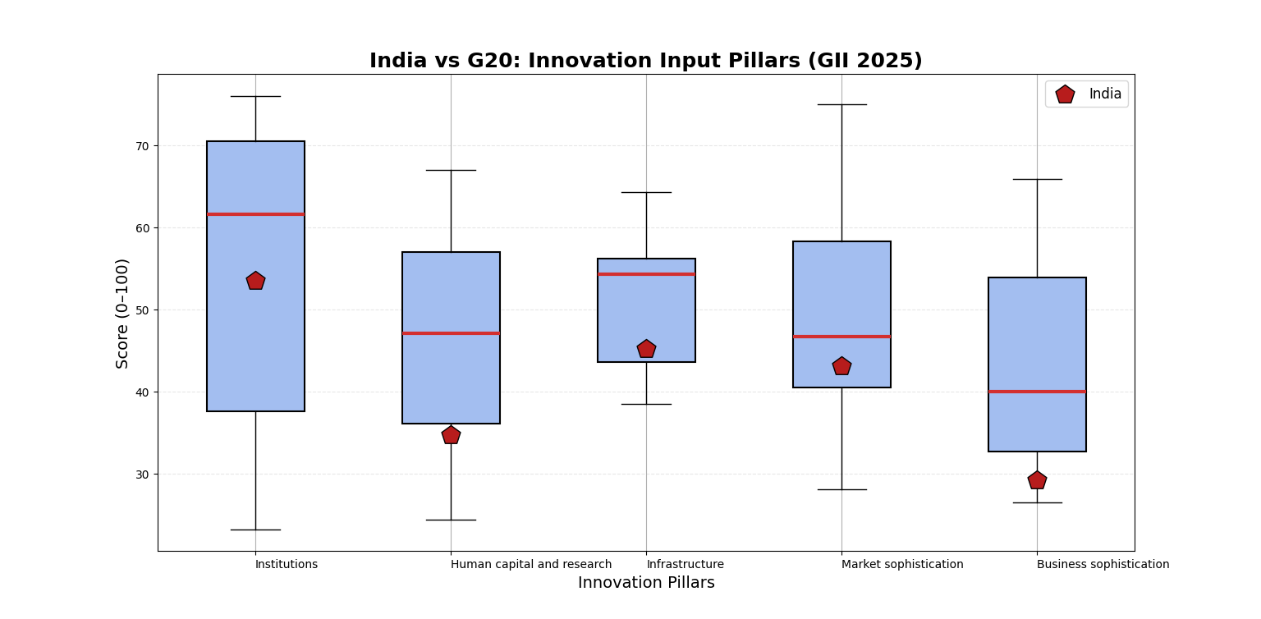The graph with the boxplots of 5 input GII pillars and in all of them India’s is below the quartile 2 The red pentagon represents India And It clearly depicts that India is behind its peers in many components it's in the first quartile such as in Human Capital Research and Business Sophistication it shows this is the weakest point because of which India lags behind its peer G20 nations 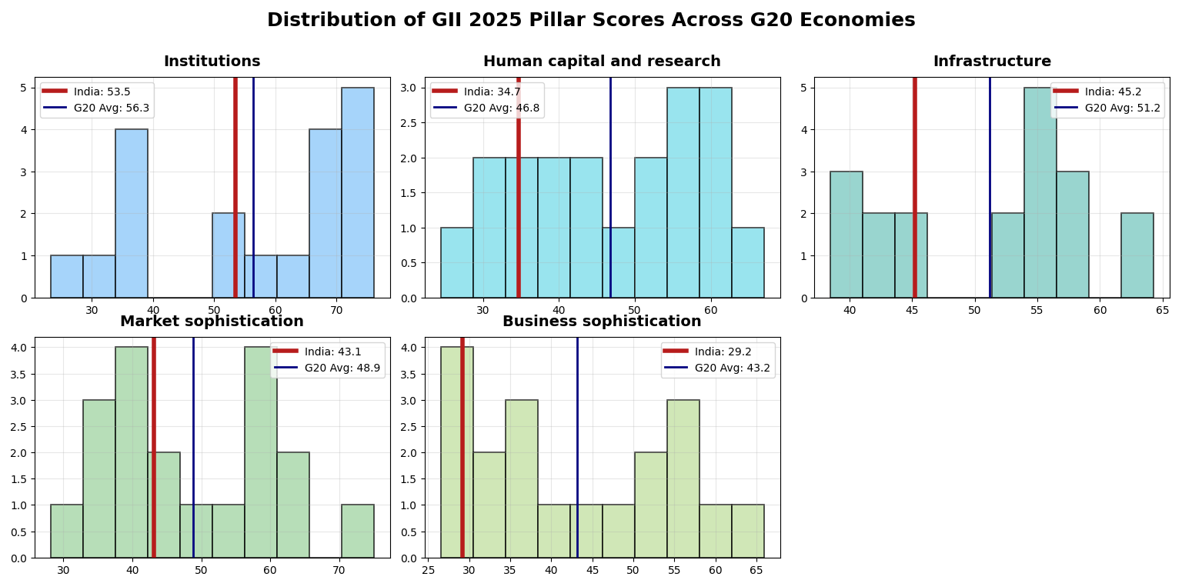
This graph is majorly to highlight how far is India from the global average and how long is journey to be there near the G20 journey The Innovation input pillars though have the deviation across domains far from India (x and y axis)
In the institution pillar India (53.3) is very near to G20 average (56.3) as we saw in the boxplot with increase in effectiveness of the legislative, executive, and judiciary the stability and transparency of government the efficiency of regulation and the policy for entrepreneurship.
The gap considerably very wide(46.8-34.7) in Human capital and research focus on weaknesses in education R&D investment and scientific capacity quality in educational system quality universities eligible in QS Ranking and proper spending in R&D are fundamental need to make this part grow for long term growth
Infrastructure India(45.2) is at a position that is moderately close to the G20 average (51.2) which shows that the country has made progress in infrastructure if we focus more on easy access to availability and reliability of electricity logistics and internet service with energy efficiency.
Market Sophistication is below average(48.9-43.1) yet in much better position as compared to Human Capital and Research representing the limited assesses startup formation, private sector growth, trade performance, and financial market dept.
The largest lag is in Business Sophistication where India’s(29.2) score is lower than the G20 mean(43.2) reflecting weaker industry academia linkages knowledge absorption and innovation capacity within industries

India’s Innovation vs G20 (2025): GAP & Z-Score
Pillar | India Score | G20 Average | Gap | Z-Score
Institutions | 53.49 | 56.31 | 2.82 | -0.162
Human capital & research | 34.73 | 46.78 | 12.05 | -1.005
Infrastructure | 45.21 | 51.20 | 5.99 | -0.766
Market sophistication | 43.10 | 48.86 | 5.76 | -0.479
Business sophistication | 29.20 | 43.18 | 13.98 | -1.120
Z scores of India depicts that nation performs below the average of other G20 countries across all the pillars Mainly institutions infrastructure and market sophistication have smaller relatively smaller Z score whereas the Human capital and research and business sophistication that means these require major attention to grow because there gap is too large i.e. 12.05 and 13.98 respectively. Overall we think India is doing below average but worse in Human Capital and Research and Business Sophistication compared to other G20 This table mainly compare India and it’s peers on basis of z score revealed the gap India’s innovation inputs compare with the G20 average.We need to focus on Business Sophistication where gap is 13.98 and then Human Capital & Research with gap of 12.05 then we need to focus moderately on the Infrastructure with gap of 5.99 and then Market Sophistication with gap 5.76 and the least Institutions with gap 2.82. The business sophistication gap is 5 times larger than institution gap so The Business ecosystem is real bottleneck that hampers India’s position

Correlation between pillar score and overall rank of the nation:-
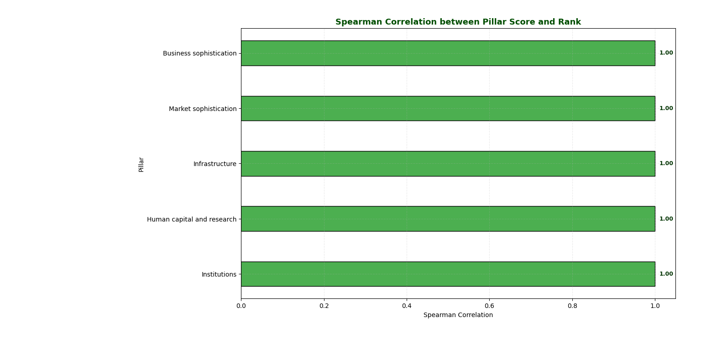The above graph depicts why the Pillars matter in the Global Innovation Index with respect to the rank though there are few subpillars belonging to all the pillars. We can see that the Institutions, Human capital & research, Infrastructure, market sophistication, business sophistication are strongly correlated positively (1.00) it’s strongly correlated positively. We can say that as the pillar score increases, the rank also increases. So that’s why we used the hypothesis testing for this
Step1: Building the Hypothesis( correlation hypothesis testing)
Null Hypothesis=> H0 : ρ = 0(There is no linear correlation between the G20 avg pillar score and India’s pillar scores)
Alternative Hypothesis=> Ha : ρ != 0 (Two tailed)(There is linear correlation between the G20 avg pillar score and India’s pillar scores)
Level of significance: 0.05
Step2: Test statistics t test because sample size is 19 and population variance is unknown
t = r / √( (1 - r²) / (n - 2) )
Step3: Criteria of rejection
Degrees of freedom=n-2=5-2= 3
Significance level = 0.05 so 0.05 / 2 = 0.025
t-value: We found t 0.025, 3 from table according to table it is
t 0.025 , 3 = 3.182 t 0.025,3 =3.182
Hence, Criteria for Rejection: Reject H₀ if ∣ t ∣ > 3.182 ∣t∣>3.182
Step4: Calculation of Test Statistics
Mean of X (G20 Avg): (56.31+46.78+51.20+48.86+43.18)/5 =49.266
Mean of Y (India): (53.49+34.73+45.21+43.10+29.20)/5 =41.146
(X-mean of X)*(Y-mean of Y)=182.672
(X-mean of X)^2=96.742
(Y-mean of Y)^2=356.580
r= 182.672/ √34493.34=0.984
t= r ( √n-2)/√1-r^2 = 0.984*√3/√1-0.968 = 9.52
Therefore | t | = 9.52
Step5: Decision to reject or not reject the hypothesis
We got t as approximately equal to infinity hence we can say that |t| is greater than 3.182 it satisfy this hence we reject the H 0.
Hence we can say that they are strongly correlated
We used t test to check if the relationship between the pillar score and rank really correlate or it was just by chance we can say that the correlation between each gii pillar score and overall rank is statistically significant.
Correlation matrix between all the pillars to analyze how other pillars affect each other
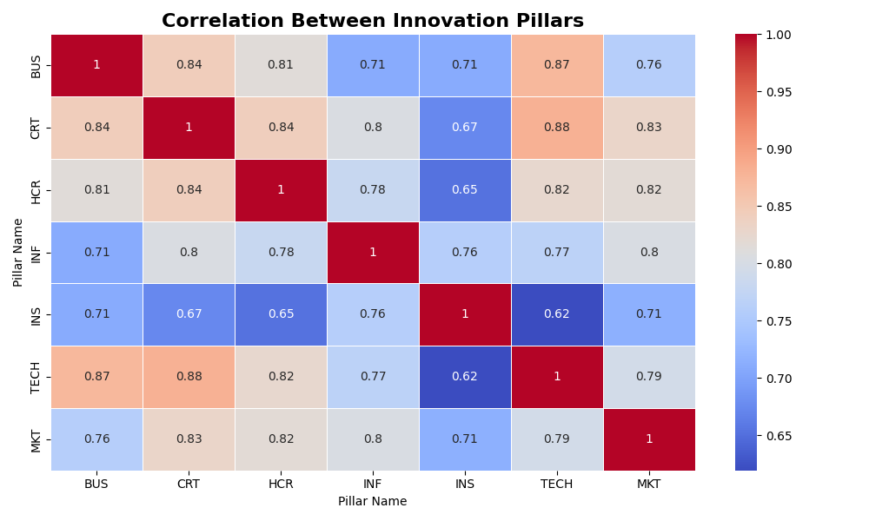
The correlation results revealed the overall interconnection between the 5 input pillars the matrix shows us a symmetrical matrix and also here we can see most of correlations are above 0.70 this means if a country performs well in any one pillar it tends to perform well in other pillars as well innovation does not grow in a single area it develops in nearby area too such as education business environment markets and institutions etc. and most of them move together cause of this and we can also say that business sophistication and the human capital and research they are highly linked with rest of their scores pull down the scores of the other parameters and the pillars too . We can say that this matrix confirms that india innovation gap is not due to one single isolated problem but due to weakness in other pillars too which affect everything else strengthenitng human capital and research with business sophistication would create a positive effect and help India to move closer to the G20 averages.
Conclusion: We can see that India has built reasonable stable foundation in institutions infrastructure market sophistication even tho it lags behind a bit but for now the main concerns who are also are responsible for the India’s deviation from G20 was for those pillars whose gap is too large from G20 nations those are business sophistication as well as the human capital and research They are most serious weakness with almost 14 points. We can say that the India’s business ecosystem is not absorbing creating or commercializing the knowledge properly because of strong positive correlation above 0.70 among the input pillars as we can see in the heatmap we realised that innovation doesnt grow isolated it require collaborated efforts and positive impacts of the other pillars too.

From this analysis India’s priorities become very clear:
Business Sophistication is very first are to focus in that we gotta focus on factors such as skills in the youth, patents, collaboration between industry and academia, and innovation linkages and then moving on to human capital and research works on education R&D investment and scientific capacity quality in educational systems quality universities participating in QS Ranking and spending in R&D would be efficient.
Lastly, we have Infrastructure and Market Sophistication although they are not alarming, but with consistency and implementation it could get better.
With proper intervention India could shift from G20 follower to within or maybe better than G20

Data Source: https://www.wipo.int/en/web/global-innovation-index/2025/index
References:
- https://link.springer.com/article/10.1007/s11192-015-1632-4
- https://www.researchgate.net/publication/357084261_Innovation_measurement_An_extensive_literature_analysis
- https://www.mdpi.com/2076-3387/14/2/32
- https://www.sciencedirect.com/science/article/pii/S2949753123000644?ref=pdf_download&fr=RR-2&rr=9984c3646b8fa7b2
- https://www.mdpi.com/2076-3387/14/2/32

