**­­­­­Requirements / Functional Specification for the KUAR System**

**CSC354 Introduction to Software Engineering, Dr. Dale Parson, Spring 2015**

**Kutztown University Augmented Reality Project**

**Lori Bogumil, Steven Gantz, Justin Hartz, Taylor Sharp, Katherine Shay**

**KUAR Visualization Team**

1. **Requirements Specification** 
   1. **System Level Requirements (Lori Bogumil & Steven Gantz)**

The goal of this project is to create an android mobile application in which the user will be able to use their handheld device to locate buildings residing on the Kutztown University of Pennsylvania campus and obtain information about such buildings and the campus itself with a simple download of the application and just a tap of the finger.

The application idea was derived from the admissions staff here at Kutztown University. The implementation of this application will help free up hours in the admissions department so that student workers can spend more time answering specific questions and tending to more advanced matters rather than walking around campus day after day touring prospective students and their parents. Money will be saved in the account that the tour guides will not have to work as many hours; some may even be able to work from home.

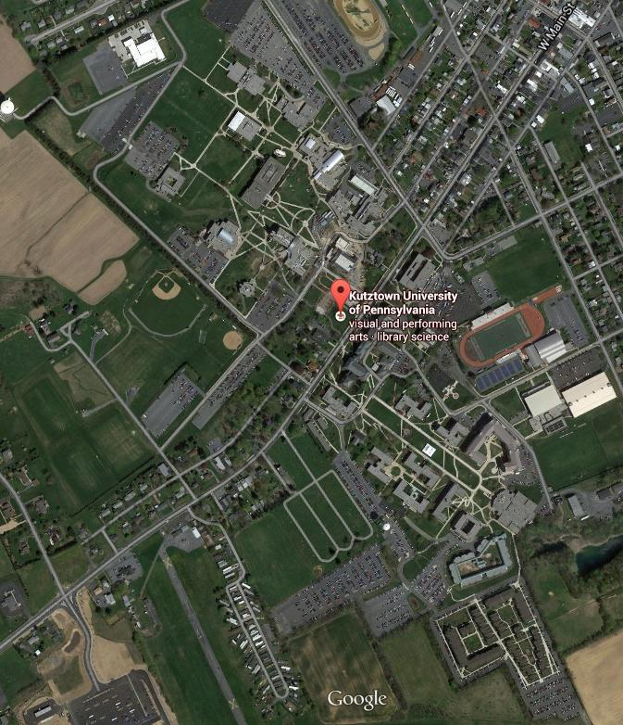

The prospects will be able to tour Kutztown’s campus themselves solely with the help of their android device. This application could be utilized even more in the summer and winter months, when tour guides’ presence are limited and buildings aren’t as easily accessible. It can also be doubled as a digital map so new students know their location on campus at all times.

* 1. **Technical Requirements (Lori Bogumil & Steven Gantz)**
     1. **Hardware Requirements (Lori Bogumil)**

Some hardware devices are necessary for implementation testing and prototyping. Each student will require a device with the android operating system installed that has camera capabilities, internet access, and location services access. The devices also need to have the ability to be connected to a computer for the application to be tested. These computers need be fully enveloped with the software listed in the software requirements section to have full development capabilities. Each device is required to be running on the latest version of the android OS, namely 4.4 KitKat. From a design perspective, at least one camera equipped device must be used to generate targets for the software. This camera, or some other type of software, must have the ability to change picture resolution.

* + 1. **Software Requirements (Steven Gantz)**

The application will be built using some commercial software as well as student-developed code. The commercial software used to realize the application would be the following: Android Studio, Unity3D, and the Vuforia Unity3D Extension by Qualcomm. We will be using the Open Licenses for each of these where applicable. Ancillary software is required for Unity3D’s operation using the Vuforia extension. This software is in the form of a web application that builds a database of targets for the Unity3D software. When the augmented reality portion is coded and generated completely within the Unity3D editor, it is regenerated into an Android Studio Google Project. This project can be imported into Android Studio and the Android Application built around it. For collaborative purposes, we are inputting our information into a web-based version control system. We decided to use GitHub, which is described as an “online web-based repository hosting service”. This software is necessary to keep track of data and collaborations between the mobile developers working on the application. From a design perspective, an imaging program with alpha capabilities is necessary, namely PhotoShop, available in Sharadin.

Link to GitHub repository: <https://github.com/StevenPG/CSC354-CDE335>

* 1. **Design Constraints (Lori Bogumil)**

The KUAR application is designed to be optimally utilized as the user is located on the Kutztown University campus. The 2D map view will show the map of campus, however their location will not be displayed while they are found to be off campus. The application will alert the user if they are out of range to use the “where am I on campus” feature. However, if they are on campus, a marker will show them their exact location anywhere they are currently located.

The augmented reality camera will not function on any buildings besides the campus buildings, due to the fact that the application's database is based solely off of pictures taken of the buildings on campus.

The application is device specific and can currently only be run on android devices.

1. **Functional Specification**
   1. **Main Screen (Justin Hartz)**

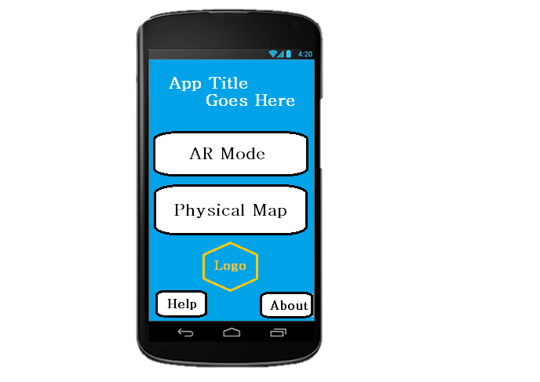

When the user opens the application they will be brought to a screen with 4 buttons and a logo for the application set into the background of the page. The first buttons will be an option to go into augmented reality view. The next button will be an option to go into 2 Dimensional map view. Next there will be a button that will take you to the settings screen so the user can set their preferences for the application. Finally there will be a button that will be a help button. When the user clicks this button they will be brought to a screen that will inform them how to use the application in the most efficient way for them.

* 1. **Augmented Reality (Justin Hartz)**

When the user pushes the button to go into the augmented reality view the camera will open and the user will be able to look through the camera at the buildings of campus. When the user looks at a building there will be information about the building displayed. It will look as if the information is floating above the building. As the user moves the camera around the campus the data will stay with the building as if it’s attached. When the user pans the camera from one building to another, the information will flip to the building that is shown most in the camera. There will be an option with the information around the building that will allow the user to go to the Kutztown University website to view more information about the building. The information that will be displayed will be the name of the building, the users distance from the building, departments with offices located inside the building, and the date it was built. Finally there will be note able offices located in the buildings such as resnet , the writing center, the planetarium, or the computer labs. There will also be three more buttons. The first button will be a help button to help the user while using the Augmented Reality view. The second button is a button that will allow the user to flip to the 2 Dimensional map part of the application. Finally there will be a button that will allow the user to go to the main screen of the application.

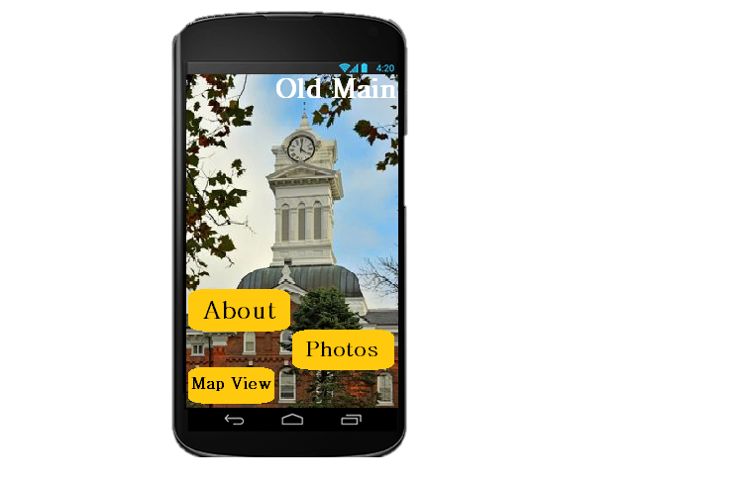

* 1. **2 Dimensional Map (Justin Hartz)**

When the user pushes the button they will be taken to the 2 Dimensional view, this view will open a view of the Kutztown University campus. On the map there will be a little person showing where the user is standing if they are currently on the campus. If the user is not on the map the person will not show up and a message will be displayed on the top of the screen informing them that their location cannot be displayed. On the map there will be visuals of the buildings. Each building will be clickable by the user. When the user clicks the building a box will be opened with some of the information about the building. On this dialog box there will be a button the user can click in order to view more information about the building. The user will be also be able to click on a building and be shown the best path to get to each building. The little person that represents them will walk the path ahead of them and then go back and represent where the person is once again. This path will then stay on the map until the user either follows the path completely or presses a button to remove the path. On this screen there will also be four buttons. The first button will take the user back to the home screen. The second button will take the user to the augmented reality view of the application. Third will be a button that will allow the user to click one or more buildings that they want to go to in order to see the paths from where you are to each of the buildings. Finally the last button will take the user to the help screen. The help screen when clicked from the 2 Dimensional view page will tell the user how to use this part of the application most efficiently.

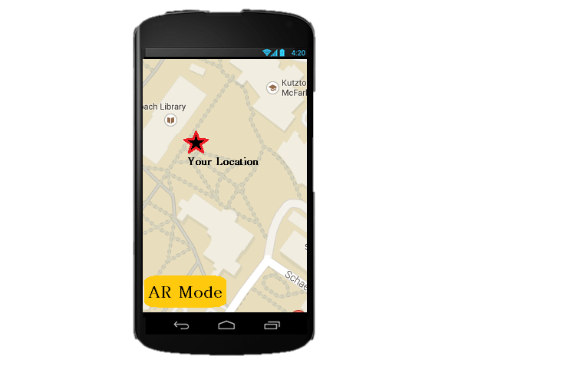

* 1. **Usage (Lori Bogumil & Steven Gantz)**

Over the summer, thousands of perspective college students visited Kutztown in hopes of one day being a Golden Bear. This dream, however, cannot come true for every visitor. Two out of every ten students that visited the campus would have to re-visit once more in the future because the admissions office was temporarily closed the day they visited for some unspecified reasons. It was said that these students were left quite dissatisfied with the university and began to head back to their cars with their parents. It left them with a very bad first impression of the campus. Just then, they got a notification on their cell phones directing them to a particular app in the android app store. Confused by this, the students let their phones take over. Just a few moments later, the KUAR application was seen on their home-screen.

Then the app opened itself. A loading page stating, “Welcome to Kutztown University!” appeared as they arrived at their cars. The prospects seemed very pleased with the surprise of this application. It seemed very user friendly and they began to realize what its main purpose was. The admissions office took note of every student visiting the days they were going to be unavailable and sent this application directly to their phones. Now, the students have a virtual tour guide right at the palms of their hands and they can rest assured that their trip to Kutztown University would not be wasted.

The students told the parents that the tour must go on. As they ventured around campus with the application open, they were amazed at how much information was packed into this nifty app. The homepage gave the user two main choices: The Augmented Reality camera view, and the 2 Dimensional Map view.

Inside the Augmented Reality view, the outside of each building on campus was filled with information. It was almost as if the buildings came to life. The 2 Dimensional Map showed the user’s exact location and was able to guide them and their parents from building to building effortlessly at their own leisure. This seemed to be their favorite part. They got to tour themselves around and around every corner was more information to take in.