Experiment 10: K Means Clustering
Algorithm:
- Import libraries
- Load the customer dataset.
- Show basic info and first few rows.
- Plot pairwise relationships between columns.
- Select two columns: income and spending score.
- Apply K-Means with 5 clusters.
- Predict cluster labels and add them to the data.
- Plot the clusters using a scatter plot.
- Try different cluster counts (1 to 9).
- Plot WCSS values to find the best number of clusters.
Let me know if you want this turned into a document or paired with the full source code.
2. Source Code
import numpy as np
import pandas as pd
import matplotlib.pyplot as plt
import seaborn as sns
%matplotlib inline

df = pd.read_csv('Mall_Customers.csv')
df.info()
df.head()

sns.pairplot(df)

features = df.iloc[:, [3, 4]].values

from sklearn.cluster import KMeans
model = KMeans(n_clusters=5)
model.fit(features)

Final = df.iloc[:, [3, 4]]
Final['label'] = model.predict(features)
Final.head()

sns.set_style("whitegrid")
sns.FacetGrid(Final, hue="label", height=8) \
.map(plt.scatter, "Annual Income (k$)", "Spending Score (1-100)") \
.add_legend()
plt.show()

features_el = df.iloc[:, [2, 3, 4]].values
wcss = []
for i in range(1, 10):
model = KMeans(n_clusters=i)
model.fit(features_el)
wcss.append(model.inertia_)
plt.plot(range(1, 10), wcss)
3. Output:
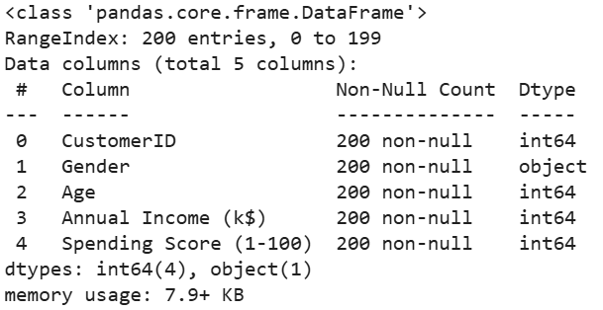
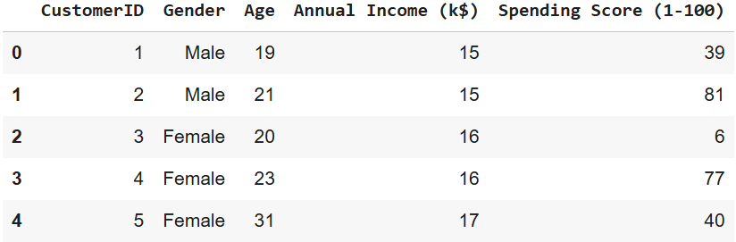
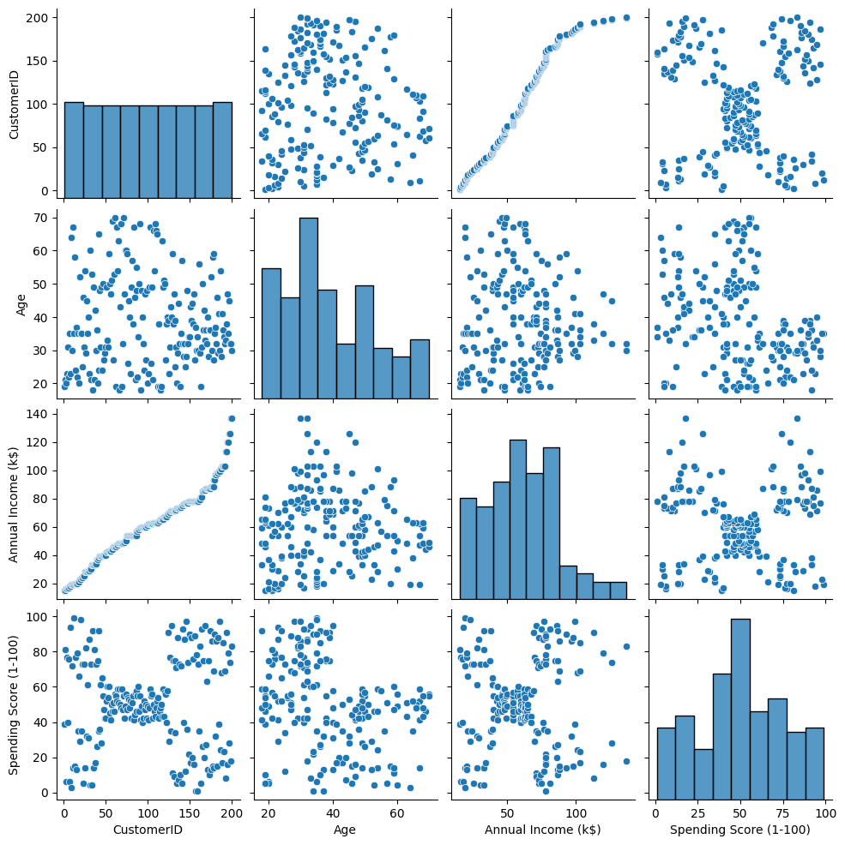
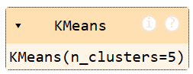
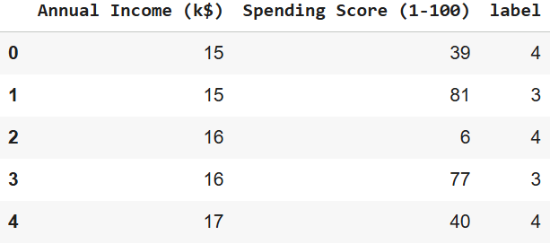
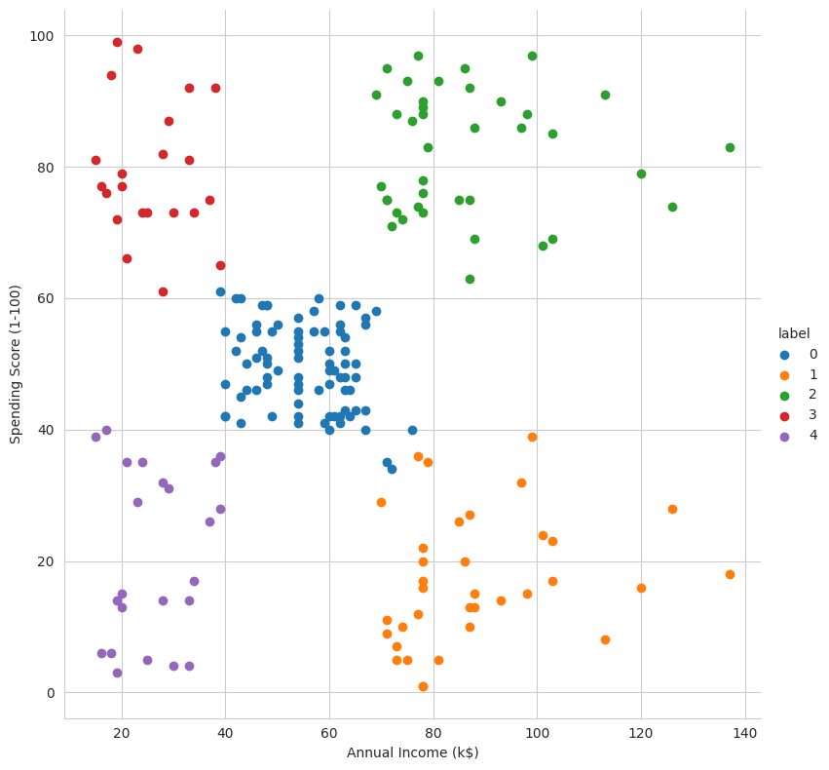
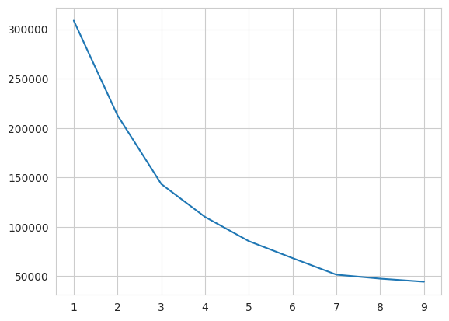
4. Result
The python code to perform KMeans Clustering on the give dataset was executed successfully.

