Matplotlib Library – Data Visualization
1. Algorithm
- Make a list of years.
- Create numbers that grow each year.
- Add some random changes to those numbers.
- Replace any negative numbers with zero.
- Put the years and numbers into a table.
- Show the table.
- Draw a line graph using the table.
- Add labels and a title.
- Show the graph.
2. Source Code
import numpy as np
import pandas as pd

years = np.arange(2015, 2025)

job_postings = (years - 2014) * 5000 + np.random.randint(-2000, 2000, size=len(years))
job_postings[job_postings < 0] = 0 # Ensure no negative values

df_job_trends = pd.DataFrame({'year': years, 'num_postings': job_postings})
display(df_job_trends)

import matplotlib.pyplot as plt
plt.figure(figsize=(10, 6))
plt.plot(df_job_trends['year'], df_job_trends['num_postings'])
plt.title('Trend of Data Science Job Postings (Last Decade)')
plt.xlabel('Year')
plt.ylabel('Number of Job Postings')
plt.grid(True)
plt.show()
3. Output
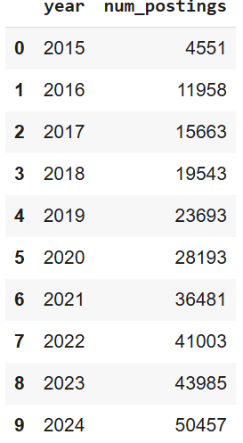
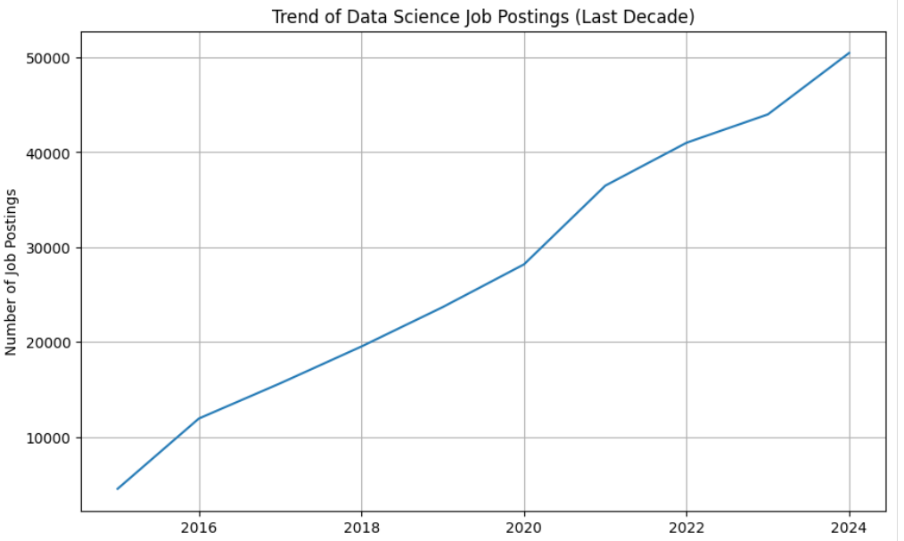

4. Result
The python code to visualize given data was executed successfully.

