Matplotlib Library – Data Visualization
1. Algorithm
- Make a list of job titles.
- Put the job titles into a table.
- Count how many times each title appears.
- Print a message about the role distribution.
- Show the counts.
- Set the size of the chart.
- Draw a bar chart using the counts.
- Add a title to the chart.
- Label the x-axis and y-axis.
- Rotate the x-axis labels.
- Adjust the layout.
- Show the chart.
2. Source Code
import pandas as pd
import matplotlib.pyplot as plt
data = {'job_title': ['Data Scientist', 'Data Analyst', 'Data Engineer', 'Data Scientist', 'Machine Learning Engineer',
'Data Analyst', 'Data Scientist', 'Data Engineer', 'Data Scientist', 'Data Analyst',
'Data Architect', 'Data Scientist', 'Data Analyst', 'Data Engineer', 'Data Scientist']}
df_roles = pd.DataFrame(data)
role_counts = df_roles['job_title'].value_counts()
print("Distribution of Data Science Roles:")
display(role_counts)
plt.figure(figsize=(12, 6))
role_counts.plot(kind='bar')
plt.title('Distribution of Data Science Roles')
plt.xlabel('Data Science Role')
plt.ylabel('Count')
plt.xticks(rotation=45, ha='right')
plt.tight_layout()
plt.show()
3. Output
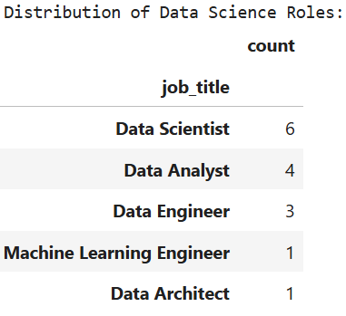
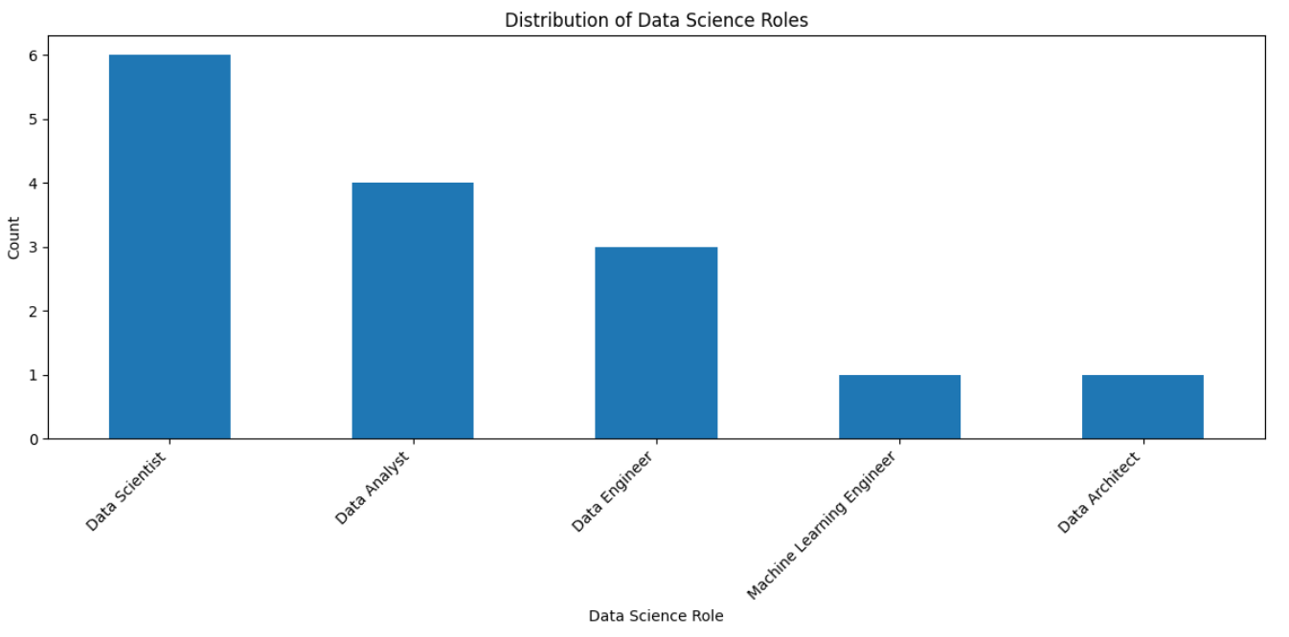

4. Result
The python code to visualize given data was executed successfully.

