Matplotlib Library – Data Visualization
1. Algorithm
Structured Data
- Create a dictionary with consistent keys: ID, Name, Age.
- Convert the dictionary into a DataFrame.
- Display the DataFrame.
Semi-Structured Data
- Create a dictionary with nested elements and varying fields.
- Convert the dictionary into a JSON-formatted string.
- Print the formatted JSON.
Unstructured Data
- Define a plain text string with no fixed format.
- Print the text string.
2. Source Code
import pandas as pd
import json

structured_data = {
'ID': [1, 2, 3],
'Name': ['Alice', 'Bob', 'Charlie'],
'Age': [30, 25, 35]
}
df_structured = pd.DataFrame(structured_data)
print("Structured Data (DataFrame):")
display(df_structured)

semi_structured_data = {
"employees": [
{"id": 1, "name": "Alice", "skills": ["Python", "SQL"]},
{"id": 2, "name": "Bob", "age": 25},
{"id": 3, "name": "Charlie", "skills": ["Java", "C++"], "city": "New York"}
]
}
print("\nSemi-structured Data (JSON):")
print(json.dumps(semi_structured_data, indent=2))

unstructured_data = "This is a sample text document. It contains free-form text without any specific structure. Analyzing this type of data requires specialized tools and techniques."
print("\nUnstructured Data (Text):")
print(unstructured_data)
3. Output
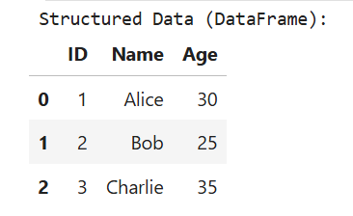
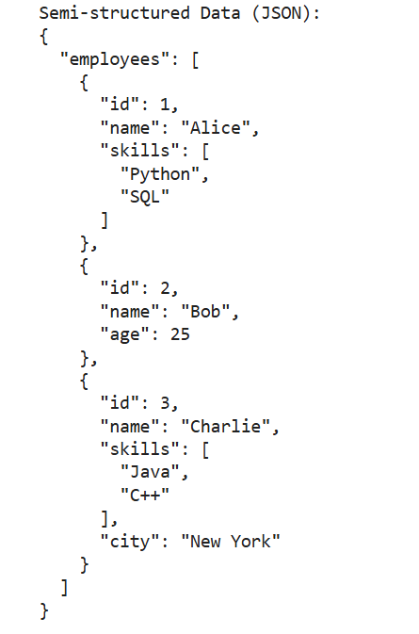
4. Result
The python code to understand structured, unstructured and semi-structured data was executed successfully.

