Pandas library -Basic Concept
1. Algorithm
Load the CSV file into a DataFrame.
- Display the first few rows of the data.
- Check for missing values in each column.
- Fill missing values in the "Sales" column with the column’s average.
- Drop rows with missing values in "Product", "Quantity", or "Region".
- Show summary statistics of the cleaned data.
- Group the data by "Product" and calculate total "Sales" and "Quantity".
- Display the grouped summary.
- Create a bar chart showing total sales for each product.
- Convert the "Date" column to datetime format.
- Group the data by "Date" and calculate total daily sales.
- Create a line chart showing sales over time.
- Create a pivot table showing sales by "Region" and "Product".
- Display the pivot table.
- Calculate the correlation matrix for numeric columns.
- Display the correlation matrix.
- Create a heatmap to visualize the correlation matrix.
2. Source Code
import pandas as pd
import numpy as np
import matplotlib.pyplot as plt
# Load the data into a pandas DataFrame
file_path='C:\sales_data.csv'
df = pd.read_csv(file_path)
# Display the first few rows of the DataFrame
print(df.head())
# Check for missing values
print(df.isnull().sum())
# Fill or drop missing values if necessary
df['Sales'].fillna(df['Sales'].mean(), inplace=True)
df.dropna(subset=['Product', 'Quantity', 'Region'], inplace=True)
# Summary statistics
print(df.describe())
# Group by product and calculate the total sales and quantity
product_summary = df.groupby('Product').agg({
'Sales': 'sum',
'Quantity': 'sum'
}).reset_index()
print(product_summary)
# Bar plot of total sales by product
plt.figure(figsize=(10, 6))
plt.bar(product_summary['Product'], product_summary['Sales'])
plt.xlabel('Product')
plt.ylabel('Total Sales')
plt.title('Total Sales by Product')
plt.show()
# Line plot of sales over time
df['Date'] = pd.to_datetime(df['Date'])
sales_over_time = df.groupby('Date').agg({'Sales': 'sum'}).reset_index()
plt.figure(figsize=(10, 6))
plt.plot(sales_over_time['Date'],sales_over_time['Sales'])
plt.xlabel('Date')
plt.ylabel('Total Sales')
plt.title('SalesOver Time')
plt.show()
# Pivot table to analyze sales by region and product
pivot_table = df.pivot_table(values='Sales', index='Region', columns='Product',
aggfunc=np.sum, fill_value=0)
print(pivot_table)
# Correlation matrix
correlation_matrix = df.corr()
print(correlation_matrix)
# Heatmap of the correlation matrix
import seaborn as sns
plt.figure(figsize=(8, 6))
sns.heatmap(correlation_matrix, annot=True, cmap='coolwarm')
plt.title('Correlation Matrix')
plt.show()
3. Output
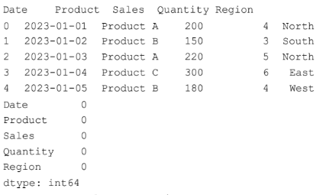
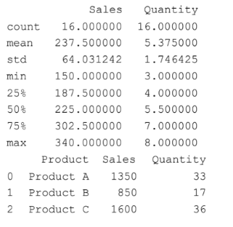
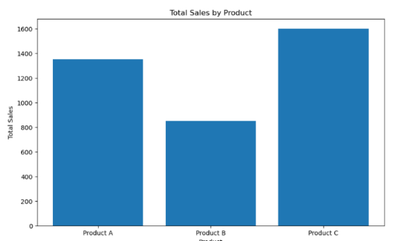
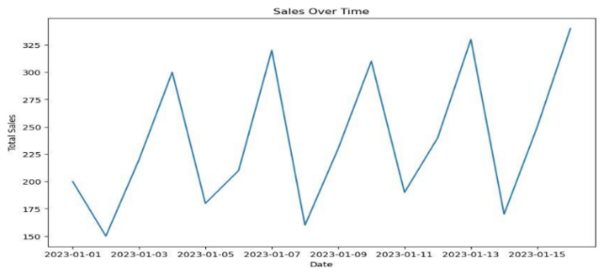
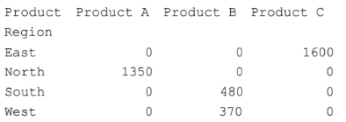
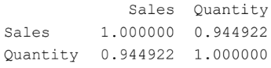
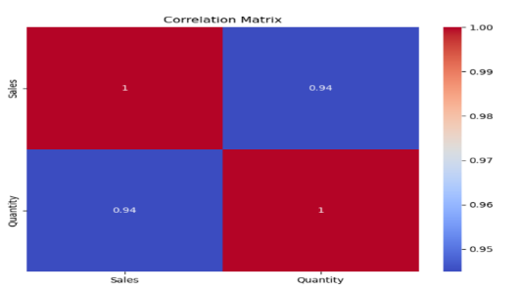
4. Result
The python code to understand structured, unstructured and semi-structured data was executed successfully.

