Matplotlib Library – Data Visualization
1. Algorithm
- Import the required libraries for numerical and data operations.
- Load the dataset from a CSV file into a DataFrame.
- Display basic information about the dataset structure.
- Identify the most frequent value in the Country column.
- Replace missing values in the Country column with its mode.
- Replace missing values in the Age column with its median.
- Replace missing values in the Salary column with its rounded mean.
- Apply one-hot encoding to the Country column.
- Concatenate the encoded Country columns with Age, Salary, and Purchased columns.
- Display updated dataset structure.
- Convert Purchased values from 'No' and 'Yes' to 0 and 1.
- Display the final preprocessed dataset.
2. Source Code
import numpy as np
import pandas as pd
df=pd.read_csv("/content/pre-process_datasample.csv")
df.info()
df.Country.mode()
df.Country.mode()[0]
type(df.Country.mode())
df.Country.fillna(df.Country.mode()[0], inplace=True)
df.Age.fillna(df.Age.median(), inplace=True)
df.Salary.fillna(round(df.Salary.mean()), inplace=True)
pd.get_dummies(df.Country)
updated_dataset=pd.concat([pd.get_dummies(df.Country), df.iloc[ :, [1,2,3]]], axis=1)
df.info()
updated_dataset. Purchased.replace([ 'No', 'Yes' ], [0,1], inplace=True)
updated_dataset

3. Output
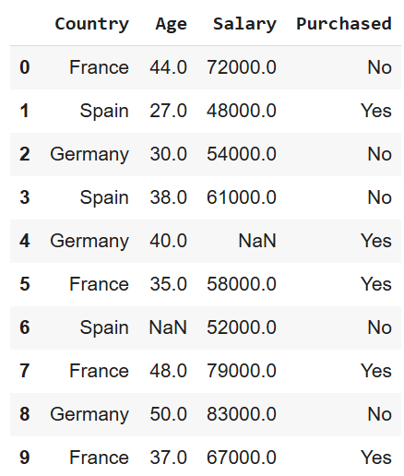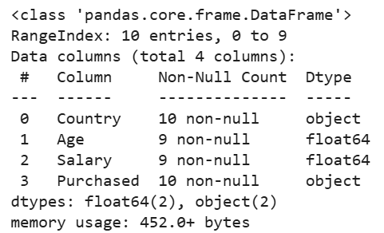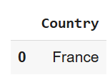
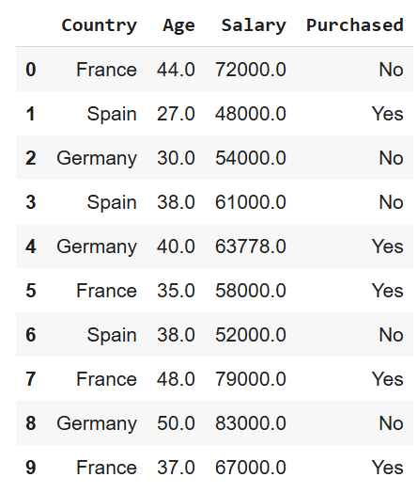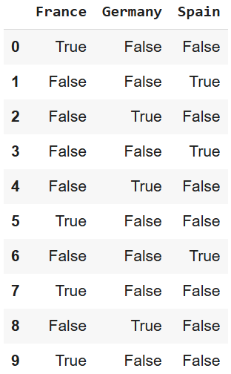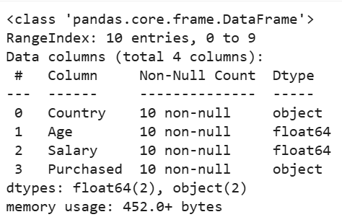
4. Result
The python code to perform data preprocessing was executed successfully.

