Pandas library - Hanling Missiing Values
1. Algorithm
- Import NumPy and Pandas libraries.
- Load the hotel dataset from a CSV file.
- Identify and remove duplicate rows.
- Reset the index after dropping duplicates.
- Drop the redundant column Age_Group.1.
- Replace invalid values in CustomerID, Bill, and EstimatedSalary with NaN.
- Replace out-of-range values in NoOfPax with NaN.
- Standardize inconsistent entries in Hotel and FoodPreference columns.
- Fill missing values
2. Source Code
import numpy as np
import pandas as pd
df=pd.read_csv("Hotel_Dataset.csv")
df.duplicated()
df.info()
df.drop_duplicates(inplace=True)
len(df)
index=np.array(list(range(0,len(df))))
df.set_index(index,inplace=True)
df.drop(['Age_Group.1'],axis=1,inplace=True)
df.CustomerID.loc[df.CustomerID<0]=np.nan
df.Bill.loc[df.Bill<0]=np.nan
df.EstimatedSalary.loc[df.EstimatedSalary<0]=np.nan
df['NoOfPax'].loc[(df['NoOfPax']<1) | (df['NoOfPax']>20)]=np.nan
df.Hotel.replace(['Ibys'],'Ibis',inplace=True)
df.FoodPreference.replace(['Vegetarian','veg'],'Veg',inplace=True)
df.FoodPreference.replace(['non-Veg'],'Non-Veg',inplace=True)
df.EstimatedSalary.fillna(round(df.EstimatedSalary.mean()),inplace=True)
df.NoOfPax.fillna(round(df.NoOfPax.median(),inplace=True)
df['Rating(1-5)'].fillna(round(df['Rating(1-5)'].median()), inplace=True)
df.Bill.fillna(round(df.Bill.mean()),inplace=True)

3. Output
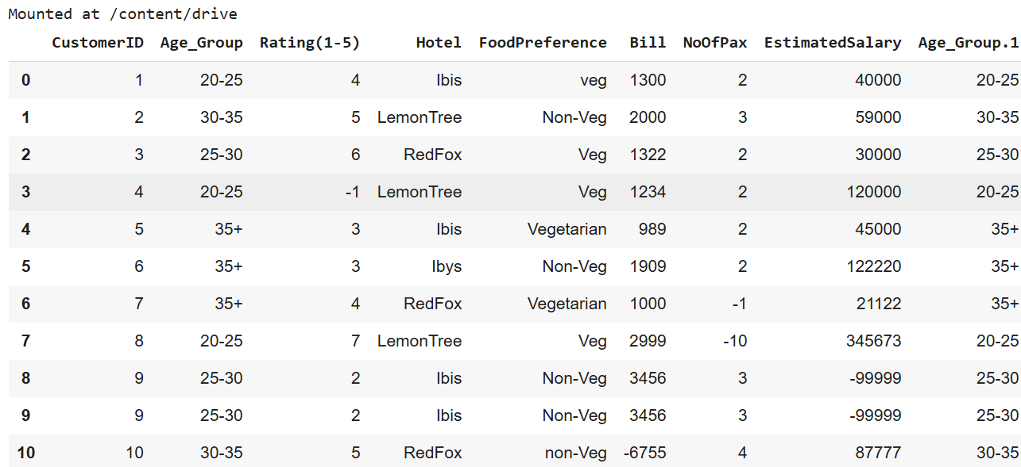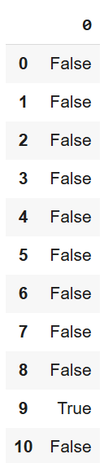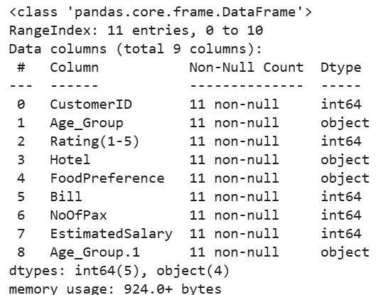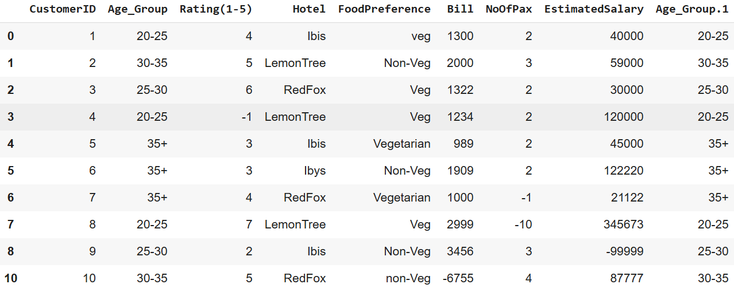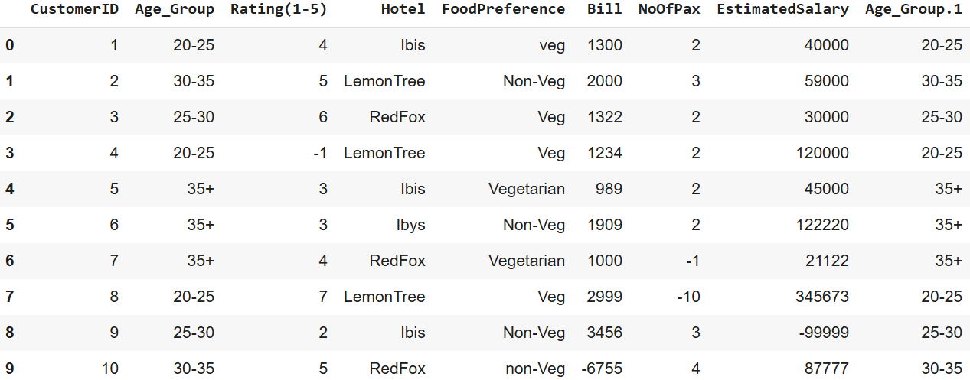
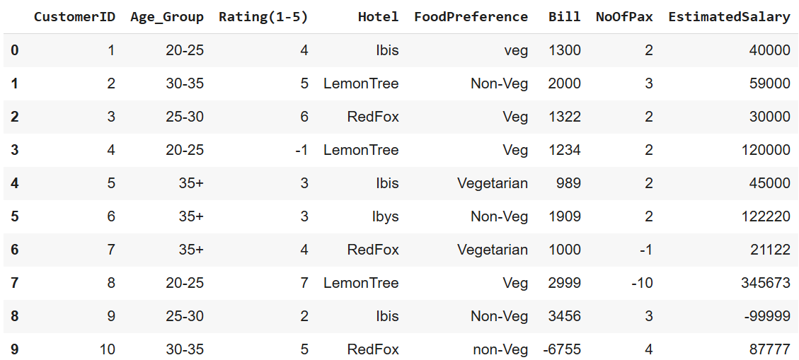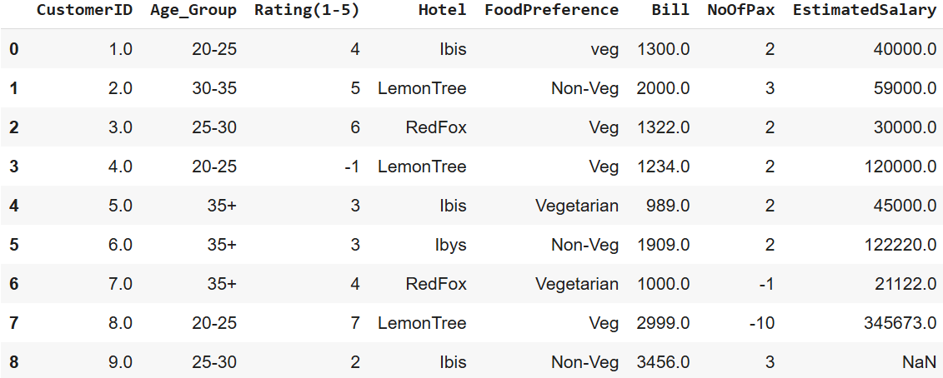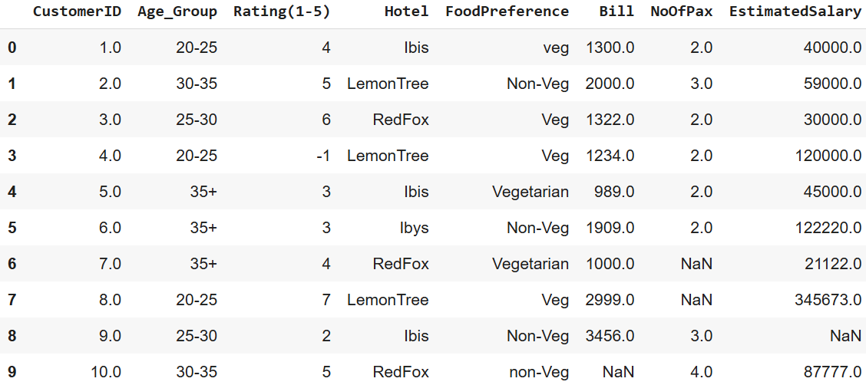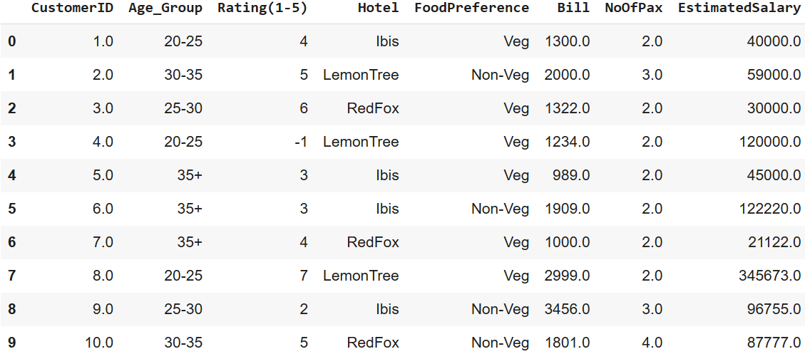
4. Result
The python code to perform data preprocessing was executed successfully.

