Pandas library -Outlier Detection
1. Algorithm
- Import NumPy and generate 16 random integers between 1 and 100
- Calculate the mean and percentiles (25th, 50th, 75th, 100th) of the array.
- Define a function to compute lower and upper bounds for outlier detection using the IQR method.
- Apply the function to the array to get the outlier thresholds.
- Visualize the original array using seaborn's displot and distplot.
- Filter the array to exclude outliers based on the computed thresholds.
- Visualize the filtered array.
- Recalculate outlier thresholds on the filtered array.
- Apply the new thresholds to get the final cleaned array.
- Visualize the final array distribution.
2. Source Code
import numpy as np
array = np.random.randint(1, 100, 16)
array.mean()
np.percentile(array, 25)
np.percentile(array, 50)
np.percentile(array, 75)
np.percentile(array, 100)

def outDetection(array):
sorted(array)
Q1, Q3 = np.percentile(array, [25, 75])
IQR = Q3 - Q1
lr = Q1 - (1.5 * IQR)
ur = Q3 + (1.5 * IQR)
return lr, ur

lr, ur = outDetection(array)
lr, ur

import seaborn as sns
%matplotlib inline
sns.displot(array)
sns.distplot(array)

new_array = array[(array > lr) & (array < ur)]
sns.displot(new_array)

lr1, ur1 = outDetection(new_array)
lr1, ur1

final_array = new_array[(new_array > lr1) & (new_array < ur1)]
sns.distplot(final_array)
3. Output
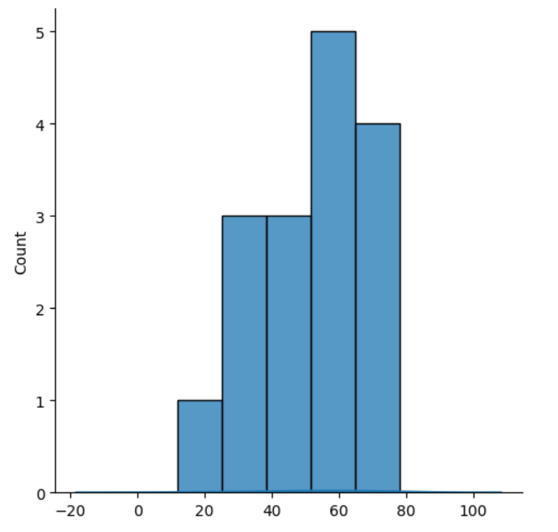
4. Result
The python code to detect outliers was executed successfully.

