Do EDA for Qualitative and Quantitative data
Algorithm
- Load the built-in tips dataset.
- Display the first few rows of the dataset.
- Plot the distribution of total_bill with and without KDE.
- Create joint plots of tip vs total_bill using scatter, regression, and hex styles.
- Create pair plots to show relationships between all numeric columns.
- Count values in the time column.
- Create pair plots with color grouping by time and day.
- Compute and plot a heatmap of the correlation matrix.
- Create box plots for total_bill and tip.
- Create count plots for day and sex.
- Plot a pie chart and bar chart for sex distribution.
- Create a count plot for day filtered by Dinner time.
2. Source Code
import seaborn as sns
import pandas as pd
import numpy as np
import matplotlib.pyplot as plt
%matplotlib inline
tips=sns.load_dataset('tips')
tips.head()
sns.displot(tips.total_bill,kde=True)
sns.displot(tips.total_bill,kde=False)
sns.jointplot(x=tips.tip,y=tips.total_bill)
sns.jointplot(x=tips.tip,y=tips.total_bill,kind="reg")
sns.jointplot(x=tips.tip,y=tips.total_bill,kind="hex")
sns.pairplot(tips)
tips.time.value_counts()
sns.pairplot(tips,hue='time')
sns.pairplot(tips,hue='day')
sns.heatmap(tips.corr(numeric_only=True),annot=True)
sns.boxplot(tips.total_bill)
sns.boxplot(tips.tip)
sns.countplot(tips.day)
sns.countplot(tips.sex)
tips.sex.value_counts().plot(kind='pie')
tips.sex.value_counts().plot(kind='bar')
sns.countplot(tips[tips.time=='Dinner']['day'])
3. Output
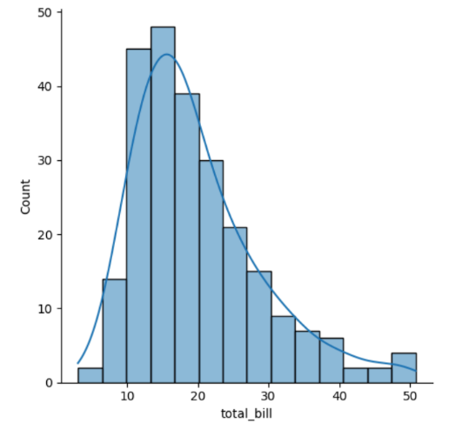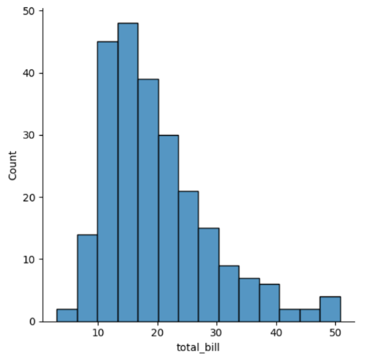
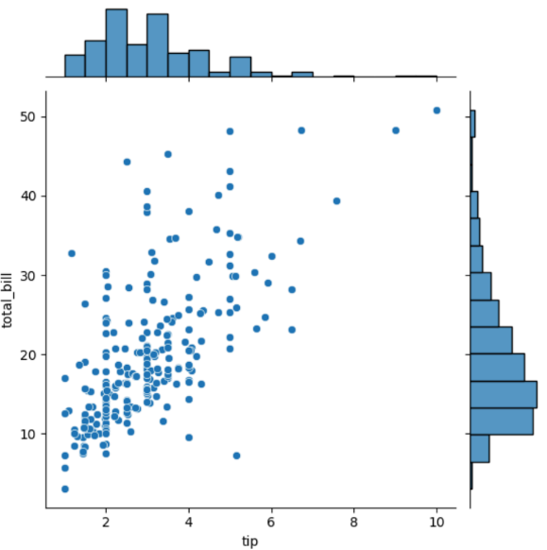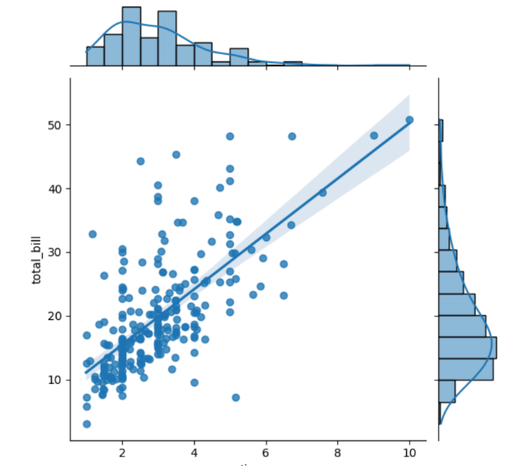
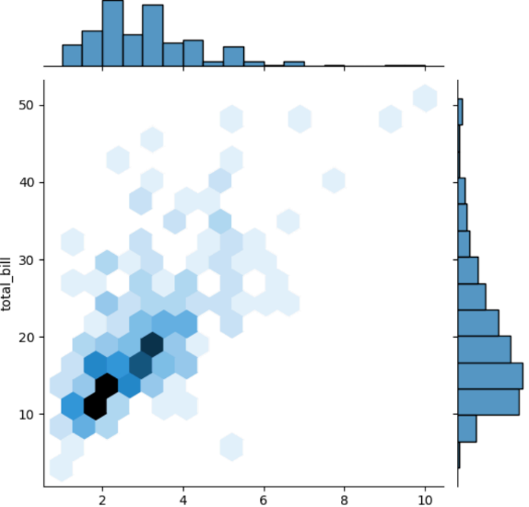
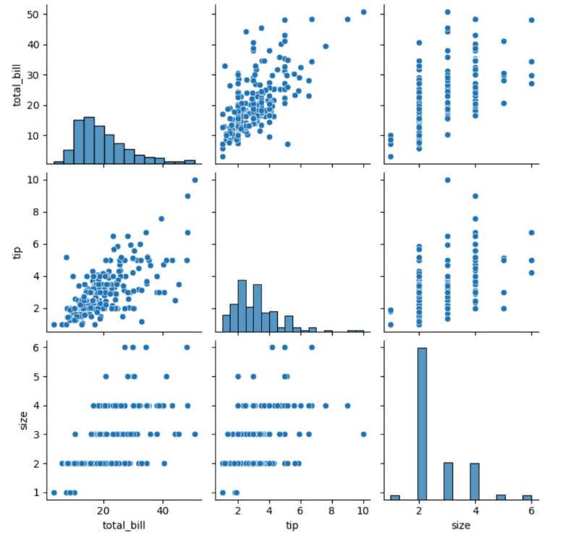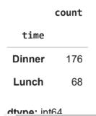
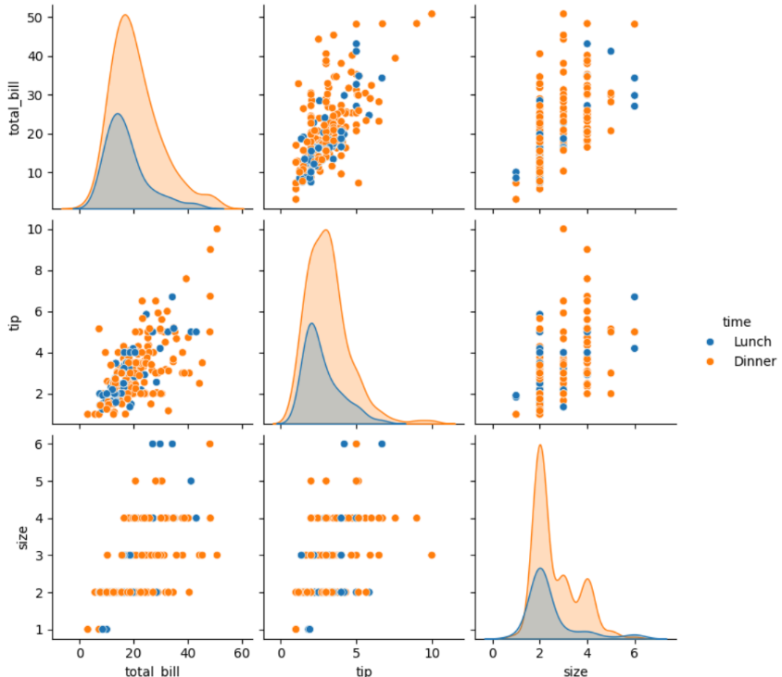
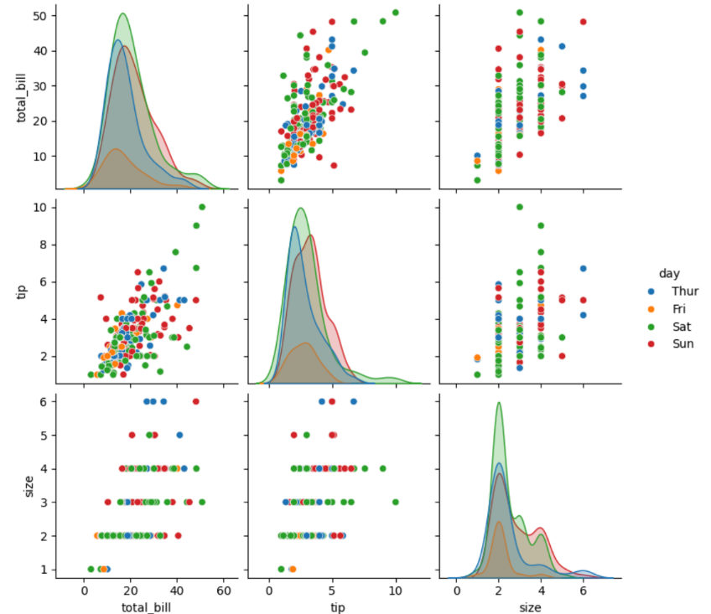
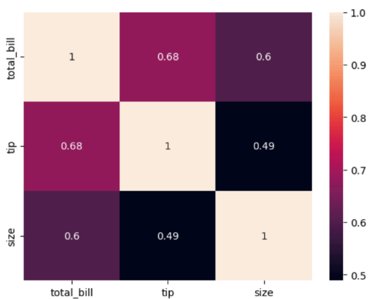
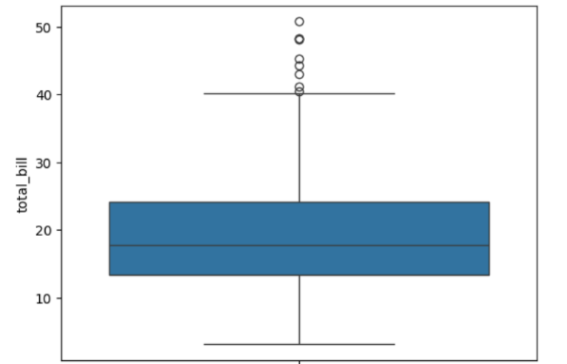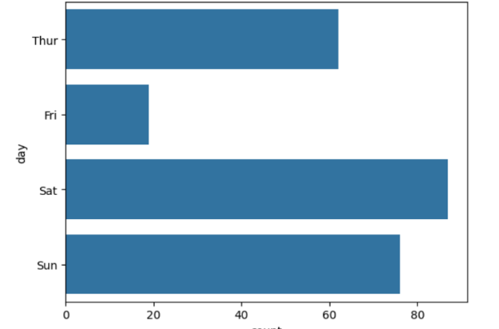
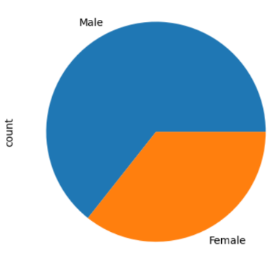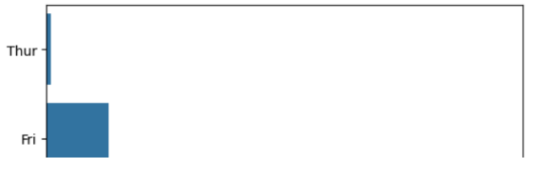
4. Result
The python code to exploratory data anlysis was executed successfully.

