Exp7: Linear Regression
Algorithm:
- Load the built-in tips dataset.
- Display the first few rows of the dataset.
- Plot the distribution of total_bill with and without KDE.
- Create joint plots of tip vs total_bill using scatter, regression, and hex styles.
- Create pair plots to show relationships between all numeric columns.
- Count values in the time column.
- Create pair plots with color grouping by time and day.
- Compute and plot a heatmap of the correlation matrix.
- Create box plots for total_bill and tip.
- Create count plots for day and sex.
- Plot a pie chart and bar chart for sex distribution.
- Create a count plot for day filtered by Dinner time.
2. Source Code
import numpy as np
import pandas as pd
from google.colab import drive
drive.mount('/content/drive')
df = pd.read_csv('/content/drive/My Drive/Salary_data.csv')
df.dropna(inplace = True)
df.info()
df.describe()
features=df.iloc[:,[0]].values
label=df.iloc[:,[1]].values
from sklearn.model_selection import train_test_split
x_train,x_test,y_train,y_test=train_test_split(features,label,test_size=0.2,random_state = 42)
from sklearn.linear_model import LinearRegression
model=LinearRegression()
model.fit(x_train,y_train)
model.score(x_train,y_train)
model.score(x_test,y_test)
model.coef_
model.intercept_
import pickle
pickle.dump(model,open('SalaryPred.model','wb'))
model=pickle.load(open('SalaryPred.model','rb'))
yr_of_exp=float(input("Enter Years of Experience: "))
yr_of_exp_NP=np.array([[yr_of_exp]])
Salary=model.predict(yr_of_exp_NP)
print("Estimated Salary for {} years of experience is {}: " .format(yr_of_exp,Salary))
import matplotlib.pyplot as plt
plt.scatter(x_train, y_train, color = 'red')
plt.plot(x_train, model.predict(x_train), color = 'blue')
plt.title('Salary vs Experience (Training set)')
plt.xlabel('Years of Experience')
plt.ylabel('Salary')
plt.show()
plt.scatter(x_test, y_test, color = 'red')
plt.plot(x_train, model.predict(x_train), color = 'blue')
plt.title('Salary vs Experience (Test set)')
plt.xlabel('Years of Experience')
plt.ylabel('Salary')
plt.show()
3. Output:
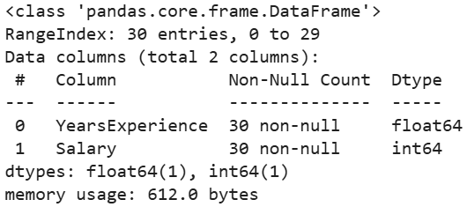
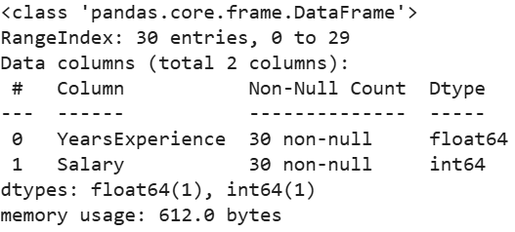
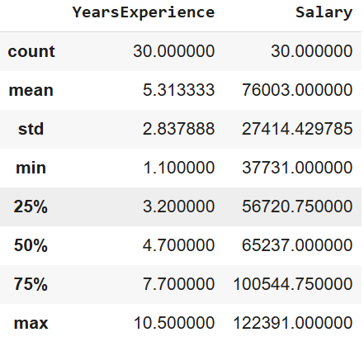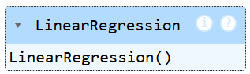
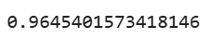
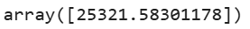
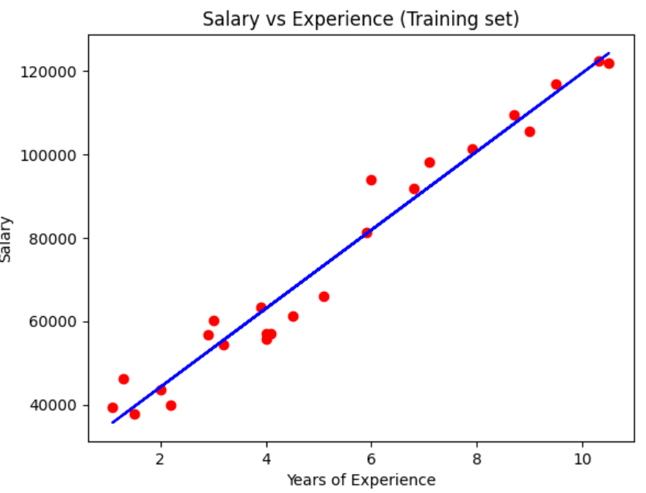
4. Result
The python code to perform linear regression on the give dataset was executed successfully.

