Experiment 8: Logistic Regression
Algorithm:
- Load the built-in tips dataset.
- Display the first few rows of the dataset.
- Plot the distribution of total_bill with and without KDE.
- Create joint plots of tip vs total_bill using scatter, regression, and hex styles.
- Create pair plots to show relationships between all numeric columns.
- Count values in the time column.
- Create pair plots with color grouping by time and day.
- Compute and plot a heatmap of the correlation matrix.
- Create box plots for total_bill and tip.
- Create count plots for day and sex.
- Plot a pie chart and bar chart for sex distribution.
- Create a count plot for day filtered by Dinner time.
2. Source Code
import numpy as np
import pandas as pd
from google.colab import drive
drive.mount('/content/drive')
df = pd.read_csv('/content/drive/My Drive/Social_Network_Ads - Social_Network_Ads.csv')
features=df.iloc[:,[2,3]].values
label=df.iloc[:,4].values
features
label
from sklearn.model_selection import train_test_split
from sklearn.linear_model import LogisticRegression

for i in range(1, 401):
x_train, x_test, y_train, y_test = train_test_split(
features, label, test_size=0.2, random_state=i
)
model = LogisticRegression()
model.fit(x_train, y_train)
train_score = model.score(x_train, y_train)
test_score = model.score(x_test, y_test)
if test_score > train_score:
print("Test {:.4f} Train {:.4f} Random State {}".format(test_score, train_score, i))
x_train, x_test, y_train, y_test = train_test_split(features, label, test_size=0.2, random_state=42)
finalModel = LogisticRegression()
finalModel.fit(x_train, y_train)
print(finalModel.score(x_train,y_train))
print(finalModel.score(x_test,y_test))
from sklearn.metrics import classification_report
print(classification_report(label,finalModel.predict(features)))

import matplotlib.pyplot as plt
from matplotlib.colors import ListedColormap
X_set, y_set = features, label
X1, X2 = np.meshgrid(np.arange(start = X_set[:, 0].min() - 10, stop = X_set[:, 0].max() + 10, step = 1),
np.arange(start = X_set[:, 1].min() - 10000, stop = X_set[:, 1].max() + 10000, step = 500))

plt.contourf(X1, X2, finalModel.predict(np.array([X1.ravel(), X2.ravel()]).T).reshape(X1.shape),
alpha = 0.75, cmap = ListedColormap(('red', 'green')))
plt.xlim(X1.min(), X1.max())
plt.ylim(X2.min(), X2.max())
for i, j in enumerate(np.unique(y_set)):
plt.scatter(X_set[y_set == j, 0], X_set[y_set == j, 1], c = ListedColormap(('red', 'green'))(i), label = j)

plt.title('Logistic Regression (Training set)')
plt.xlabel('Age')
plt.ylabel('Estimated Salary')
plt.legend()
plt.show()

3. Output:
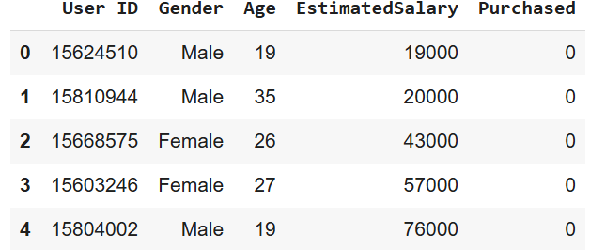
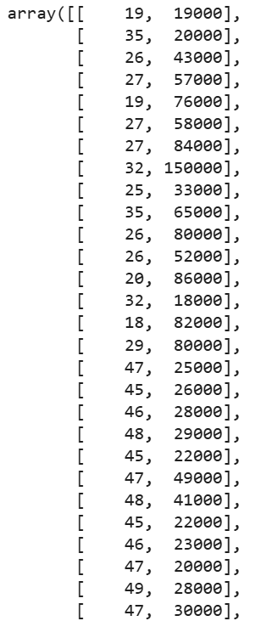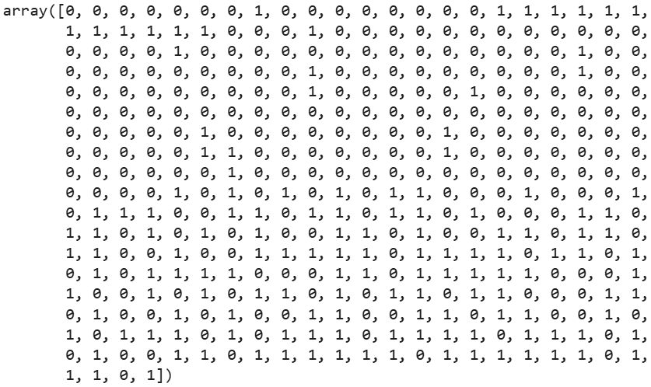
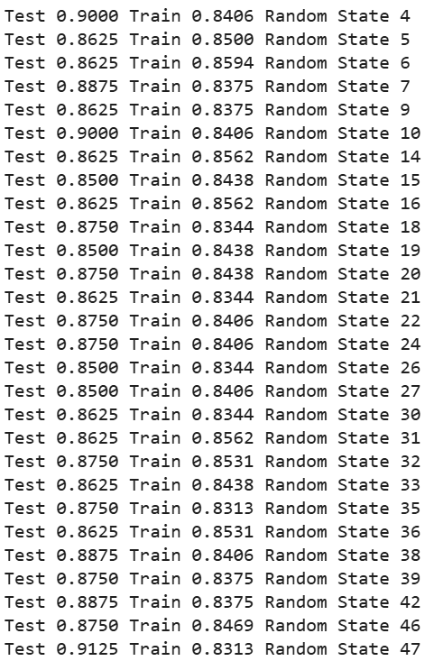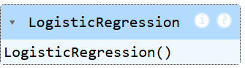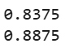
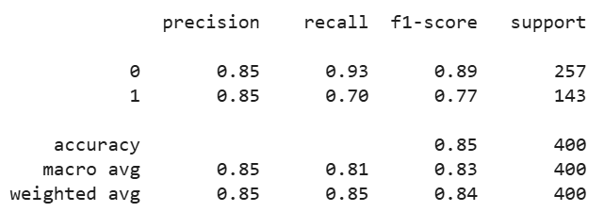
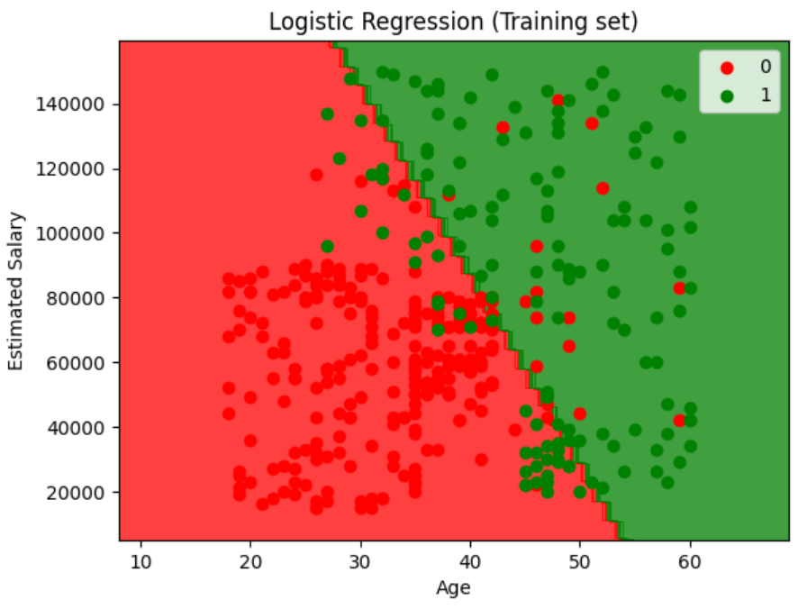

4. Result
The python code to perform logistic regression on the give dataset was executed successfully.

