Experiment 9: KNN
Algorithm:
- Import necessary modules from sklear
- Extract feature columns (all except the last) and label column (5th column) from the DataFrame.
- Split the data into training and testing sets (80% train, 20% test).
- Create a KNN classifier with 5 neighbors.
- Train the model using the training data.
- Predict labels for the test data.
- Get the list of feature names and the target label name.
- Print the accuracy score of the model.
- Print the classification report.
- Print the confusion matrix.
- Print the list of features used.
2. Source Code
from sklearn.model_selection import train_test_split
from sklearn.neighbors import KNeighborsClassifier
from sklearn.metrics import accuracy_score, classification_report, confusion_matrix

features = df.iloc[:, :-1].values
label = df.iloc[:, 4].values

xtrain, xtest, ytrain, ytest = train_test_split(features, label, test_size=0.2, random_state=42)
model_KNN = KNeighborsClassifier(n_neighbors=5)
model_KNN.fit(xtrain, ytrain)
y_pred = model_KNN.predict(xtest)

feature_names = df.columns[:-1].tolist()
target_name = df.columns[4]

print(f"Accuracy: {accuracy_score(ytest, y_pred):.2f}")
print("\nClassification Report:")
print(classification_report(ytest, y_pred, target_names=[target_name]))
print("\nConfusion Matrix:")
print(confusion_matrix(ytest, y_pred))
print("\nFeatures used:", feature_names)
3. Output:
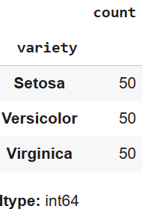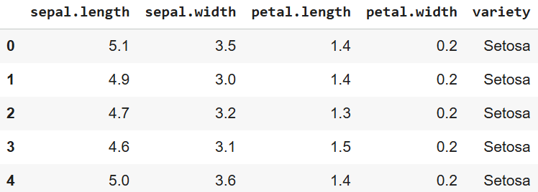
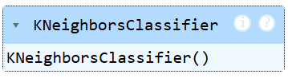
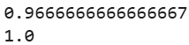
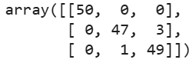
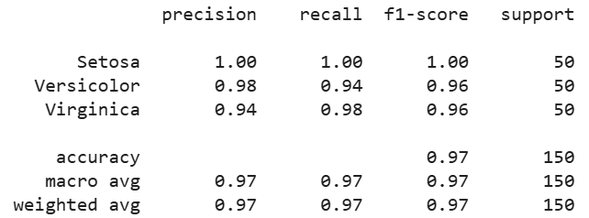

4. Result
The python code to perform KNeighboursClassification on the give dataset was executed successfully.

