Library Book Issue Request Form (Advanced) — Advanced Fields: Output
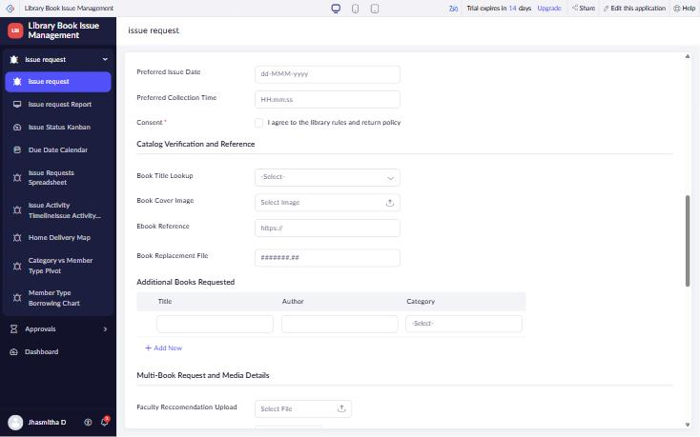
Figure 1: Catalog Verification and Reference – Lookup, Image, URL, Decimal, Subform
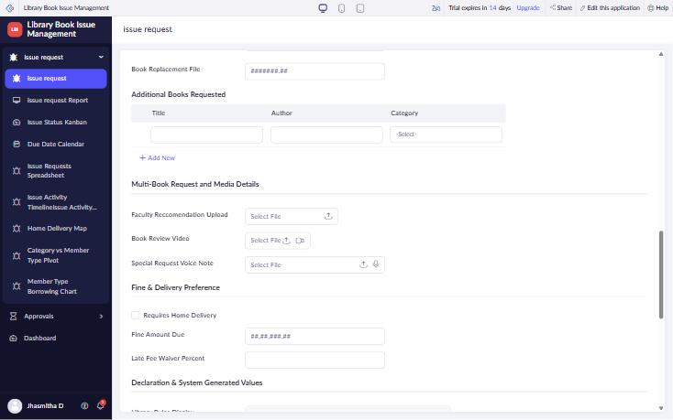
Figure 2: Multi-Book Request and Media, Fine and Delivery – File Upload, Video, Audio, Decision Box, Currency, Percent
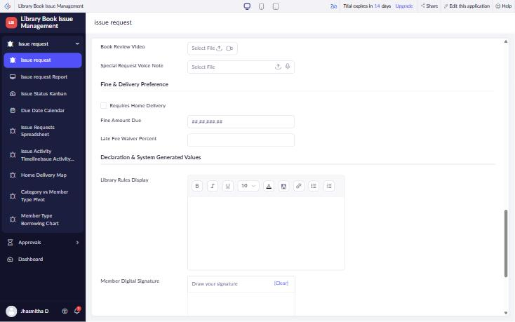
Figure 3: Declaration – Rich Text and Signature
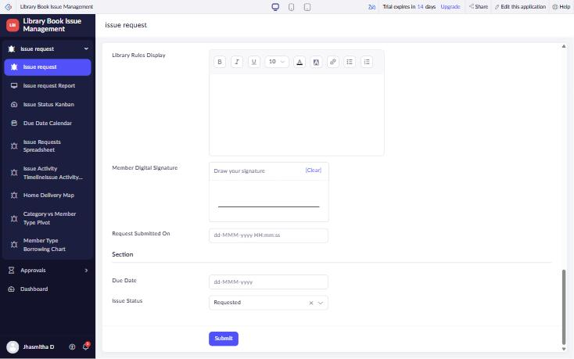
Figure 4: System Generated Values – Date-Time, Auto Number, QR Code (hidden), Formula

