Library Book Issue Request Form — Basic Fields: Output
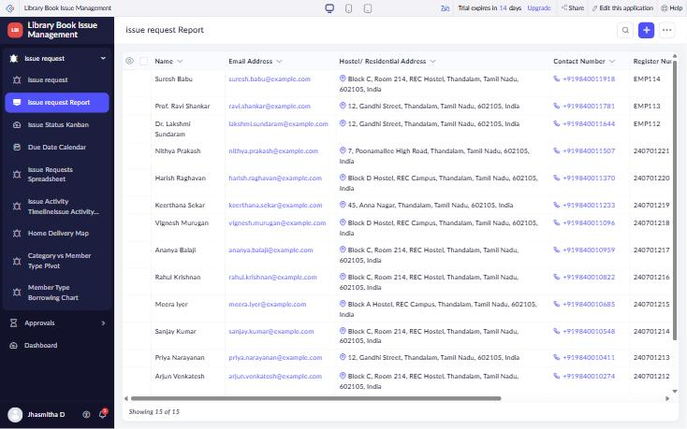
Figure 1: Submitted issue requests – Book_Issue_Request_Report (15 records)
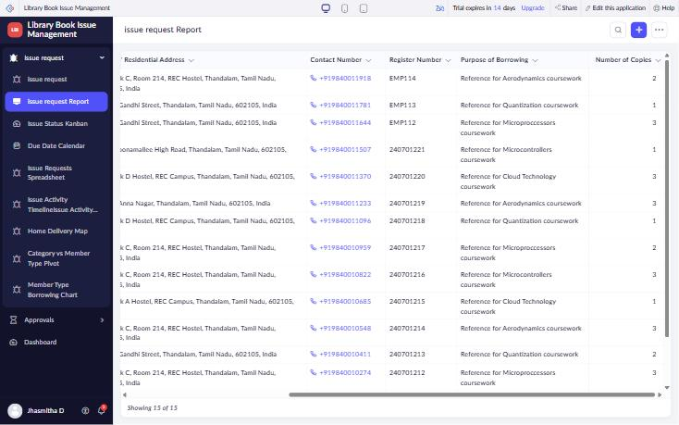
Figure 2: Report columns – Contact Number, Register Number, Purpose, Number of Copies
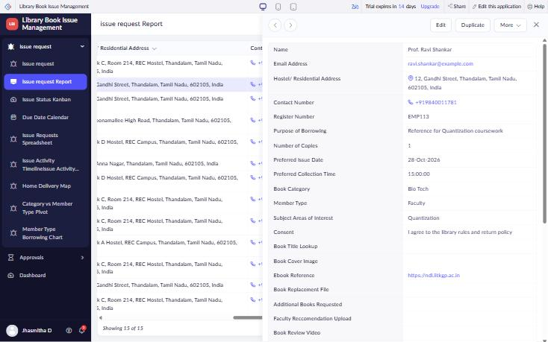
Figure 3: Record detail view of a submitted request
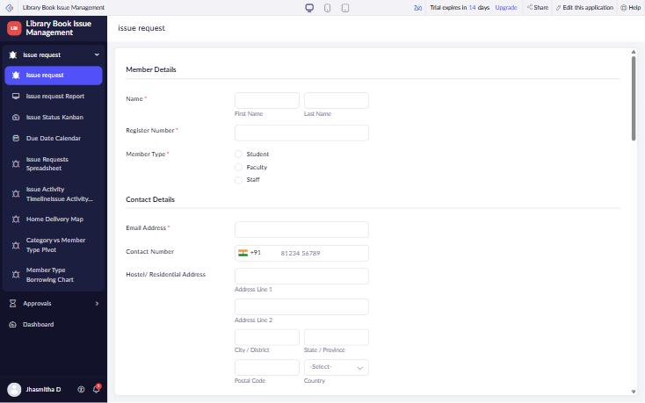
Figure 4: Member Details and Contact Details sections (Name, Single Line, Radio, Email, Phone, Address)
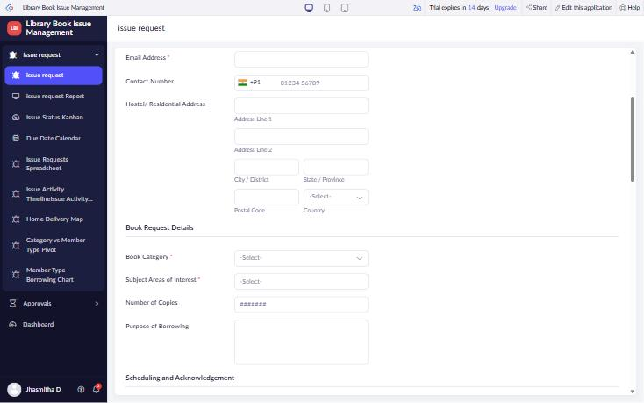
Figure 5: Address and Book Request Details (Dropdown, Multi Select, Number, Multi Line)
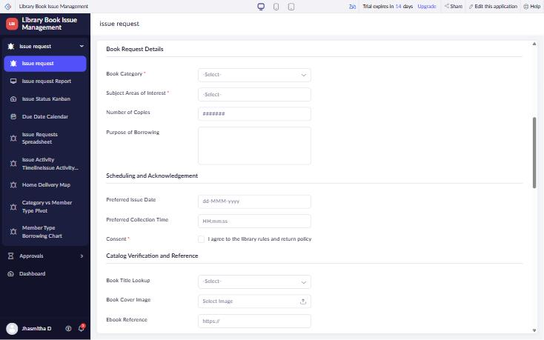
Figure 6: Scheduling and Acknowledgement (Date, Time, Checkbox)

