Library Book Issue Command Center — Page Elements: Output
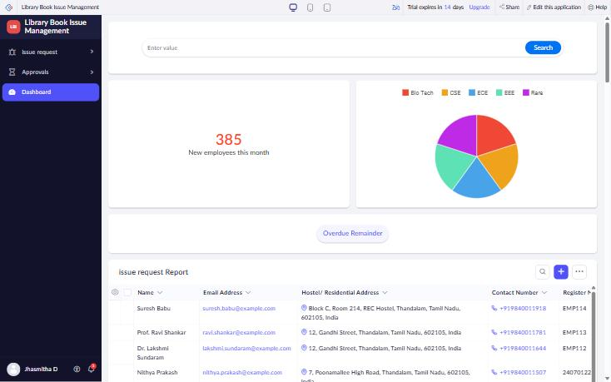
Figure 1: Library Command Center page – Search, Panel, Chart, Button and Report elements
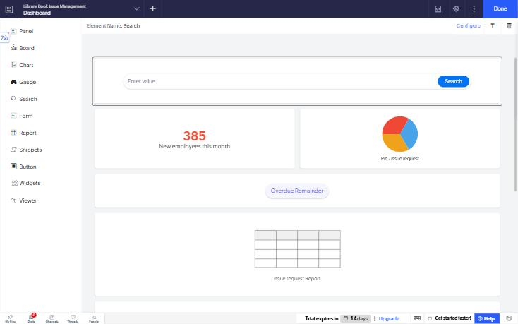
Figure 2: Page Builder – element palette (Panel, Board, Chart, Gauge, Search, Form, Report, Snippets, Button, Widgets, Viewer)
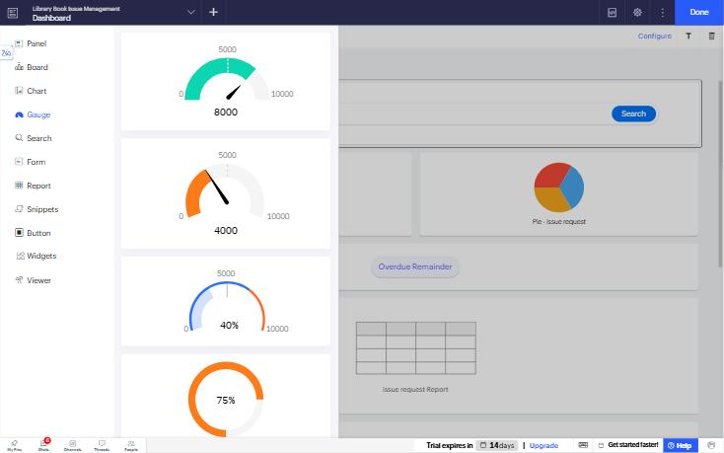
Figure 3: Gauge element templates

