Library Book Issue Reports Suite — Report Types: Output
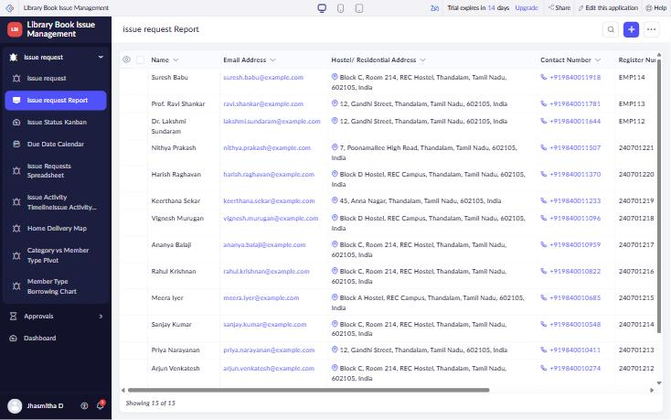
Figure 1: List View – issue request Report
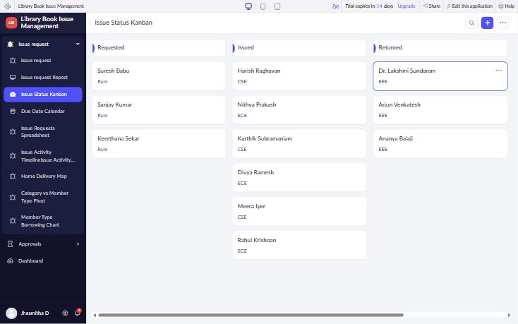
Figure 2: Kanban View – Issue Status Kanban
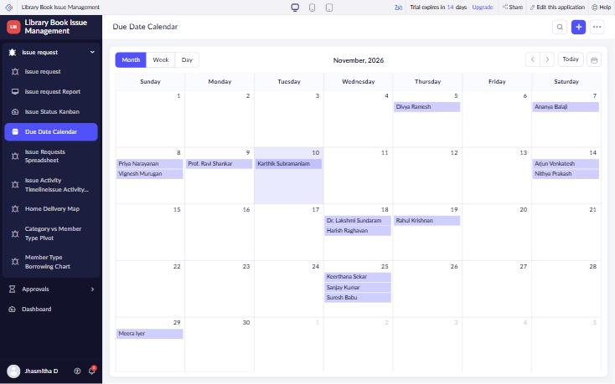
Figure 3: Calendar View – Due Date Calendar
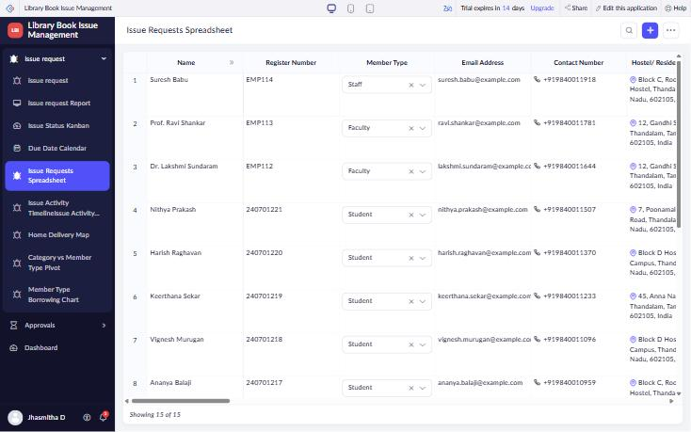
Figure 4: Spreadsheet View – Issue Requests Spreadsheet (inline editable)
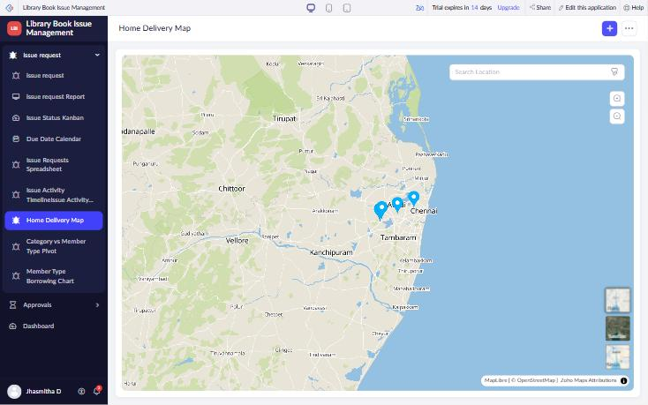
Figure 5: Map View – Home Delivery Map
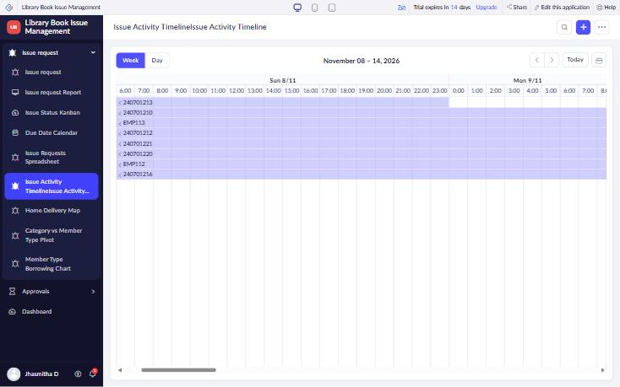
Figure 6: Timeline View – Issue Activity Timeline (Preferred Issue Date to Due Date)
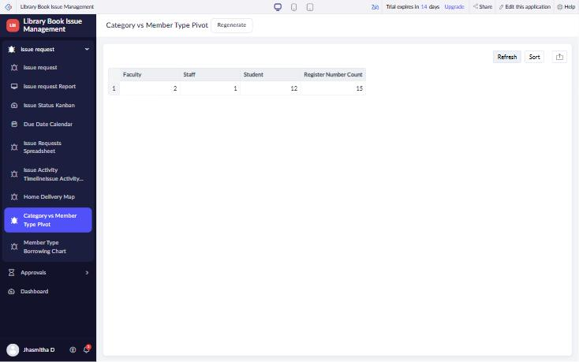
Figure 7: Pivot Table – Member Type wise Issue Requests
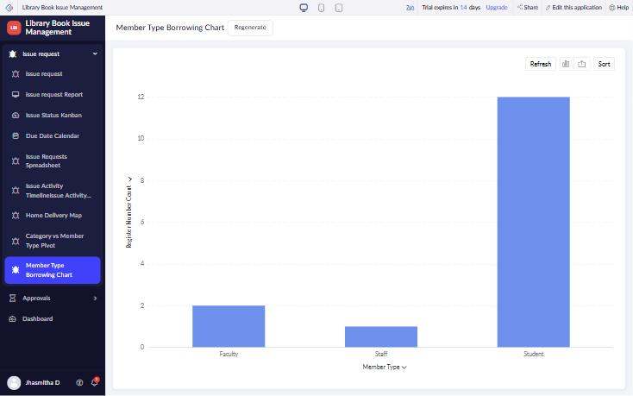
Figure 8: Chart View – Member Type Borrowing Chart
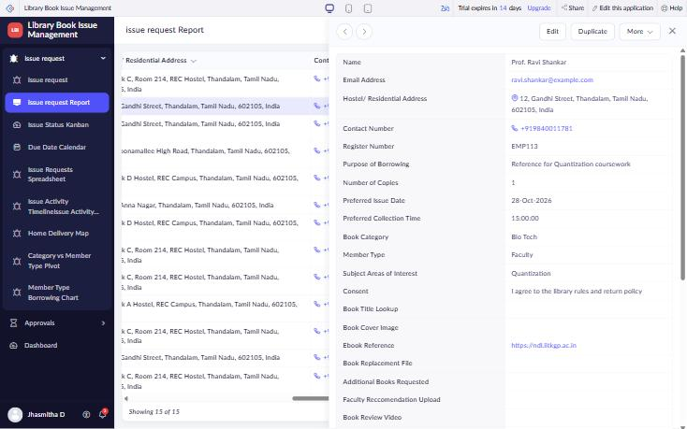
Figure 9: Summary View – Record summary (detail view)

