Library Book Issue Automation Suite — Workflow Options: Output
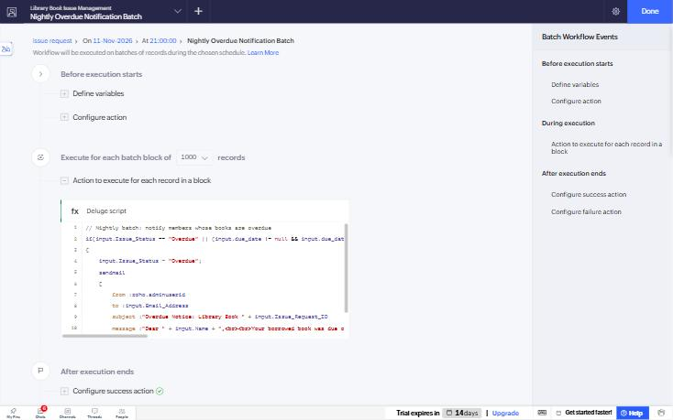
Figure 1: Batch workflow – Nightly Overdue Notification
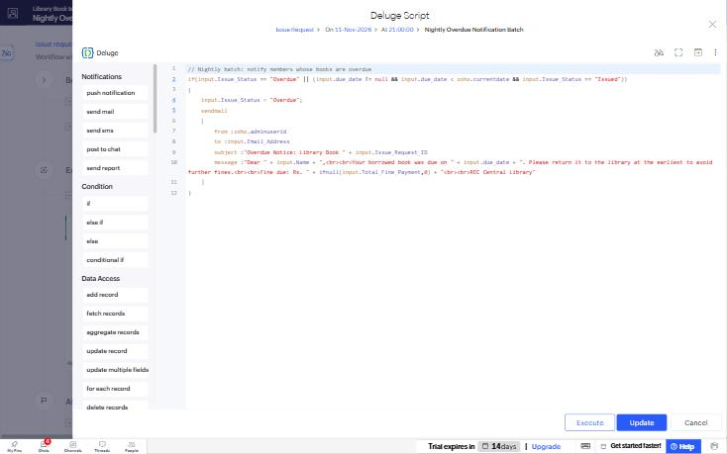
Figure 2: Batch workflow – Deluge action
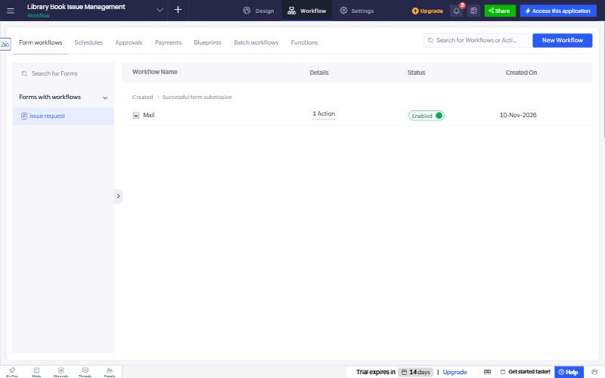
Figure 3: Form workflows
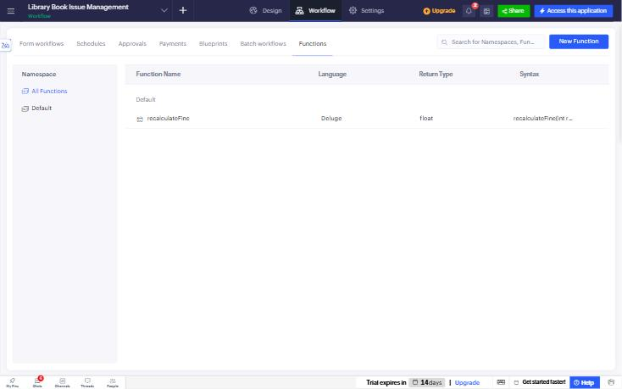
Figure 4: Functions – recalculateFine (Deluge function)
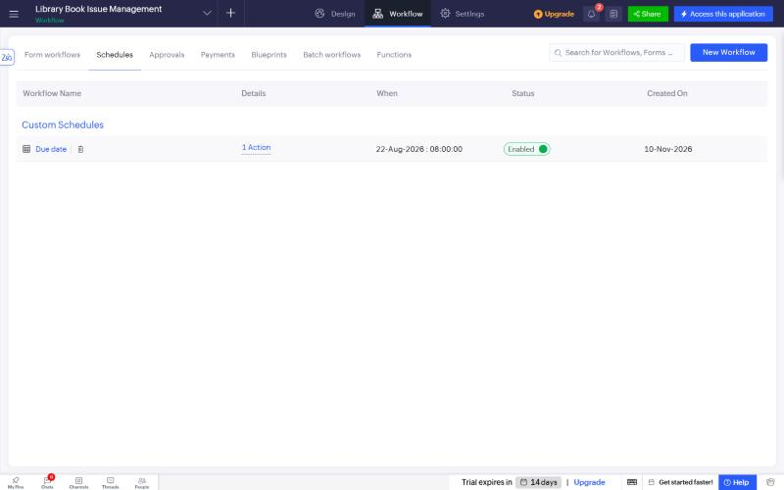
Figure 5: Schedules – Due date reminder schedule (daily, enabled)
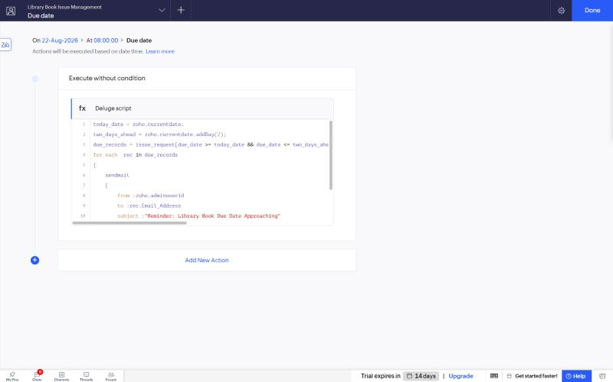
Figure 6: Schedule action – Deluge script sending due-date reminder emails
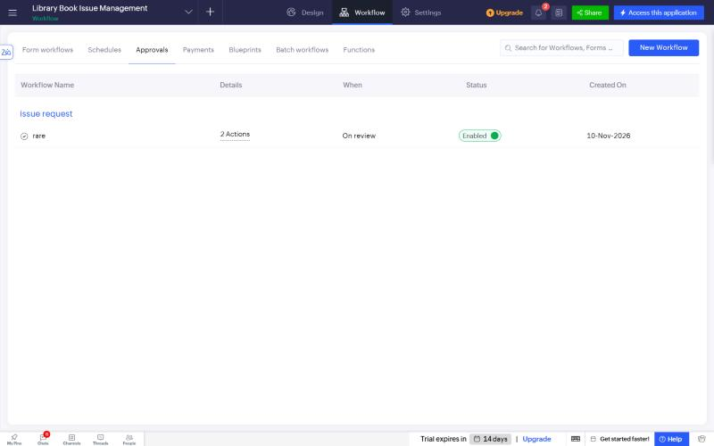
Figure 7: Approvals – 'rare' approval process for Rare book requests
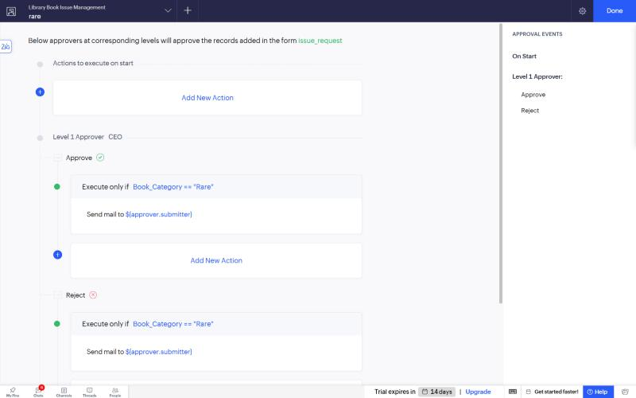
Figure 8: Approval process – Level 1 approver with Approve/Reject email actions
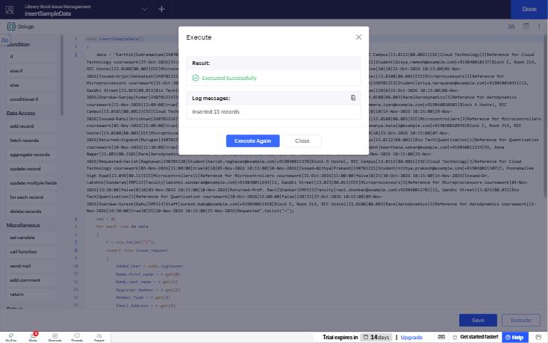
Figure 9: insertSampleData executed

