**A**

**PROJECT REPORT**

**ON**

**Car Service**

**Online Car Service Portal**

**SUBMITTED BY**

RUTVI D. RUPAPARA

DIPENDRASINH P. ZALA

**ACADEMIC YEAR 2023-2024**

**T.Y B.C.A. SEM - 5**

**UNDER THE GUIDANCE OF**

Mr. KHUSHAL RAJANI

Ms. DEVKI TRIVEDI

**SMT. C.Z.M GOSRANI B.C.A. COLLEGE**

**JAMNAGAR**

**SUBMITTED TO**



**SAURASHTRA UNIVERSITY -RAJKOT**

**A**

**PROJECT REPORT**

**ON**

**Online Car Service Portal**

**SUBMITTED BY**

RUTVI D. RUPAPARA

DIPENDRASINH P. ZALA

**ACADEMIC YEAR 2023-24**

**T.Y B.C.A. SEM – 5**

**UNDER THE GUIDANCE OF**

Mr. KHUSHAL RAJANI

Ms. DEVKI TRIVEDI

**SMT. C.Z.M GOSRANI B.C.A. COLLEGE**

**JAMNAGAR**

**SUBMITTED TO**



**SAURASHTRA UNIVERSITY – RAJKOT**

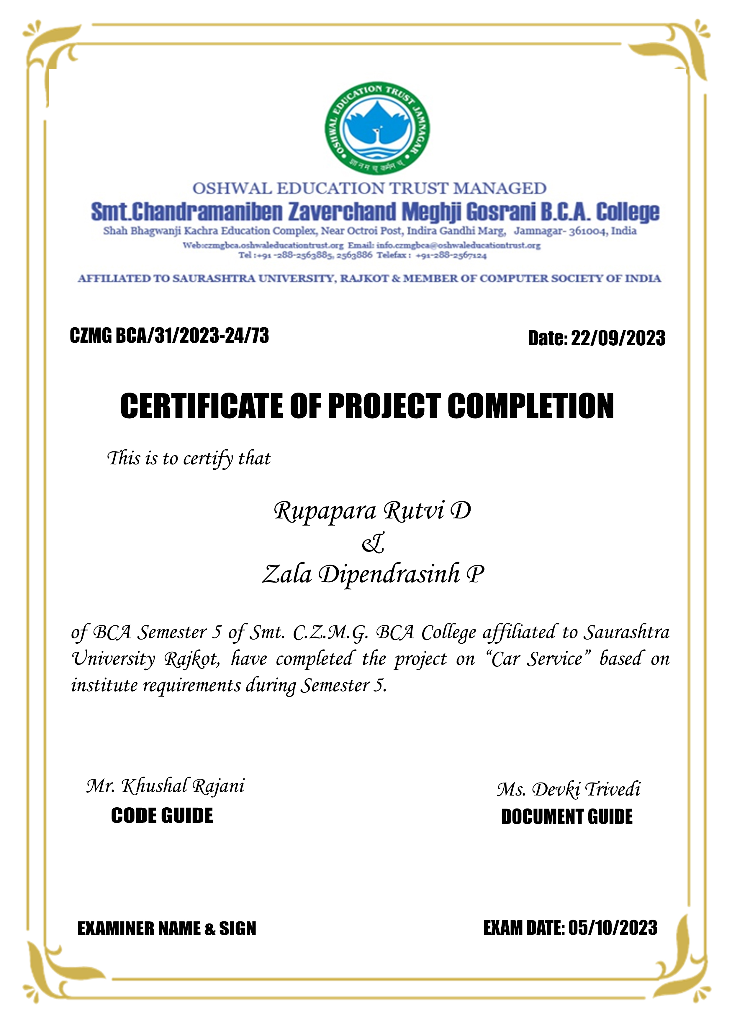

# **ABSTRACT**

Client can book slot for car service or client can book time slot. Client will get notification about working status like car service started or completed. A message is also sent to client regarding any query for parts which needs to be repaired or changed by the admin side.

# **ACKNOWLEDGEMENT**

I feel great pleasure in submitting this project report as a part of my B.C.A. Semester 5 curriculum. A practical study plays an important role.

For the successful completion of my project, I would especially like to thank my parents for their support and unconditional help. I would also like to thank my Project Guide Mr. Khushal Rajani & Ms. Devki Trivedi for their constant support and help in implementation of this project.

I am also thankful to our Principal Ma'am, Ms. Hetal G. Savla for all the facilities they provided throughout our semester and for encouraging me to take up this activity.

Lastly, I would also like to thank the faculties and staff members of Smt. C.Z.M. Gosrani B.C.A. College, Jamnagar.

# **PROJECT PROFILE**

|  |  |  |
| --- | --- | --- |
| STUDENT INFORMATION | | |
| Name  RUTVI D. RUPAPARA  DIPENDRASINH P. ZALA | **Enrollment Numbers**  003203212581  003203212602 | |
| PROJECT DETAILS | | |
| Project Title | Online Car Service Portal | |
| Duration | 3 Months | |
| Name of Project | CarServ | |
| Platform | ASP.NET  SQL SERVER | |
| Team Size | 2 | |
| GUIDE INFORMATION | | |
| Name of Guide | | Mr. KHUSHAL RAJANI  Ms. DEVKI TRIVEDI |

# **INDEX**

|  |  |  |
| --- | --- | --- |
| Sr No. | TITLE | Page No. |
|  | TITLE PAGE | I |
|  | ABSTRACT | II |
|  | ACKNOWLEDEMENT | III |
|  | PROJECT PROFILE | IV |
| CHAPTERS | | |
| 1 | SDLC OVERVIEW | 1 |
| 2 | REQUIERMENT GATHERING AND ANALYSIS | 2 |
| 2.1 Organization Details | 2 |
| 2.2 Meetings | 2 |
| 2.3 Data which will be Input into the system | 3 |
| 2.4 Data which will be Output from the system | 3 |
| 2.5 Type of Project | 3 |
| 2.6 Method of collecting Data | 3 |
| 3 | SYSTEM REQUIREMENT SPECIFICATIONS | 4 |
| 3.1 Introduction | 4 |
| 3.2 Overall Description | 5 |
| 3.3 External Interface Requirement | 7 |
| 3.4 System Features | 8 |
| 3.5 Other Nonfunctional Requirements | 8 |
| 3.6 Feasibility Study | 9 |
| 4 | SYSTEM ANALYSIS AND MODELING | 11 |
| 4.1 Use case Diagram | 11 |
| 4.2 Normalization and E-R Diagram | 13 |
| 4.3 Data Dictionary | 17 |
| 4.4 Functional and Behavior Modeling | 21 |
| 4.5 Gantt Chart | 24 |
| 5 | TEST CASE | 25 |
| 6 | SCREENSHOTS | 27 |
| 7 | LIMITATIONS AND FUTURE ENHANCENT | 35 |
| 8 | CONCLUSION | 36 |
| 9 | REFERENCES AND BIBLIOGRAPHY | 37 |