**LEARNING ACTIVITY SHEET**

**SPECIAL PROGRAM IN ICT 7**

**OFFICE PRODUCTIVITY 7**

*Second Quarter, Week 1 & 2*

Name of Learner: _____________________________ Date: __________________________

Grade Level /Section: __________________________

# Getting Started with PowerPoint

**BACKGROUND INFORMATION FOR LEARNERS**

Presentation leads ideas and encourages audience making it an important tool in advertising and business related fields, clarifying an organizational structure, and also in teaching as a whole.

*Presentation graphics* offers tool for creative and effective demonstration and a professional looking report using different color, patterns, clipart, sound, moving effects etc.

Microsoft PowerPoint is a presentation software and a default feature of MS Windows Office used for performing computer-based and allows creating dynamic slide presentations enabling to create easily professional presentations effectively. It enables to share and manage presentations efficiently.

**Introduction**

*MS Office PowerPoint* or simply PowerPoint is one of the powerful tools today in promoting products and services, disseminating information and exhibiting impressions. It is practically made for all presentation needs.

With the introduction of several **enhanced features**, students will learn how to use basic features of Microsoft PowerPoint and how to create effective presentations.

**MOVING AROUND THE POWERPOINT SCREEN**

When opening PowerPoint 2013, Start ***Screen*** will appear. At this point, creating a ***new presentation***, choosing a ***template***, or accessing ***recently edited presentations* are desirable***.* To start the lesson, open PowerPoint 2013 and the *MS PowerPoint Window* appears as shown below:

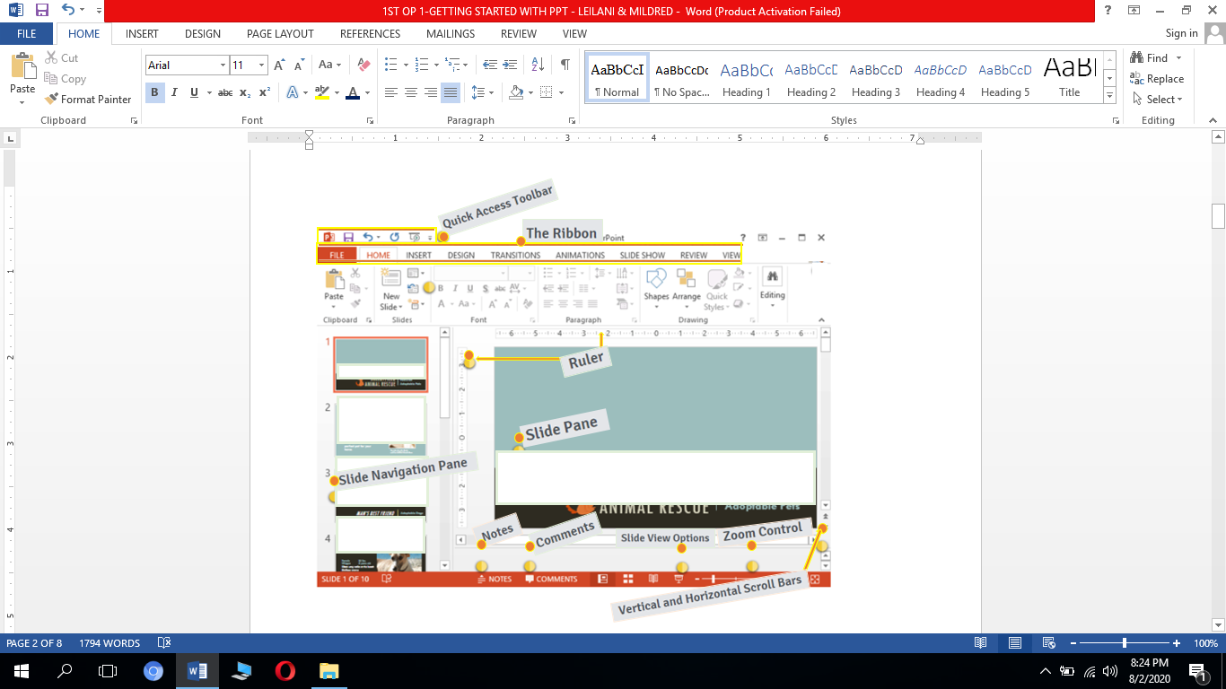



*Figure 1. MS PowerPoint Window*

**QUICK ACCESS TOOLBAR**

The *Quick Access Toolbar* lets the user access common commands whatever which tab is being selected. By default, the Save, Undo, Redo and Start Presentation commands are included.

**THE RIBBON**

The *Ribbon* comprises all of the commands needed to perform common tasks in PowerPoint. It has multiple tabs wherein each has groups of commands.

**SLIDE NAVIGATION PANE**

The slide navigation pane lets viewing and working with the slides in presentation. Use this for easy adding, deleting, duplicating, and rearranging slides in the slide navigation pane.

**RULER**

The *ruler* makes aligning text and objects on slide easier.

**SLIDE PANE**

*Slide pane* can view and edit the selected slide.

**VERTICAL AND HORIZONTAL SCROLL BARS**

To view the part of the slide just click, hold, and drag the *vertical or horizontal scrollbars*.

**NOTES**

*Notes* is often called speaker notes and use to add notes to current slide which can help in delivering or preparing for presentation.

**COMMENTS**

Click *Comments* in viewing comments for the current slide.

**SLIDE VIEW OPTIONS**

Adjust slide view by choosing one of the following:

***Normal View*** is the default view that displays the slide navigation pane and the selected slide.

***Slide Sorter***displays smaller versions of all slides in the presentation.

***Reading View***makes slides easier to review as it hides all editing tools.

***Play Slide Show*** will play slides as an actual presentation.

**ZOOM CONTROL**

To use the zoom control: click, hold, and drag the slider. The number on the right of the slider bar shows the zoom percentage.

#### **OVERVIEW OF THE USER INTERFACE**

**1. RIBBON**

PowerPoint 2013 uses a ***tabbed Ribbon system***whichcontains **multiple tab** each having some ***groups of commands* u**se to execute the most ***common tasks*** in PowerPoint.

The ***Home***tab gives access to the most regularly used commands including ***copying and pasting, formatting,*** and ***New Slide***command.

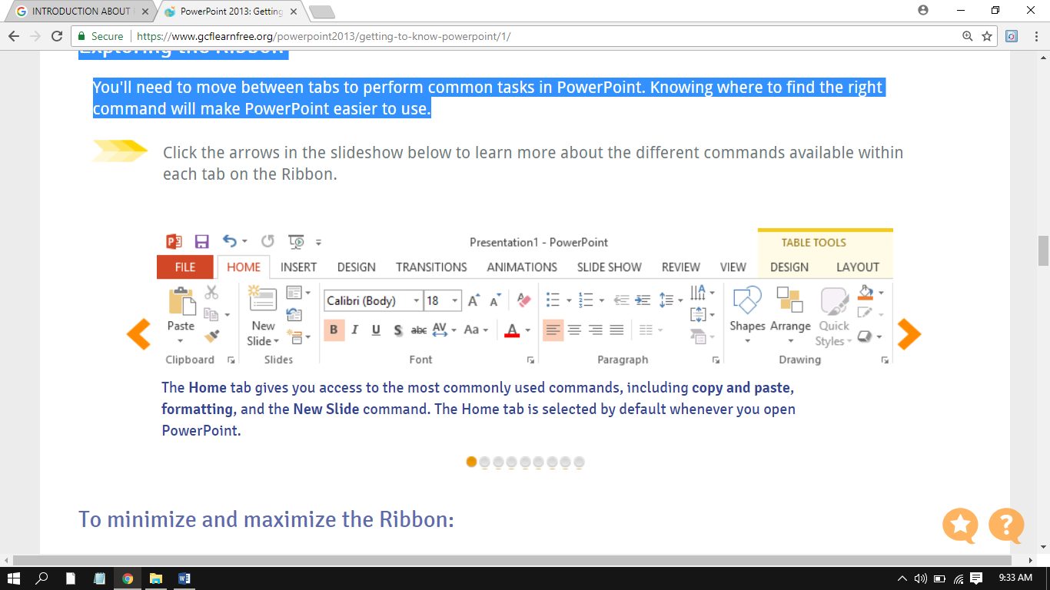

The ***Insert*** tab lets inserting **pictures, charts, tables, shapes,** and **videos** that can help communicate information **visually**and add **style**to presentation.

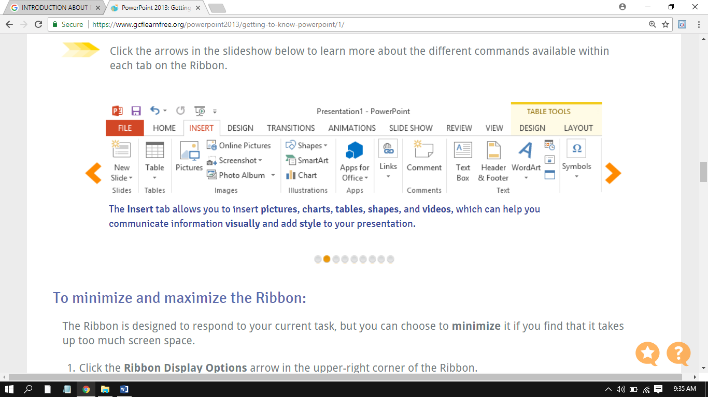

The ***Design*** tab allows applying **themes**. A theme is a **predefined combination** of colors, fonts, and effects from which can quickly change the look of entire slide show including ***slide layouts.***

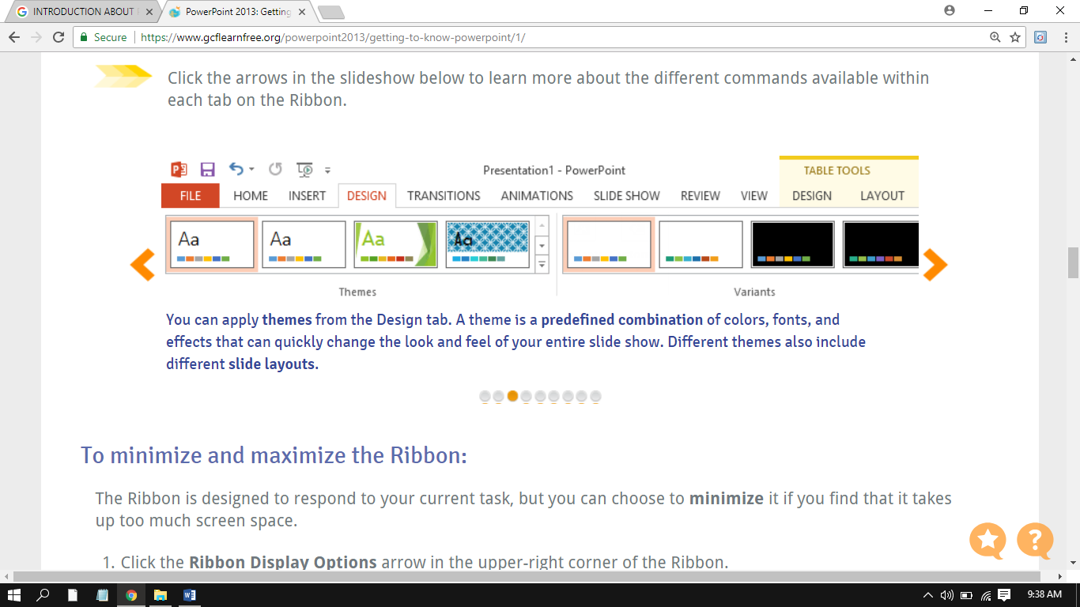

Apply slide transitions from the***Transitions*** tab. Transitions are the movements that can be seen between slides when presenting slide show.

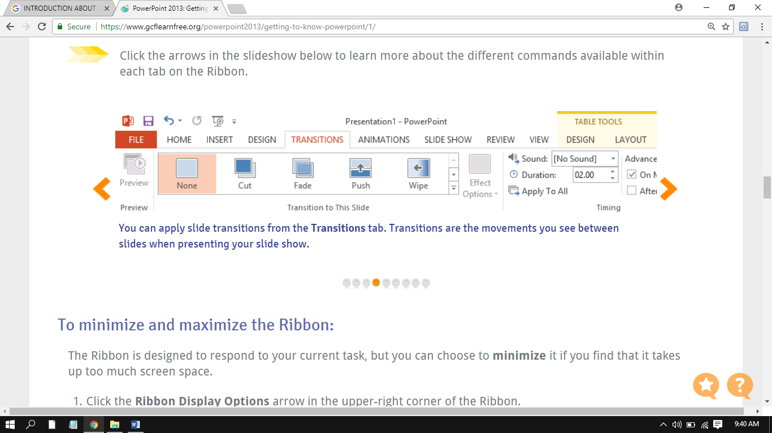

The ***Animations***tab allows animating text and objects and use to draw attention to specific content and make the slide easier to read.

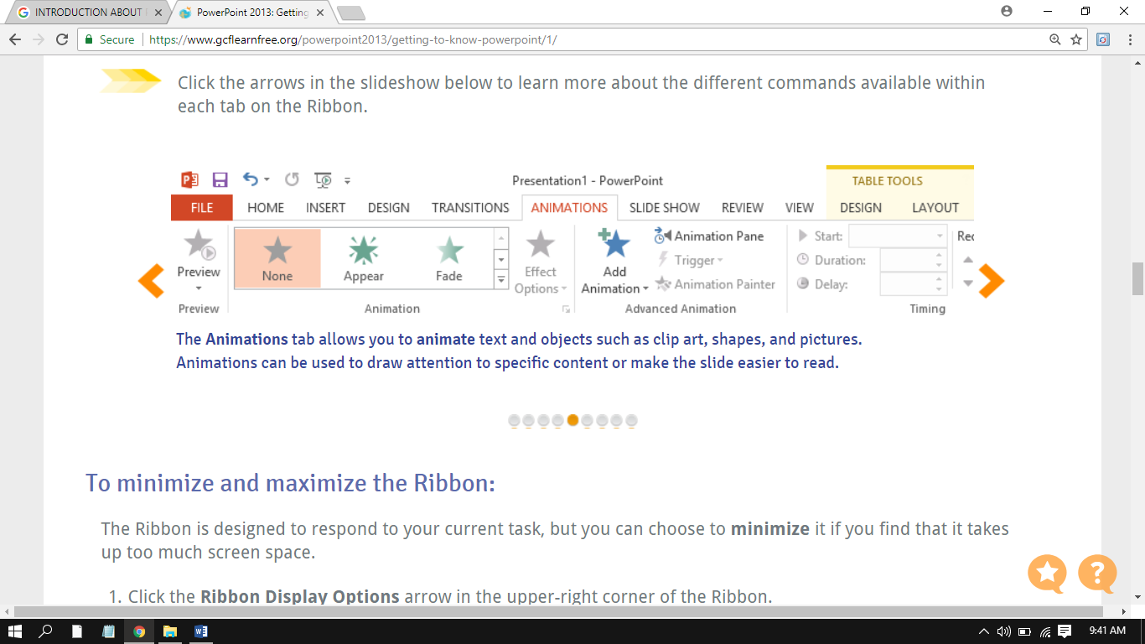

***Slide Show***tab provides tools in making presentation even and professional such as option to ***rehearse timings***and ***record narration***.

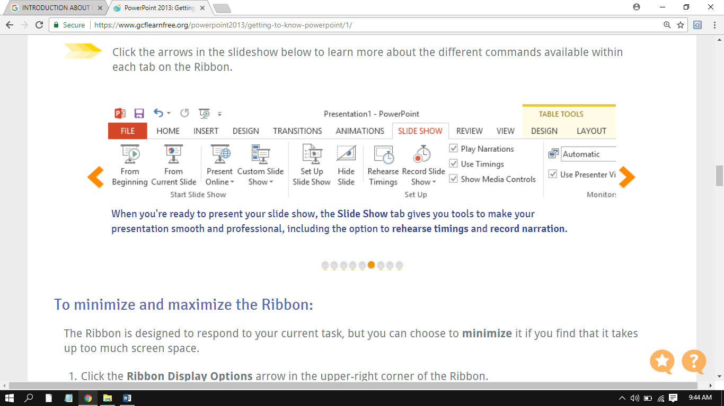

To access the PowerPoint powerful **editing features** such as ***spell check*** and ***comments*; and easy to review and collaborate presentations features, use the *Review* tab*.***

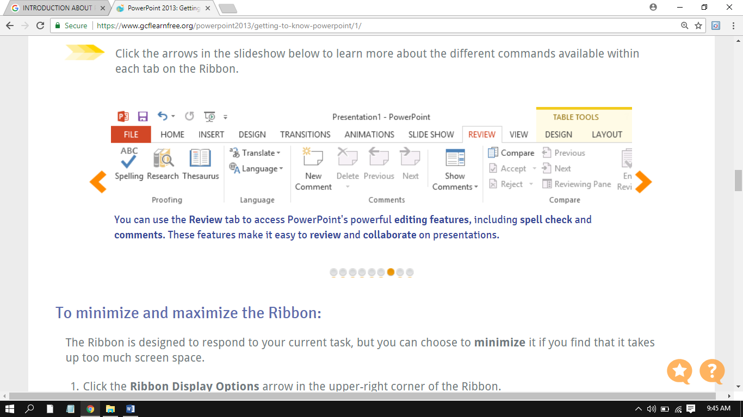

The ***View*** tab includes **Outline View, Slide Sorter**, and **Slide Master** which can help to **prepare** and to **organize** slide show and allows switching between different views for presentation.

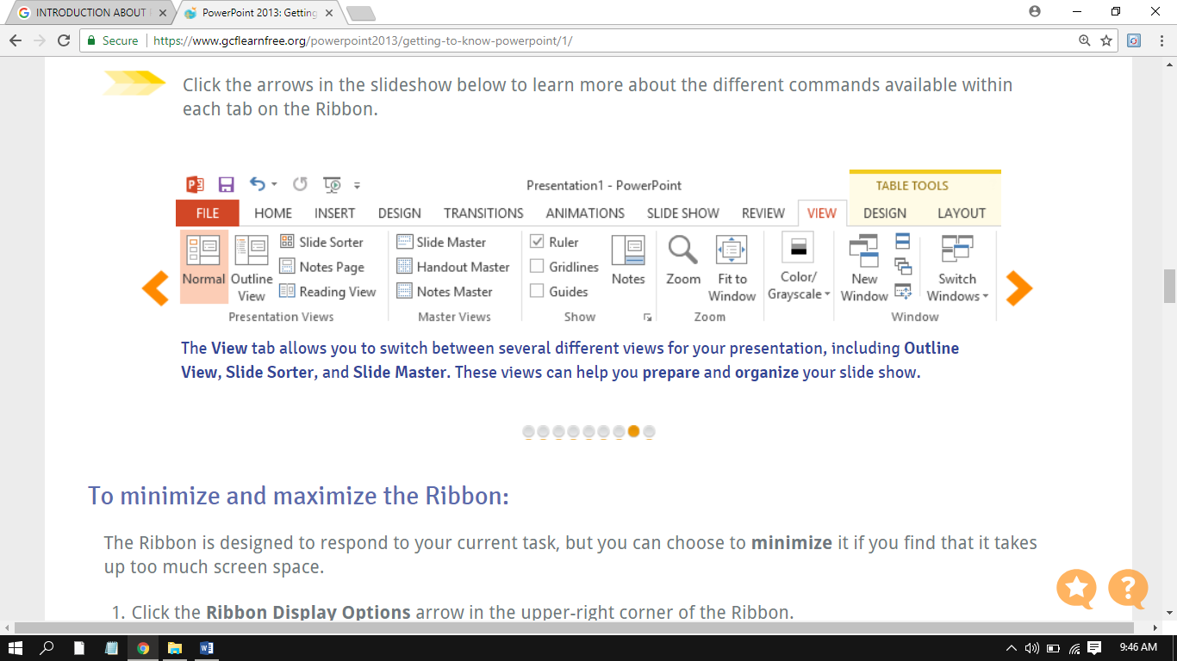

***Contextual*** tabs only appears on the Ribbon when working with **tables, shapes,** and **pictures.** These tabs comprise special command groups which help formatting selected items as needed.

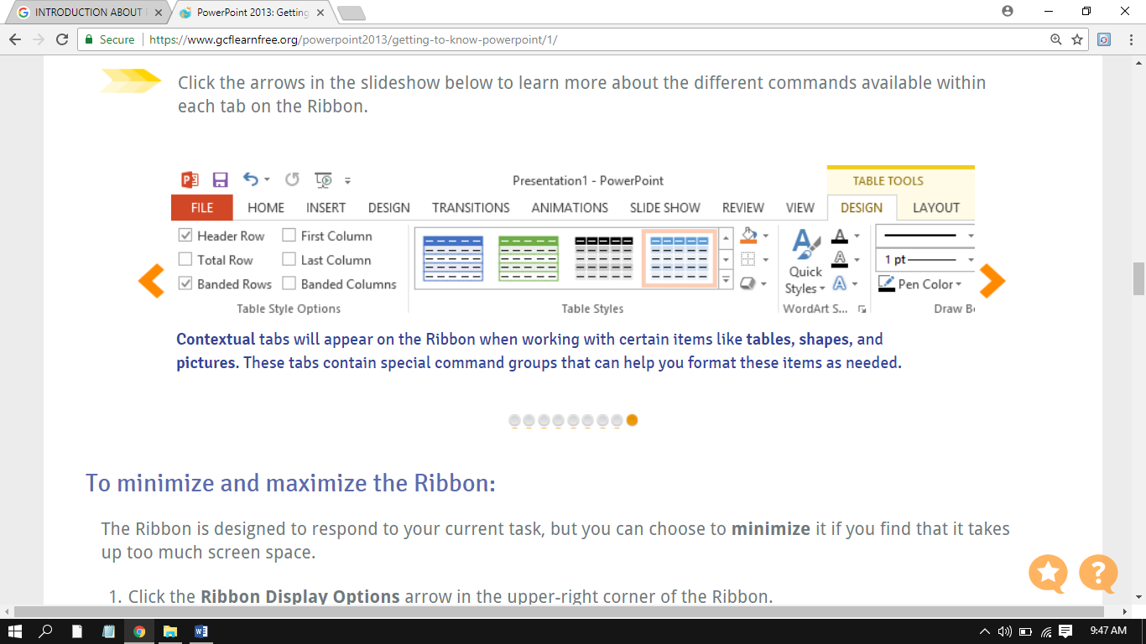

**2. QUICK ACCESS TOOLBAR (QAT)**

***Quick Access Toolbar*** contains common commands including the **Save, Undo, Repeat,** and **Start Presentation**commands. Add other commands depending on preference.

### 3. THE RULER, GUIDES, AND GRIDLINES

*R****uler, guides,*** and ***gridlines*** help in organizing and arranging content on slides**.** These tools make to **align objects**on slides easier. Just click the **check boxes**on the **Show**group of the ***View***tab to display and hide these tools.

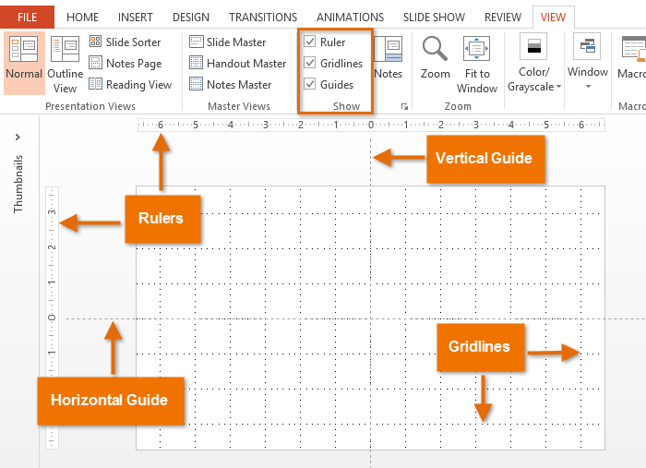

**4. MINI TOOLBAR**

*Mini toolbar*appears when the text is selected and hover the mouse cursor over the highlighted text or right clicked. The mini toolbar presents some of the most frequently used text editing functions which include as shown below:



*Font Type*

*Font Size*

*Increase Font Size*

*Decrease Font Size*

*Increase Indent*

*Decrease Indent*

*Format Painter*

*Text Highlight Color*

*Font Color*

*Center*

*Bold*

*Italic*

*Underline*

**5. SHORTCUT MENUS**

Right clicking an object activates the *shortcut menu***.**

**6. BACKSTAGE VIEW**

***Backstage view*** provides several options for saving, opening, printing, and sharing presentations.

## LEARNING COMPETENCIES

1. To describe Presentation Graphics using MS PowerPoint 2013
2. To provide overview of MS PowerPoint 2013 user interface

**ACTIVITIES**

### ACTIVITY 1

***Directions:*** Label the Parts of MS PowerPoint Screen 2013 and give its function when moving around the presentation.

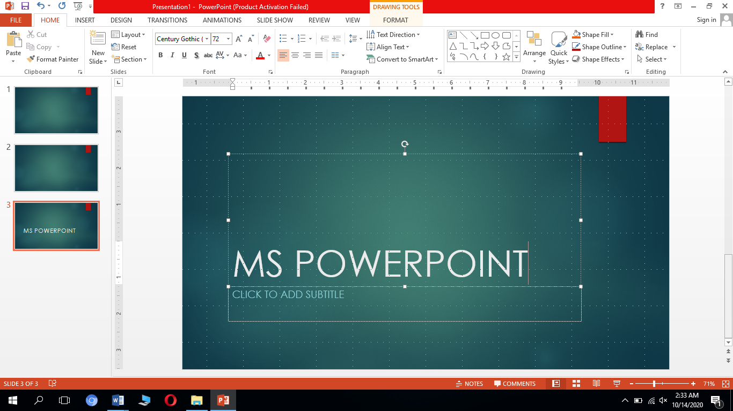

1.

2.

3.

4.

5.

6.

7.

8.

9.

10.

### ACTIVITY 2

***Directions:*** Decode the words by finding the corresponding letters for each number. Discover the hidden computer user interface on each item and write your answer on the space provided.

Decoding:

|  |  |  |  |  |  |  |  |  |  |  |  |  |  |
| --- | --- | --- | --- | --- | --- | --- | --- | --- | --- | --- | --- | --- | --- |
| **A** | **B** | **C** | **D** | **E** | **F** | **G** | **H** | **I** | **J** | **K** | **L** | **M** | **N** |
| 1 | 2 | 3 | 4 | 5 | 6 | 7 | 8 | 9 | 10 | 11 | 12 | 13 | 14 |
| **O** | **P** | **Q** | **R** | **S** | **T** | **U** | **V** | **W** | **X** | **Y** | **Z** |  |  |
| 15 | 16 | 17 | 18 | 19 | 20 | 21 | 22 | 23 | 24 | 25 | 26 |  |  |

### 1. 18 21 12 5 18 1 14 4 7 21 9 4 5 19

### 

2. 13 9 14 9 20 15 15 12 2 1 18

3. 19 8 15 18 20 3 21 20 13 5 14 21 19

4. 17 1 20

### 5. 18 9 2 2 15 14

6. 2 1 3 11 19 20 1 7 5 22 9 5 23

### ACTIVITY 3

***Directions****:* Identify the tab command groups being described in each number. Write your answer on the space provided for.

_________________1. It allows applying **themes** form which can quickly change the look of entire slide show including **slide layouts*.***

_________________2. It applies slide movements that can be seen between slides when presenting slide show.

_________________3. Use this to access the PowerPoint powerful **editing features** such as **spell check** and **comments.**

_________________4. Apply this to animate text and objects.

_________________5. It includes **Outline View, Slide Sorter**, and **Slide Master** which can help to **prepare** and to **organize** slide show and allows switching between different views for presentation.

_________________6. It gives access to the most regularly used commands including **copying and pasting, formatting,** and **New Slide**command.

_________________7. It lets inserting **pictures, charts, tables, shapes,** and **videos** that can help communicate information **visually**and add **style**to presentation.

_________________8. ***It*** provides tools in making presentation even and professional such as option **rehearsing timings**and **record narration**.

_________________9. **It** only appears on the Ribbon when working with **tables, shapes,** and **pictures.**

### ACTIVITY 4

***Instructions:***

1. Open a blank presentation and navigate to the PowerPoint 2013 **interface**.
2. Click through all of the **tabs**, and review the **commands** on the **Ribbon**.
3. Try **maximizing** and **minimizing** **options in** the **Ribbon**.
4. View the **Backstage view.**
5. Try to show the **Mini Toolbar** and **Shortcut Menus.**
6. Add a **command** to the **Quick Access toolbar**.
7. Hide and show the **Ruler, Grid and Gridlines**.
8. Close **PowerPoint** (you do not have to save the presentation).

## REFLECTION

Why it is necessary to get familiarize on the different features and user interface of Microsoft PowerPoint 2013?

_______________________________________________________________________________________________________________________________________________________________________________________________________________________________.

## REFERENCES

https://support.microsoft.com/en-us/office/powerpoint-for-windows-training-40e8c930-cb0b-40d8-82c4-bd53d3398787

https://edu.gcfglobal.org/en/powerpoint2013/

|  |  |
| --- | --- |
| Prepared by: | **LEILANI A. LEONCIO** |
|  | **MILDRED M. DUMLAO** |
|  | Name of Writers |
| Noted by: | **LABERNE A. LADIGNON, JR** |
|  | Division ICT Coordinator/ OIC EPS |

**KEY TO CORRECTIONS**

