**

**LEARNING ACTIVITY SHEET**

**SPECIAL PROGRAM IN ICT 7**

**OFFICE PRODUCTIVITY 7**

*Fourth Quarter, Week 10*

**Formatting your Picture in Publisher**

**BACKGROUND INFORMATION FOR LEARNERS**

In the previous learning activity sheet that we had, we have learned how to insert a picture and online picture or clipart in a publication.

Well, it does not stop there; we are going to learn how to enhance them by modifying their format.

In an existing picture/ image in the publication, select it by double left-clicking it. When you do that, an additional tab will appear, **Format.**

Under the *Format* tab, you will see seven (7) groups, namely:

* **Insert –** used when you want to insert a new picture/ image
* **Adjust –** used when you want to adjust the color, the brightness, and the contrast of the picture/ image. Also, you can change or delete your selected picture in this group. If you want to reset your picture, you can go here.
* **Swap –** used when you want to swap two pictures/ images in your publication.
* **Picture Styles –** used when you want to change the picture style, put a picture border, and apply picture effects to your image or image. Also, if you want to insert a caption to your picture, you may go here.
* **Arrange –** used when you want to arrange the position of your image in your publication.
* **Crop –** used when you want to remove unwanted areas in your image.
* **Size –** used when you want to modify the size of your image.

**LEARNING ACTIVITY SHEET**

**SPECIAL PROGRAM IN ICT 7**

**OFFICE PRODUCTIVITY 7**

*Fourth Quarter, Week 10*

Name of Learner: _____________________________ Date: __________________________

Grade Level /Section: __________________________

**LEARNING COMPETENCY**

This learning activity sheet will teach you how to create professional-looking publications and will help you demonstrate an understanding of sophisticated design considerations by formatting picture boarders, and cropping pictures.

**ACTIVITIES**

ACTIVITY 1

**Directions/Instructions:** Follow the instructions given in each number. Write your observation after each direction.

1. Insert an *Online Picture* of the Sun and Moon.
2. The size of the *Online Picture* of the Sun is 19.43 cm x 19.43 cm.
3. The size of the *Online Picture* of the Moon is 14.53 cm x 14.53 cm.
4. The Moon should be placed in the scratch.
5. The Sun should be placed in your canvass.
6. The brightness of the Moon should be 30% and 50% of the contrast.
7. Select the two images.
8. Click the *Swap* command.

Write your observations below:

_____________________________________________________________________________________________________________________________________________________________________________________________________________________

1. Select the *Online Picture* of the Sun.
2. Change the picture style of the Sun into “Bevel Oval, Black.”

Write your observations below:

_____________________________________________________________________________________________________________________________________________________________________________________________________________________

1. Select the *Online Picture* of the Moon.
2. Change the picture style of the Moon into “Metal Oval.”

Write your observations below:

_____________________________________________________________________________________________________________________________________________________________________________________________________________________

1. Crop the Sun until the background is removed.

Were you able to crop the picture based on its shape?

_____________________________________________________________________________________________________________________________________________________________________________________________________________________

1. Crop the Moon until the background is removed.

Were you able to crop the picture based on its shape?

_____________________________________________________________________________________________________________________________________________________________________________________________________________________

**REFLECTION**

1. Did you find the activity easy? Why or why not?

_____________________________________________________________________________________________________________________________________________________________________________________________________________________

1. What are the problems that you have encountered? Were you able to give solutions to them?

_____________________________________________________________________________________________________________________________________________________________________________________________________________________

**REFERENCES FOR LEARNERS**

For further learning, you may visit the link below:

* **Working with Pictures**

**Link:** https://bit.ly/3aQJbl9

Prepared by : **LEMUEL-KIM A. GARCIA**

Name of Writer

Noted: **LABERNE A. LADIGNON, JR**

Division ICT Coordinator/ OIC EPS

**Answer Key**

1. Ideal layout for number 1 – 6.

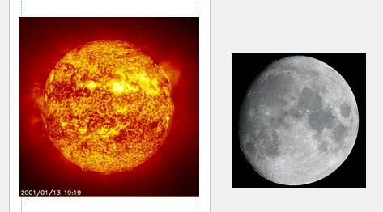

1. Ideal layout for number 7 – 8.

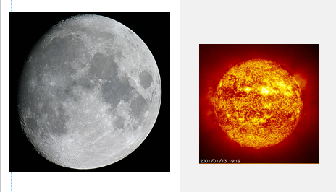

1. Ideal layout for number 9 – 12.

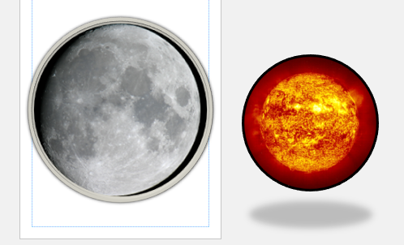

1. Ideal layout for number 13 -14.

