**

**LEARNING ACTIVITY SHEET**

**SPECIAL PROGRAM IN ICT 7**

**OFFICE PRODUCTIVITY 7**

*Fourth Quarter, Week 11*

**Positioning your Pictures Right 1**

**BACKGROUND INFORMATION FOR LEARNERS**

Layouting in MS Publisher is not always composed of one picture alone. We often put more objects to enhance our design. The question is, “What if your designs overlap with one another?”

In this learning activity sheet, you will learn how to arrange your picture and how to complement your text using the commands in the *Arrangement* group.

The *Arrangement* group is under the *Format* tab, which is seen when you double left-click your selected image in the publication. It has different commands:

* *Arrange thumbnails*
* *Wrap text*
* *Bring Forward*
* *Send Backward*
* *Rotate*

In this learning activity, we are going to focus on *Bring Forward, Send Backward* and *Rotate* commands.

**LEARNING ACTIVITY SHEET**

**SPECIAL PROGRAM IN ICT 7**

**OFFICE PRODUCTIVITY 7**

*Fourth Quarter, Week 11*

Name of Learner: _____________________________ Date: __________________________

Grade Level /Section: __________________________

**LEARNING COMPETENCY**

In this learning activity sheet, you will learn how to wrap text and arrange your images by rotating and flipping them.

**ACTIVITIES**

ACTIVITY 1

**Directions/Instructions:** Let us discover the functions of the commands under the *Arrange* group by following the instructions given in each number.

1. Insert the online picture of the Sun, Moon, and Jupiter (should be inserted based on the order of this sentence).
2. The arrangement of the pictures should be like the sample below:

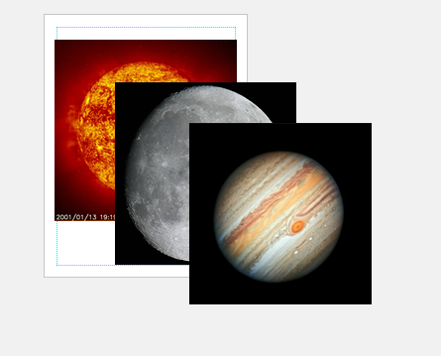

1. Double left-click the image of Jupiter. Then, the *Format* tab will appear.
2. On the *Format* tab, click *Send Backward*.

What happened to the image of Jupiter?

__________________________________________________________________________________________________________________________________________________

1. Double left-click the image of the Sun. Then, the *Format* tab will appear.
2. On the *Format* tab, click the drop-down (▼) symbol beside *Send Forward*.
3. Click *Bring to Front.*

What happened to the image of the Sun?

__________________________________________________________________________________________________________________________________________________

1. Double left-click the image of Jupiter. Then, the *Format* tab will appear.
2. On the *Format* tab, click *Send Forward*.

What happened to the image of Jupiter?

__________________________________________________________________________________________________________________________________________________

1. Create a new blank page.
2. Insert an online picture of a cartoon image of a boy/ girl.
3. Double left-click the image of a cartoon image of a boy/ girl. Then, a *Format* tab will appear.
4. On the *Format* tab, click *Rotate* .
5. Click *Rotate Right* 90o.

What happened to the picture? Where is the head of the cartoon image of a boy/ girl placed?

__________________________________________________________________________________________________________________________________________________

1. Double left-click the image of a cartoon image of a boy/ girl. Then, a *Format* tab will appear.
2. On the *Format* tab, click *Rotate* .
3. Click *Flip Horizontal*.

What happened to the picture? Where is the head of the cartoon image of a boy/ girl placed?

__________________________________________________________________________________________________________________________________________________

1. Select the image of the cartoon image of a boy/ girl. Then, focus on the head of the cartoon image of a boy/ girl. You will see a dot just like the image below:



1. Hold the dot using your left-click button in your mouse.
2. Try to move your mouse as you hold the dot.

What happened to the image?

____________________________________________________________________________________________________________________________________________________________________________________________________________

**REFLECTION**

Share your experience as you accomplish the activity. Also, share what you have learned

____________________________________________________________________________________________________________________________________________________________________________________________________________________________________________________________________________________________

**REFERENCES FOR LEARNERS**

For more learnings, you may visit the link below:

* **Working with Shapes and Objects**

**Link:** https://bit.ly/32ewigO

Prepared by : **LEMUEL-KIM A. GARCIA**

Name of Writer

Noted: **LABERNE A. LADIGNON, JR**

Division ICT Coordinator/ OIC EPS

**KEY TO CORRECTIONS**

4. The image of Jupiter had been moved in the back of the moon.

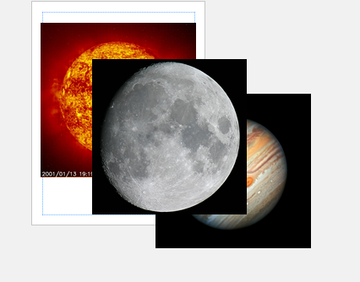

7. The image of the Sun had been placed into the front of the Moon and Jupiter

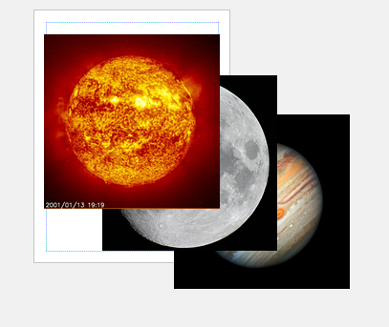

9. The image of Jupiter is now in between the image of the Sun and of the moon.

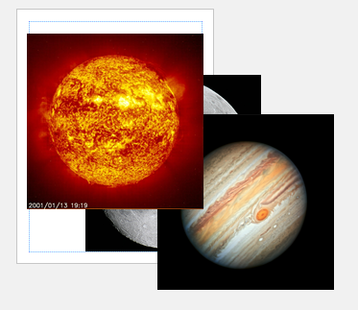

14. The image turned and the head of the cartoon boy/ girl is now found on the right part of the publication.

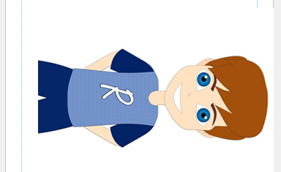

17. The head of the cartoon boy/ girl was placed on the left side of the platform.



20. The image rotates.

Prepared by

**lemuel – kim a. garcia**

Name of Writer

*Note: Practice Personal Hygiene Protocols at all times.*