**

**LEARNING ACTIVITY SHEET**

**SPECIAL PROGRAM IN ICT 7**

**OFFICE PRODUCTIVITY 7**

*Fourth Quarter, Week 2*

**MS Publisher: Menus and Toolbar**

**BACKGROUND INFORMATION FOR LEARNERS**

When you open Microsoft Publisher 2016, you are going to see the **Welcome Page,** where you can find different templates and the blank pages.

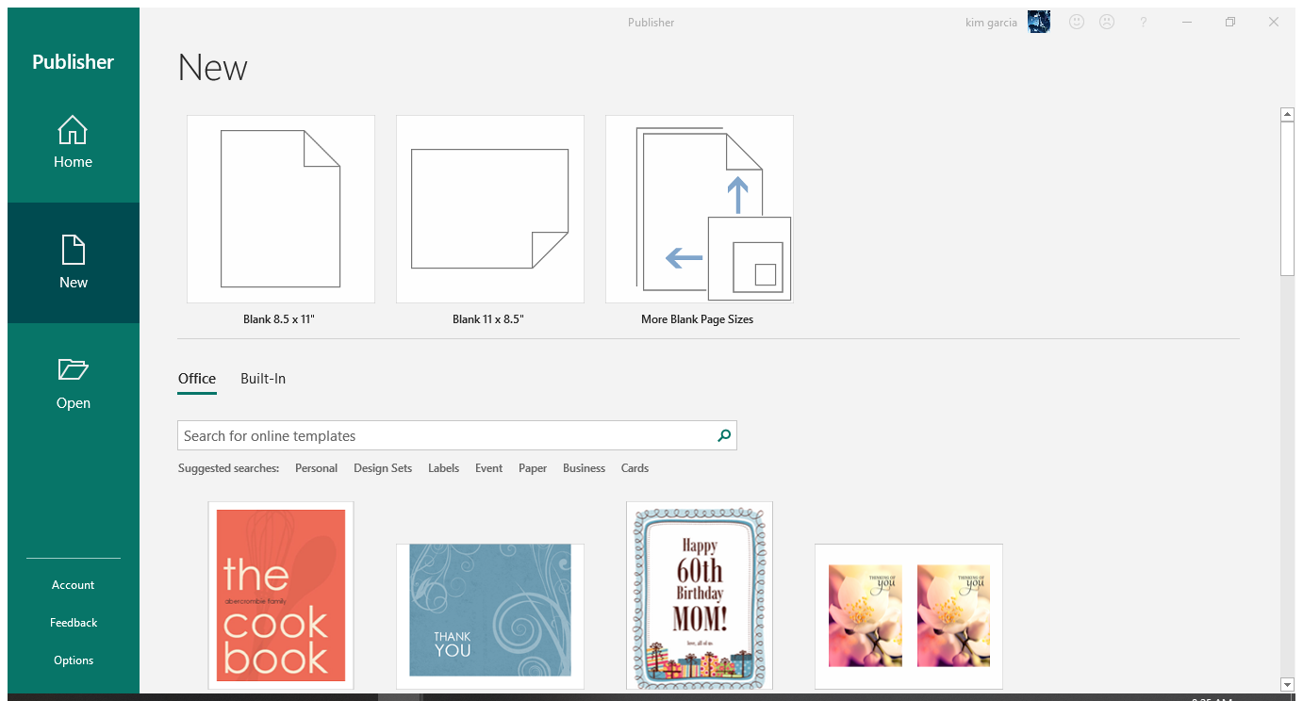

**TEMPLATES**

Image 1 – Welcome Page of MS Publisher 2016

Pages that do not have any layouts are called **blank pages.** In the Philippines, we usually use 8.5 x 11 inches (equivalent to a letter-size bond paper or known as “short” bond paper) and 8.5 x 11 inches (also known as “long” bond papers).

**User Interface** is the way how the menus are organized in MS Publisher 2016[1]. In the user interface, we have **The Ribbon, Access Toolbar,** **File Menu,** and other vital parts.

**The Ribbon –** runs along the top (after the *Title Bar*), where you can find MS Publisher tools. It is organized into three parts:

* **Tabs –** represent a general activity area.
* **Groups –** show tools that are related to one another.
* **Commands –** are specific buttons to perform a task.

**Quick Access Toolbar –** are the group of commands that we use often. One of the frequently used commands found in Quick Access Toolbar is “Save.”

**File Menu ­–** are the actions that concern about “what to do to the file?” It is the green button on the far left of the tabs.

**Other Key Parts of Publisher**

* **Title Bar –** it shows the name of your document. It is on the top-most bar of the program window. When you create a new file in publisher, its default name is “Publication1.”
* **Help Menu –** this contains help articles that would assist you in using the program.
* **Windows Display Options –** this is on the top-most-left part of the program window. It is where *minimize, restore,* and *close* buttons are found.

**LEARNING ACTIVITY SHEET**

**SPECIAL PROGRAM IN ICT 7**

**OFFICE PRODUCTIVITY 7**

*Fourth Quarter, Week 2*

Name of Learner: _____________________________ Date: __________________________

Grade Level /Section: __________________________

**LEARNING COMPETENCY WITH CODE**

In this learning activity sheet, you will be able to determine the different MS Publisher menus and Toolbars

**ACTIVITIES**

**ACTIVITY 1**

**Directions/Instructions:** Label the following parts of the User Interface of MS Publisher 2016. Write your answers on the box provided. Happy answering!

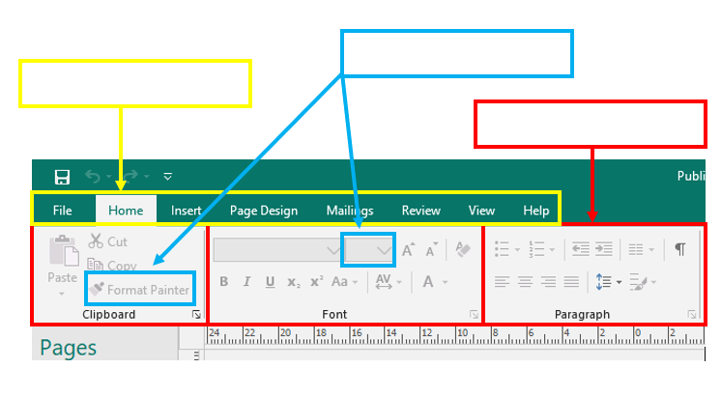

**ACTIVITY 2**

**Directions/Instructions:** Below is the user interface of MS Publisher. Using shapes, identify the icon of what is being asked in each number.

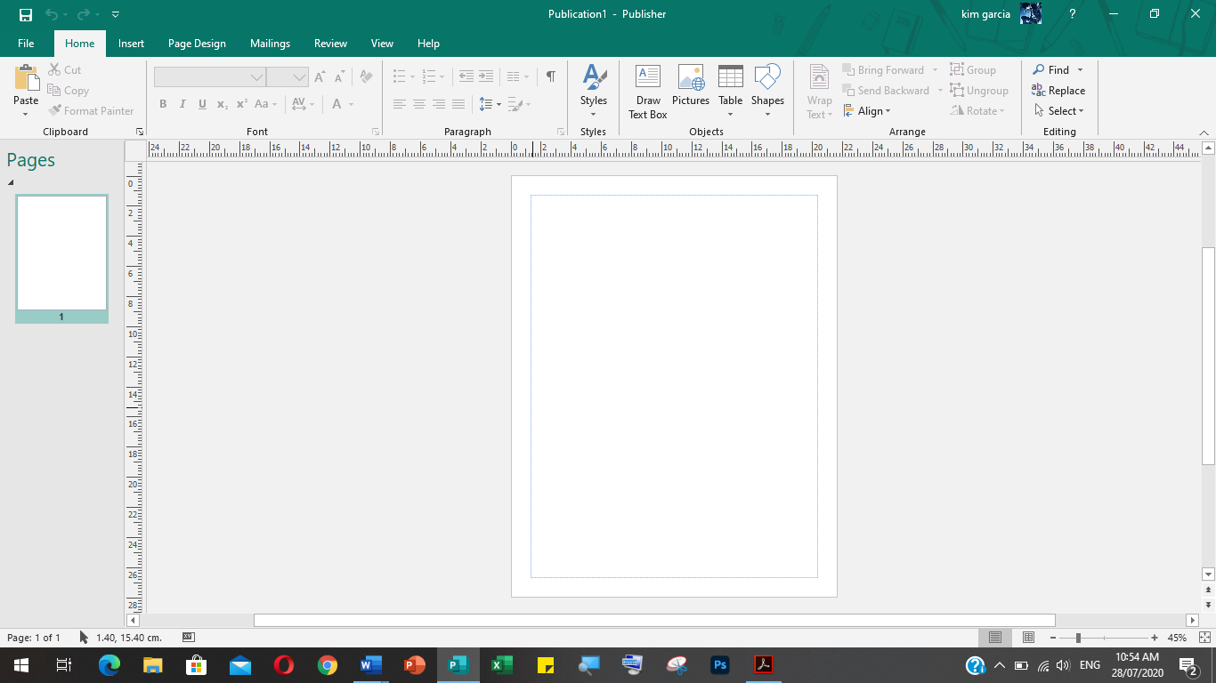

|  |  |
| --- | --- |
| **Key Parts of MS Publisher** | **Shape** |
| *Title Bar* |  |
| *Help Menu* |  |
| *Windows Display Option* |  |
| *File Menu* |  |
| *Quick Access Toolbar* |  |

**REFLECTION**

1. What are the key parts of MS Publisher that you think are very helpful to you?

______________________________________________________________________________________________________________________________________________

1. Aside from the “Save” button, which command do you think is the most commonly used in MS Publisher? Explain your answer.

______________________________________________________________________________________________________________________________________________

**REFERENCES FOR LEARNERS**

For further study, you may visit the following links:

* **Publisher 2016 – Tutorial for Beginners Part 1**

**Link:** https://bit.ly/2YlbTpg

* **Tech Tutor – One-on-One Help Computer Classes (Microsoft Publisher 2016)**

**Link:** https://bit.ly/2EcPrb3

1. kcls.org/techtutor/Microsoft Publisher Manual 2016