**

**LEARNING ACTIVITY SHEET**

**SPECIAL PROGRAM IN ICT 7**

**OFFICE PRODUCTIVITY 7**

*Fourth Quarter, Week 4*

**MS Publisher: Creating, Saving and Opening a Blank Publication**

**BACKGROUND INFORMATION FOR LEARNERS**

Before arriving in this learning activity sheet, you should be familiar with running your MS Publisher program. Also, in our previous lessons, the *Menus* and *Toolbars* were presented to you. Now, it is time for you to use them!

In our previous lesson, we have discussed running the MS Publisher in your computer program.

When you run your MS Publisher program, you are going to see the *Welcome Page*:

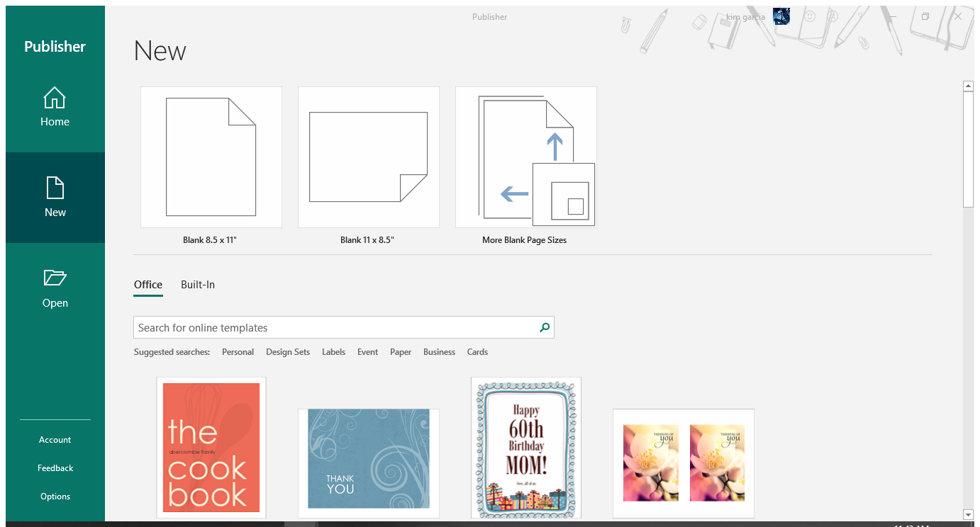

Image 1 - MS Publisher 2016 Welcome Page

In our welcome page, you will see the **blank pages** and **templates** (as discussed in our LAS no. 1).

Suppose you wish to create a new document without any pre-placed images or designs, select **blank pages.** If you want to create a new publication with pre-placed images or designs, select any of the **templates** found below the blank pages.

In this lesson, we are going to focus on creating, saving, and opening blank presentations.

**To create** a blank page, do the following steps below:

1. Run your MS Publisher.
2. Click on your desired blank page. In the *welcome page*, you will see two commonly blank pages and another option:
   1. **Blank 8.5 x 11 (Portrait – Short bond paper)**

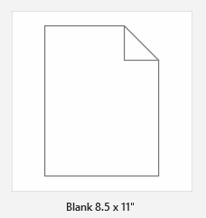

* 1. **Blank 11 x 8.5 (Landscape – Short bond paper)**

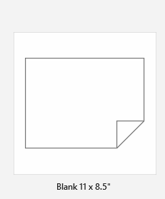

* 1. **More blank pages –** if you want to use blank pages other than the given above, you may click here.

1. When you click the desired blank page, you will proceed to the *Publisher Interface,* where you will see the *Ribbon, Quick Access Toolbar, File Menu,* and other organizational tools (which will be discussed later on the proceeding LAS).

**TO SAVE YOUR WORK,** you should do the following:

1. Click the *File* tab.
2. Click *Save As*. This is only clicked *when you want to save a NEW file.*

**Note:** *If you opened an existing Publisher file (as discussed in LAS no. 3), and you want to save changes from it, click Save.*

1. After clicking *Save As*, you will be asked where do you want to save your file. See to the image below.

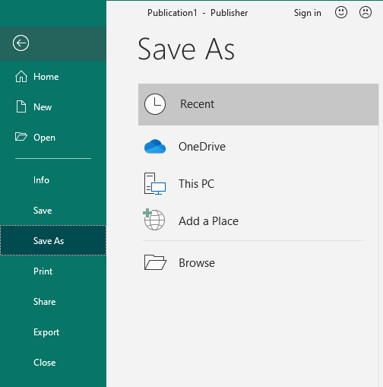

**Recent –** these are the folders where you recently saved your previous publications.

**One Drive –** is a Microsoft cloud drive or online storage where you can save your files[1].

**This PC –** enables you to save on your computer’s storage.

**Browse –** to navigate the place where do you want to save your folder.

Usually, we select *Browse* to save our files.

1. When you have chosen the destination where you want to save your files (which in our case, *Browse*), a dialog box will appear:

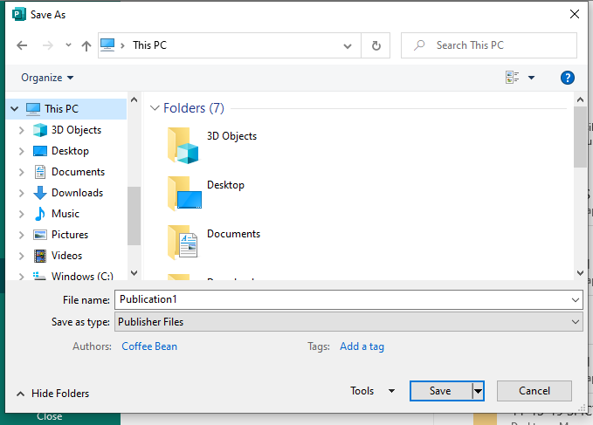

1. Select the location where you want to save your file and type the name of your document on the “File Name.”
2. Click *Save* to save your work.

**TO OPEN YOUR EXISTING PUBLISHER FILE,** do the steps below:

1. Find the desired MS Publisher File that you want to open. Remember the location where you saved your file.
2. Put the mouse arrow on the desired file and double-click the left button of your mouse.

***Tip:*** *If you want to learn more about opening an existing MS Publisher File, go back to LAS no.*

**REFERENCES FOR LEARNERS**

You may visit the link below to learn more about this lesson

* **A Quick Beginner’s Guide to Microsoft Publisher**

**Link:** https://bit.ly/3j0x1cb

**LEARNING ACTIVITY SHEET**

**SPECIAL PROGRAM IN ICT 7**

**OFFICE PRODUCTIVITY 7**

*Fourth Quarter, Week 4*

Name of Learner: _____________________________ Date: __________________________

Grade Level /Section: __________________________

**LEARNING COMPETENCY**

By the time that you have accomplished this learning activity sheet, you will be able to

* create, and save blank MS Publisher file; and
* open an existing MS Publisher file.

**ACTIVITIES**

**ACTIVITY 1**

**Directions/Instructions:** We are going to do the steps which were discussed at the beginning of this LAS. Be guided with instructions on the exercises and activities.

1. Create your own MS Publisher document.
2. The name of your file should be “My Publisher Example”
3. It should be saved in your Document folder.

**Guide Questions (if necessary)**

1. Share the steps that you did in creating your publication.

________________________________________________________________________________________________________________________________________

____________________________________________________________________

1. Try to open your saved publication. Did it open? If yes, how did you do it?

________________________________________________________________________________________________________________________________________

____________________________________________________________________

**REFLECTION**

1. Did you find the activity easy or difficult? Share your experience.

______________________________________________________________________________________________________________________________________________________________

1. Did you encounter any problem during the activity? What was that?

______________________________________________________________________________________________________________________________________________________________

1. <https://www.windowscentral.com/how-get-started-onedrive-windows-10>