**LEARNING ACTIVITY SHEET**

**SPECIAL PROGRAM IN ICT 7**

**OFFICE PRODUCTIVITY 7**

*Second Quarter, Week 5 & 6*

Name of Learner: _____________________________ Date: __________________________

Grade Level /Section: __________________________

# Working with Text

**BACKGROUND INFORMATION FOR LEARNERS**

The *Microsoft PowerPoint 2013* editing tools make editing a presentation as easy as 1-2-3. Editing includes working with text like entering, selecting, editing, replacing, cutting, copying and pasting; using undo and redo commands; finding and replacing text; and such as when changing a PowerPoint or phrase throughout the presentation.

**How to Add Text to Microsoft PowerPoint Slide**

Learn the basics of working with text through adding text to slides using placeholders, text boxes, and/or shapes.

***To add text using Placeholders***

1. Select the text placeholder or box.

2. Type the text in the placeholder.

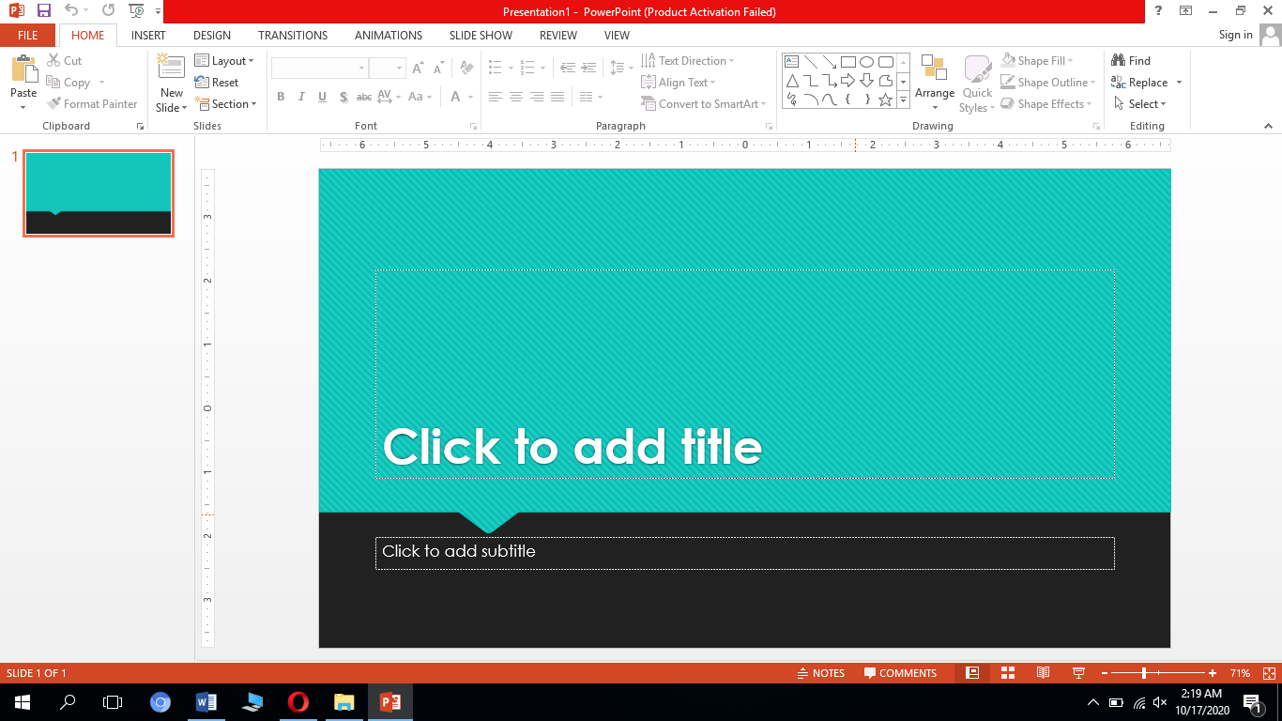

Click in the placeholder to add text

***To add text using Text box***

1. Click *Insert tab* >*Text Box* button from *Text group*.

2. Click and drag over the area in the slide where to insert the text box.

3. Type the text.

***To add text using Shape***

1. Click *Insert tab* >*Shapes* button from *Illustrations group*.
2. Click and drag over the area in the slide where to place the shape.
3. Type the text want to add to the selected shape.

### Editing Text

To see the most editing tools in PowerPoint, just take a look at the ribbon's Home tab. Before moving or arranging text, it must be ***selected***.

#### **To select text**

Click anywhere in the text, it ends up creating a text insertion cursor and whichever text to type will show up after the text insertion cursor. This does not select any text. To select text, the following are the options:

1. Highlight the text before or after the text insertion cursor by dragging in the direction you want.
2. Press Ctrl + A to select all the text.
3. Double-click anywhere in the text to select the entire word within which it has been double-clicked.
4. Triple-click anywhere in the text to select the entire sentence or bulleted list level within which it has been triple-clicked.

### *To copy and move text*

PowerPoint allows *copying* text that is previously on a slide and ***paste*** it into a different place to save time. If wish to ***move*** text, ***cut and paste*** or ***drag and drop*** the text.

#### **To copy and paste text**

1. Select the ***text***to copy> ***Home****tab* > click the ***Copy****command*.
2. Place the insertion point where to appear the text. Click ***Home****tab* > ***Paste****command*.
3. The copied text will appear.

#### **To cut and paste text**

1. Select the ***text***to move then click the ***Cut***command.
2. Place the insertion point where to appear the text then click the ***Paste*** command.
3. The text will appear in the new location.

Use the ***cut, copy***, and ***paste*** commands using keyboard shortcuts. ***Ctrl+X*** to cut, ***Ctrl+C*** to copy, and ***Ctrl+V*** to paste.

#### **To drag and drop text:**

1. Select the ***text*** to move then click and drag the text to the **desired location**.
2. The text will appear in the new location.

### USING FIND AND REPLACE

PowerPoint can search the presentation using the ***Find*** feature allowing to change the words or phrases quickly using the ***Replace*** feature.

#### **To find text**

1. ***Home****tab*>click ***Find****command*.
2. A dialog box will appear then enter the ***text***want to find in the ***Find what*:** field, then click ***Find Next***.
3. The text will be automatically selected if it is found.
4. Click ***Find Next*** to find additional occurrences. If not any is found, dialog box will appear. Click ***OK***.
5. When finished, click ***Close*** to exit the dialog box.

Access the Find command by pressing **Ctrl+F**.

#### **To replace text**

1. ***Home****tab*>click the ***Replace****command*.
2. Type the text want to find in the ***Find what*:** field.
3. Type the text want to replace it with in the ***Replace with***: field> click***Find Next***.
4. The text will be automatically selected if it is found.
5. If wanted to replace it, select one of the ***replace*** options. ***Replace*** will replace single occurrences, and ***Replace All*** will replace all occurrence.
6. The selected text will be ***replaced***.

**UNDO AND REDO CHANGES**

The *Undo* command undoes anything such as to move blocks, to format text, to create and delete text, and to format. Two ways to use the Undo command:

1. Press *CTRL+Z* or

2. *Quick Access Toolbar*> Click *Undo command button.*

If undoing something that did not meant to, using the *Redo*command it set things back to the way they are. Use also Redo command to restore the typing. The two picks are:

1. Press *CTRL+Y* or

2. *Quick Access Toolbar>* Click *Redo command button*.

## LEARNING COMPETENCIES

1. To enter and select text
2. To edit text

**ACTIVITIES**

### ACTIVITY 1

***Directions:*** Encircle diagonally, horizontally or vertically the activities in PowerPoint 2013 when working with text.

|  |  |  |  |  |  |  |  |  |  |  |  |
| --- | --- | --- | --- | --- | --- | --- | --- | --- | --- | --- | --- |
| E | T | B | S | T | L | O | P | D | D | O | R |
| Q | N | Y | E | Y | Z | Y | E | X | V | P | E |
| A | E | T | L | W | P | T | D | E | E | R | D |
| T | D | X | E | O | W | P | I | S | R | A | O |
| U | I | X | C | R | I | U | T | A | E | H | P |
| N | C | A | T | O | I | L | I | P | P | O | L |
| R | S | S | I | U | L | N | N | P | L | P | O |
| E | F | I | N | D | D | L | G | H | A | E | D |
| M | L | R | G | R | S | O | T | T | C | A | E |
| O | O | T | T | U | I | G | E | R | E | N | L |
| M | O | V | E | W | N | H | X | E | I | X | E |
| V | C | J | X | O | F | D | T | F | T | D | T |
| E | A | J | T | R | U | T | O | A | H | Y | E |

### ACTIVITY 2

***Directions:*** Modified True or False. Write **TRUE** if the underlined word/s is correct otherwise give the word/s that make the sentence correct. Write your answer on the space provided before the number.

______________1. Selecting text is less important to learn as basic in working with text.

______________2. Using text boxes is one of the options in deleting text in MS PowerPoint slide.

______________3. Pressing Ctrl + Z has the same effect with clicking Redo command button.

______________4. With PowerPoint, the user can exercise the “cut and paste” to move a paragraph, and the “copy and paste” to copy the block of text to a new location.

______________5. Press **Ctrl+F** to access the Find command.

### ACTIVITY 3

***Directions:***  Identify what activities/commands in PowerPoint should be done in each situation below. Write your answer on the space provided before the number

__________1. Tyron do typing and copying in his presentation when he suddenly press a key that did not meant to.

__________2. Anna is working with longer presentation. She wants to change quickly the words or phrases in her presentation and it can be difficult and time consuming for her to locate a specific word or phrase.

__________3. Shekinah is practicing to have multiple copies of text to different locations in her presentation.

__________4. You want to add some shapes with text in your presentation slides.

__________5. Mr. Dy is a businessman and he wants to share his business ideas and proposal to investors through slides and slide layouts.

### ACTIVITY 4

***Instructions:***Familiarize yourself with the following activities:

*a. To add text to slides using* ***placeholders, text boxes,*** *and* ***shapes***

*b. To* ***select text*** *using different options*

*c. To* ***copy-move, copy-paste, cut-paste,*** *and* ***drag-drop text***

*d. To* ***Find and Replace*** *text*

*e. To* ***delete*** *text*

*f. To* ***Undo*** *and* ***Redo*** *changes in presentation*

## REFLECTION

Why is it necessary to get acquainted to the different PowerPoint tasks such as working with text and editing text?

_______________________________________________________________________________________________________________________________________________________________________________________________________________________________.

## REFERENCES

https://support.microsoft.com/en-us/office/powerpoint-for-windows-training-40e8c930-cb0b-40d8-82c4-bd53d3398787

https://edu.gcfglobal.org/en/powerpoint2013/

|  |  |
| --- | --- |
| Prepared by: | **LEILANI A. LEONCIO** |
|  | **MILDRED M. DUMLAO** |
|  | Name of Writers |
| Noted by: | **LABERNE A. LADIGNON, JR** |
|  | Division ICT Coordinator/ OIC EPS |

**KEY TO CORRECTIONS**

### 

