**

**LEARNING ACTIVITY SHEET**

**SPECIAL PROGRAM IN ICT 7**

**OFFICE PRODUCTIVITY 7**

*Fourth Quarter, Week 6*

**Importing and Editing Texts**

**BACKGROUND INFORMATION FOR LEARNERS**

Our publication usually has a text. We use it to inform or persuade other people depending on the purpose of our publication document.

In MS Publisher, we can insert texts in several ways. Here are some tips:

**By Inserting a Text Box**

1. Go to the *Insert* tab.
2. Click *Draw Text Box*.
3. Click where you want to put your textbox in the canvass. A box will appear after doing this.
4. Inside the box, you can then type the letters or words that you desire.

**By Inserting a Word Art**

1. Go to the *Insert* tab.
2. Click *Word Art*.
3. Select the design that you want by left-clicking it. A dialog box will appear after doing this.
4. In the dialog box, you can put the letters or words that you want.
5. Then, click left-click Enter.

In editing our text, there are functions that you should know. They are found on the Home tab under the Font group:

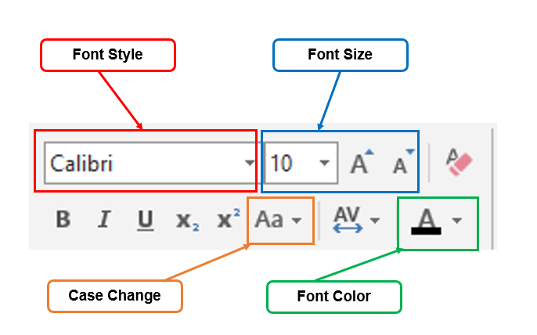

1. **Font style –** this is where you can change the style of your font.
2. **Font size –** this changes the size of your font.
3. **Font Color –** this changes the color of your font.
4. **Case Change –** this is where you can change the font’s case. It may vary depending on what you want. They are as follow:

* *Sentence case*
* *lowercase*
* *UPPERCASE*
* ***C****apital* ***E****ach* ***W****ord*
* *tOGGLE cASE*

Also, if you want to copy from an external source such as website, other document and the like, you will need to use the *Copy, Cut* and *Paste* functions.

1. **Copy –** this is used when you want to duplicate a text from a source. It is done selecting your source and pressing Ctrl + C.

Illustration 1-Process of Copying

1. **Cut –** this is used when you move the source to your desired document. It is done by selecting your source and pressing Ctrl + X.

Illustration 2 – Process of Cutting

1. **Paste –** this is used when you want to transfer your copied/ cut source to your desired document.

**LEARNING ACTIVITY SHEET**

**SPECIAL PROGRAM IN ICT 7**

**OFFICE PRODUCTIVITY 7**

*Fourth Quarter, Week 6*

Name of Learner: _____________________________ Date: __________________________

Grade Level /Section: __________________________

**LEARNING COMPETENCY**

This learning activity sheet will teach you how to import/ edit and correct design errors. Specifically, the following skills will be taught to you to do that:

* + Importing texts
  + Editing text content
  + Correct text and design errors
  + Copying, cutting and pasting

**ACTIVITIES**

**ACTIVITY 1**

**Directions/Instructions:** Follow the instructions found in each number. Accomplish the task and submit it to your teacher.

1. Create a new publication.
2. Find the “History of Computers” on the internet.
3. Copy the text to your publication.
4. The font size should be 12.
5. The font style should be Arial.
6. The title of your publication should be “History of Computers”.
7. Your title should be uppercase found at the center of the document.
8. On the bottom part of your publication, indicate the URL or source where you get the history of computers.
9. The source’s size should be 9.
10. Its font style is Arial Black.
11. Its font color should be blue.
12. Save your work and name *it [Insert your Name]_My CCP Exercise* *(Example: Juan Dela Cruz_ My CCP Exercise)*

You can submit your work in two ways:

* Submit it to your teacher’s social media account (like Facebook Messenger) or e-mail.
* Print your work and wait until your teacher collects it. But remember, face-to-face submission is not allowed. Wait for the announcement of your teacher on how would you submit your printed work.

**Rubric for Scoring (if necessary)**

|  |  |  |  |
| --- | --- | --- | --- |
| **Score** | **3** | **2** | **1** |
| **Criteria** |  |  |  |
| ***Accuracy*** | The publication was perfectly done based on the instructions given in the activity. | The publication was done, but there are some instructions which were missed—committed 1 – 2 errors. | There are 3 or more instructions which were missed in the publication. |
| ***Layout Design*** | The design of the publication was based on the instruction given in the activity. Also, the copied source was arranged correctly. | The design of the publication was based on the instruction given in the activity. However, the source was not arranged perfectly. There are some layout faults/ errors present in the publication. | The design of the publication was somehow based on the instruction given in the activity. However, it was purely copied. No arrangement was done. |
| ***Font Design*** | The style and color of the font were based on the instructions of the activity. | One (1) error was committed in following the direction in the layout of the font. | Two (2) or more errors were committed in following the direction in the layout of the font. |
| ***Total Score*** | | |  |

**REFLECTION**

1. How was your experience in doing the activity?

_____________________________________________________________________________________________________________________________________________________________________________________________________________________

1. Did you find it difficult or easy? Share you experience.

_____________________________________________________________________________________________________________________________________________________________________________________________________________________

**REFERENCES FOR LEARNERS**

For further readings, you may visit the link below:

* **Word Art Tools**

**Link:** https://bit.ly/32fupAD

Prepared by : **LEMUEL-KIM A. GARCIA**

Name of Writer

Noted: **LABERNE A. LADIGNON, JR**

Division ICT Coordinator/ OIC EPS