**LEARNING ACTIVITY SHEET**

**SPECIAL PROGRAM IN ICT 7**

**OFFICE PRODUCTIVITY 7**

*Second Quarter, Week 7 - 9*

Name of Learner: _____________________________ Date: __________________________

Grade Level /Section: __________________________

# Formatting Text

**BACKGROUND INFORMATION FOR LEARNERS**

***Formatted text*** can draw audience's attention to specific parts of a presentation and emphasize important information. In PowerPoint, there are several options for adjusting the text, including ***size***and ***color***; and also to adjust the ***alignment***of the text to change how it is displayed on the slide.

**Changing Fonts in PowerPoint 2013 Windows**

Explore how to replace font in the entire presentation applying the following steps:

***To change the font on single slide***

1. Do one of the following:
   * Select the text to change.
   * To change all font in a placeholder, either select all the text in the placeholder or click the placeholder.
2. *Home* tab> *Font* group>select a font in the *Font* list.

***To change the font style throughout the presentation***

1. *View* tab> *Master Views* group>click *Slide Master*.
2. Click slide master thumbnail or layout that contains the font to change.
3. On the slide master or layout, click the title text or the level of body text that want to apply a new font style to.
4. *Slide Master*Tab> *Background*group> *Fonts*> select a font from the list.
5. Repeat steps 1 through 4 for any other fonts that want to change. To return to editing slides, on the *Slide Master* tab> *Close* group>click *Close Master View*.

To use the *Replace Font* option to change a font throughout the presentation:

1. *Home* tab >*Editing* group>*Replace* > select *Replace Fonts*.
2. *Replace Font*dialog box> *Replace* field>select the font want to replace.
3. *With* field>select the font want to use> *Replace*>select *Close*.

***To change the font size***

Whether text is hard to read or simply want to draw attention to it, making part of the text bigger than the surrounding text can be done.

These are the options in changing the font size.

1. Select the text to change>*Home* tab>Font group> *Font Size drop-down list*.

2. Click in the *Font Size box* and type the size want to use.

3. Use the *Increase Font Size or Decrease Font Size buttons*.

4. Press *Ctrl + Shift + >* (to increase the font) or Ctrl + Shift + < (to decrease the font)

***To change color of text on slide***

1. Select the text to change.

2. *Home* tab>*Font Color*> Select the color to change the color of the text.

3. A drop-down menu appears to show different colors. Hover the mouse and select the desired ***color***.

4. The color applied to text.

***To add or modify font effects***

1. Select a text box or certain text inside the text box. The ***Format*** appears.
2. ***Format*** tab >click ***Text Effects*** command in the ***WordArt Styles*** group.

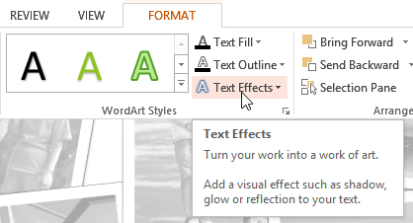

1. A drop-down menu appears that show effect categories. Hover the mouse over effect category and select the desired ***effect*** from the menu.
2. The effect applied to text. If needed, combine several different effects.

**Changing Alignment, Line Spacing, and Indentation**

Text is an important element in PowerPoint slides. Sometimes, text alignment is being taken care of by default set in presentation template.

To make the text on slides easier to read, changing the spacing between lines of text and between paragraphs is applied as well as adjusting the alignment and indentation of lines of text.

Follow these steps to align text:

1. Select the text or the entire text that want to change the alignment.
2. *Home* tab> *Paragraph* group>locate the four *text alignment icons*.

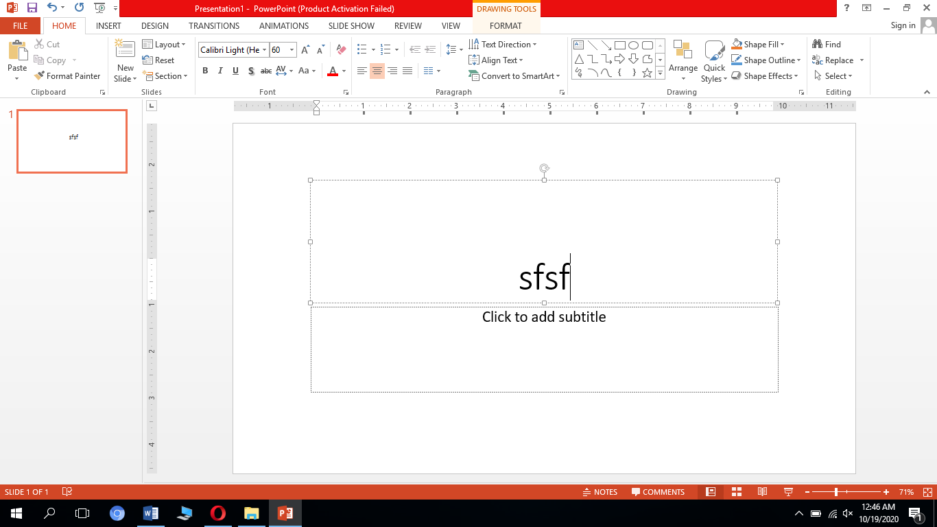

**LINE SPACING**

To improve readability or to fit more lines on a slide, just adjust the line spacing.

***To format line spacing***

1. Select the text to format.
2. *Home* tab>locate the *Paragraph group*> *Line Spacing* command.
3. Select the desired line spacing from the menu that will appear.

To have more precise line spacing, follow the following steps

1. Select *Line Spacing Options* from the drop-down menu.
2. The *Paragraph dialog box* will open.
3. To change the spacing above or below a paragraph, type or click the arrows next to *Before* or *After*. The number can be whole number or a decimal.
4. To change the spacing above and within a paragraph, use the Line Spacing options: single, 1.5 lines, or double.

***To indent text***

Indentation is used in creating multilevel lists or to visually set paragraphs at a distance from one another. Indenting text helps in formatting the layout so it will appear on slide more organized.

1. *To indent using the Tab key*: Place the insertion point at the very beginning of the line to indent> press the Tab key.
2. *To indent using the Indent commands*: Place the insertion point at the very beginning of the line to indent. *Home* tab> *Increase Indent or Decrease Indent* command.
3. *To decrease an indent*: select the line> press Shift+Tab.

**INDENT MARKERS**

Indent markers are located to the left of the horizontal ruler providing a number of indenting options:

First-line indent markerBar Tab Icon: Adjusted the first line of the paragraph

Hanging indent markerBar Tab Icon: Except for the first line, it adjusted every line of the paragraph

Left indent markerBar Tab Icon: Moved both the first-line indent and hanging indent markers

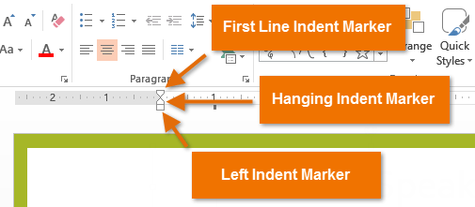

***To indent using the indent markers***

1. Place the insertion point in the paragraph where to indent one or more paragraphs.
2. Click, hold, and drag the mouse into the desired indent.
3. Release the mouse.

### Creating Bulleted and Numbered Lists and Multiple Columns

### Creating effective PowerPoint presentation is essential to make the slides **easy to read by the audience**. One of the best common techniques of doing this is through using **bulleted or numbered list**.

#### **To modify the bullet style**

1. Select the existing list to format. ***Home*** tab>click the ***Bullets*** drop-down arrow.
2. Select the desired ***bullet style.***
3. The bullet style appeared in the list.

#### **To modify a numbered list**

1. Select an existing list to format. ***Home***tab>click the ***Numbering*** drop-down arrow.
2. Select the desired ***numbering option***from the menu that appears.
3. The numbering option will appear in the list.

#### **To change the starting number**

By default, numbered list starts count from number one. However, it can be changed counting from a different number as a continuation from a previous slide.

1. Select an existing numbered list. ***Home*** tab>click the ***Numbering*** drop-down arrow.
2. Select ***Bullets and Numbering***from the menu that appears>Dialog box appears> ***Start At*** field>enter the desired starting number.
3. The list numbering will change.

# Formatting Text into Columns

To convert text into columns, follow these steps:

1. Select the text box.

2. *Home* tab>*Paragraph group*>select *Add or Remove Columns*.

3. Drop-down list>select One Column, Two Columns, Three Columns, or More Columns.

# Copying Text Formatting

There are two ways to quickly copy text formatting and paste it in Microsoft PowerPoint.

## *Using the Format Painter*

#### Highlight the text or select the shape.

#### Home tab>Clipboard group>Format Painter.

#### Click Format Painter to apply the copied formatting once and Double-click Format Painter to apply the formatting to multiple objects. The cursor changes to a paintbrush symbol.

#### Drag the tool across the text to format.

#### Press Esc or click Format Painter to close the Format Painter.

## *Copying Text and Its Formatting*

#### Highlight the text to copy>Press Ctrl + C.

#### Place the cursor where the text to appear.

#### Home tab > click the Arrow beneath the Paste icon.

#### Select Keep Source Formatting.

# Clearing all Text Formatting

*Home* tab>*Font* group>click *Clear All Formatting*.

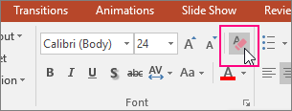

## LEARNING COMPETENCIES

1. To change the font, font size, and color of the text
2. To align text
3. To create bulleted and numbered list, multiple columns, and text formatting

**ACTIVITIES**

### ACTIVITY 1

***Directions:*** Rearrange the following procedures in their proper order. Use numbers to indicate their order of precedence.

**A. To change the font throughout the presentation**

_____Click slide master thumbnail or layout that contains the font to change.

_____Repeat steps 1 through 4 for any other fonts that want to change.

_____On the slide master or layout, click the title text or the level of body text that want to apply a new font style to.

_____From the View tab> Master Views group>click Slide Master.

_____To return to editing slides, on the Slide Master tab> Close group>click Close Master View.

_____Slide Master tab> Background group> Fonts> select a font from the list.

**B. To add or modify font effects**

_____A drop-down menu appears that show effect categories.

_____Select a text box or select some text inside of the text box.

_____From the **Format** tab >click **Text Effects** command in the **WordArt Styles** group.

_____The **Format** appears.

_____The effect applied to text.

_____Hover the mouse over effect category and select the desired **effect** from the menu.

**C. To format line spacing**

_____Select the text to format.

_____Select the desired line spacing from the menu that appears.

_____From Home tab>locate the Paragraph group> Line Spacing command.

**D. To indent using the indent markers**

_____Click, hold, and drag the desired indent marker.

_____Place the insertion point in the paragraph where to indent or select one or more paragraphs.

_____Release the mouse to indent the paragraph.

#### **E. To modify a numbered list**

_____Select the desired **numbering option**from the menu that appears.

_____**Home**tab>click the **Numbering** drop-down arrow.

_____The numbering option will appear in the list.

_____Select an existing list to format.

# F. Formatting Text into Columns

_____Drop-down list>select One Column, Two Columns, Three Columns, or More Columns.

_____Select the text box.

_____From Home tab>Paragraph group>select Add or Remove Columns.

### ACTIVITY 2

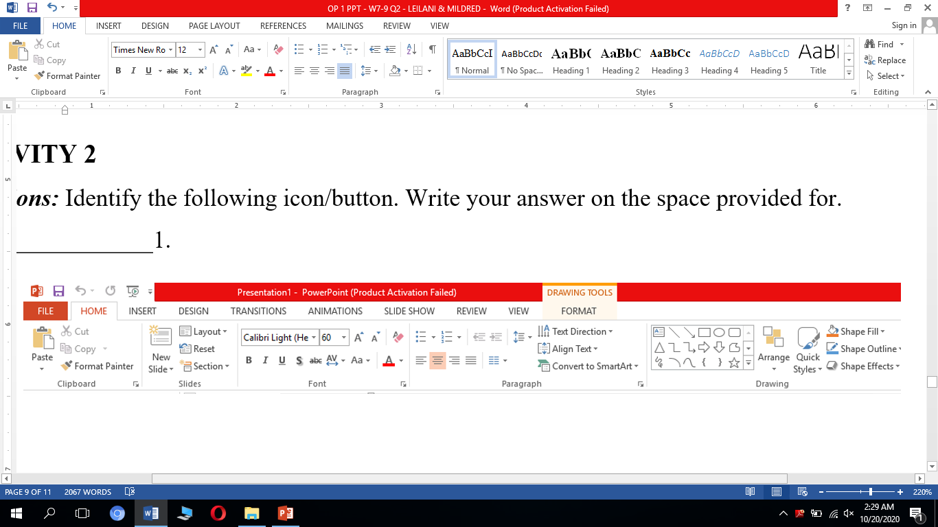***Directions:*** Identify the following icon/button. Write your answer on the space provided for.

____________________1. ____________________6.





____________________2. ____________________7.



____________________3. ____________________8.



____________________4. ____________________9.



____________________5. ____________________10.

### ACTIVITY 3

***Instructions:***Familiarize yourself in the following activities:

*a. To change the* ***typeface, font size****, and* ***font color*** *of text*

*b. To apply* ***font styles*** *and* ***effects*** *in text or paragraph*

*c. To change the* ***alignment, line spacing****, and* ***indentation*** *of paragraph*

*d. To create* ***bulleted*** *and* ***numbered lists****, and* ***multiple columns***

*e. To* ***copy*** *and* ***clear text formatting***

## REFLECTION

How are formatting text, aligning text, creating bullets and numbers, and copy and clear text formatting help to enhance one’s presentation?

_______________________________________________________________________________________________________________________________________________________________________________________________________________________________.

## REFERENCES

https://support.microsoft.com/en-us/office/powerpoint-for-windows-training-40e8c930-cb0b-40d8-82c4-bd53d3398787

https://www.indezine.com/products/powerpoint/learn/textandfonts/2013/text-alignment.html

https://www.webucator.com/how-to/how-format-text-into-columns-microsoft-powerpoint.cfm

https://books.google.com.ph/books?id=rMY2MHA5xSwC&pg=PT282&lpg=PT282&dq=creating+multiple+columns+in+powerpoint+2013&source=bl&ots=4c0bI8qyZ5&sig=ACfU3U10_WbbxPYS0v-yzwEq8t_SebHrVQ&hl=en&sa=X&ved=2ahUKEwiF_svQl8DsAhWNEqYKHZqfC6QQ6AEwHnoECAoQAg#v=onepage&q=creating%20multiple%20columns%20in%20powerpoint%202013&f=false

https://smallbusiness.chron.com/copy-text-formatting-powerpoint-40250.html

|  |  |
| --- | --- |
| Prepared by: | **LEILANI A. LEONCIO** |
|  | **MILDRED M. DUMLAO** |
|  | Name of Writers |
| Noted by: | **LABERNE A. LADIGNON, JR** |
|  | Division ICT Coordinator/ OIC EPS |

**KEY TO CORRECTIONS**

