**

**LEARNING ACTIVITY SHEET**

**SPECIAL PROGRAM IN ICT 7**

**OFFICE PRODUCTIVITY 7**

*Third Quarter, Week 10*

**setup, previewand print worksheet**

**BACKGROUND INFORMATION FOR LEARNERS**

When doing some work like databased task using Excel software, we often need to have a hard copy eof it to either distribute or file it for record. In such cases, we need to set up the excel worksheets to make sure that we will print it properly the way we want it to be printed. Having knowledge to setup the page, familiarizing the use of print preview and printing worksheet is something we all need to learn in this lesson.

**Page Setup**

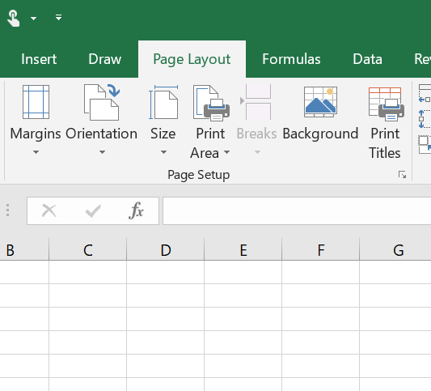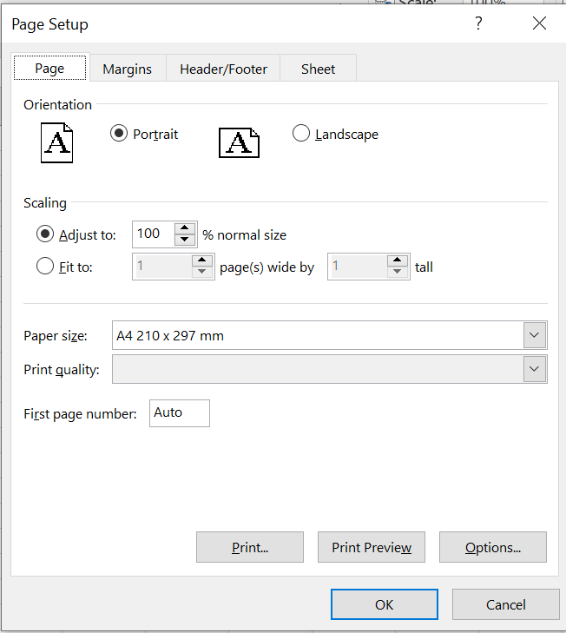

1. To locate the page setup, click the Page layout on the menu bar then click this arrow at the corner
2. Page setup window will appear. As you can see, it has for tab namely: Page, Margins, Header/Footer and Sheet.

**Parts of Page Tab**

**Orientation** – you can change the orientation of the sheet either Landscape or Portrait.

**Scaling**- you can adjust the scale of the content you want to print. You can adjust manually by typing

the percentage of the normal size or choose fit to your prefer page size. Be careful in adjusting

the scale because the output might be too small or cut to fit two pages.

**Paper size**- you may choose the size of paper where you want to print the worksheet

**Print quality**- the quality of printed output you prefer. It may be draft, standard, or high quality.

**First Page Number**- set up what page should print first.

**Margin Tab**

* Setting margins from top, left, right, bottom, header and footer of the page.
* You can also adjust either the worksheet will center horizontally or vertically.

**Header/Footer Tab**

You may choose or customize the header and footer of your worksheet. It will show on every page of the printed worksheet.

**Sheet Tab**

**Print Area**- select the specific area you want to print

**Print Title**- Aside from the header, you can set if you want the title of the worksheet will be printed in

all pages of worksheet.

**Print**- check or uncheck if you want to show the gridlines, make the printed output black and white,

printed output in draft quality or show row and columns headings.

**Print order**- setup the order of pages.

**At the bottom of Page Setup Window:**

**Print**- will automatically go to print window

**Print preview**- depending on MS Excel version, it will show the actual print output of the worksheet.

**Options**- will show the printer set up.

**Print Preview**

You can locate the Print Preview by clicking File at the menu bar then click Print.

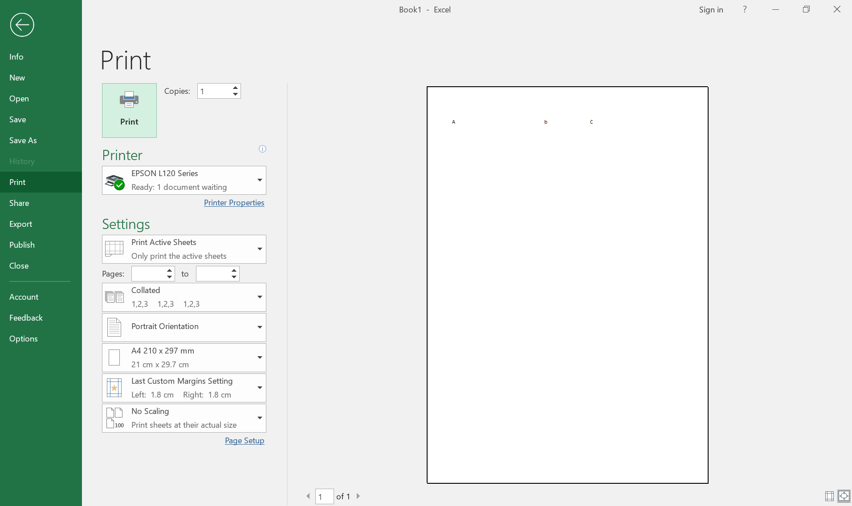

**Parts of Print Preview**

**Print Button**- by clicking this button, it will proceed to printing the worksheet.

**Copies**- number of copies to be printed

**Printer button**- choose the available printer where you will print the worksheet. Under the Printer

options, you may click the link to Printer Properties if you want to change the paper or printer quality.

**Settings**:

* Print Active Sheets- only print the whole sheet you currently working.
* Print Entire Workbook- print all sheets on the workbook
* Print Selection- print only the selected or highlighted part of the sheet

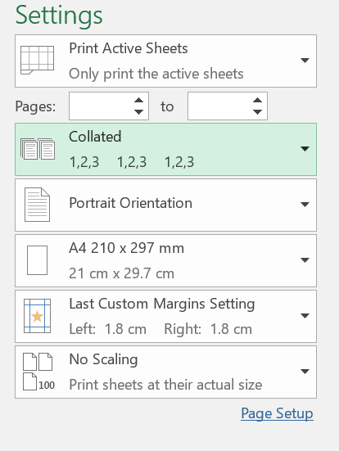

Customize the page/s to be printed

Collated- print copies of multiple sheets in order

Uncollated- print copies of multiple sheets separately and not in order

Select either Landscape or Portrait Orientation

Select paper size

Change paper margins

Adjust the size of the sheet.

**LEARNING ACTIVITY SHEET**

**SPECIAL PROGRAM IN ICT 7**

**OFFICE PRODUCTIVITY 7**

*Third Quarter, Week 10*

Name of Learner: Date:________________________

Grade Level /Section:

**LEARNING COMPETENCY**

Setup page, preview and print a workbook in Microsoft Office Excel.

ACTIVITY 1

**Directions:** Identify what is being described by the following statements. Write the appropriate answers on the blanks provided before each number.

______________1. It will select the specific area you want to print.

______________2. Depending on MS Excel version, it will show the actual print output of the worksheet.

______________3. It adjusts the scale of the content you want to print.

______________4. It only prints the whole sheet you currently working.

______________5. It prints copies of multiple sheets separately and not in order

______________6. By clicking this button, it will proceed to printing the worksheet.

______________7. Aside from the header, you can set if you want the title of the worksheet will be printed

in all pages of worksheet.

______________8. It set up what page should print first.

______________9. It will print copies of multiple sheets in order.

______________10. Choose or customize the header and footer of your worksheet.

Choose your answer below (Piliin ang iyong sagot sa nasa ibaba)

Scaling

Print Active Sheet

Uncollated

First Page Number

Collated

Header/Footer

Print button

Print Title

Print Area

Print Preview