**

**LEARNING ACTIVITY SHEET**

**SPECIAL PROGRAM IN ICT 7**

**OFFICE PRODUCTIVITY 7**

*Third Quarter, Week 1*

# Getting Started with Excel

**BACKGROUND INFORMATION FOR LEARNERS**

Excel is a spreadsheet program developed by Microsoft which works on different kind of operating system like windows macOS, IOS, android etc. Now what excel exactly does is? Excel is huge application and has various types of option and function in this application you can create different type of functions, formulas graphs, charts, manipulation of data and its widely used for business, education, home, and entertainment as well.

### **INTRODUCTION**

The *MS Excel* or simply *Excel* has significantly affected the way calculation, reports and charts are prepared nowadays. Excel 2013 is a spreadsheet program that allows you to store, organize and analyze information. While you may think that Excel is only used by certain people to process complicated data, anyone can learn how to take advantage of Excel's powerful features and can be use in different task that require a data presentation. Whether you're keeping a budget, organizing a training log, or creating an invoice, Excel makes it easy to work with different kinds of data.

**LAUNCHING OF EXCEL 2013**

When opening Excel 2013, the *Excel Start Screen*will appear. At this point, creating new *Spreadsheet*, choosing template, or accessing the *recently spreadsheet* is possible.

From *Excel Start Screen*, select *Blank Spreadsheet* to access the Excel interface.

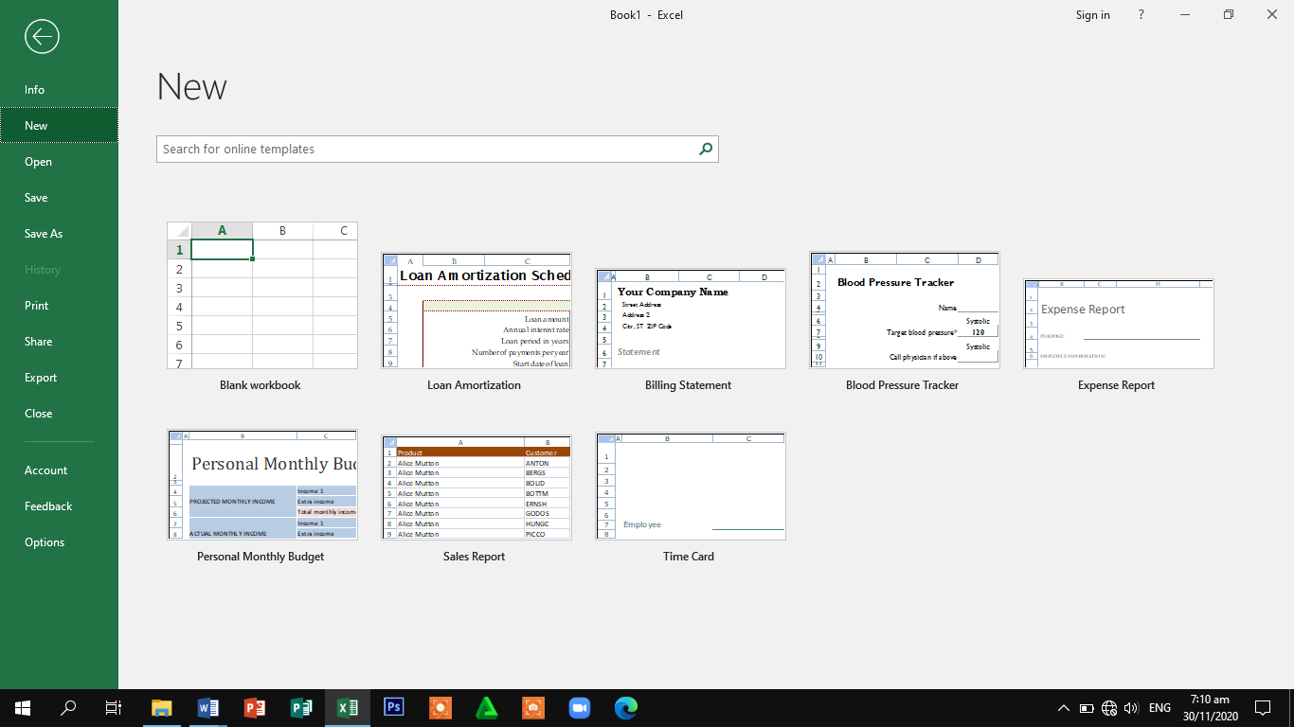

*Figure 1. Excel Start Screen*

This lesson will introduce the Excel Window. Use this window to interact with excel. To start the lesson, open Excel 2013.

The Microsoft Excel Window will appear and the screen looks like as shown below:

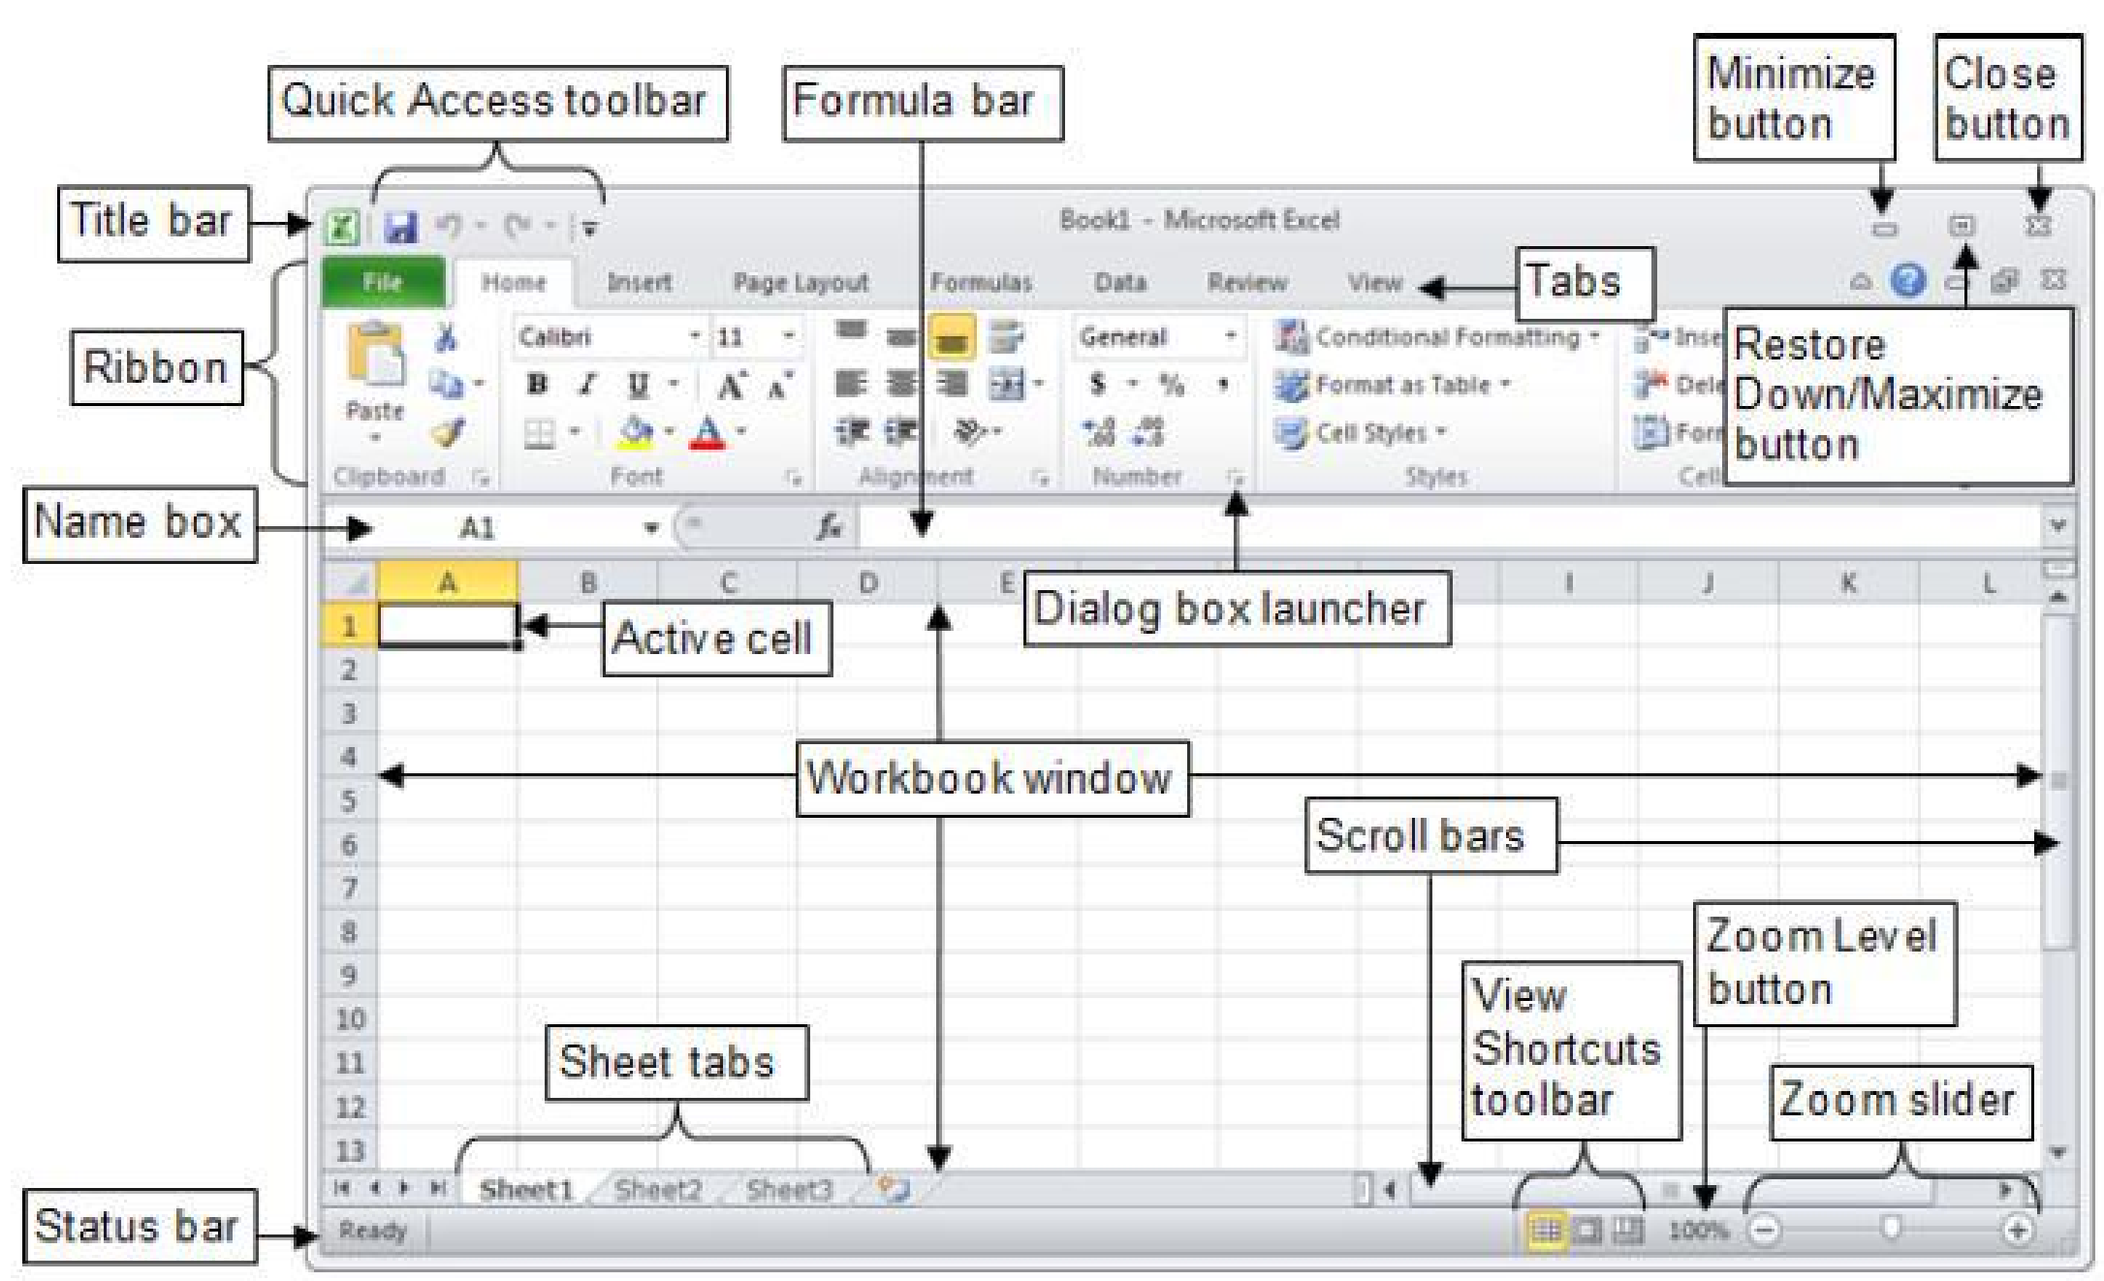

*Figure 2. MS Excel Window*

### **Title Bar**

Displays the name of the workbook and the program.

**Minimize, Restore Down/Maximize Close buttons**

Controls the program window. Use the Minimize button to hide the window. Use the Restore Down/Maximize button to adjust the size of the window. Use the Close button to exit Excel**.**

### **Quick Access Toolbar**

The *Quick Access Toolbar* lets the user access common commands whatever which tab is being selected. By default, the Save, Undo, and Redo commands are included.

**The Ribbon**

Contains all the commands related to managing workbooks and working with workbook content.

**Formula**

Displays the data or formula stored in the active cell. It can also be used to enter or edit a formula, a function, or data in a cell.

**Name Box**

Displays the active cell address or the name of the selected cell, range, or object.

**Workbook Window**

Displays a portion of the worksheet.

**Sheet tabs**

Each tab represents a different worksheet in the workbook. A workbook can have any number of sheets, and each sheet has its name displayed on its sheet tab.

**Scroll bars**

Used to move upward or downward through a worksheet.

**Status bar**

Displays various messages as well as the status of the Num Lock, Caps Lock, and Scroll Lock keys on the keyboards.

**View Shortcuts toolbar**

Used to display the worksheet in a variety of views, each suited to a specific purpose.

**Zoom Level button Zoom slider**

Used to change the magnification of the worksheet.

**OVERVIEW OF THE USER INTERFACE 1. RIBBON**

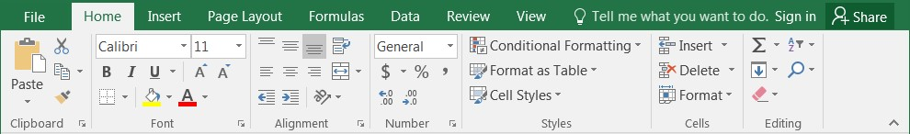

The ***RIBBON*** is a device that presents commands organized into groups. The groups on the Ribbon display the commands that are the most relevant for each of the task areas in the applications.



The ***HOME*** tab gives access to the most frequently use commands when working with Excel 2013, which include copy and paste, font, cell border, and selecting spreadsheet

styles. It is a default tab when opening Word.

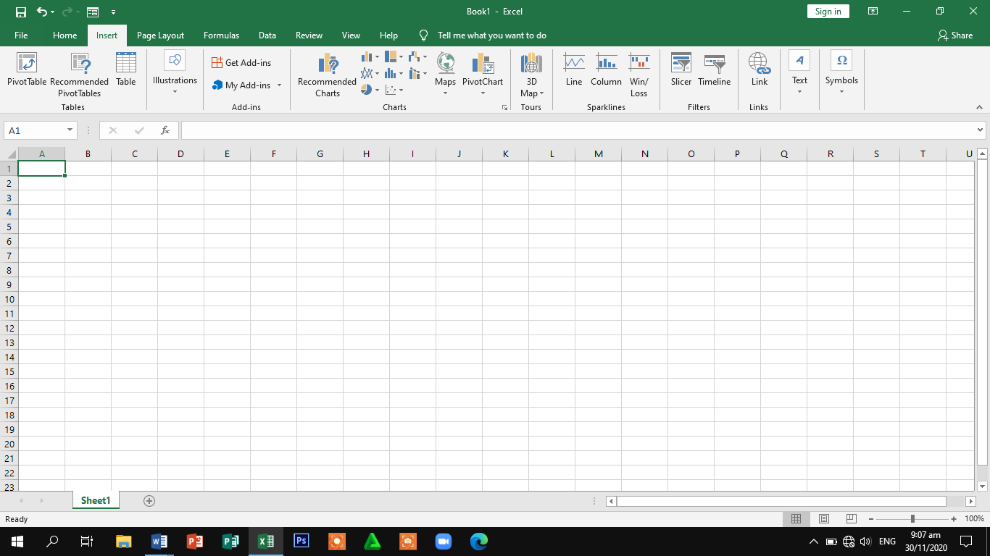

The ***INSERT*** tab allows inserting tables, illustrations, charts, reports, sparklines, filters, links, text, symbols which can help add style and communicate information visually to the spreadsheet.

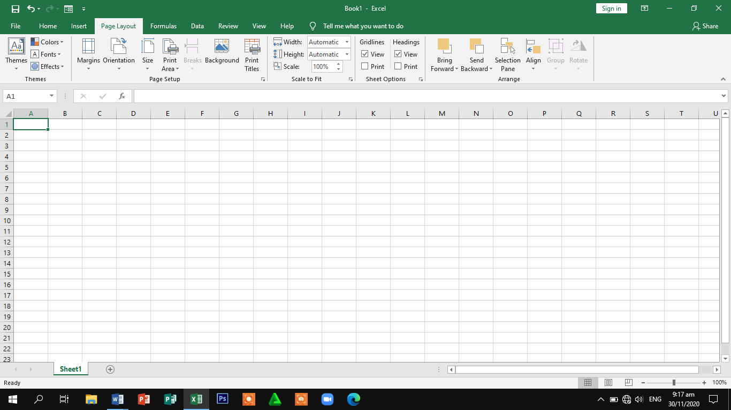

The ***PAGE LAYOUT*** tab allows changing print formatting of spreadsheet such as themes, page setup, scale to fit, sheet options, margin width, page breaks, and page orientation. These commands are useful in printing the spreadsheet.

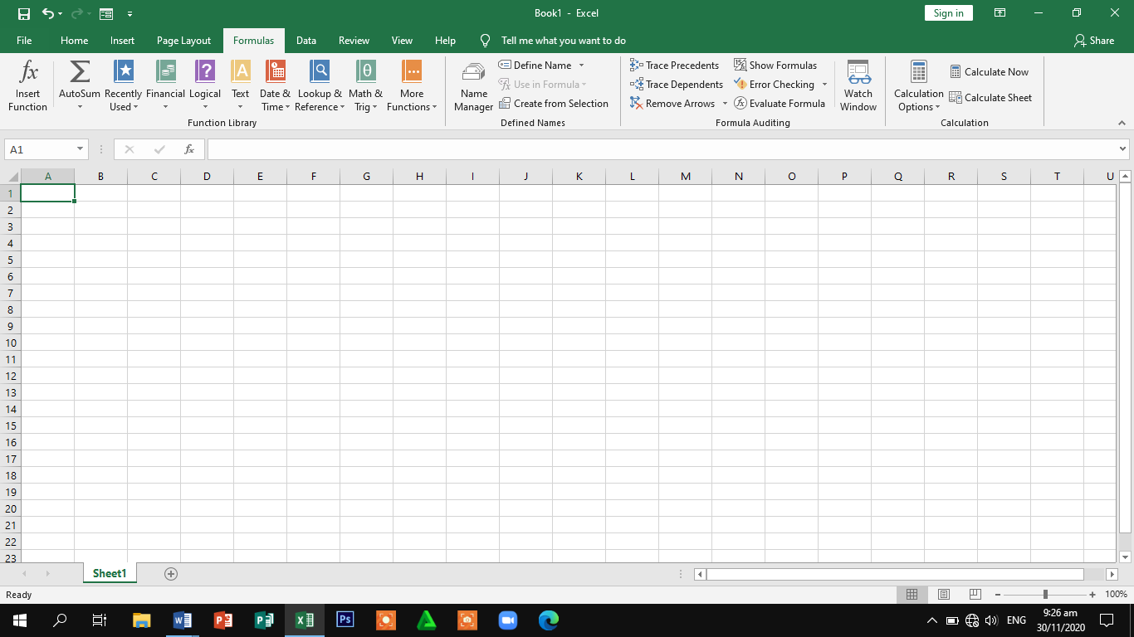

The ***FORMULA*** tabis use to access the powerful formula editing features of excel such as function library, defined names and formula auditing, calculation.

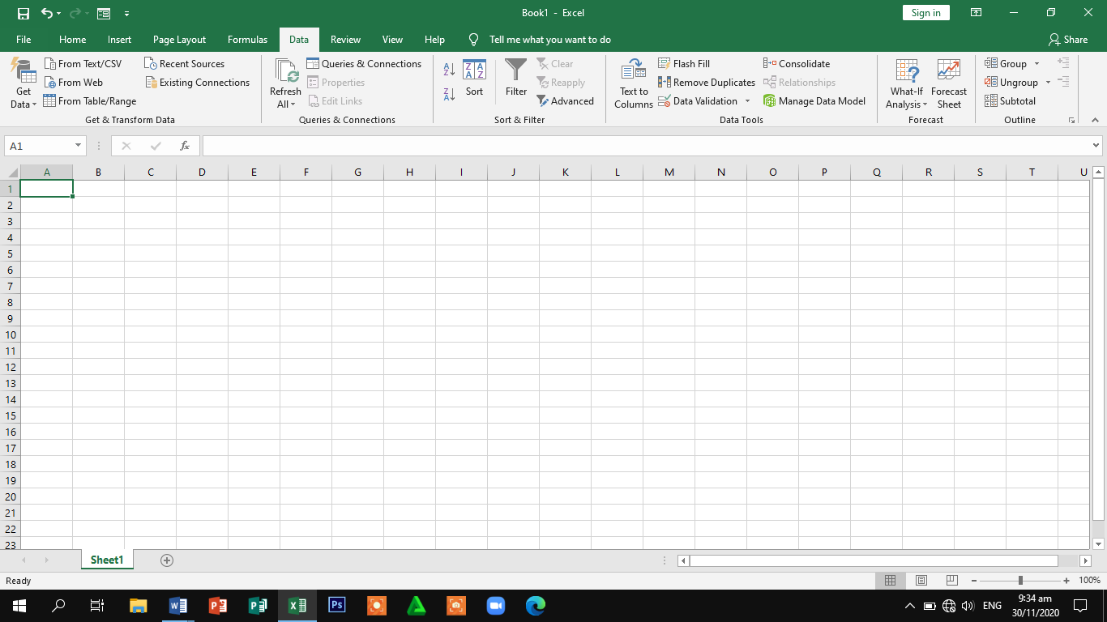

The ***DATA tab*** is use to access the External Data, Connections from Web, Sort & Filter and Data Tools, Outline

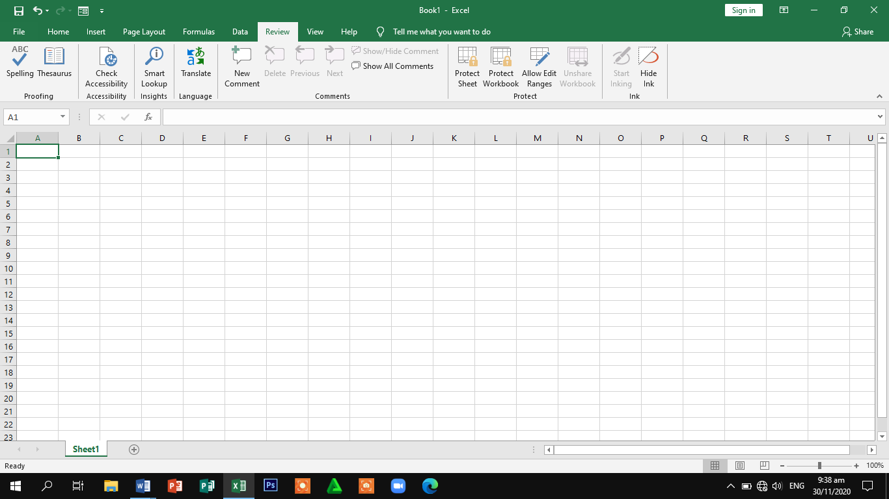

The ***REVIEW*** tab is use to access the powerful editing features of excel which include tracking changes and adding comments that make it easy sharing and collaborating on spreadsheets.

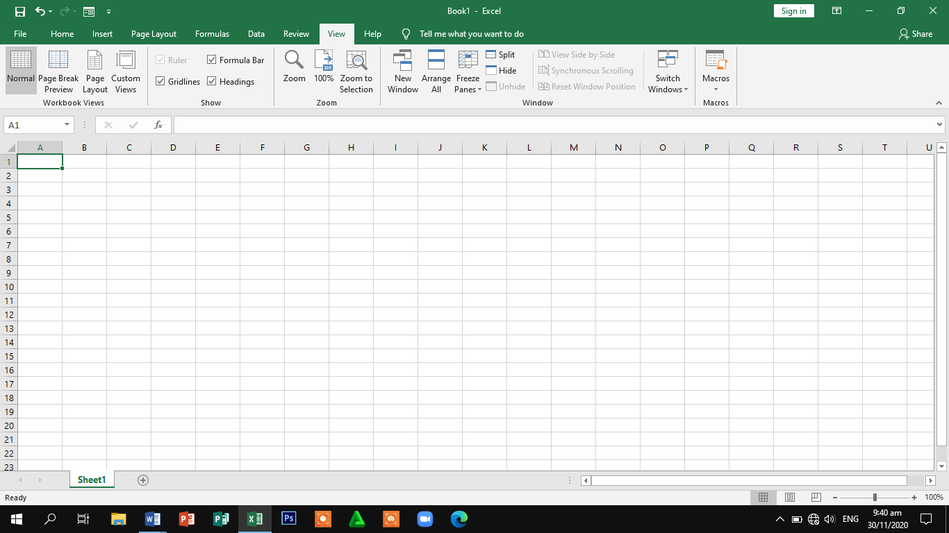

The ***VIEW*** tab allows to use to access workbook views, show, zoom, window and macros These commands are also useful to prepare printing documents.

### **2. QUICK ACCESS TOOLBAR (QAT)**

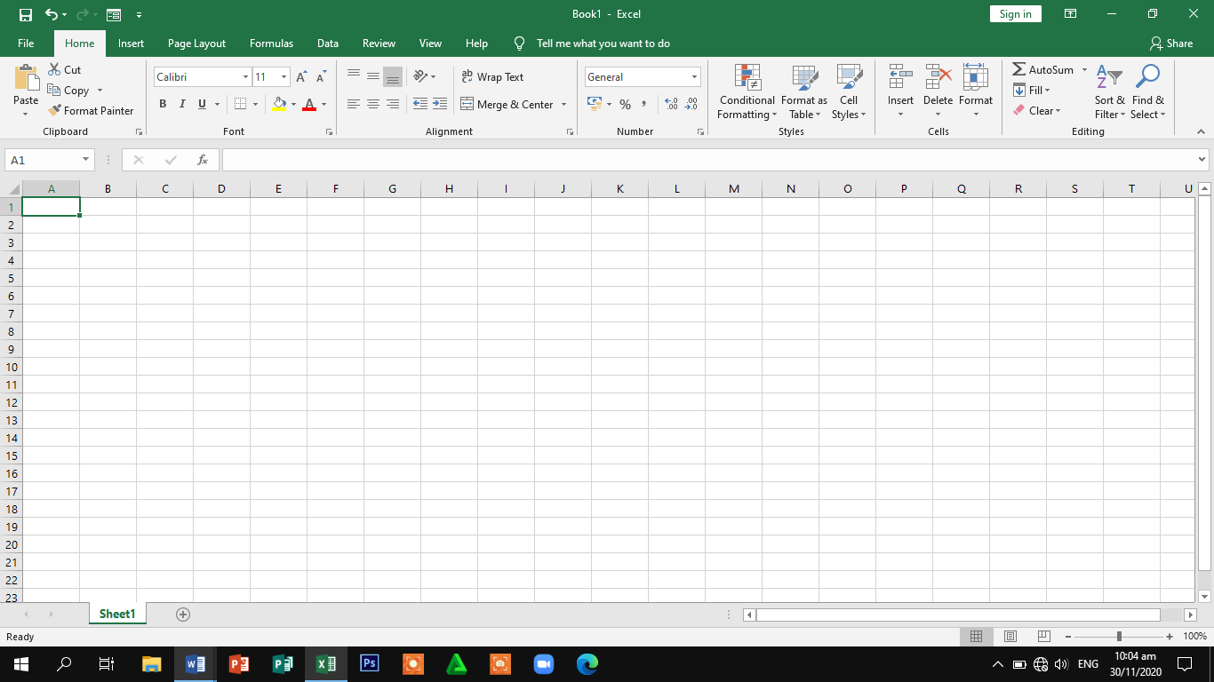

Itis a toolbar that contains set of commands that are independent of the tab on the ribbon that is presently displayed. It can be moved from one of the two possible locations and can be added buttons representing commands to the QAT.

***To add and remove commands on QAT***

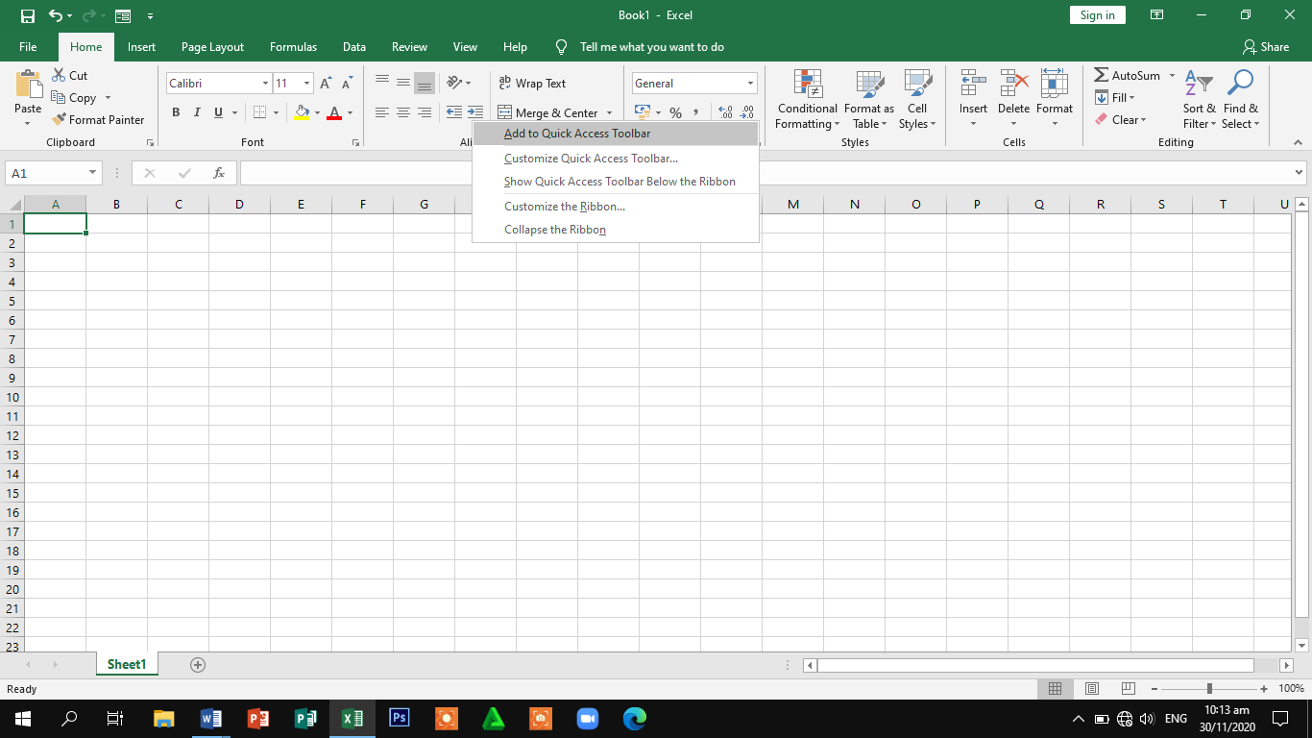

*Right click the command, and then click Add to Quick Access Toolbar.*

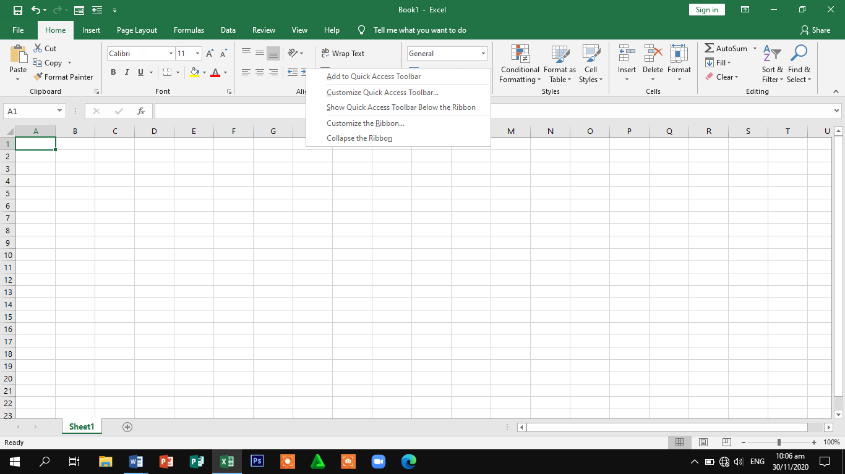

*You can now find this command on the quick access toolbar.*

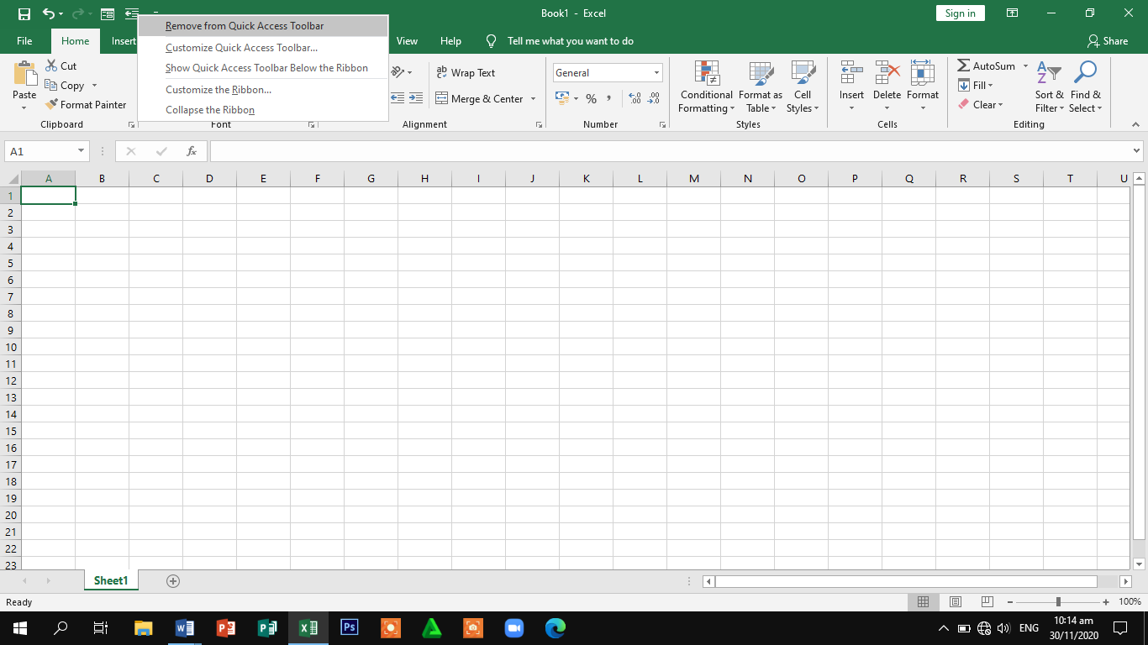

*To remove a command from the quick access toolbar, right click the command and then click remove from the quick access toolbar*

**3. SHORTCUT MENUS**

Right clicking an object activates a *shortcut menu***.**

**4. EXCEL BACKSTAGE VIEW**

*Backstage view* is the area where files and data about them is managed, control, creating, saving, printing, sending to others, inspecting for hidden metadata or personal information, and setting options. The Ribbon contains the set of commands for working in a workbook, while the Microsoft Office. Backstage view is the set of commands you use to do things to a workbook

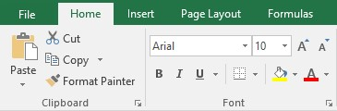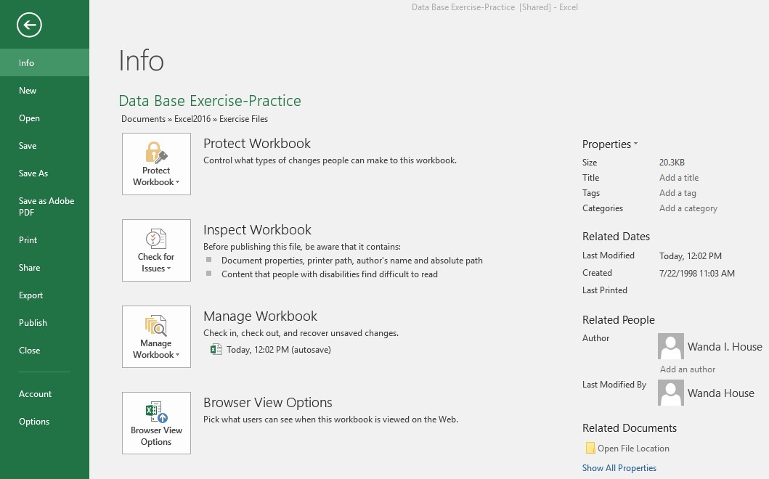

**New**

This category will provide a gallery of different templates, including Blank Workbook, which can be used to create a new workbook.

**Open**

Click this option to open a previously saved workbook. A list of Recent Workbooks will display. To search for additional workbooks, click the This PC or Browser link.

**Save**

Use this option to save a workbook when it is first created. If this option is clicked after a workbook has been created, the older version of the workbook will be replaced with the newer version.

**Save As**

This option is used to save a previously saved workbook under a new name or to a new location. Click the This PC or Browse button to open the Save As window.

**Print**

Use this category to access the options for printing a workbook. A preview of the workbook along with printer options will appear in this view.

**Share**

To send the workbook as an Attachment, as a Link, as a PDF file, or as an XPS file, select this option.

**Export**

This option is used to export a file in PDF or XPS format. It is also possible to change the file type for the workbook from this area.

**Close**

To close a workbook, click this option. This will close the current workbook but not the Excel window.

**Account**

This area is used to locate information about your account. It is also the area where the Office Theme and Office Background can be changed.

**Options**

Use this area to change the options for the Excel program. These options will not change until they are physically changed by you.

**LEARNING ACTIVITY SHEET**

**SPECIAL PROGRAM IN ICT 7**

**OFFICE PRODUCTIVITY 7**

*Third Quarter, Week 1*

Name of Learner: _____________________________ Date:__________________________

Grade Level /Section: __________________________

**LEARNING COMPETENCIES**

1. To Familiarize the parts and functions of a program window element of MS Excel 2013.

## **ACTIVITIES**

### **ACTIVITY 1**

***Directions:*** Label the Parts of MS Excel Screen 2013 and give its function in moving around the spreadsheet.



1.

8.

5.

7.

6.

3.

2.

10.

7.

9.

4.

1.

2.

3.

4.

5.

6.

7.

8.

9.

10.

### **ACTIVITY 2**

***Instructions:***

1. Open and navigate to the Excel 2013 **interface**.
2. Click through all of the **tabs**, and review the **commands** on the **Ribbon**.
3. Add and remove **command** to the **Quick Access toolbar**.
4. Navigate to **Backstage view**.
5. Close **Excel** (you do not have to save the document).

### **ACTIVITY 3**

***Directions:*** Explain when to use the following Word User Interface. Use the rubric below for your scoring guide.

**SCORING RUBRIC**

|  |  |  |
| --- | --- | --- |
| **CRITERIA** | **PERCENTAGE** | **SCORE** |
| ***Content*** (Covers topic in depth with details. Subject knowledge is excellent) | **30%** |  |
| ***Accuracy*** (Consistently explain the User Interface accurately) | **30%** |  |
| ***Presentation*** (Present the sequence of information well) | **20%** |  |
| ***Clarity*** (Clearly delivered with a modular voice tone each interface) | **20%** |  |
| **TOTAL SCORE** | **100%** |  |

1. Status Bar

1. Ribbon

1. QAT

1. Formula bar

1. Backstage View

6. Workbook Window

7. Title bar