**

**LEARNING ACTIVITY SHEET**

**SPECIAL PROGRAM IN ICT 7**

**OFFICE PRODUCTIVITY 7**

*Third Quarter, Week 2*

**Create, Save, Open and Close a Workbook**

**BACKGROUND INFORMATION FOR LEARNERS**

A **Workbook** in Microsoft Office Excel, is a file of one or more **spreadsheets** or **worksheets**. Some users may have confusions on workbook,worksheets and spreadsheets. The things you need to remember is when you open Microsoft Excel,you are opening a **workbook** which has default filename “Book1”. Whereas, workbook can contain one or more **worksheets** that you can select or change through tabs at the bottom of the worksheet which has default name “Sheet1”. Worksheets and speadsheets are the same but some users use the term Spreadsheet as other name for Microsoft Office Excel or any similar program.

**File terms to understand**

**New**- used to create new workbook.

**Save**- used to save a file or workbook you have had made changes or created. Do save your work at least every five minutes until your done to avoid losing any changes you have made when there is a power interruption or sudden shutdown of the computer.

**Save** **as**- used when you are saving an existing file using other filename or saving the file in other format (e.g. PDF file, XPS document, Web Page)

**Open**- This is used to open an existing file from the hard drive of your computer or in a flashdrive.

**Close**- used to close a workbook.

**Creating Workbooks**

To create a new workbook using Microsoft Office Excel, follow the steps listed below:

1. Open the application Microsoft Excel by any of these options; (1) double clicking the shortcut icon on the desktop, (2) if the Microsoft Excel icon is located in the taskbar or in start menu, do single click.
2. There are several templates to choose from depending on what kind of work you will 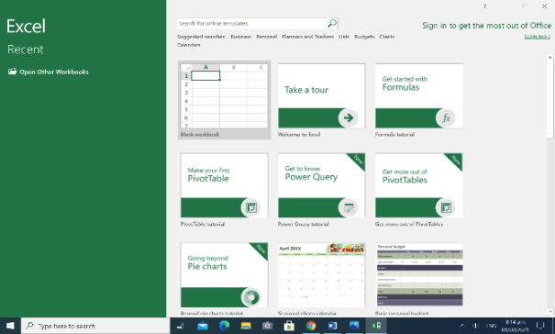create. Normally, users choose “Blank workbook” for basic workbook.

If there is an open workbook file and you want to create new;

1. Click File tab at the Menu bar.
2. Click New.
3. Select the template of workbook you want to create.

You can also use shortcut keys to create new but applicable when there is an open workbook only.

To do so, just press Ctrl + N on the keyboard and you will automatically create a blank workbook.

**Saving a Workbook**

1. You can save a workbook even if there is no content yet. To do so, click on the File at the Menu bar.

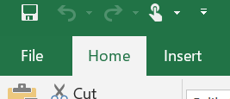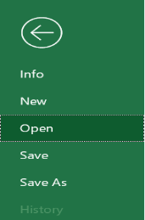

1. Then click Save or Save as. Any of the two can do.
2. You can also use shortcut keys, just press Ctrl + S on your keyboard.
3. Next, under Save as, select the location where you want to save your workbook. If the location you want is not listed, click Browse. The Save as window will appear which will give you more option where to save your workbook.
4. After selecting the location, rename your workbook.

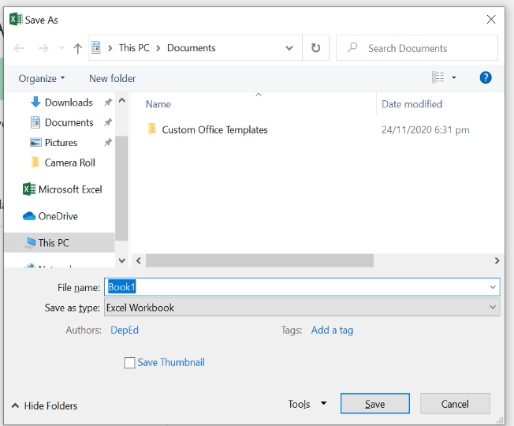

You can select the location where you want your workbook be saved

After selecting the location, you can also create New Folder by clicking this tab if you want a separate folder for your workbook.

This part is where you will type the filename of your workbook. Do not use colon (:) symbols in your filename or it will not be valid.

Click this if you want to save your workbook in different file format.

1. Lastly, click Save button.

***Note***: When editing an existing file which belongs to other user, click Save as first and rename the file you are editing to avoid overwriting or losing the data of the original file.

**Closing a Workbook**

Before closing a workbook, remember to save your workbook first to avoid losing any changes you made. To close a workbook, you may use any of the steps below:

1. Click File at the Menu bar, then click Close;
2. You may also click the  close button placed at the upper-right corner of the workbook window;
3. Or press Alt + F4.

If you wish to close the existing workbook only without closing the Excel program, press Ctrl + W or Ctrl + F4.

**Opening an Existing Workbook**

There are three ways to open an existing workbook. You can use any of the steps below:

|  |  |  |
| --- | --- | --- |
| Option 1 | Option 2 | Option 3 |
| Search on the file by typing the filename you wish to open on the Search bar at the lower-left corner of your desktop. When you see the file you want to open, single click the file. | If the file you wish to open is located at the Desktop, in Document or in any folder on your computer, double click the file. | Press Ctrl + O on your keyboard. Then browse for the filename of the workbook you wish to open. |

**LEARNING ACTIVITY SHEET**

**SPECIAL PROGRAM IN ICT 7**

**OFFICE PRODUCTIVITY 7**

*Third Quarter, Week 2*

Name of Learner: Date:________________________

Grade Level /Section:

**LEARNING COMPETENCY**

Create, save, close and open a workbook in Microsoft Office Excel.

**ACTIVITY 1**

**Directions:** Complete the paragraph below. Write the appropriate answers on the blanks provided. Choose your answer on the given box below.

|  |
| --- |
| Save or save the workbook  Ctrl+ S  Rename  Click the Microsoft Excel  Workbook  Blank workbook  Ctrl + O  Save as  5 or five minutes  Ctrl + W or Ctrl + F4 |

Carmela’s task is to create a class schedule using Microsoft Excel or a ________________. First thing she do is to __________________________. Then she sees several templates but she chose__________________________ as basic. Next, she starts creating a class schedule but suddenly she remembered one important thing to do to avoid losing what she’s been doing. The very important thing she must do is to _____________________. She continued her work but always press the shortcut key ______________ to save her file every ________________. When Carmela is done with the class schedule and saved it, she then presses ____________ as shortcut to close the workbook but she did not close the program. Carmela open an existing file using the shortcut key ______________. She looked for her sister’s personalized calendar created using Excel. She edited the file to make a personalized calendar for herself. After a while, she clicked ________________, changed the location of the file then ______________ the filename to avoid overwriting her sister’s work.

**Activity 2.**

Direction: Differentiate the following terms below (Paghambingin o Pagkumparahin ng kahulugan). Write your answers inside the box provided.

**Workbooks Worksheets**

**Save Save as**

**Ctr+F4 Alt+F4**