**

**LEARNING ACTIVITY SHEET**

**SPECIAL PROGRAM IN ICT 7**

**OFFICE PRODUCTIVITY-MICROSOFT EXCEL**

*Third Quarter, Week 3*

# Move Around and Make Selection in an Excel Worksheet

## BACKGROUND INFORMATION FOR LEARNERS

Now that you already know how to create, save, close, and open a workbook it’s time to learn how to move the active cell around the worksheet. Since there are more than 17 billion cells in a worksheet, Excel offers several ways to select the particular cell where you want to enter data, or the range of cells to be formatted. You can use the **Arrow Keys**, the **Scroll Bars,** or the **Mouse** select cellsto move quickly to different areas of the worksheet.

**Understanding Cells, Rows, and Columns**

A **Cell** is the basic building block of a worksheet where you enter information or content. Each rectangle in a worksheet which is formed by the intersection of a row and a column is called a cell. Cells are named by combining the column letter and row number where they are located

A **Row** is a group of cells that runs from the left of the page to the right. They are identified by numbers, there are 1,048,576 rows in a worksheet and the default row height is 15 points or 20 pixels.

A **Column** is a group of cells that runs from the top of the page to the bottom. They are identified by letters, there are 16,384 columns in a worksheet and the default column width is 8.43 points or 64 pixels.

**To Move Around the Worksheet Using the Scroll Bar**

The **Scroll Bars** allows you to scroll the worksheet up and down or side to side.

**The Scroll Bar**

**Up Scroll Arrow**

It scrolls the workbook up one row

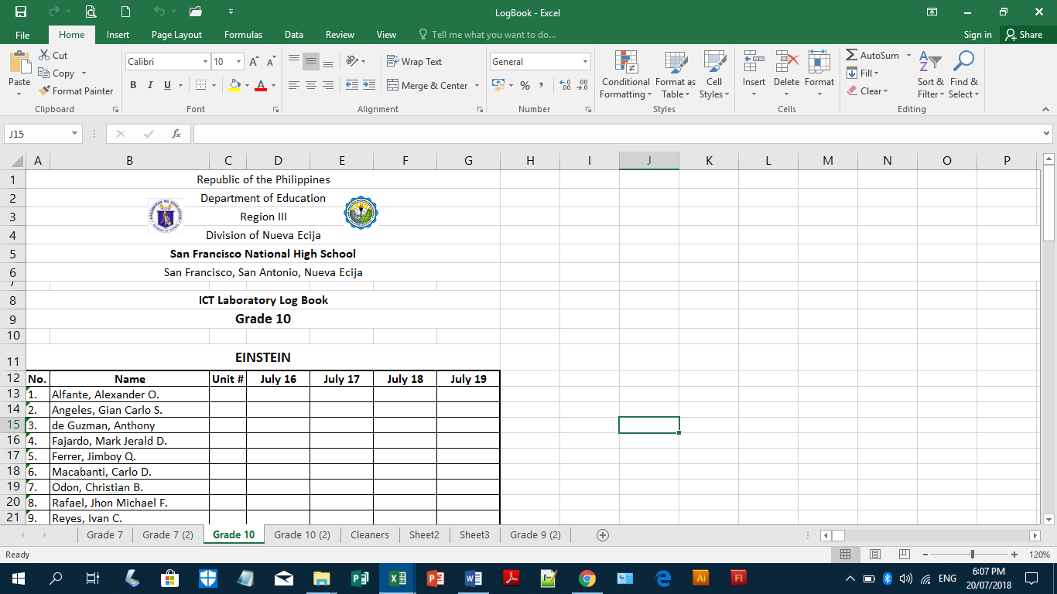

**Vertical Scroll Box**

Drag this to scroll the worksheet upward or downward

**Vertical Scroll Bar**

Click below the vertical scroll box to scroll the worksheet down one screen

Click above the vertical scroll box to scroll the worksheet up one screen

**Left Scroll Arrow**

It scrolls the workbook left one column

**Down Scroll Arrow**

It scrolls the workbook down one row

**Horizontal Scroll Box**

Drag this to scroll the worksheet leftward or rightward

**Right Scroll Arrow**

It scrolls the workbook right one column

**Horizontal Scroll Bar**

Click at the right of the horizontal scroll box to scroll the worksheet right one screen

Click at the left of the horizontal scroll box to scroll the worksheet left one screen

**To Move Using the Arrow Keys**

**Right Arrow Key** will move one cell to the right of the selected cell.

**Down Arrow Key** will move one cell below the selected cell.

**Up Arrow Key** will move one cell above the selected cell.

**Left Arrow Key** will move one cell to the left of the selected cell.

**Ctrl + Home** moves the selected cell to the very top left of the worksheet (cell A1)

**Ctrl + End** moves the selected cell to the very bottom right of the worksheet (cell XFD1048576)

**Ctrl +Arrow Key** moves the selected cell to the last cell in the group containing data

(depending on the direction of the arrow)

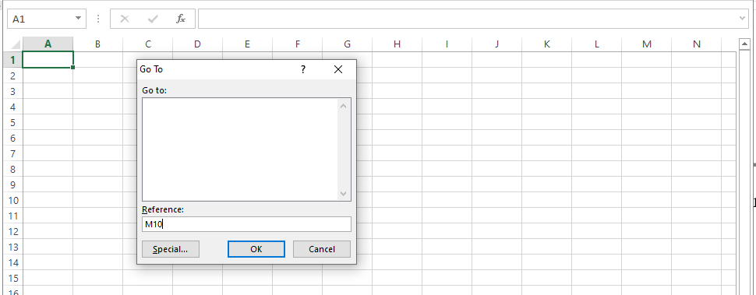**Press F5** to display the **Go To dialog box**, type the name of the cell where you want to go to in the **Reference box** and click **Ok**.

**SELECTING CELLS, ROWS AND COLUMNS**

**Selecting Cell**

It is important to learn how to select a cell, column, row, range of cells, columns and rows, because by selecting a cell, you instruct Excel where to store the data that you enter into a worksheet.

Before applying any of the formatting commands you have to select first the cell that you want to format, any formatting that you made in a worksheet will be applied in the selected cell only.

The selected cell is surrounded by a green border, and its column letter and row number will be highlighted.

**To select a single cell**:

*moves one cell up*

1. click the cell or press any of the arrow key

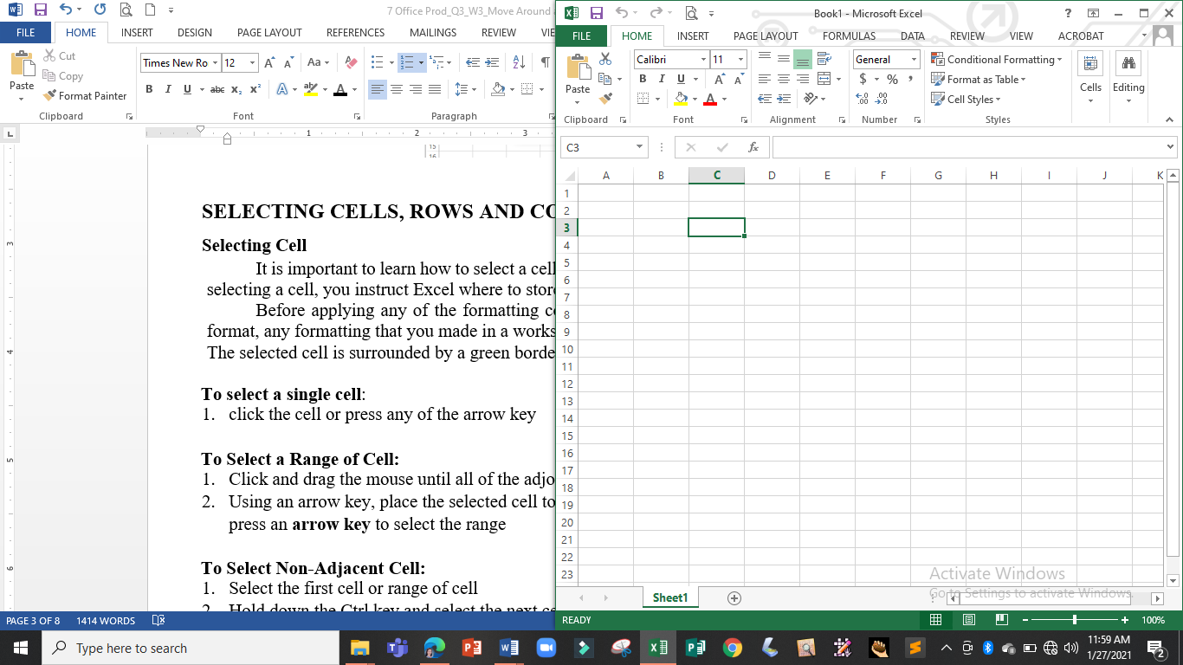

*moves one cell to the left*

*moves one cell to the right*

*just place the pointer over the cell and click the left mouse button*

*moves one cell down*

**To Select a Range of Cell:**

1. Place the pointer over the first cell, hold the left mouse button and drag the mouse until all of the adjoining cells you want to select are highlighted.

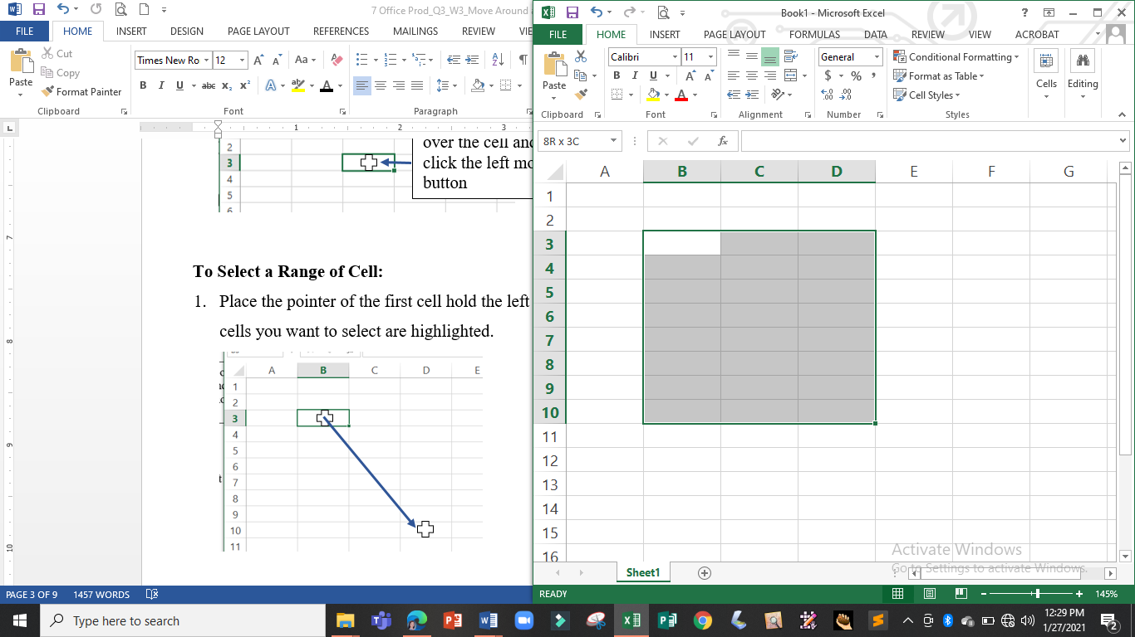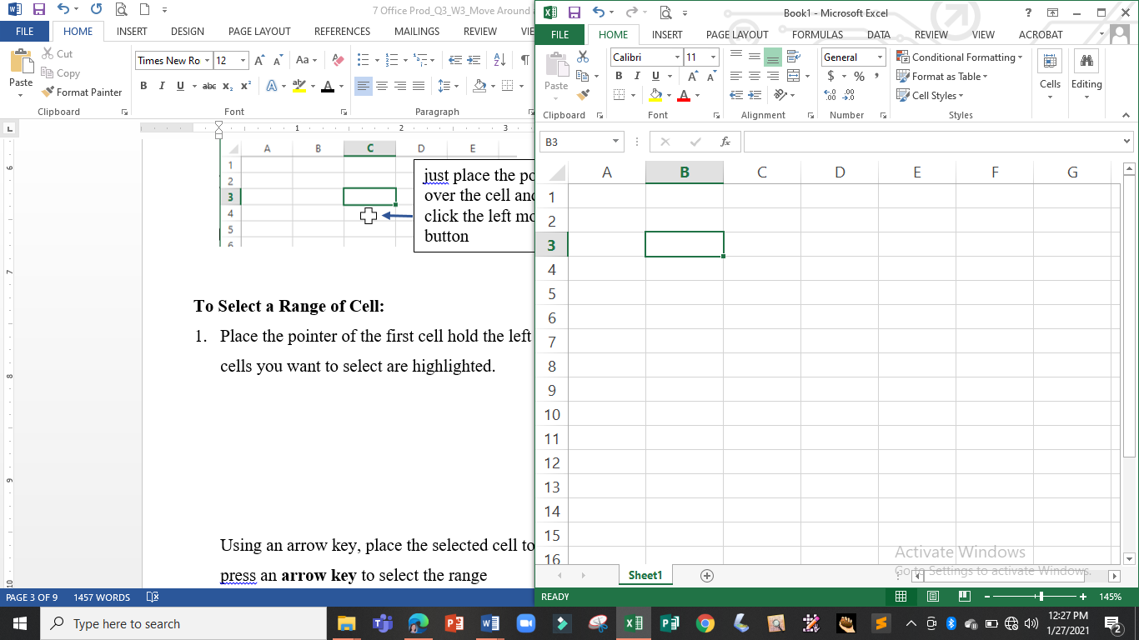

3

Using an arrow key, place the selected cell to the first cell in the range, hold down the **Shift key** and press an **arrow** **key** to select the range.

**To Select Non-Adjacent Cell:**

1. Select the first cell or range of cell
2. Hold down the Ctrl key and select the next cell or range of cell
3. 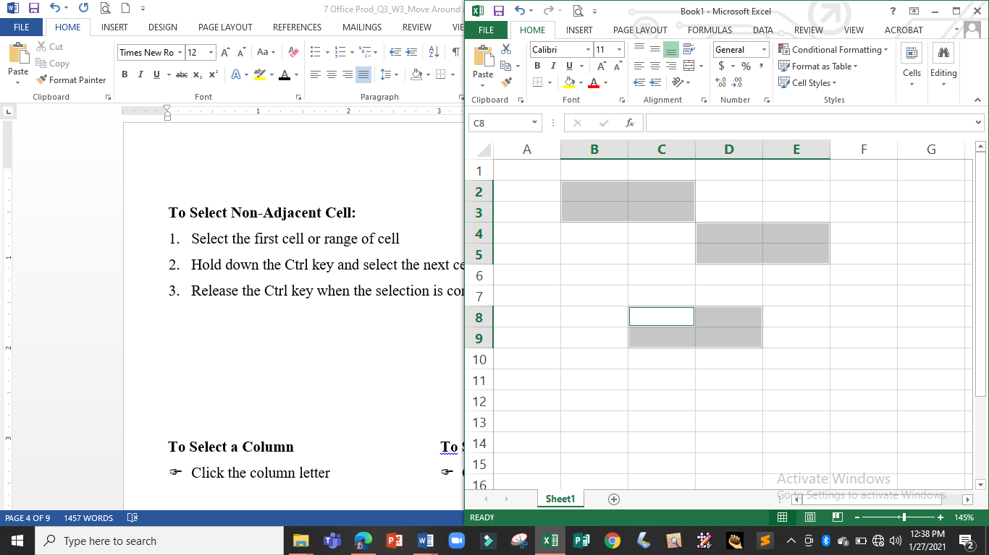Release the Ctrl key when the selection is complete

*Select the first range of cells*

*Hold the Ctrl key and Select the next range of cells*

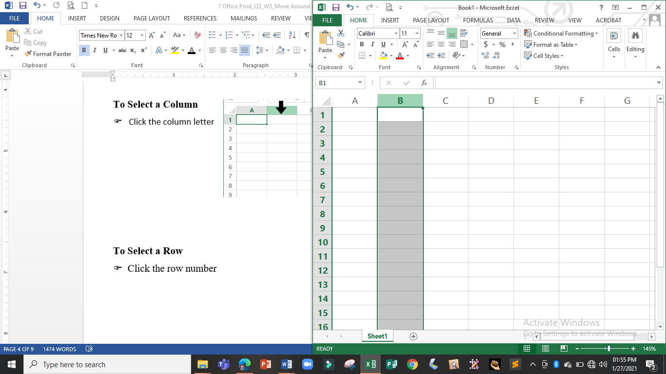

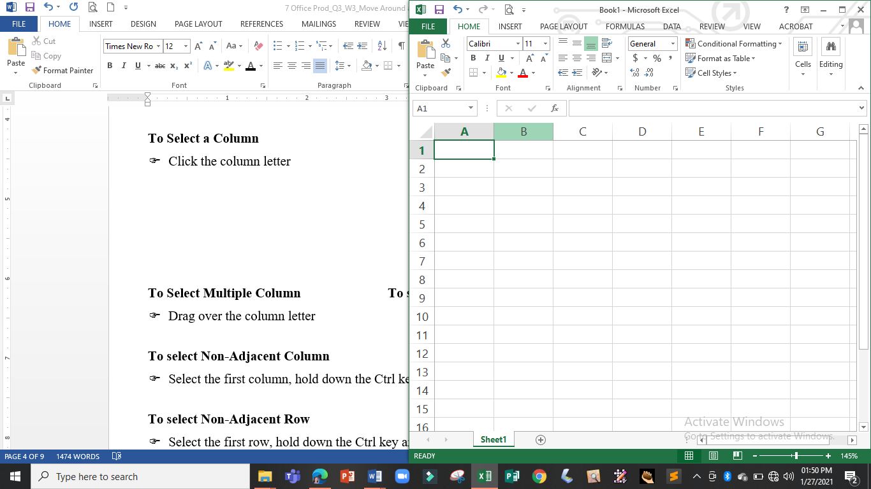**To Select a Column**

* Click the column letter

*and the entire column will be selected*

*Place the pointer over the column letter and click*

**To Select a Row**

☞ Click the row number

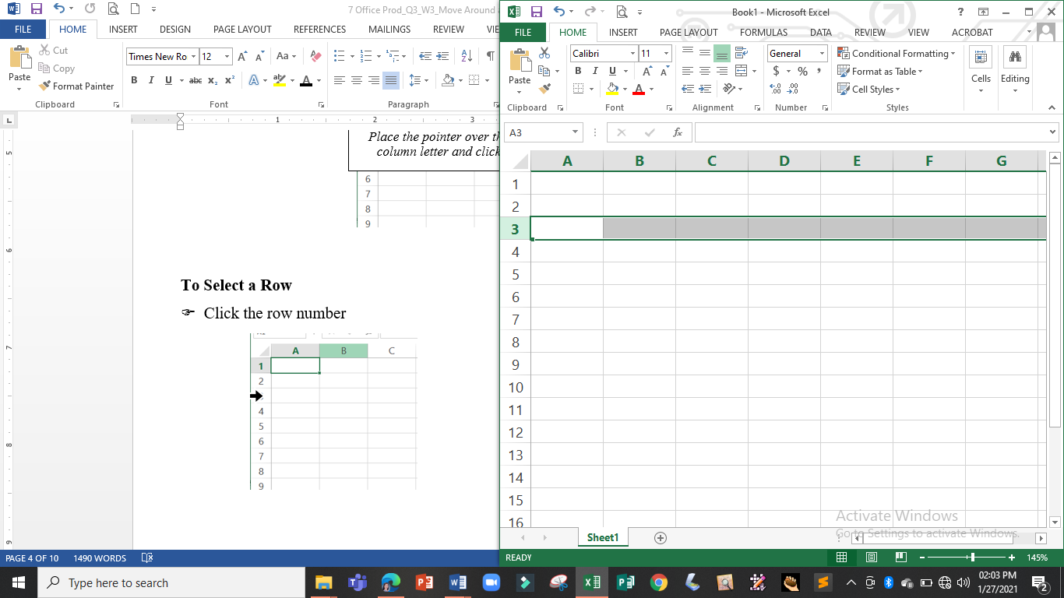

*and the entire row will be selected*

*Place the pointer over the row number and click*

4

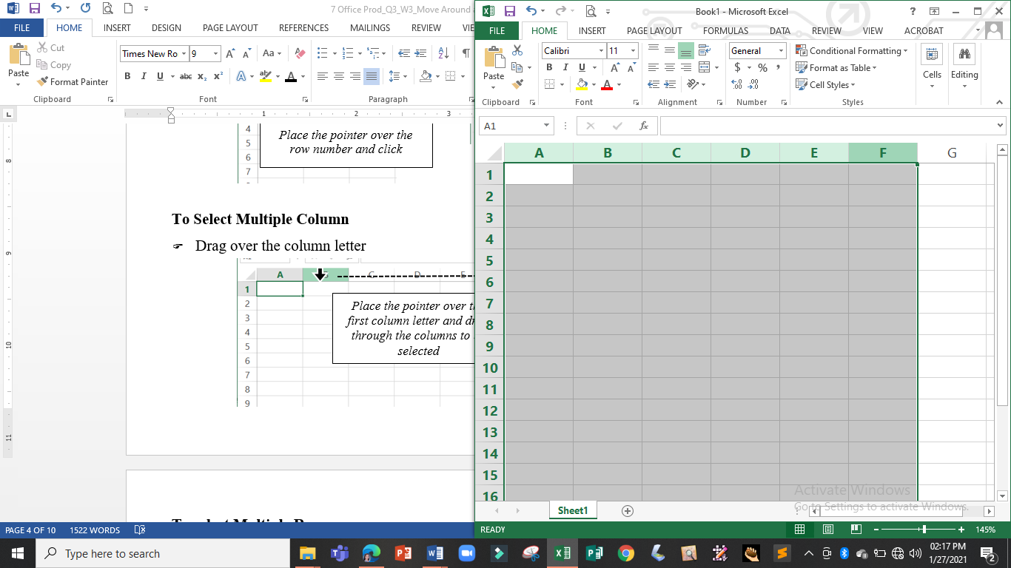**To Select Multiple Column**

* Drag over the column letter

*Place the pointer over the first column letter and drag through the columns to be selected*

*and columns A to F will be selected*

**To select Multiple Row**

☞ Drag over the row number

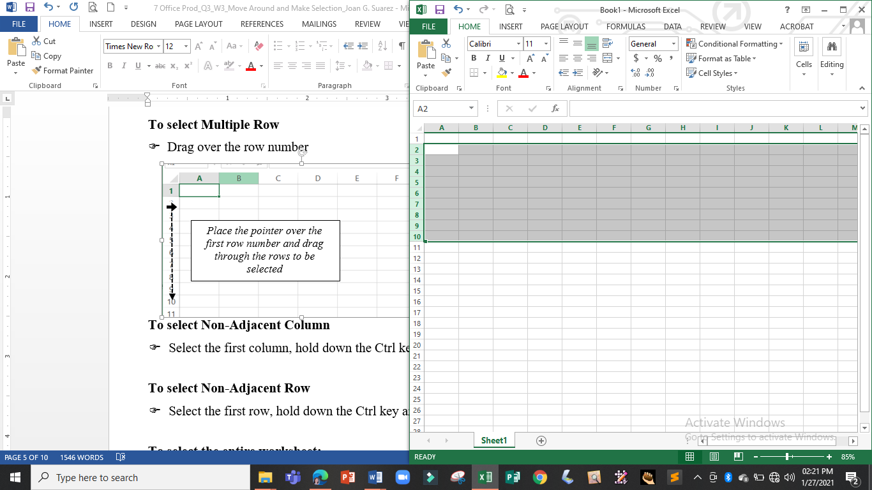

*and rows 2 to 10 will be selected*

*Place the pointer over the first row number and drag through the rows to be selected*

**To select Non-Adjacent Column**

* Select the first column, hold down the Ctrl key and select the other column.

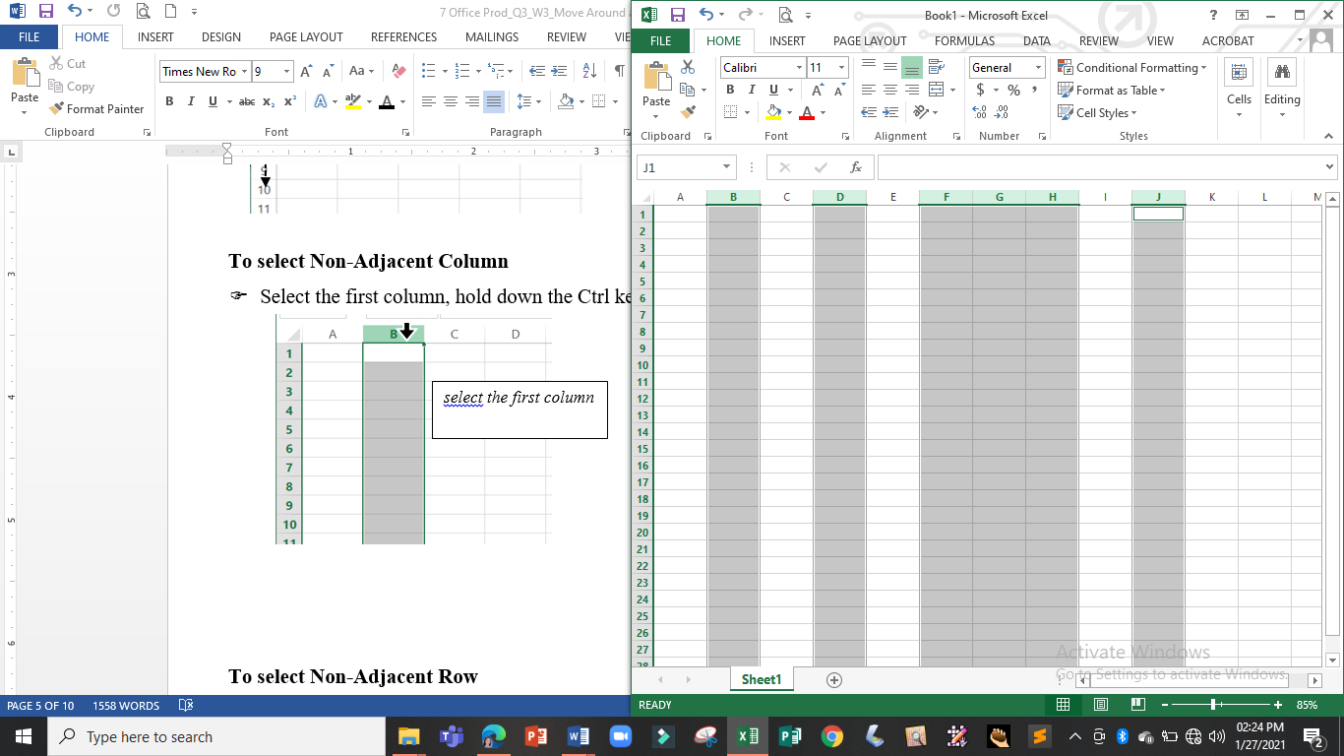

*while holding down the CTRL key place pointer over column F, hold the left mouse button and drag through column H*

*hold the Ctrl key and click the next column*

*select the first column*

5

**To select Non-Adjacent Row**

* 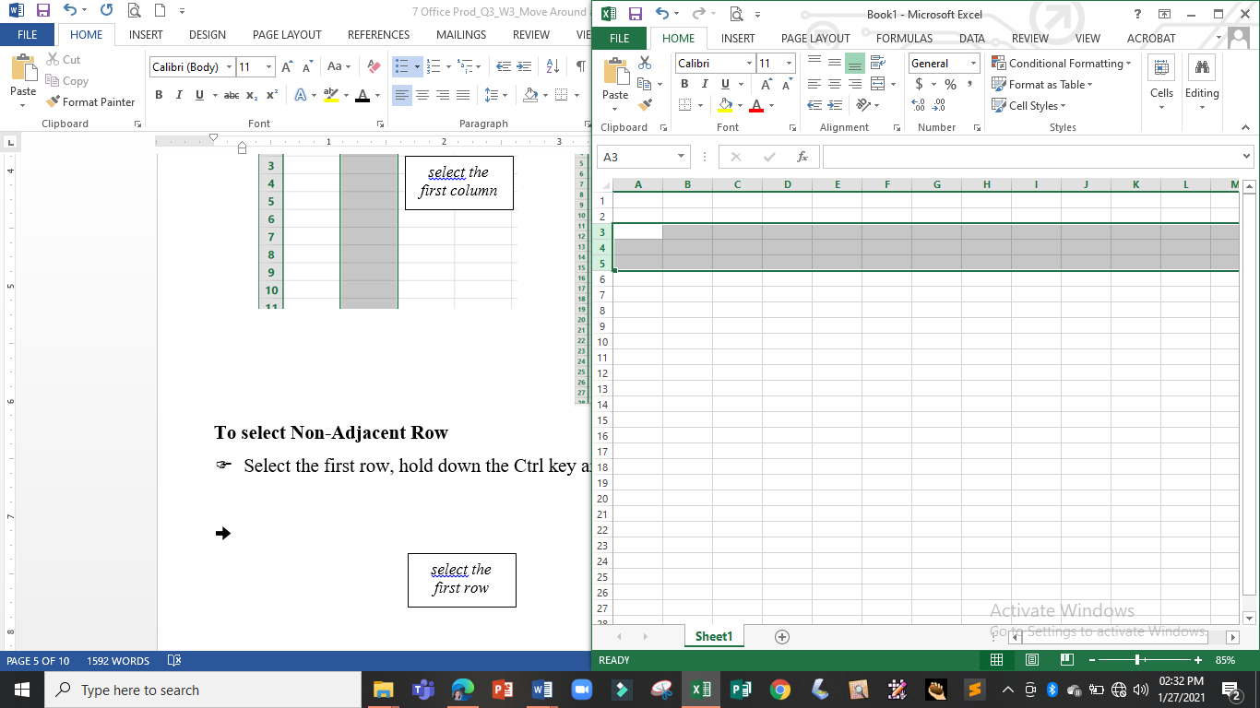Select the first row, hold down the Ctrl key and select the other row.

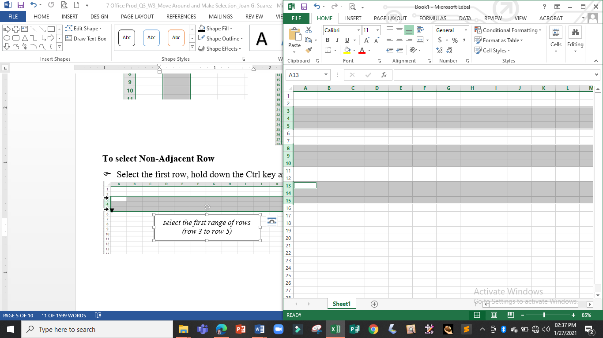

*Hold the CTRL key and select the next ranges of cell*

*select the first range of rows (row 3 to row 5)*

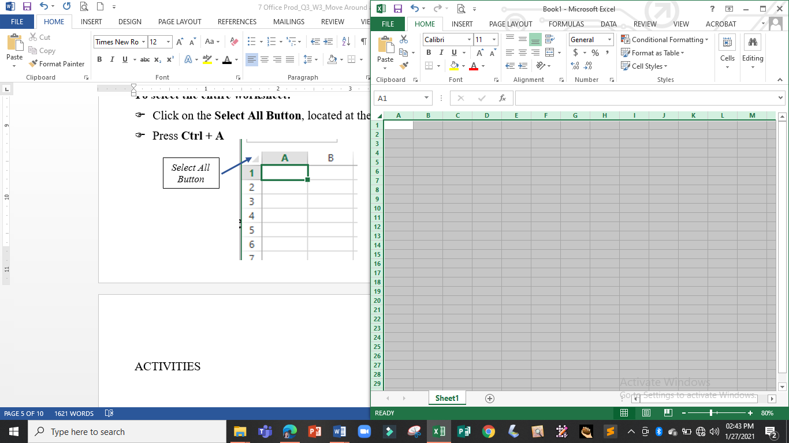

**To select the entire worksheet:**

*place the pointer over the select all button and click to select the entire worksheet*

* Click on the **Select All Button**

located at the left of column a and above row 1

* 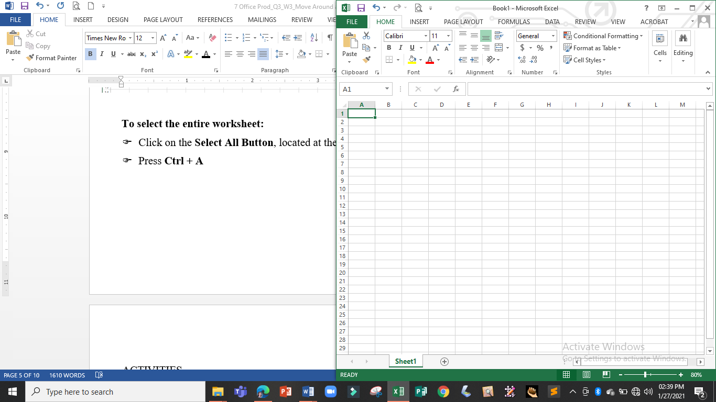Press **Ctrl + A**

*Select All Button*

**To select cells using the keyboard**

* Simply combine the **Shift Key** with the **Arrow Keys**
* **Shift + (Up Arrow Key)** – select a cell above the active cell
* **Shift + (Down Arrow Key)** – select a cell below the active cell
* **Shift + (Right Arrow Key)** – select a cell to the right of the active cell
* **Shift + (Left Arrow Key)** – select a to the left of the active cell

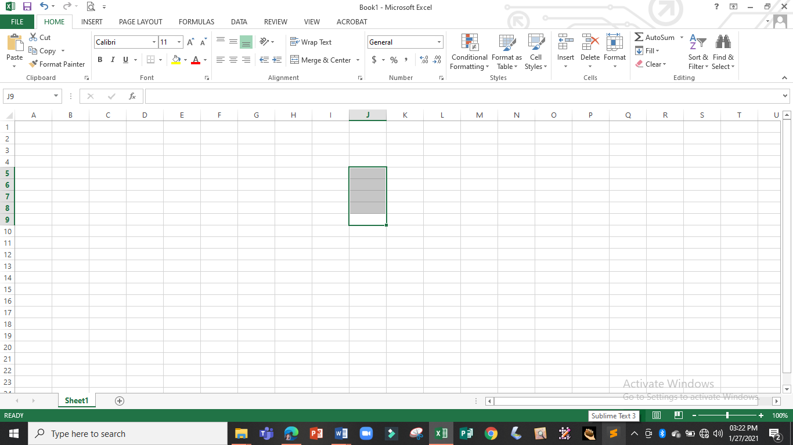

*when you press Shift + 4 imes, cells J5-J9 will be selected*

*Active Cell*

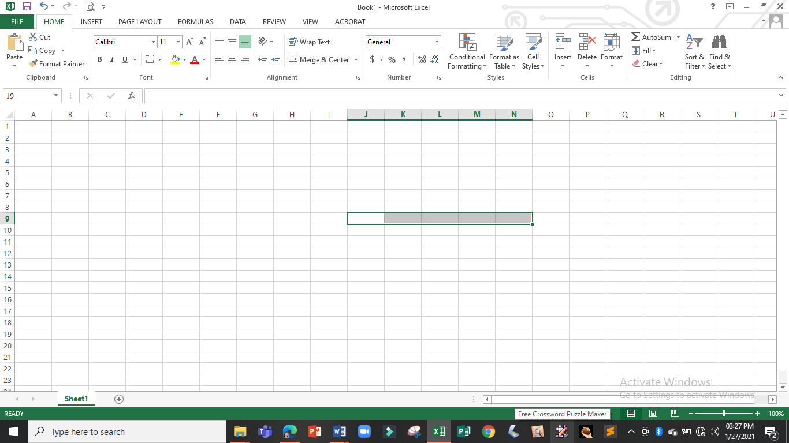

*when you press Shift + 4 times, cells L13 – P13 will be selected*

**6**

**LEARNING ACTIVITY SHEET**

**SPECIAL PROGRAM IN ICT 7**

**OFFICE PRODUCTIVITY-MICROSOFT EXCEL**

*Third Quarter, Week 3*

Name of Learner: _____________________________ Date: __________________________

Grade Level /Section: __________________________

**LEARNING COMPETENCIES**

* Moving around the worksheet using mouse and keyboard
* Selecting cell(s), row(s), column(s), and the entire worksheet

**ACTIVITIES**

**Activity 1:** Identify the parts of the scroll bars.

1



2

8

7

6

5

3

4

|  |  |  |  |
| --- | --- | --- | --- |
| 1. |  | 5. |  |
| 2. |  | 6. |  |
| 3. |  | 7. |  |
| 4. |  | 8. |  |

### Activity 2 : Identify what is being asked in each question.

|  |  |
| --- | --- |
|  | 1. It is a group of cells that runs from the top of the page to the bottom. |
|  | 1. It allows you to scroll the worksheet up and down or side to side. |
|  | 1. It displays the Go To dialog box which allows you to move the active to the desired location. |
|  | 1. It is the basic building block of a worksheet where you enter information or content. |
|  | 1. It instruct Excel where to store the data that you enter in a worksheet. |
|  | 1. It moves the selected cell to the very top left of the worksheet (cell A1) |
|  | 1. It is the key that you have to hold down when selecting non-adjacent cells. |
|  | 1. It is a group of cells that runs from the left of the page to the right. |
|  | 1. It is the keyboard shortcut for selecting the entire worksheet. |
|  | 1. It is the key that you combine with the arrow keys to select a range of cell. |

### ACTIVTY 3: Hands-on Activity

1. With your PC or Laptop try selecting the following, take a photo of each selection and send it to your Google classrooms

* Use the **Go To** dialog box to move to cell Z100
* Select the cell range C5:G10 with mouse
* Select the cell range G10:J20 with the arrow keys
* Select columns A, CD, G-I, M-P
* Select rows 2, 5-7, 11-15

1. Share your experience in selecting cells