**

**LEARNING ACTIVITY SHEET**

**SPECIAL PROGRAM IN ICT 7**

**OFFICE PRODUCTIVITY-MICROSOFT EXCEL**

*Third Quarter, Week 4*

# Enter Data into a Worksheet

## BACKGROUND INFORMATION FOR LEARNERS

Selecting a cell or a range of cells is one of the most important thing that you have to learn in Excel, because the data that you will enter into a worksheet will be stored in the selected cell as well as the selected formatting. There are several options for entering data into a cell. Data can be entered in a single cell or in a range of cells at the same time. The data that you enter can be numbers, text, dates, or times. These data can be formatted in several ways. And there are various settings that you can adjust to make data entry easier for you. The most basic way to enter data in a worksheet is by typing.

**Types of Data that can be Stored in a Cell:**

1. **Text** – composed of letters A-Z and special characters, default alignment is *left*.
2. **Numbers** – composed of numbers 0-9 and formula, default alignment is *right*
3. **Date and Time** – composed of date and time with specific formats, default alignment for date is *left*, for time is *right*.

**To Enter Text and Number in Excel**

1. Select the cell where you want the data to be stored and begin typing.

(you’ll see the data (text, date or time) appear both in the cell and in the formula bar above the worksheet)

1. When you finish typing, you can store the data in the cell in any of these ways:

* Press **Enter** – it stores the data and moves you to the next cell below
* Press **Tab** – it stores the data and moves to the next cell to the right
* Press **Shift + Ta**b – it stores the data and moves you to the next cell to the left
* Press an **Arrow Key** – it stores the data and moves you to the next cell in the direction of the arrow

**FYI:** at any time while you are typing you can press the *escape* key to cancel the data.

**To enter the same data to multiple cells:**

1. 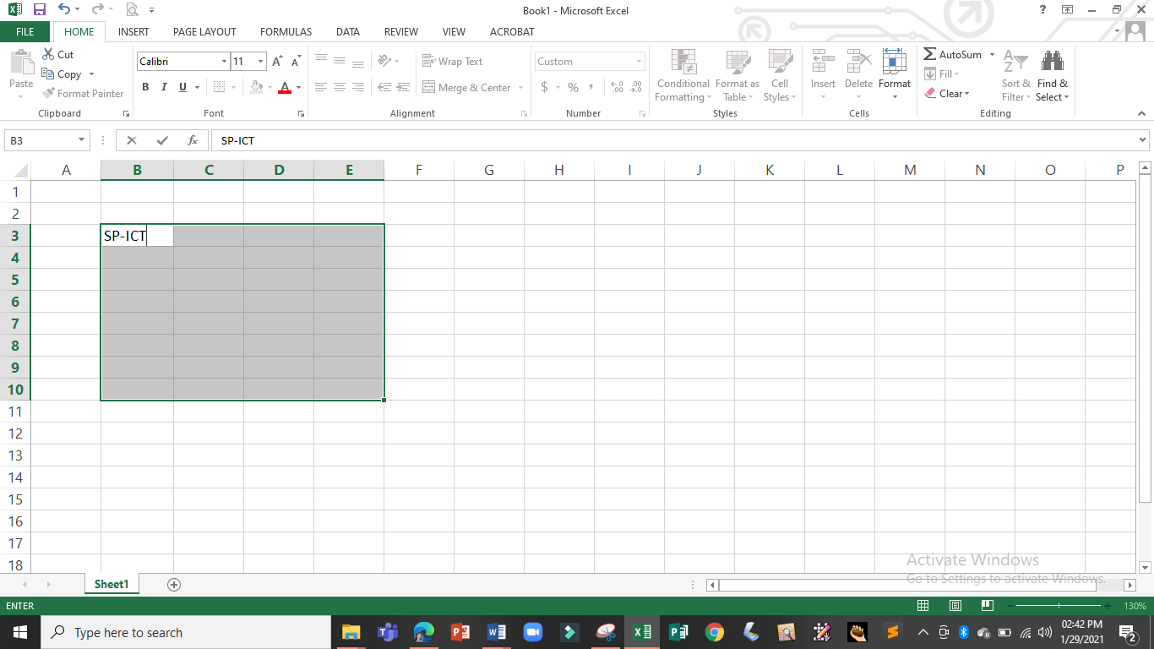Select the range of cell where you want the data to be stored and begin typing
2. 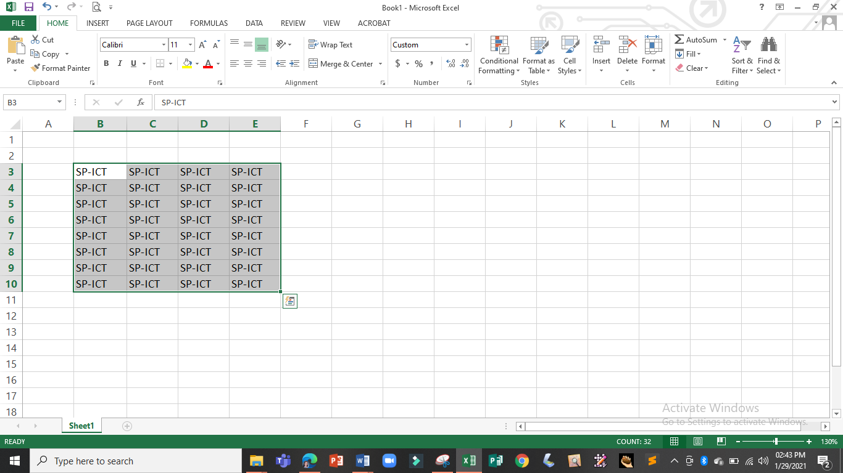Hold the Ctrl key and press the Enter key to store the data into all of the selected cells.

**ENTERING DATE AND TIME**

Dates and times are the most common data types we enter in Excel. It is a little confusing to work with dates because Excel usually store the date in its default format regardless of how you have entered date in a particular cell. In that reason, it is better to know the different Excel date format and how to apply it.

**To Enter Date and Time:**

1. Select the cell where you want the date or time to be stored and begin typing.
2. 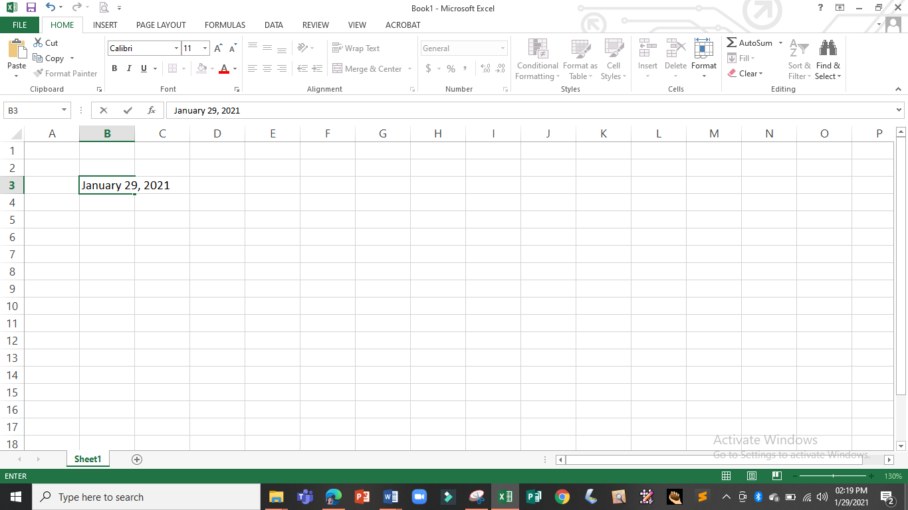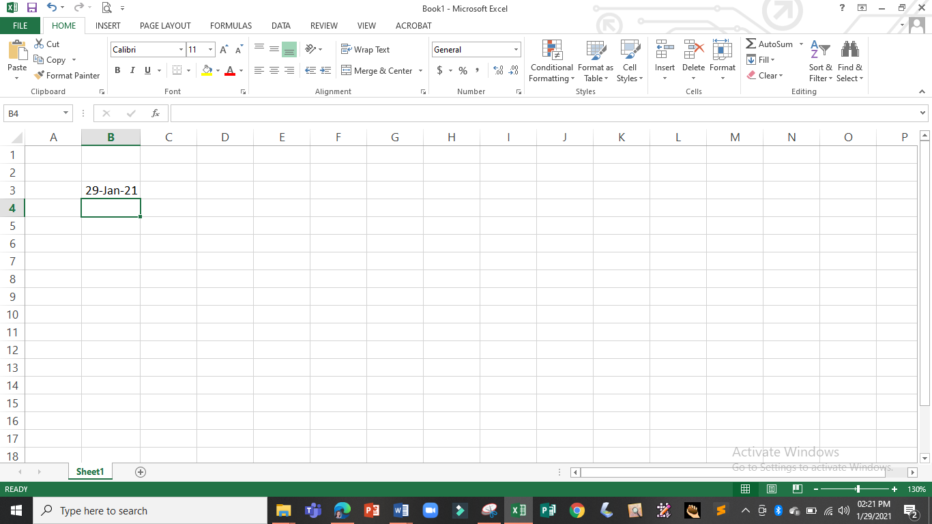Press the Enter key to store the date or time into the cell

*as you press the enter key the date will stored but Excel apply a different date format*

*for example you enter the date* ***December 28, 2020*** *at cell B3*

**To Change the Date Format:**

1. Select the cell with the date to be formatted

2

1. 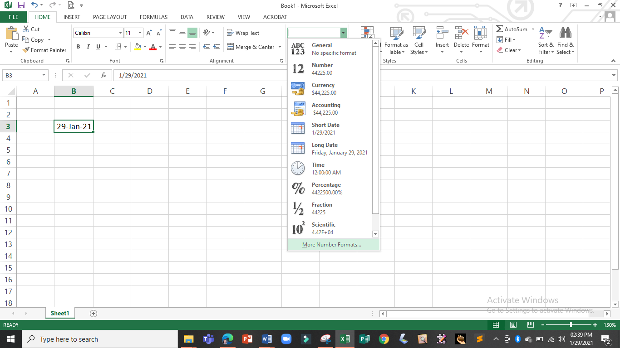In the **Number Group** of the **Home Tab**, click the down arrow next to the **Number Format Button**, and click **More Number Formats…** to display the **Format Cells** dialog box.
2. 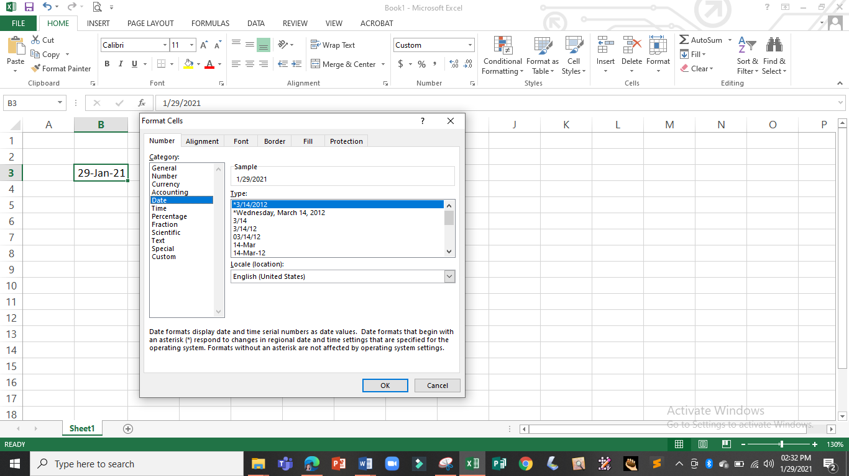In the **Number Tab**, select **Date** in the **Category Group**
3. Select the date format to be used in the **Type Group**, and click the **OK Button** to apply the selected format.

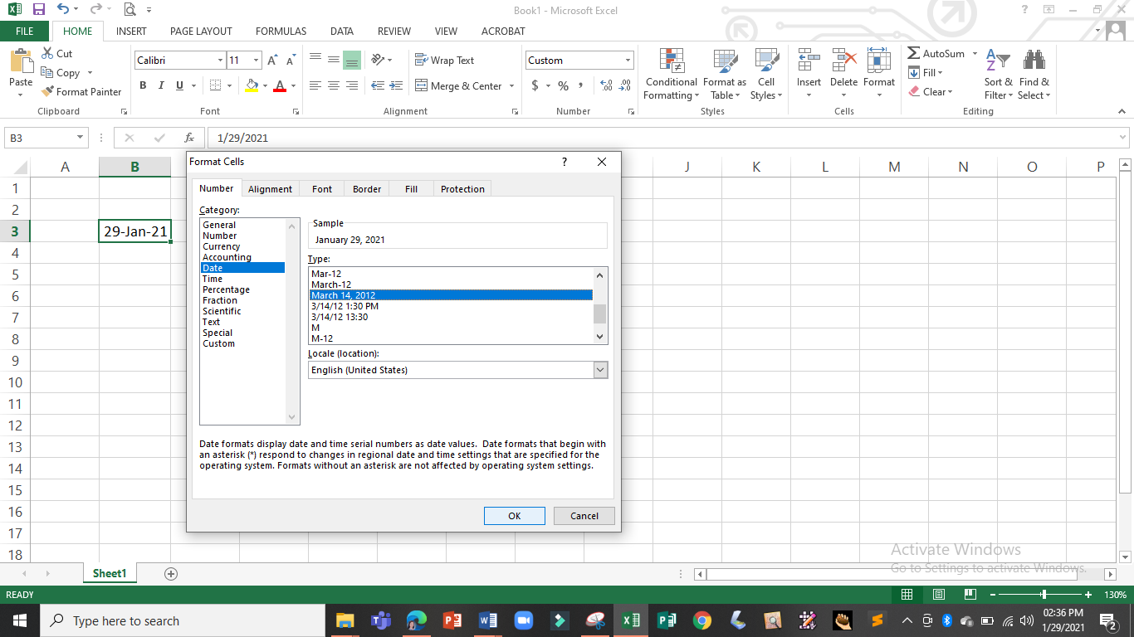

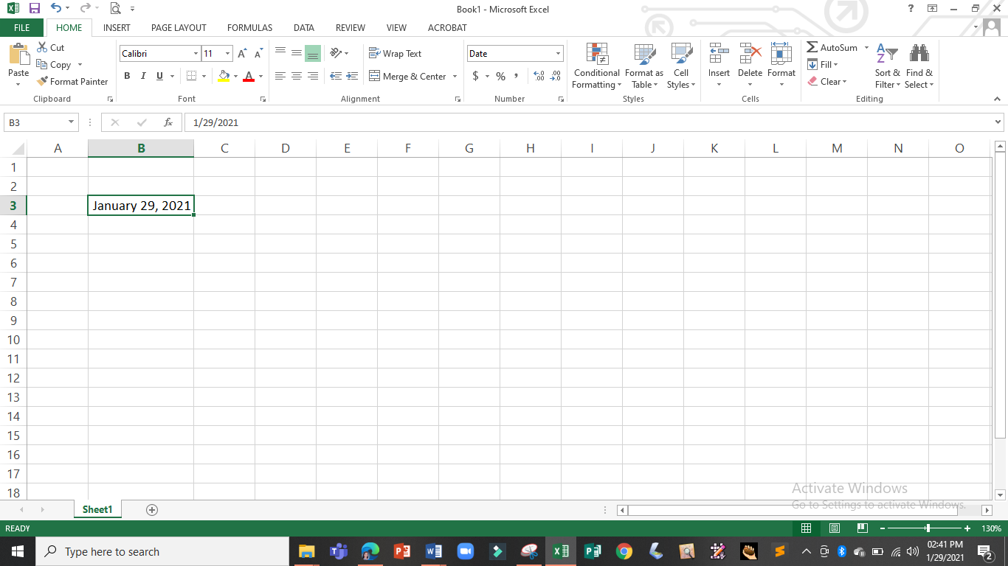

*new date format*

**3**

**Editing Cell Content:**

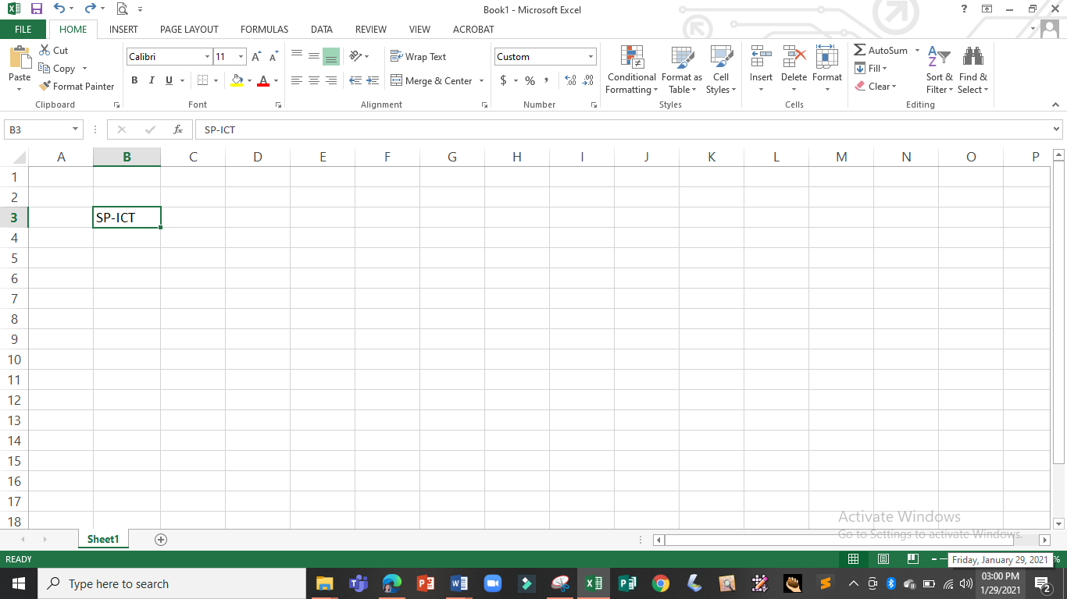**To edit using the Formula Bar:**

1. Select the cell to be edited

*click the cell containing the data to be edited*

1. 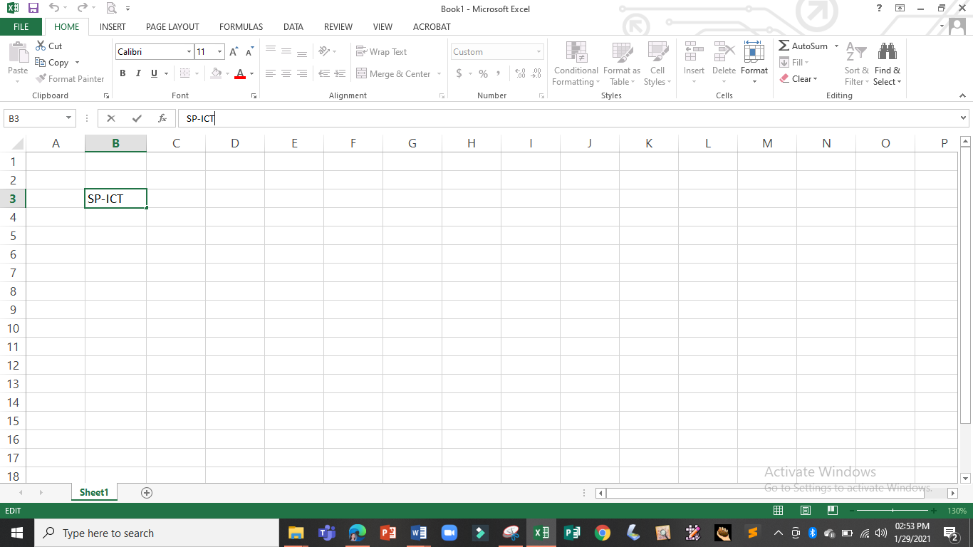Click in the Formula Bar and start editing

*as you click in the formula, an* ***insertion point (cursor)*** *will appear, that indicates that you have activated the formula bar*

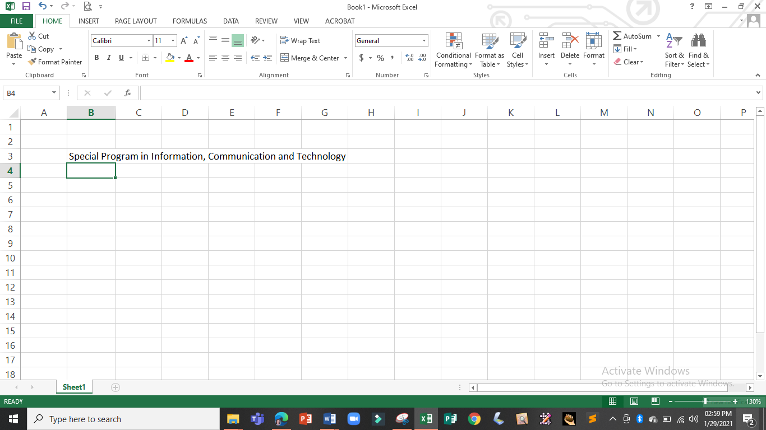

*and the edited data will be stored in the cell*

1. Press the Enter Key / Tab Key /

Shift + Tab to store the edited data

**To edit using the cell itself:**

1. Select the cell to be edited

*click the cell containing the data to be edited*

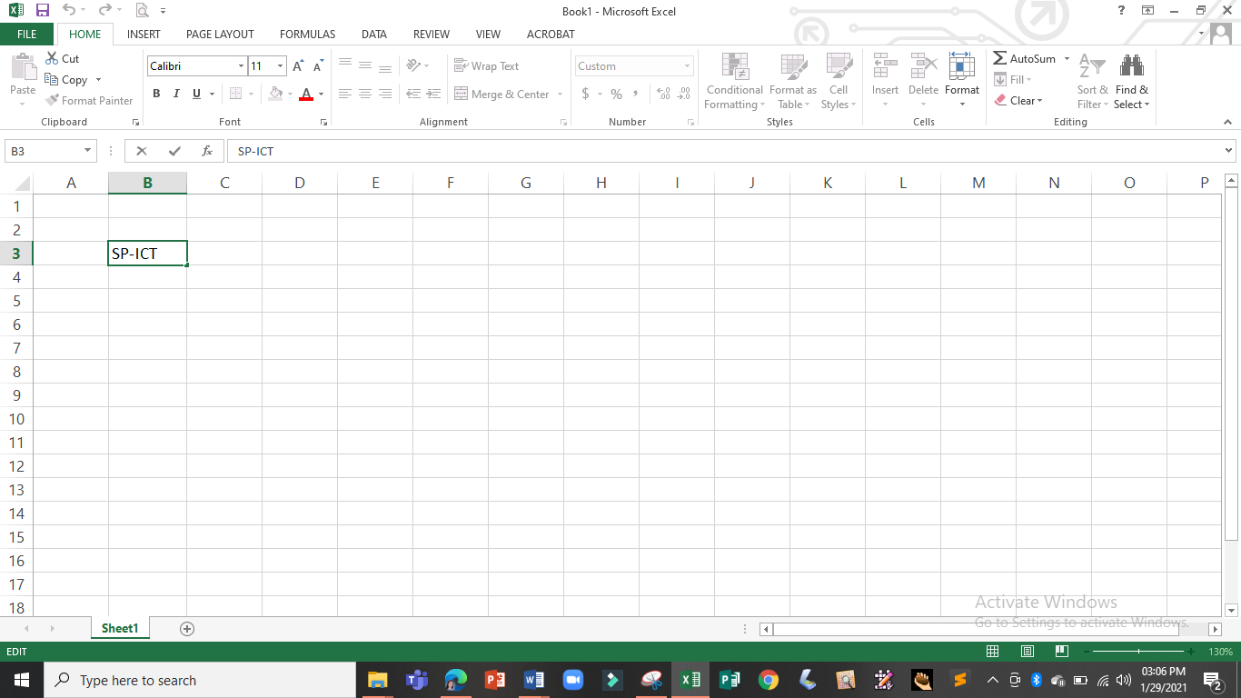

1. Press F2 or double-click over

the cell and start editing

*as you press F2 or double-click the cell, an* ***insertion point (cursor)*** *will appear in the cell itself, indicating that you have activated the cell*

|

1. Press the Enter Key / Tab Key / Shift + Tab to store the edited data

**Deleting Cell Content**

1. Select the cell with content you want to delete
2. Click Clear Command on the Home Tab and select one of the available options



clear everything from the selected cell (including text and formatting applied to the cell)

clear the hyperlinks from the selected cell

clear only the formatting that is applied to the selected cell leaving only the plain text

clear only the content in the selected cells leaving all the formatting applied to it

clear any comments that are attached to the selected cell

4

**FYI**: You may also delete cell content by selecting the cell and pressing either the **delete key** or the **backspace key** (this will delete only the content of the selected cell)

**Replacing Cell Content**

* Select the cell and begin typing, the newly typed text will overwrite the current data in the cell.

**5**

**LEARNING ACTIVITY SHEET**

**SPECIAL PROGRAM IN ICT 7**

**OFFICE PRODUCTIVITY-MICROSOFT EXCEL**

*Third Quarter, Week 4*

Name of Learner: _____________________________ Date: __________________________

Grade Level /Section: __________________________

**LEARNING COMPETENCIES**

* Enter and edit data in a worksheet
* Replace and delete data in a cell

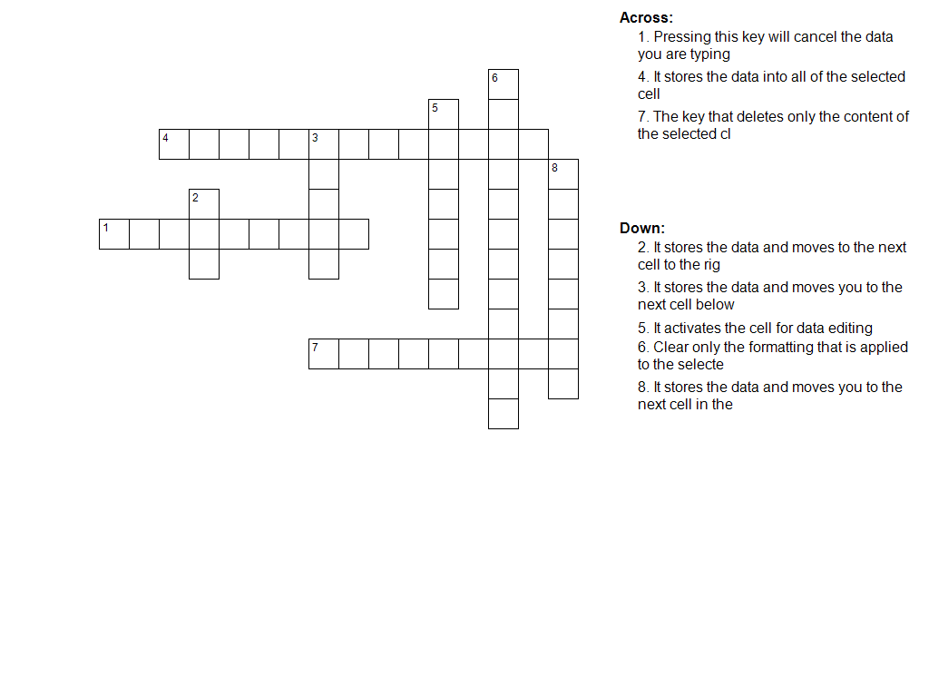**ACTIVITIES**

**Activity 1:** Crossword Puzzle



### Activity 2 : Hands-on Activity

1. With your PC or Laptop execute the following commands:

Take a short video of yourself and attach it in our Google Classroom

* Enter your name in cell B5 to B10 (follow the steps in entering the same data into multiple cells
* Enter the current date with the following format
  + December 28, 2020
  + 28-December-2020
  + Monday, December 28, 2020

1. In not less than 100 words, share your experience in executing the given commands.