**

**LEARNING ACTIVITY SHEET**

**SPECIAL PROGRAM IN ICT 7**

**OFFICE PRODUCTIVITY 7**

*Third Quarter, Week 5*

**Move, Copy, Delete, and Undo Changes in Cells**

**Background Information for Learners**

Cut, Copy and Paste are very essential operations in Excel. You can quickly copy and/or cut information in cells like texts, numbers or formulas, and paste them into another cells. These operations save you a lot of time from having to type and retype the same information. The Cut, Copy and Paste buttons are located on the Ribbon.

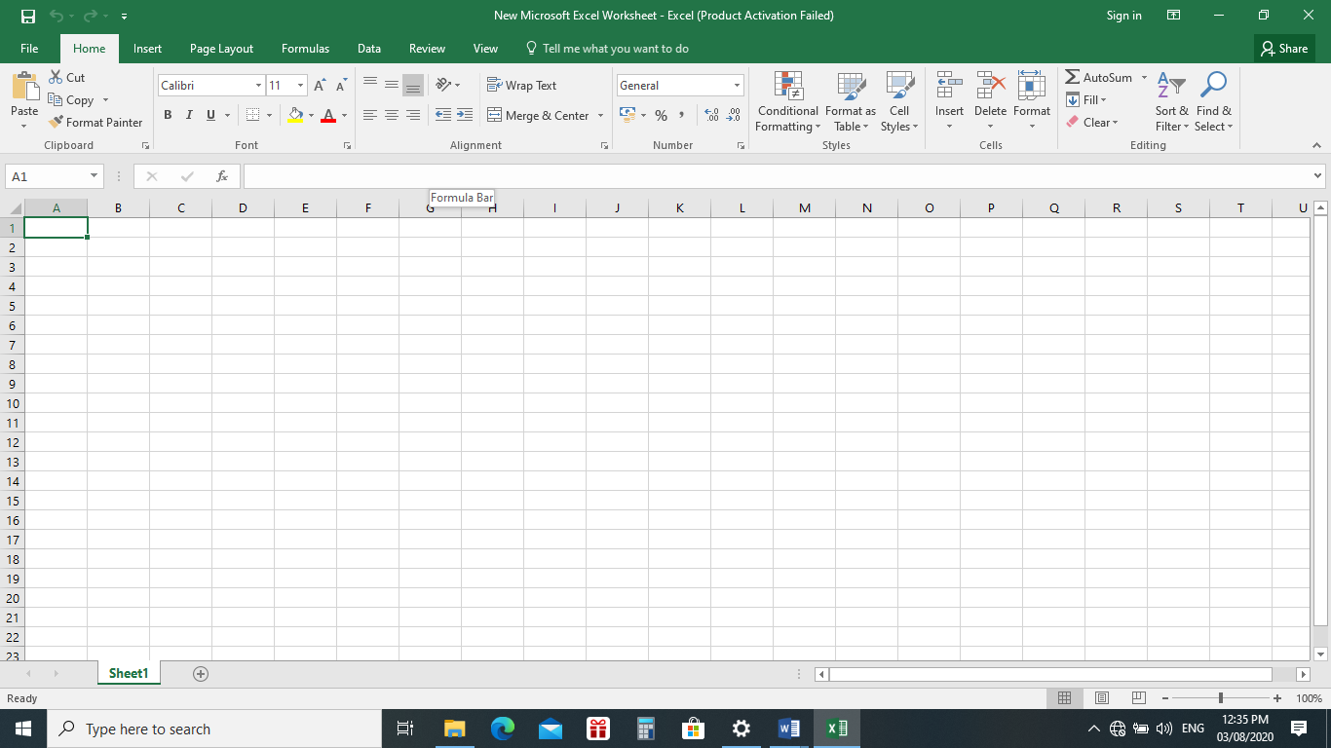

**Copy and Paste Cell Contents**

The Copy Feature allows you to copy selected information from the spreadsheet and temporarily place it on the clipboard, which is a temporary storage file in your computer’s memory. The Paste feature allows you to select any of the collected items on the clipboard and Paste it in a cell of the same or different spreadsheet.



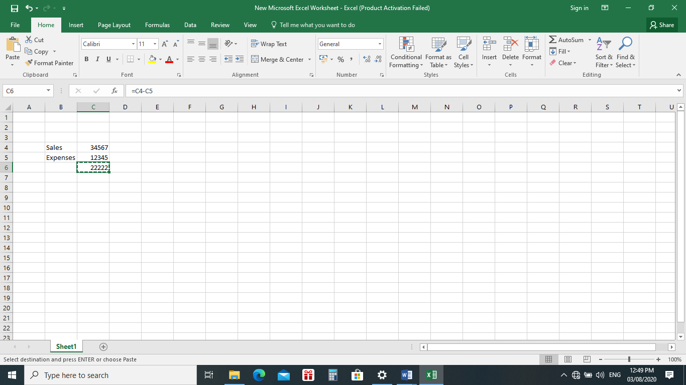**To copy data in a cell:**

1. Select a cell or cells to

Be duplicated.

1. Click on the Copy button on

the Ribbon.

1. The boarder of the copied

Copied cell

Cell(s) takes on the

Appearance of marching ants

1. Click on the cell where you want

To place the duplicated information.

The cell will be highlighted if you

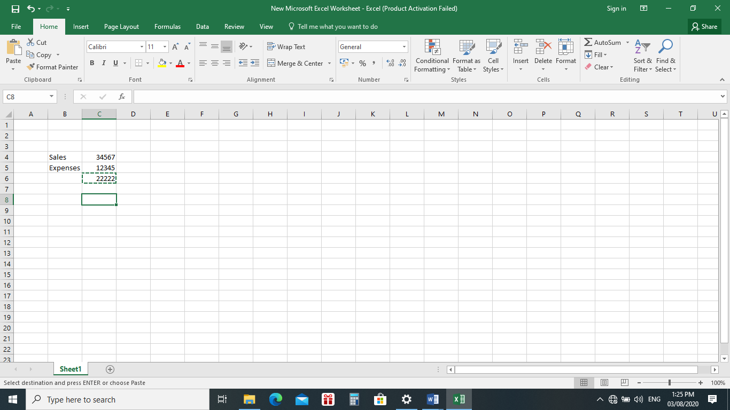are copying contents from more than one cell. Click the first cell where you want to place the duplicated information.

1. Click the location or cell where you want the duplicated information to be pasted. Click the Paste button on the Ribbon or press the Enter Key on your keyboard.

Notice the marching ants remain

Click where the information will be pasted.

Note: Be careful if you paste copied cell information into cells that already contain data. If you do, the existing data is overwritten.

You can copy information from many different sources including Websites, emails, or other Office Applications like Word and PowerPoint and paste it into an Excel Spreadsheet.

**Cut and Paste Cell Contents**

The Cut feature allows you to remove information from cells in the spreadsheet. Information that is cut can be pasted in another cell, as long as the pasting occurs before you perform another operation. If you don’t paste the cut information immediately, it is removed from the Office Clipboard.

**To cut and Paste**

1. Select a cell or cells to be cut.
2. Click on the Cut Button in the Ribbon
3. The information in the cell is removed
4. The boarder of the cut cell(s) take on the appearance of marching ants.
5. Click on the cell where you want to place the cut information. The cell will be emphasized. If you want to paste the contents into more than one cell, click the first cell where you want to place the information and paste it.
6. You can also Press the enter key so your information will be pasted to the new location.



Notice the marching ants remain

Click where the information will be pasted.

**Moving Information using Drag – and – Drop**

Alternative way to move data from one cell to another is to use the drag-and-drop process. You use the pointer to point to the data to be relocated and then drag the cell to its new location.

**To use Drag – and – Drop**

1. Highlight and select the cell(s) you want to move to a new location.
2. Place the mouse pointer near one of the outside ends of the selected cell(s). The mouse pointer changes from a large, white cross and become a slim, black cross with arrows at all ends.

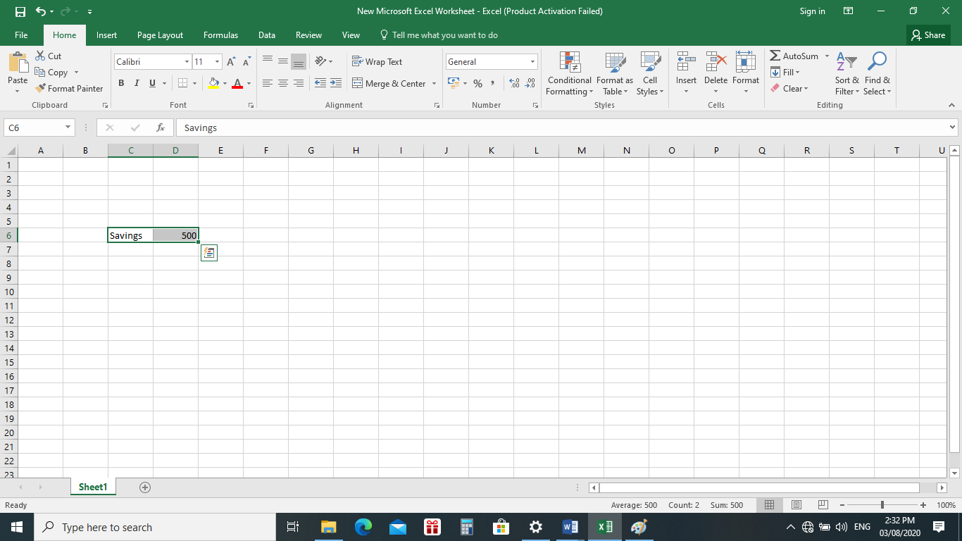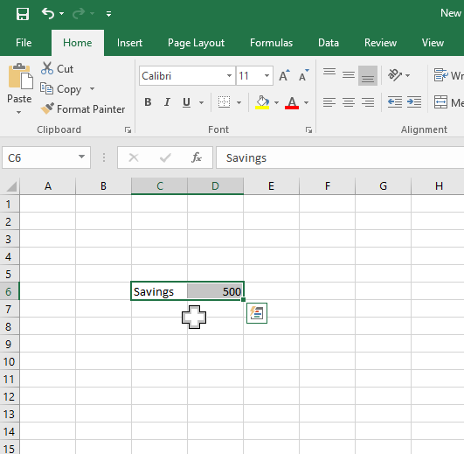

Slim, black cross with arrows at all ends

Large White Cross

1. Keep the mouse pointer on the outer edge of the selected cell, click and hold the left mouse button and drag the cell(s) to a new location.

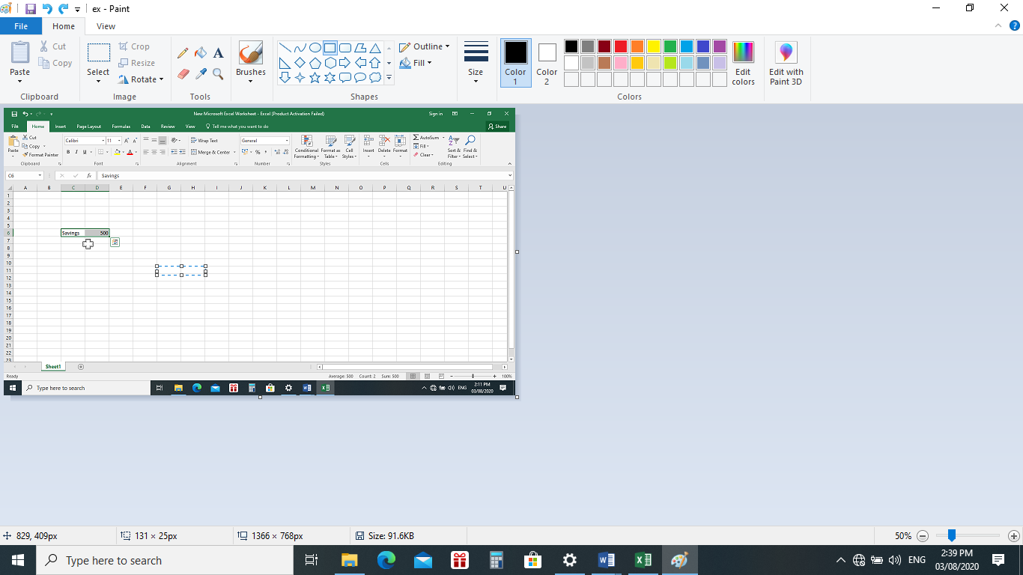

1. Release the mouse button to move the information to the new location.

**Deleting Information in a Cell**

**To delete data that already appears in a cell:**

1. Click the cell that contains the information to be deleted.
2. Press the Delete Key or
3. Right – Click and choose Clear Contents from the shortcut menu.

**To delete Data Being Typed But Not Yet Added to the Cell**

1. Stop an entry by pressing the Escape(esc) key on your keyboard or
2. Simply press the Backspace key also found in the keyboard

**Undo and Redo**

Sometimes, you might do something to a spreadsheet that you didn’t mean to do, like typing the wrong numbers or texts in a cell. MS Excel allows you to undo an operation by simply clicking the Undo Button found on the Quick Access Toolbar.

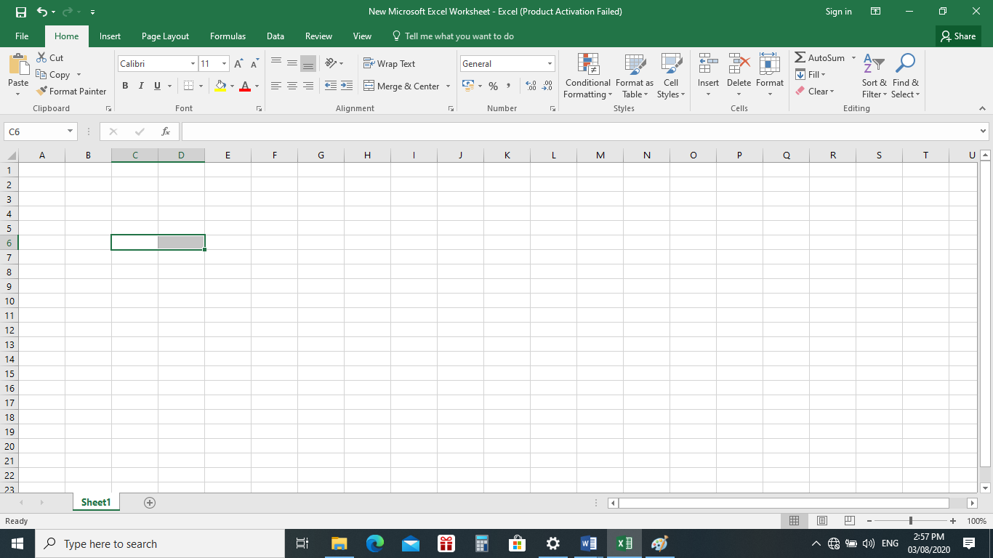

Quick Access Toolbar

Undo

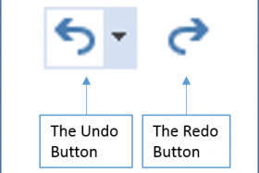**To Undo Recent Actions (Typing, Formatting, Etc, one at a time)**

1. Click the Undo Button.

**To undo several recent actions at once**

1. Click the arrow next to the Undo Button
2. Select the desired undo operation(s) from the list.

Microsoft Excel reverses the selected action and all actions that appear in the list above it.

An Undo operation can be cancelled by applying a Redo. This is useful when an Undo operation was mistakenly applied. Remember, a Redo is possible only if you have not changed an Excel spreadsheet since the last Undo operation was completed.

**To Redo an Undo Operation**

1. Press the

**To Redo several recent Undo actions at once**

1. Click the arrow next to Redo button.
2. Select the desired Redo operations from the list.
3. Microsoft Excel reverses the Undo Operation.

**Shortcut Keys for Cut, Copy and Paste, Undo and Redo**

1. Cut= Ctrl + X
2. Copy = Ctrl + C
3. Paste = Ctrl + V
4. Undo = Ctrl + Z
5. Redo = Ctrl + Y

**LEARNING ACTIVITY SHEET**

**SPECIAL PROGRAM IN ICT 7**

**OFFICE PRODUCTIVITY 7**

*Third Quarter, Week 5*

Name of Learner: _____________________________ Date:__________________________

Grade Level /Section: __________________________

**Learning Competency with Code**

Move, copy, clear, and undo changes in cells

**Directions/Instructions**

General Instructions: Before proceeding to the diffetent activities, make sure to sanitize your hands using alcohol or alcogel to make sure that you will not acquire any type of germs or viruses from the materials to be used in these activities. Wash your hands after working with your activity to ensure the cleanliness and safety of every learner. *Practice Personal Hygiene Protocols at all times.*

1. **PUZZLE** - Find 10 terms related to MS Excel and encircle them in the puzzle.
2. **TRUE OR FALSE** – Write TRUE if the statement is correct, otherwise, write FALSE and underline the words that makes the statement incorrect.
3. **EXPLAIN BRIEFLY** – Differentiate the functions of the commands.
4. **HANDS ON** – Typing data in the spreadsheet.

**Exercises/Activities**

1. **PUZZLE -** Find 10 terms related to MS Excel and encircle them in the puzzle.

|  |  |  |  |  |  |  |  |
| --- | --- | --- | --- | --- | --- | --- | --- |
| T | E | X | T | C | E | L | U |
| C | O | L | U | M | N | D | N |
| E | S | S | H | E | E | T | D |
| X | E | A | M | D | W | O | O |
| C | L | V | S | O | B | H | S |
| E | E | E | R | M | A | A | T |
| L | C | O | S | I | L | U | R |
| L | T | P | M | U | C | T | P |
| E | F | O | R | M | U | L | A |
| T | A | R | X | D | D | O | S |
| R | O | D | N | O | D | I | T |
| F | E | X | C | E | L | L | E |

1. **TRUE OR FALSE –** Write TRUE if the statement is correct, otherwise, write FALSE and underline the words that makes the statement incorrect.

______1. Ctrl + X is the shortcut key used to cut command.

______2. Copy is equivalent to Ctrl + C command.

______3. Ctrl + Y is used in pasting text in Excel.

______4. Cut feature allows you to copy selected information from the spreadsheet and temporarily place it on the clipboard.

______5. Paste feature allows tou to copy selected information from the spreadsheet and temporarily place it on the clipboard.

______6. Copy feature allows tou to copy selected information from the spreadsheet and temporarily place it on the clipboard.

______7. Clipboard is a permanent storage file in your computer memory.

______8. You cannot copy information from many different sources including Websites, emails, or other office applications like Wod and PowerPoint and paste it into anExcel spreadsheet.

______9. If you paste copied information into cells that already contain data, the existing data is duplicated.

______10. Cut button can be found in formatting toolbar.

1. **EXPLAIN BRIEFLY** – Differentiate the functions of the commands.

|  |  |
| --- | --- |
| **Copy and Paste** | **Cut and Paste** |
|  |  |

1. **HANDS ON**
2. Type the following data in the spreadsheet.

* In cell A1, type **Monthly Budget**
* In cell A2, type **Rent**
* In cell A3, type **Car Payment**
* In cell A4, type **Cable**
* In cell A5, type **Power**
* In cell A6, type **Phone**
* In cell A7, type **Insurance**
* In cell A8, type **Credit Cards**
* In cell A9, type **Groceries**
* In cell A10, type **Gas**

1. Type your other monthly bills in Column A, cells A11 to A14 if you have any.
2. Type **Total Monthly Expenses** in cell A15
3. Type **Income**  in cell A16
4. Type **Savings** in cell A17
5. Save your fille with the file name **Monthly_Budget.xls**  and close it.

**Rubric for Scoring**

**Activty III Rubrics**

|  |  |  |  |  |  |
| --- | --- | --- | --- | --- | --- |
| Criteria | 1 | 2 | 3 | 4 | Score |
| Focus/ Main Point | The answer poorly addresses topic and includes irrelevant ideas | The answer is focused on topic and includes few loosely related ideas | The answer is focused on the topic and includes relevant ideas | The answer is focused, purposeful, and reflects clear insight and ideas |  |
| Support | Provides little or no support for the main point | Supports main point with some underdeveloped reasons and/or examples | Supports main point with developed reasons and/or examples Persuasively | Supports main point with welldeveloped reasons and/or examples |  |
| Organization & Format (Paragraphs, Transitions) | Little or no organization of ideas to build an argument | Some organization of ideas to build an argument | Organizes ideas to build an argument | Effectively organizes ideas to build a logical, coherent argument |  |

**Activity IV Rubrics**

|  |  |  |  |  |  |
| --- | --- | --- | --- | --- | --- |
| Criteria | 1 | 2 | 3 | 4 | Score |
| Completeness | Only 1 - 4 data were entered in the spreadsheet | Only 5 – 8 data were entered in the spreadsheet | Only 9 – 12 data were entered in the spreadsheet | All data were entered in the spreadsheet |  |
| Correctness | Data entered were not in the proper cell addresses | Some data were entered in the proper cell address | Most of the data entered are in correct cell address | All data entered are in correct cell address |  |
| Speed | Activity was accomplished within 1 hour and more | Activity was accomplished within 30 - 55 minutes | Activity was accomplisehe within 15 - 29 minutes | Activity was accomplished in less than 15 minutes |  |