**LEARNING ACTIVITY SHEET**



**SPECIAL PROGRAM IN ICT 7**

**OFFICE PRODUCTIVITY 7**

*Third Quarter, Week 7*

# Formulas in Excel

**BACKGROUND INFORMATION FOR LEARNERS**

One eminent feature of Excel is the ability to compute or create mathematical formulas and functions. It is easier than making computations manually. Excel’s environment became receptive and lively once you use formulas, it automatically updates when you change a data.

Examples of calculations that can be done in excel are:

* Totals
* Subtotals
* Average
* Standard Deviation

In Excel, calculation can be specified by *formulas* and *function.*

**Formulas** are *self-defined* instructions in doing calculations.

**Functions** are *pre-defined* formulas that is already in Excel

Both formulas and functions should be entered in a cell. They should always start with an equal sign “=”.

**ENTERING FORMULA**

After the equal sign, a formula includes the addresses of the cells whose values will be manipulated with appropriate operands placed in between. The operands are the standard arithmetic operators:

|  |  |  |
| --- | --- | --- |
| **Operator** | **Meaning** | **Example** |
| + | Addition | =C13+B14 |
| - | Subtraction | =C13-C14 |
| * | Multiplication | =C13*C14 |
| / | Division | =C13/C14 |
| ^ | Exponents | =C13^C14 |

**Fig. 1.** *Arithmetic Operations*

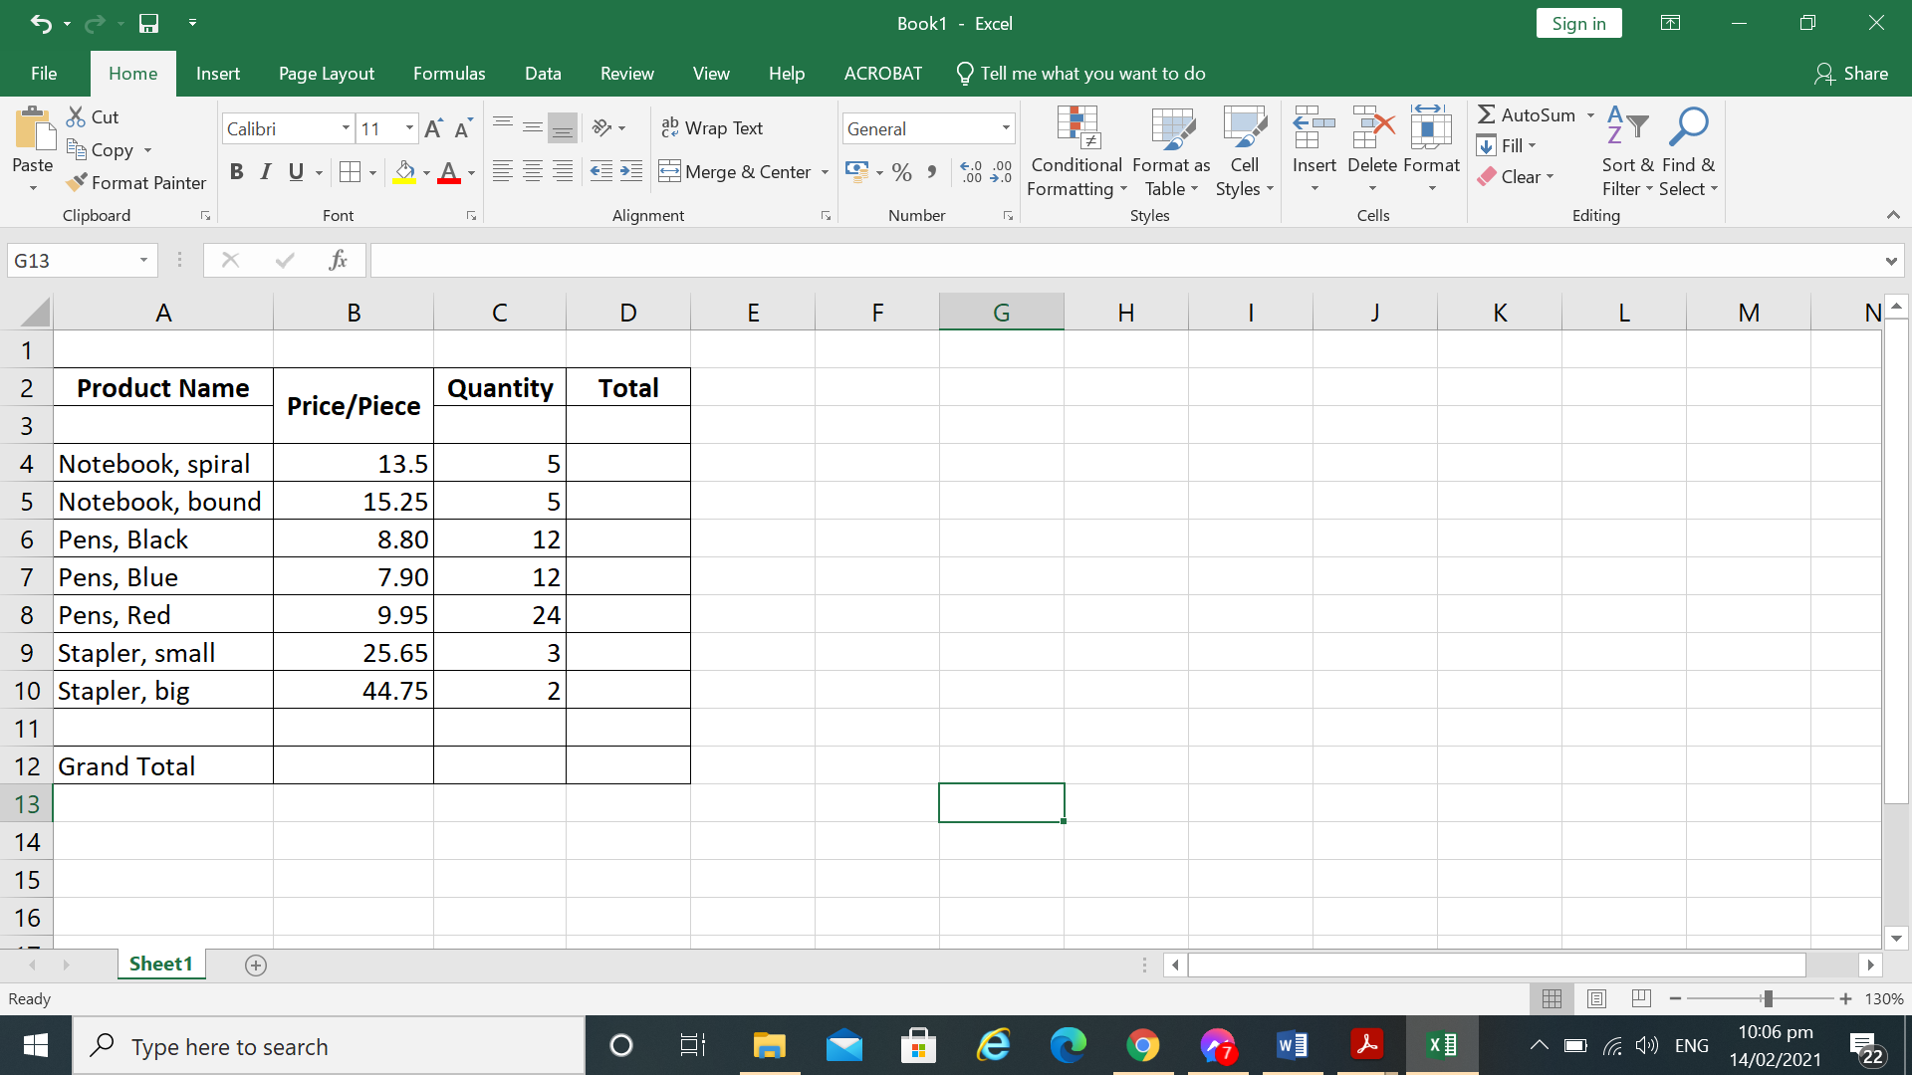**Practice:**

Open a new worksheet.

Enter the following data:

**Fig. 2.** *Sample Table*

You can **resize columns** if text overlaps in another cell. Position your mouse pointer in between **column headers**. Double click. It will **auto fit** the columns to the widest width in the entire column. Or, you can point your mouse in between two column headers (ex. A and B) then drag your mouse to your desired width.

Using arithmetic operations in **Fig. 1,** enter a simple formula for the **Grand total** of the **Price per pieces** of the product.

* Using simple formula, in cell B12, you can simply type ‘=B4+B5+B6+B7+B8+B9+B10’. This is the most logical solution.
* Press **Enter** in your keyboard when done. Notice that the result of the calculation is displayed in the cell B12 that you selected.
* The formula is displayed in formula bar.
* If equal sign ‘=’ is not entered at the beginning, the formula you entered will display a regular text.

**Cell Reference**

Why use cell reference or cell range instead of the actual data (ex. 13.5 or 15.25) in the cell to do the computation? Cell reference makes calculation *automatic*. We say automatic simply because if you change a digit or data in a cell included in the formula, the answer automatically change.

**Practice:**

We are going to change some data in cells included in the formula and notice how the Excel recalculates the formulas we entered.

* Change the amount in cell B4 from ’13.5’ to ‘18.25’.
* See how the total of calculations referencing cell ‘B12’ automatically changed.

*Automatic Calculations*automatically recalculates the result of any formulas as cell entries changes.

**Create Formula that contains Function**

Function is different from formula because after entering the equal sign ‘=’ you will then enter the cell address but not the operators. The function performs calculations by using specific values, which is called *arguments* in a particular order called *syntax. Syntax* must be followed strictly for the function to work correctly.

How to use function:

* Start with equal sign ‘=’
* After = sign state the **function name** (example: Sum)
* Enclosed the **argument** inside a parenthesis. **Argument** is the cell range or cell reference.
* Use a comma to separate the function’s individual arguments.

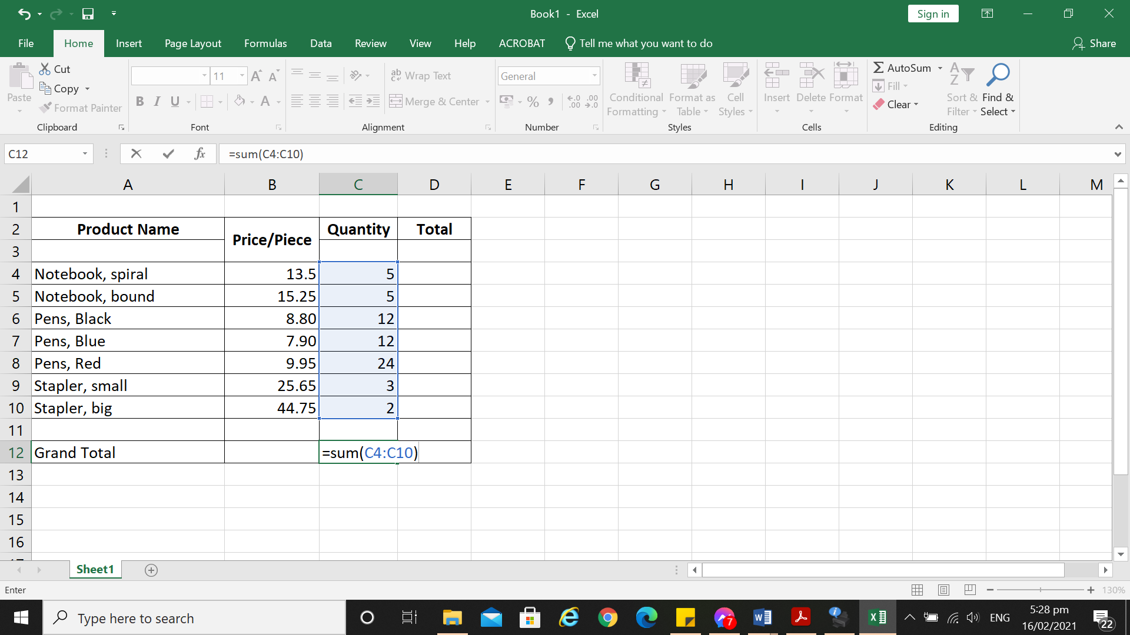

cell range or cell reference

* Formula will display on formula bar by clicking the cell.



Cell reference

Function name

**Practice:**

Using the same spreadsheet above, *Fig. 2 Sample Table,* calculate the Grand Total of Quantity using the *SUM* function.

**Editing Formula**

Sometimes we entered an incorrect cell address in our formula so we will need to correct it. To edit a formula, do the following:

1. 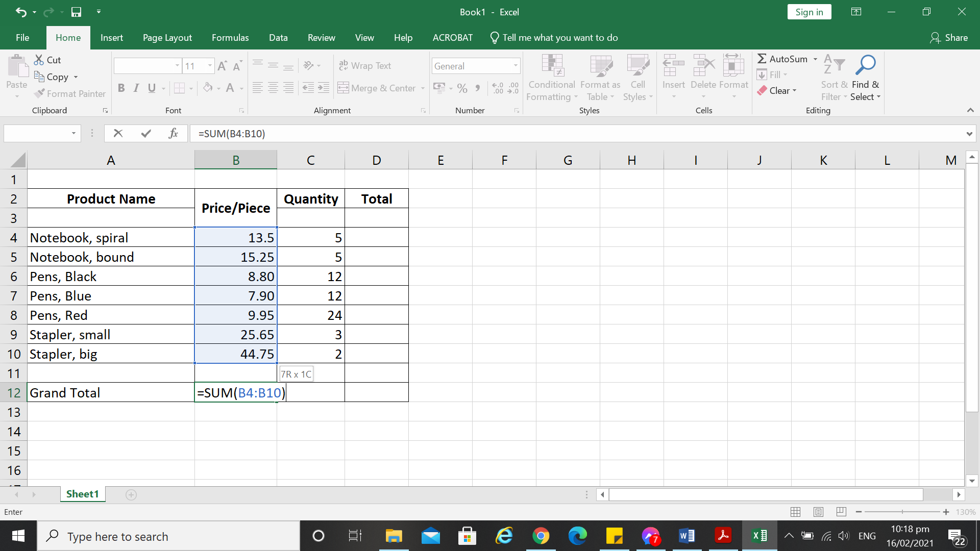Select the cell that contains the formula you would like to edit. For example, select B12, then double click it.
2. You can also edit the formula in the *formula bar*.
3. A colored border will appear to the referenced cells.
4. In the above table you can see that I have changed the referenced cell from B4 to B6. Instead of adding them all, I just get the sum of all the pens. Notice a blue border to the amount of cells included in the formula.

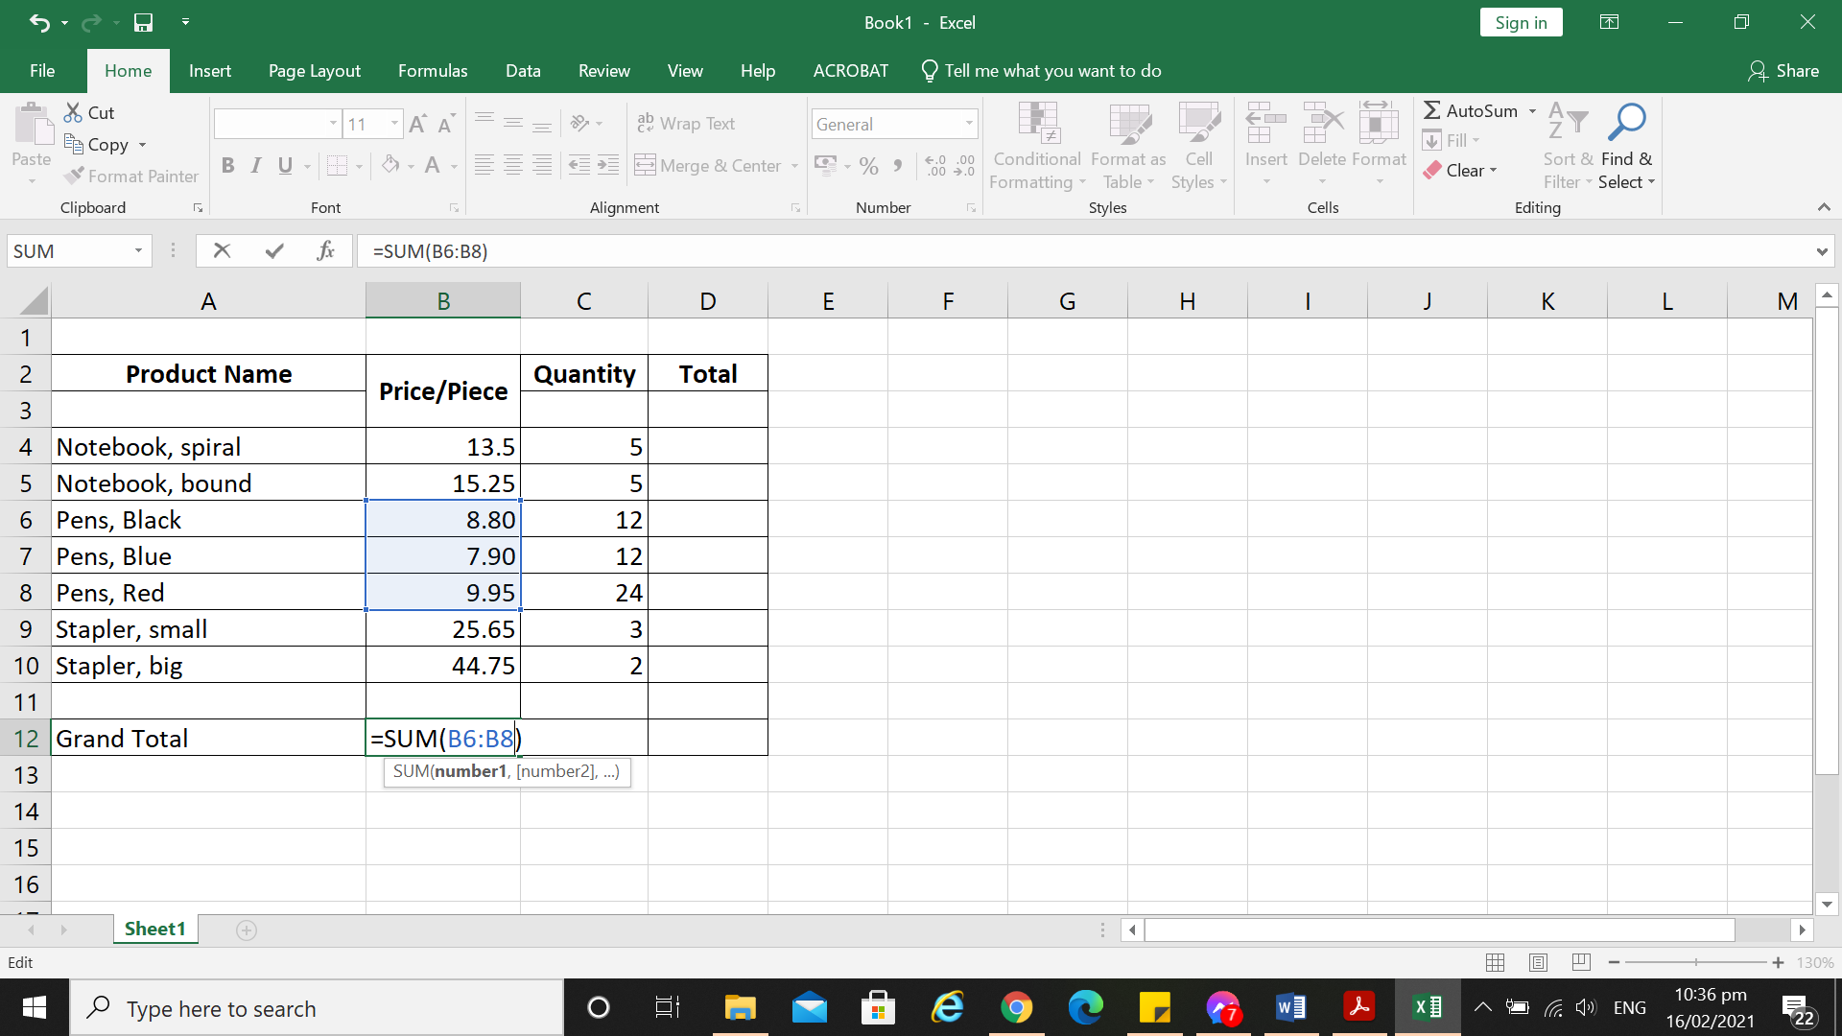

1. When finished, click on **Enter** in your keyboard.

**COPYING FORMULA using CLIPBOARD**

You can always copy or move a formula in a cell, but it is important to note what happens to cell references when you do so.

* When you move a formula, the cell references within the formula *do not* *change* whatever type of cell references (absolute or relative) that you use.
* When you copy a formula, the cell references *may change* based on the type of cell reference that you use.

***Move a formula***

1. Select the cell that contains the formula that you want to move.
2. In the **Home** tab, in the **clipboard** group, click **Cut.**

*You can also move formulas by dragging the border of the selected cell to the upper-left cell of the paste area. Any existing data is replaced.*

1. Click on the cell where you would like put the formula.
2. Do one of the following:

* To paste the formula and any formatting, on the **Home** tab, in the **Clipboard** group, click **Paste**.
* To paste the formula only, on the **Home** tab, in the **Clipboard** group, click the small arrow below the **Paste**, click **Paste Special**, and then click **Formulas.**

***Copy a formula***

* 1. Select the cell that contains the formula that you want to copy.
  2. On the **Home** tab, in the **Clipboard** group, click **Copy**.
  3. Do one of the following:
* To paste the formula and any formatting, on the **Home** tab, in the **Clipboard** group, click **Paste**.
* To paste the formula only, on the **Home** tab, in the **Clipboard** group, click the small arrow below **Paste**, click **Paste Special**, and then click **Formulas**.

*You can paste only the formula results. On the* ***Home*** *tab, in the* ***clipboard*** *group, click* ***Paste****, click* ***Paste Special****, and then click* ***Values****.*

***Using Fill Handle***

You can also copy formula using Fill Handle.

1. Using the same sample table in Fig. 2, enter the formula at the top cell.

* Go to D4, enter the formula ‘=B4*C4’. Hit Enter.
* Select the cell with the formula, and hover the mouse cursor over a small square at the lower right-hand corner of the cell, which is called the **Fill handle**. As you do this, the cursor will change to a thick black cross.
* 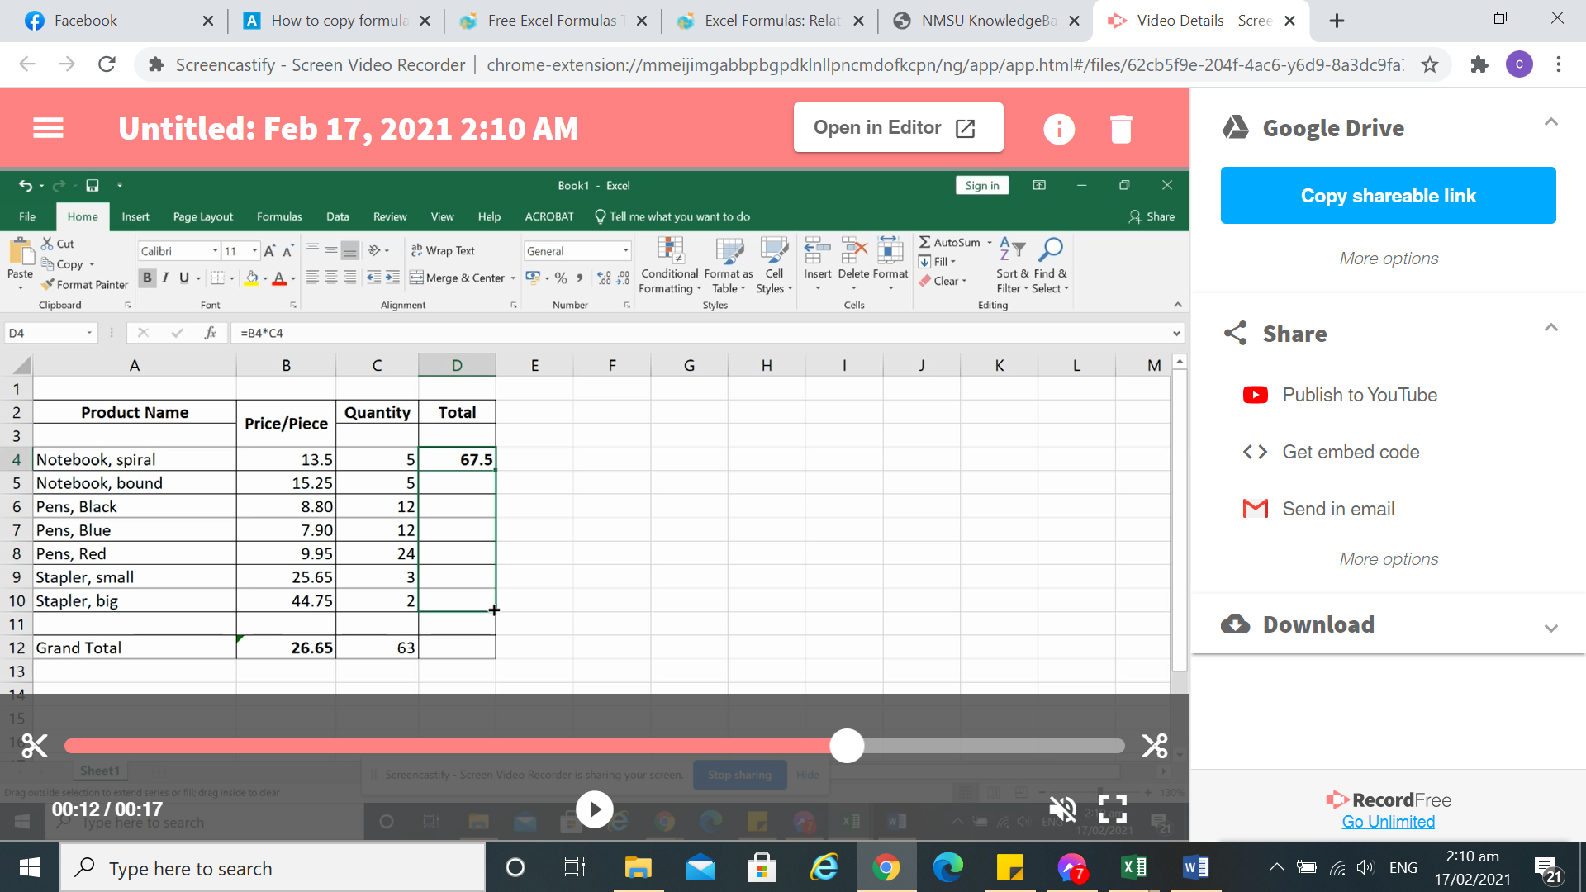

Hold and drag the plus sign down to copy the formula

You can also drag it to the adjacent cell to the left or right or upwards.

**ABSOLUTE CELL REFERENCE**

Absolute Cell reference is used when you want a formula to consistently refer to a particular cell even if you copy or move the formula elsewhere in the worksheet. An absolute cell reference is a cell address that contains a dollar sign ($) in the row or column coordinate or both.

When you enter a cell reference in a formula, Excel assumes it is a relative reference unless you change it to an absolute reference. If you want to make part of a formula relative, remove the dollar sign that appears before the column or row number.

**Create an Absolute Reference**

* + - 1. Click the cell where you want to enter the formula.
      2. Type = (an equal sign) to begin the formula.
      3. Select a cell reference, and then type an arithmetic operator (+, -, *, or /).
      4. Select another cell reference and click F4 to make the cell reference absolute.
      5. If necessary, continue entering the formula.
      6. Click the 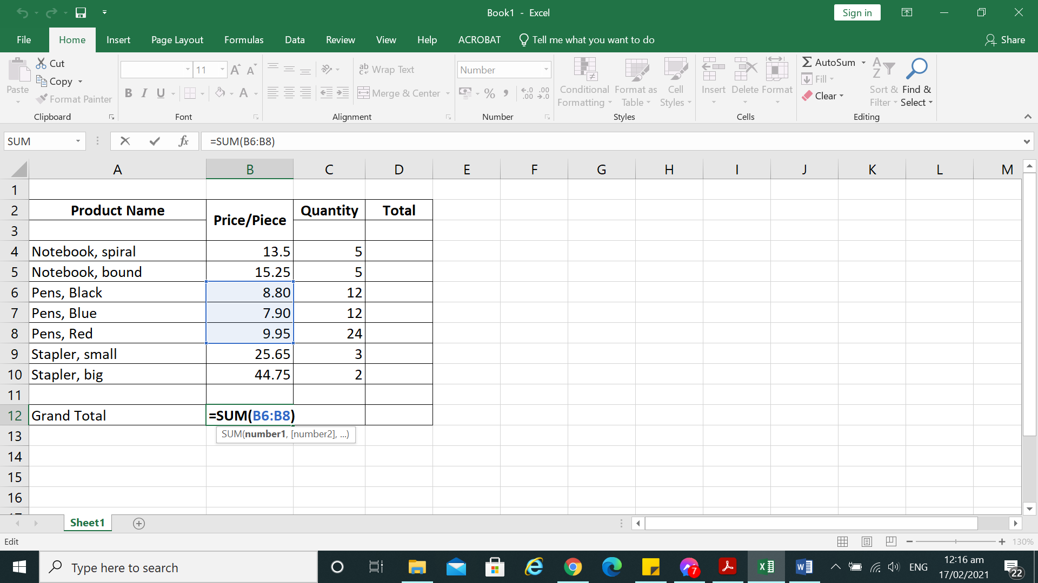 (Enter) in the formula bar, or press **Enter** in your keyboard.

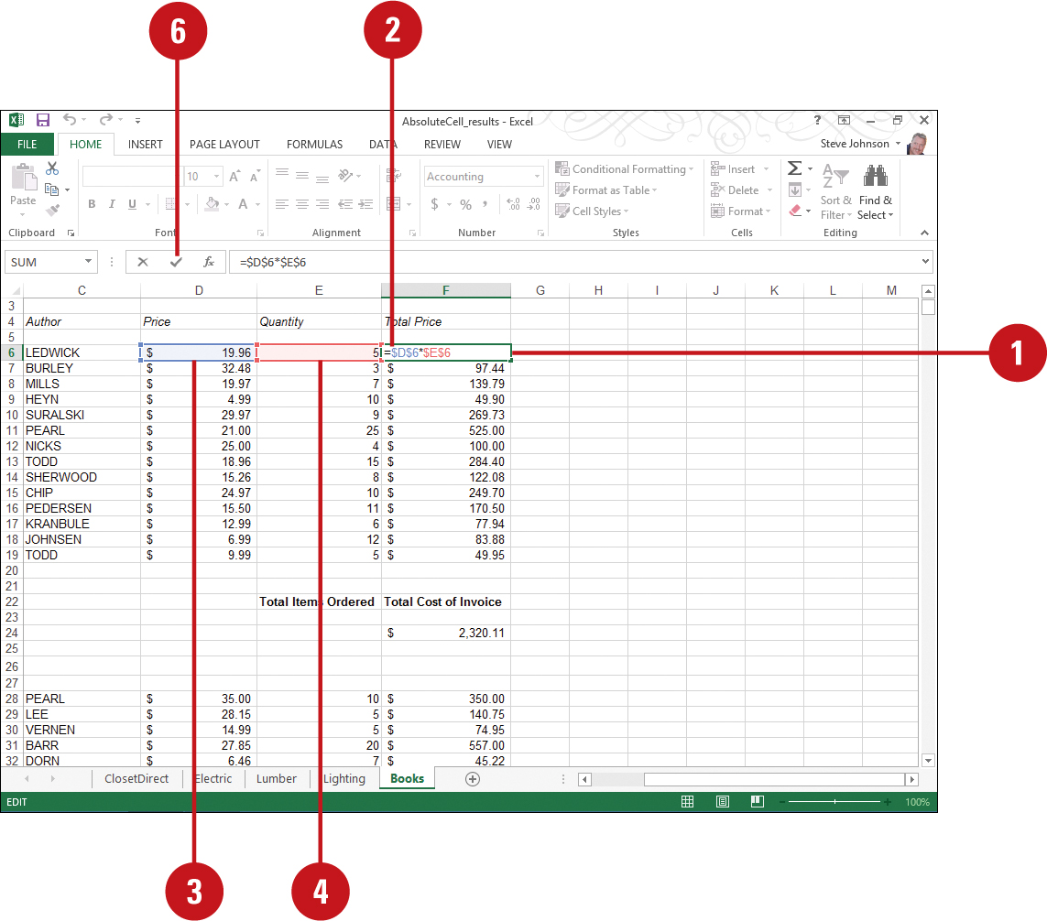

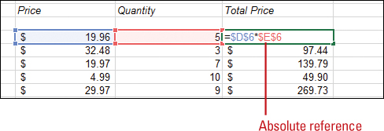

When a formula or function contains absolute cell, reference is copied to a new location, the cell reference is not adjusted.

Example: When the Formula ‘=B4*$C$4’ is copied from D4 to D5, the relative cell reference changes from ‘B4’ to ‘B5’, but the ‘$C$4’ absolute cell reference remains unchanged.

An absolute cell reference is most often used when you want to use a constant in a formula or function.

**LEARNING ACTIVITY SHEET**



**SPECIAL PROGRAM IN ICT 7**

**OFFICE PRODUCTIVITY 7**

*Third Quarter, Week 7*

Name of Learner: _____________________________ Date: __________________________

Grade Level /Section: __________________________

**LEARNING COMPETENCY**

To be able to create, edit, copy and move formula in excel.

To be able to identify and use absolute and relative cell reference in a formula.

**ACTIVITIES**

### ACTIVITY 1

### Directions:

1. Open a blank worksheet.
2. Copy the data on the table below

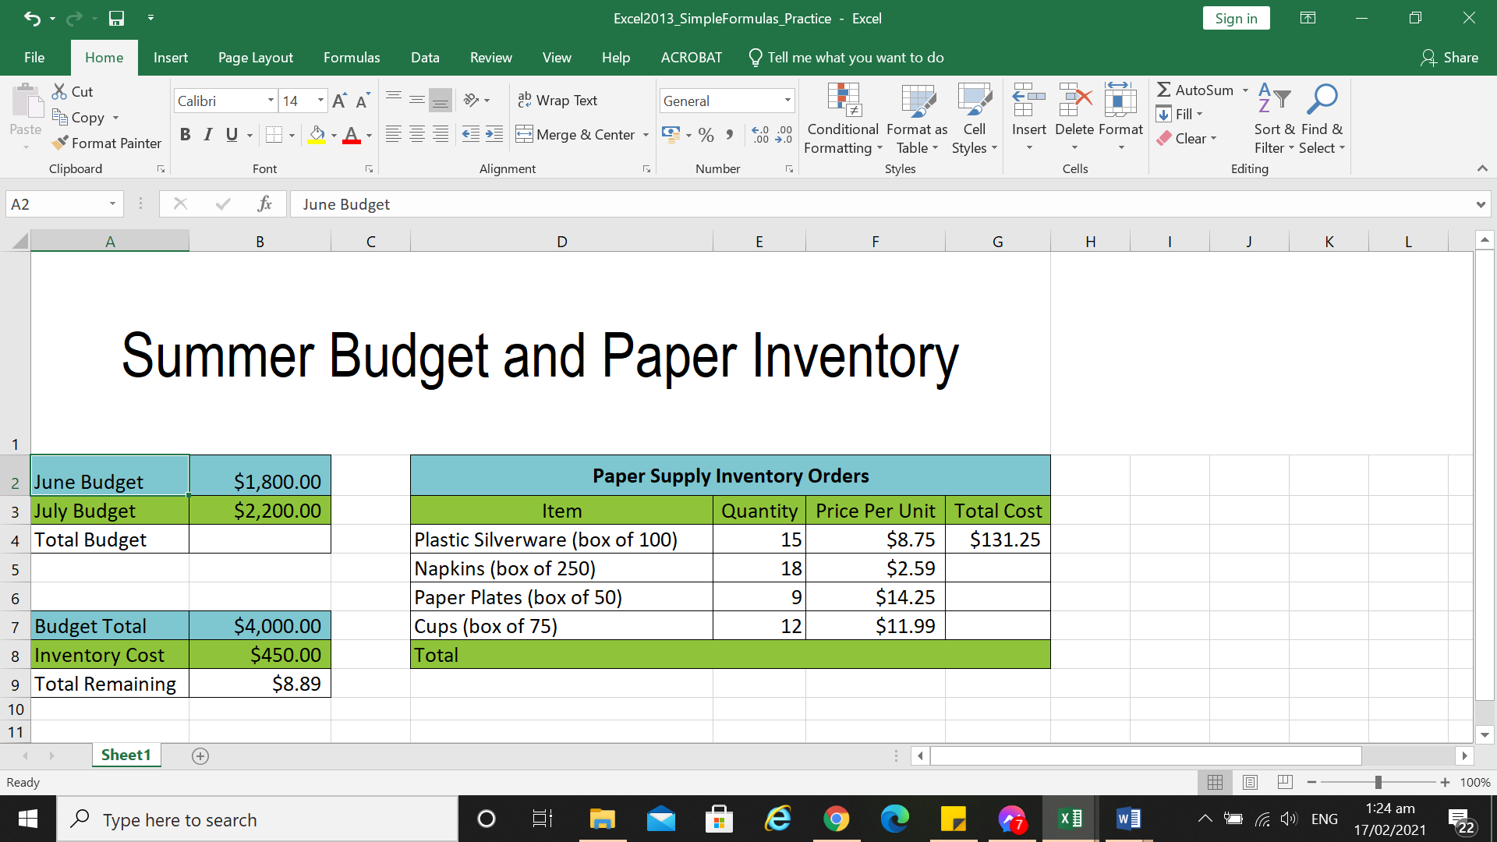

1. Create a simple addition formula using cell references. Create the formula in cell B4 to calculate the total budget.
2. Try to modify the value of a cell referenced in a formula. Change the value of cell B2 to $2,000. Notice the formula in cell B4 recalculates the total.
3. Go to cell G5. Create a formula that multiplies the cost of napkins by the quantity needed to calculate the total cost.
4. Edit a formula using the formula bar. Go to cell B9, the formula should be ‘=B7/B8’. Edit this formula in cell B9 from division (/) to minus sign (-).
5. Save your work. Filename: Act1_week7_Surname, Given name.
6. Send your work to designated Facebook group or google classroom.

**ACTIVITY 2**

**Directions:**

1. Open the file sent to you by your teacher or copy the table below in your worksheet.

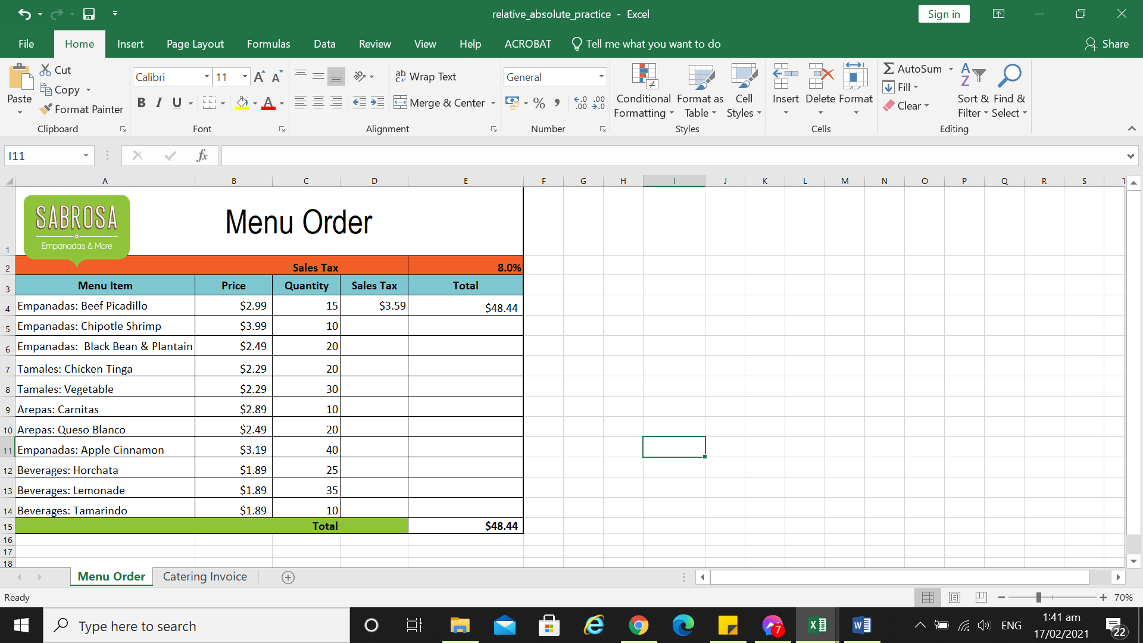

1. Create a formula that uses a **relative** **reference**. Use the **fill handle** to fill in the formula in cells **E4**through **E14**. Double-click a cell to see the copied formula and the relative cell references.
2. Create a formula that uses an **absolute** **reference**. Correct the formula in cell **D4** to refer only to the tax rate in cell **E2** as an **absolute reference**, then use the fill handle to fill the formula from cells **D4** to **D14**.
3. Save your work with filename: Act2_Week7_surname, given name.
4. Send it to your teacher.