

**LEARNING ACTIVITY SHEET**

**SPECIAL PROGRAM IN ICT 7**

**OFFICE PRODUCTIVITY 7**

*Third Quarter, Week 8*

**FUNCTIONS**

**BACKGROUND INFORMATION FOR LEARNERS**

To unlock the power of Excel, you need to use formulas and functions. These calculation tools help you bring information to the surface and make better decisions. Formulas and Functions shows beginner-level users how to summarize and analyze data with these powerful data analysis features.

**INTRODUCTION**

A **function** are the ready-made formulas that perform a series of operations on a specific range of values. Excel includes many common functions that can be used to quickly find the **sum**, **average**, **count**, **maximum value**, and **minimum value** for a range of cells. In order to use functions correctly, you'll need to understand the different **parts of a function** and how to create **arguments**to calculate values and cell references.

#### The Parts of a Function

In order to work correctly, a function must be written a specific way, which is called the **syntax**. The basic syntax for a function is the **equals sign (=) indicates that what follows is a function(formula),** the **function name**indicates the operation that will be performed (example SUM, AVERAGE, COUNT, MIN, MAX), and one or more **arguments**. Arguments contain the information you want to calculate. The function in the example below would add the values of the cell range A1:A20.

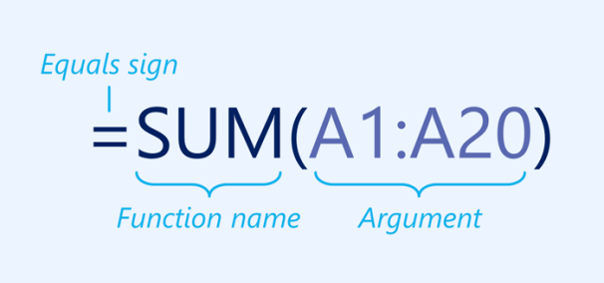

#### Working with arguments

Arguments can refer to both **individual cells** and **cell ranges**and must be enclosed within **parentheses**. You can include one argument or multiple arguments, depending on the syntax required for the function.

For example, the function **=AVERAGE(B1:B9)**would calculate the **average** of the values in the cell range B1:B9. This function contains only one argument.

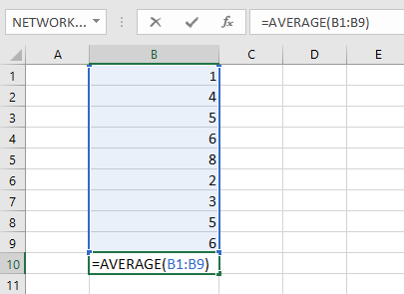

Multiple arguments must be separated by a **comma**. For example, the function **=SUM(A1:A3, C1:C2, E1)**will **add** the values of all of the cells in the three arguments.

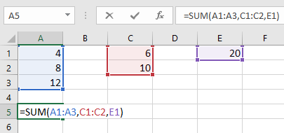

### Creating a Function

There are a variety of functions available in Excel. Here are some of the most common functions you'll use:

* **SUM**: This function **adds** all of the values of the cells in the argument.

To insert the SUM function, you can type the function manually.

The SUM function setup (syntax) is: **SUM(number1**, [number2],...).

* It has one required argument: **number1**
* It also has optional arguments (enclosed in square brackets): [number2],..

These arguments can be cell references, or can be typed into the formula.

In the example below (**=SUM(J7:M7)**), there is one argument -- a reference to cells A1:A4.

1. Place your cursor in cell N7.

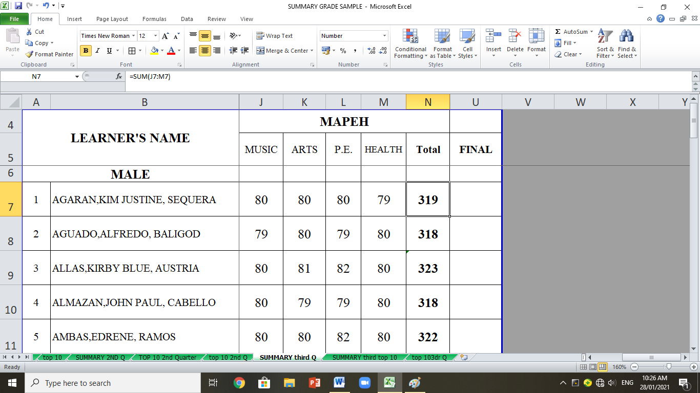

### 2. Look at the formula bar to view the formula contained within the cell M7:J7.

### Formula bar

The formula bar within Microsoft Excel allows the user to view or display the contents of the active cell. The formula bar can be used to manually enter a formula into a cell, edit an existing formula or function and view a formula or function. It is important to remember that the values you see displayed in a cell can be information that has been manually typed or can be the result of a formula or function which is active within a cell. If you want to see where the a is coming from, select the cell and check the formula bar.

* **AVERAGE**: This function determines the **average** of the values included in the argument. It calculates the sum of the cells and then divides that value by the number of cells in the argument.

1. Place your cursor in cell **N7.**
2. Type the = sign followed by the AVERAGE function.

**=AVERAGE**

1. Type the open parenthesis.

**=AVERAGE(**

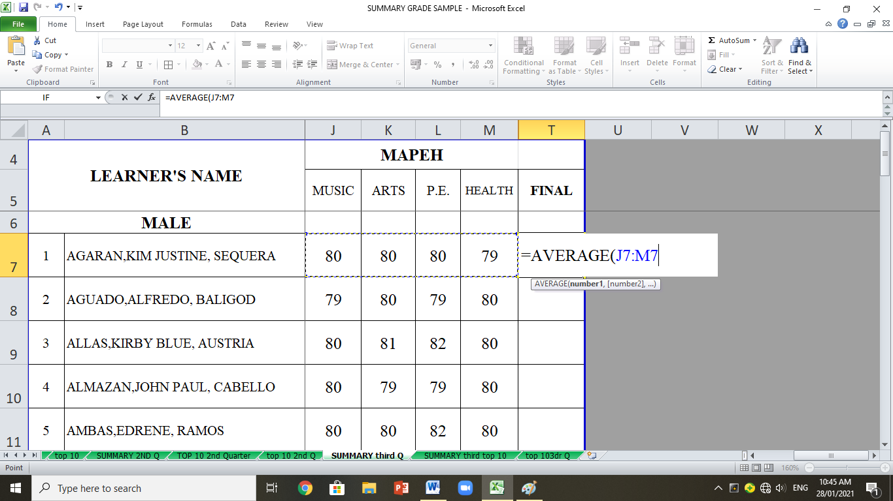

1. Place your cursor in cell J7 and drag unto M7.
2. Now you can press the **Enter** key on the keyboard

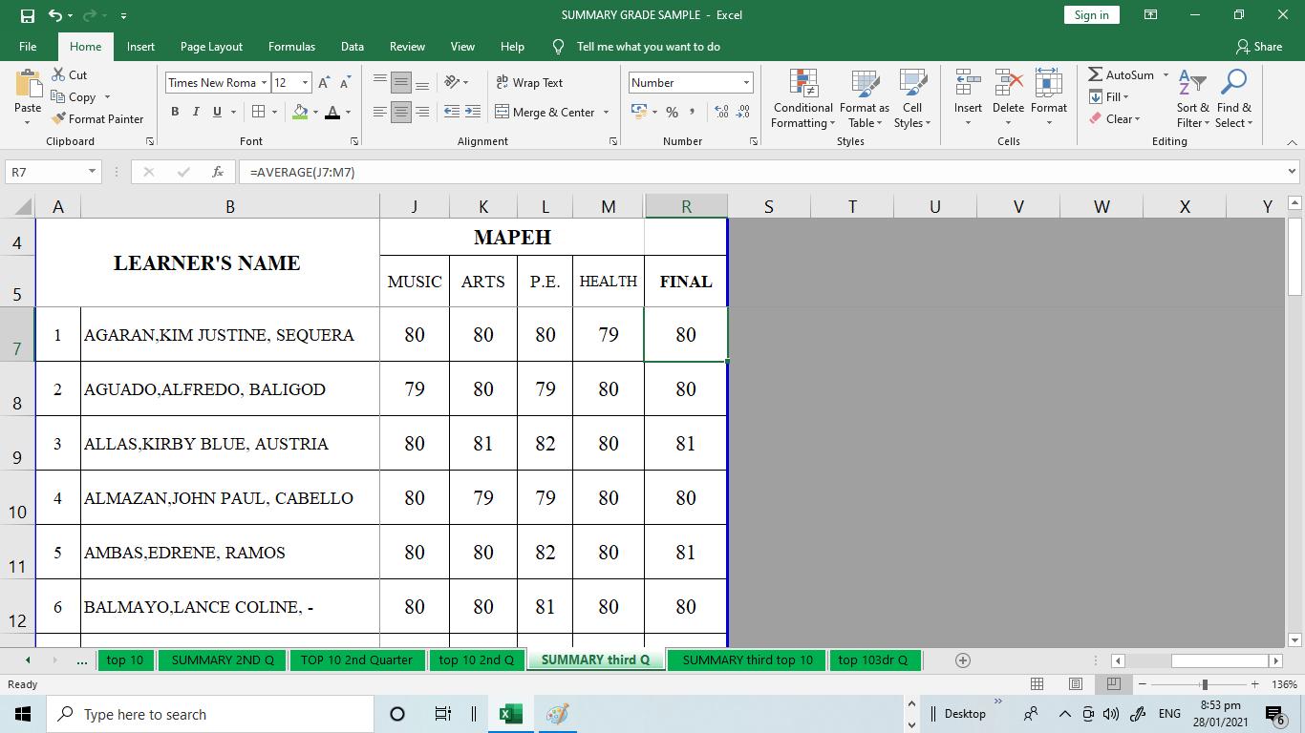

1. You can use the Average function found in Formula Tab.

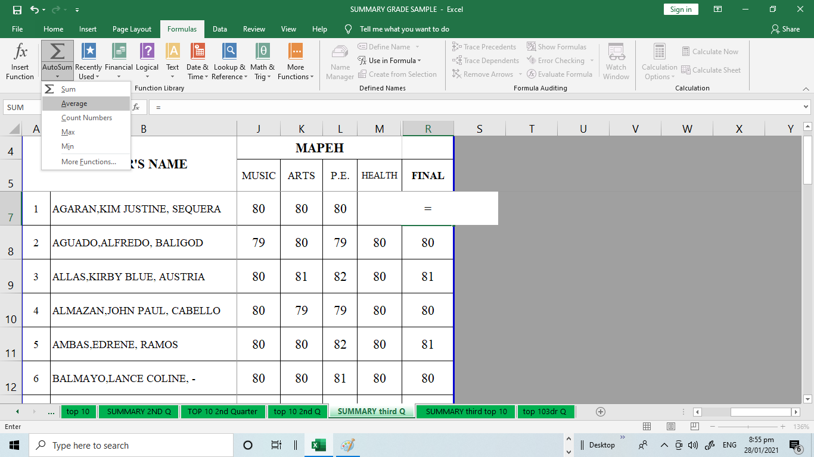

9. Click the **AVERAGE** function click and drag the arguments from **J7:M7** and press **enter.**

* **COUNT**: This function **counts** the number of cells with numerical data in the argument. This function is useful for quickly counting items in a cell range.

1. In B19 type the **=COUNT** and the open parenthesis (. Place the cursor in B5 drag in to B18 type the close parenthesis then **enter.**

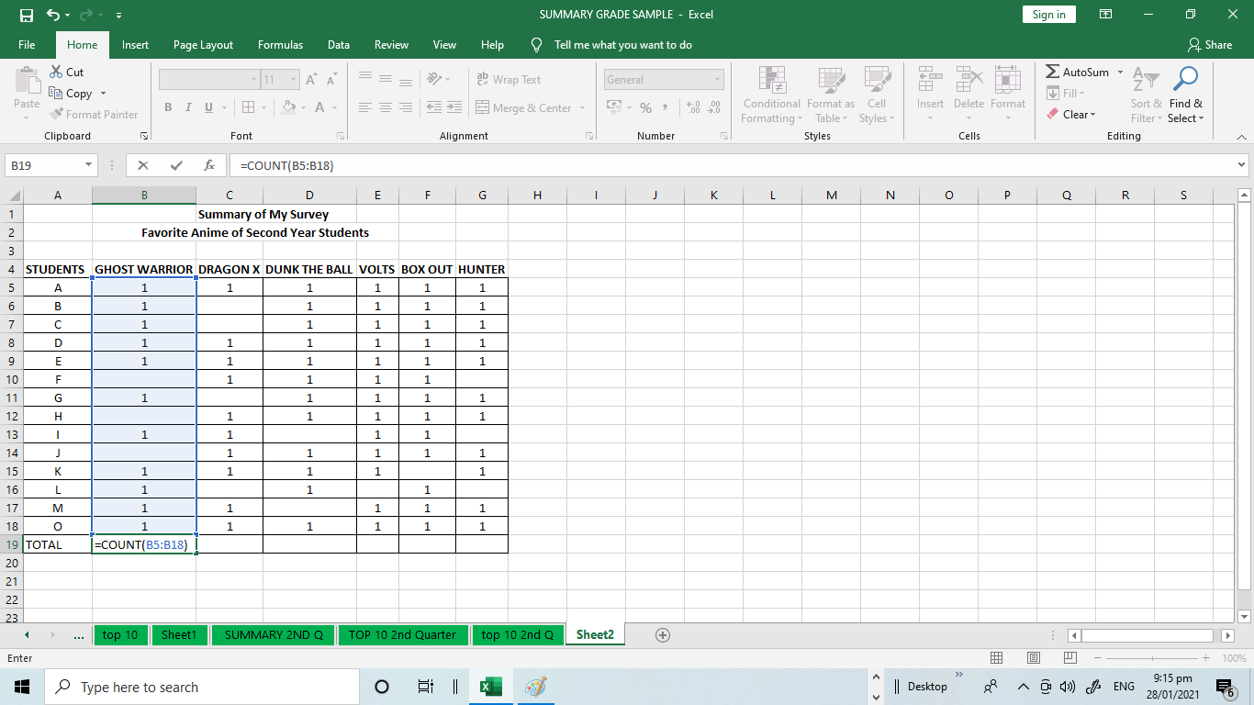

* **MAX**: This function determines the **highest** **cell value** included in the argument.

The MAX function is used when trying to determine the maximum or highest value from a range of cells or values.

1. Using the example above, you can get the highest total number of votes for anime by using the MAX function.

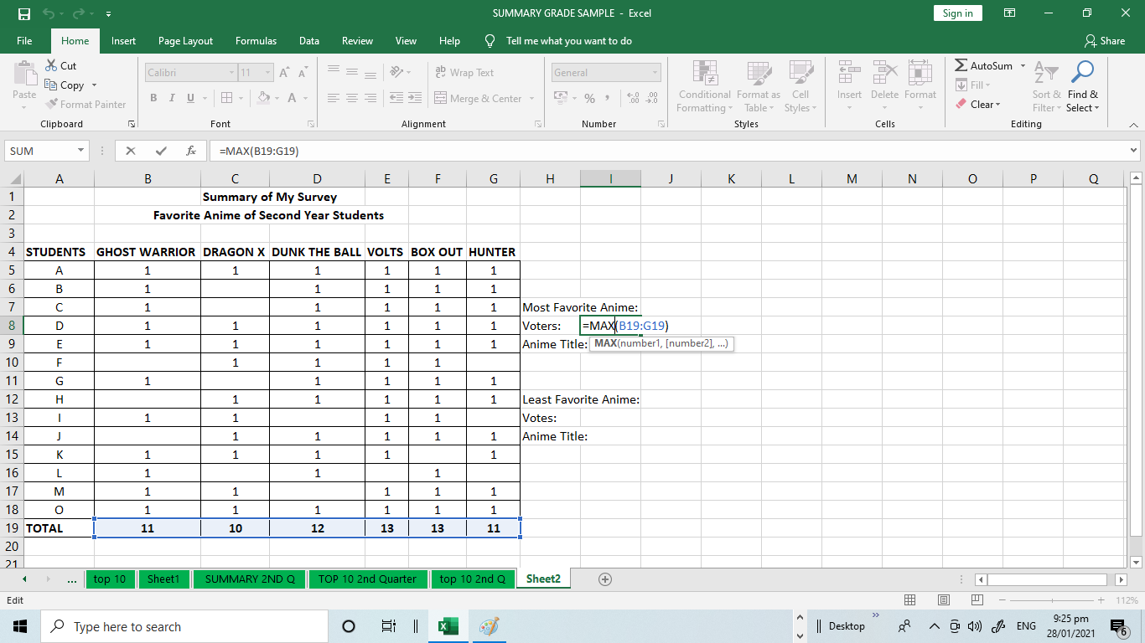

2. You can use the MAX function found in Formula tab.

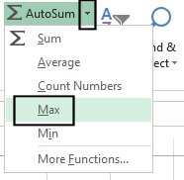

* **MIN**: This function determines the**lowest cell value** included in the argument.

The MIN function is useful for: determining the lowest cost of an item; the lowest quantity; lowest percentage or dollar amount.

1. Using the MIN function, get the lowest total number of anime.

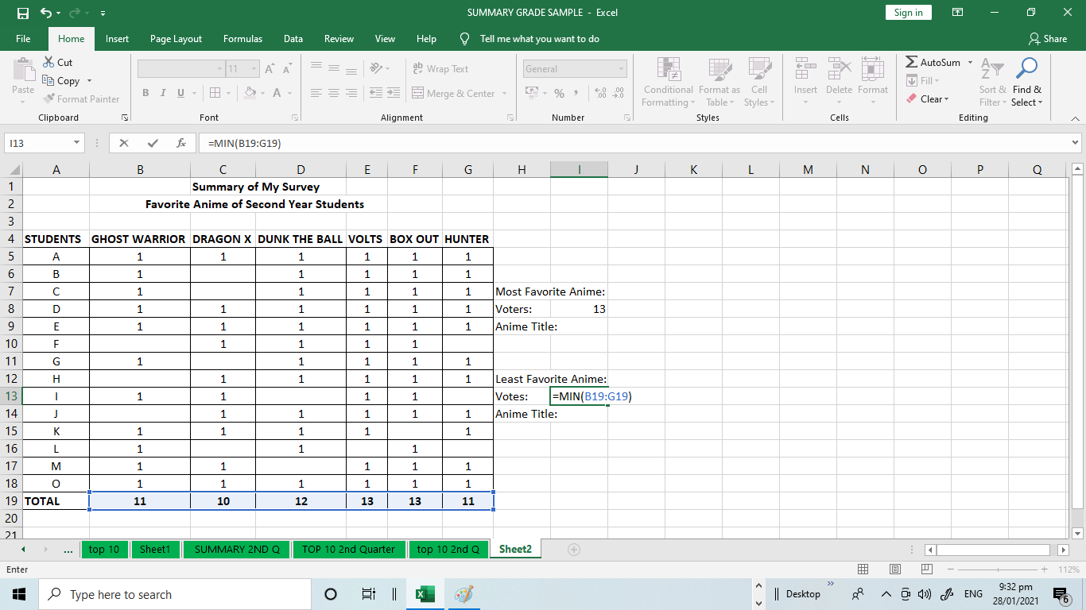

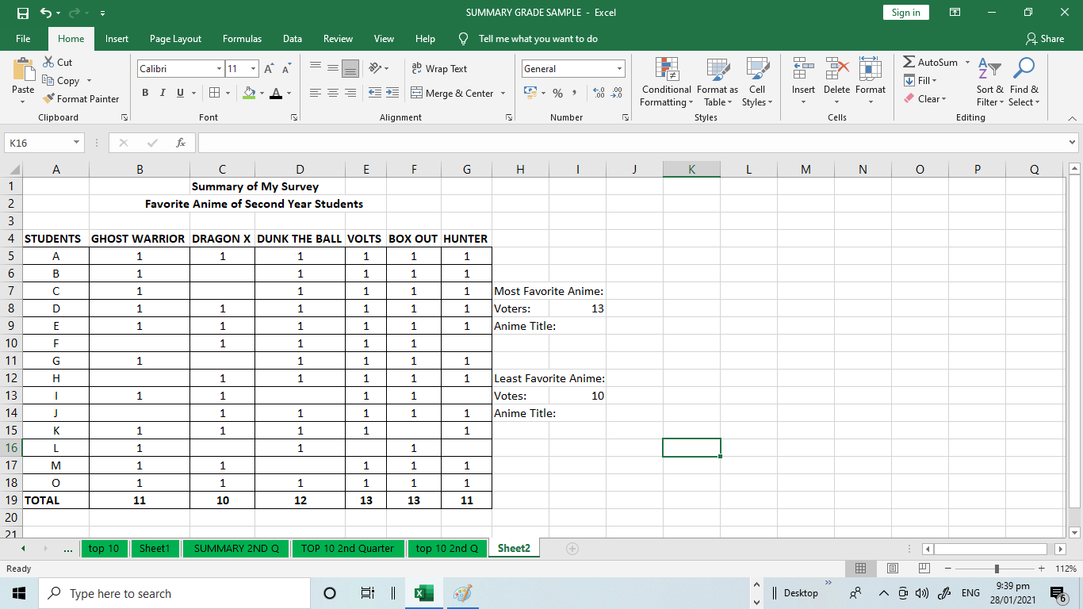

3. You can use the MIN function found in Formula Tab.

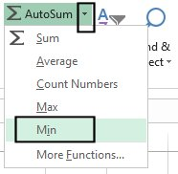

**SORT DATA IN AN EXCEL WORKSHEET**

When sorting information in a worksheet, you can rearrange the data to find values quickly. You can sort a range or table of data on one or more columns of data. For example, you can sort students—first by section, and then by last name.

**How to sort in Excel?**

**1. Select the data to sort**

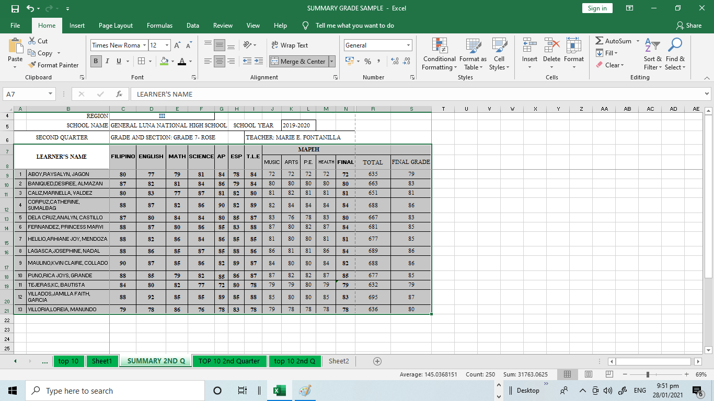

**2. Sort by specifying criteria**

Use this technique to choose the column you want to sort, together with other criteria such as font or cell colors.

1. Select a single cell anywhere in the range that you want to sort. Select the column B.

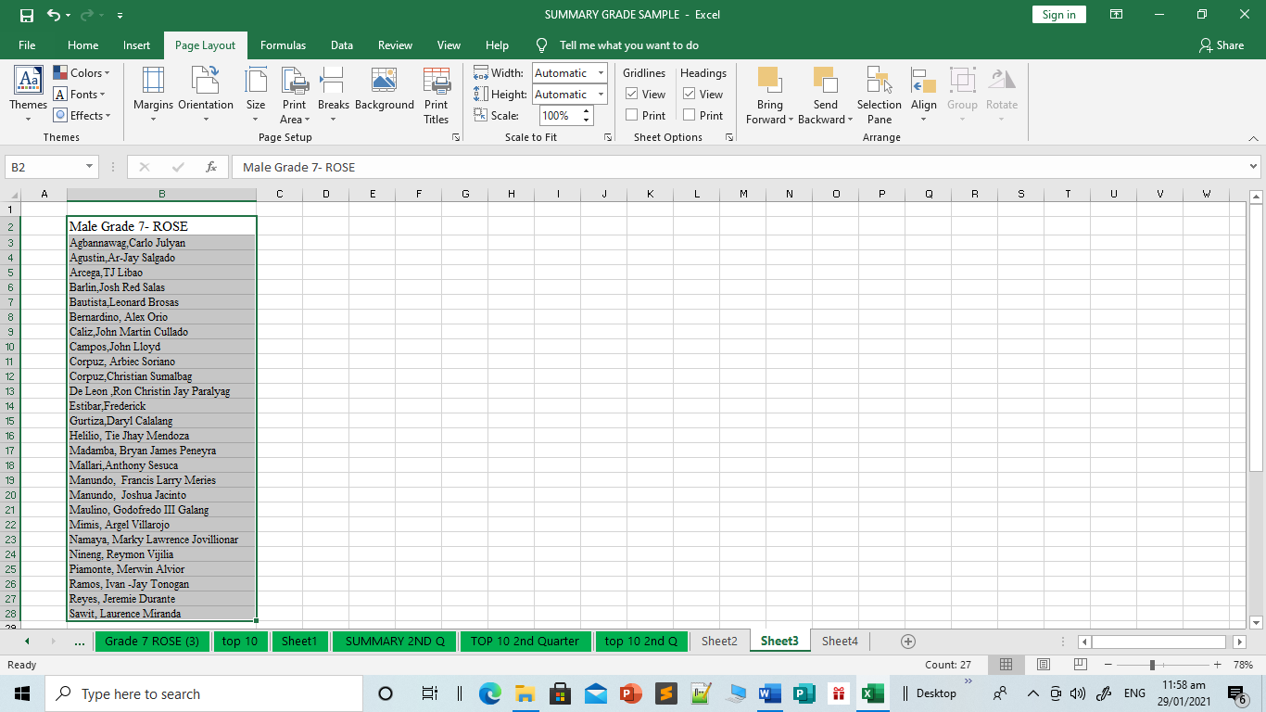

1. On the **Home** tab, in the **Sort & Filter** group, click **Sort** to display the Sort popup window or you can right click the mouse and it will display the menu click sort and click Sort A to Z. 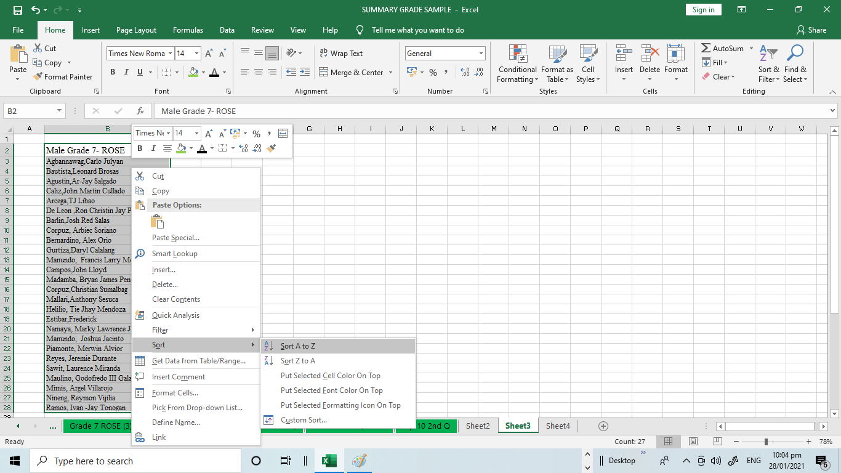

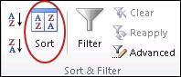

In the **Order** list, choose the order that you want to apply to the sort operation—alphabetically or numerically, ascending or descending (that is, from A to Z (or Z to A) for text, or lower to higher, or higher to lower for numbers).

We can use the data sorting in finding your top 10 in your class.

1. Select the column you want to sort.

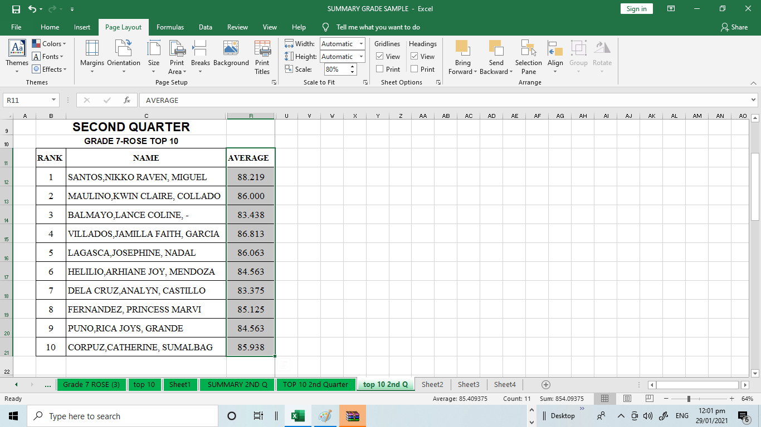

2. Right click your mouse and click Sort. Click Sort Largest to Smallest.

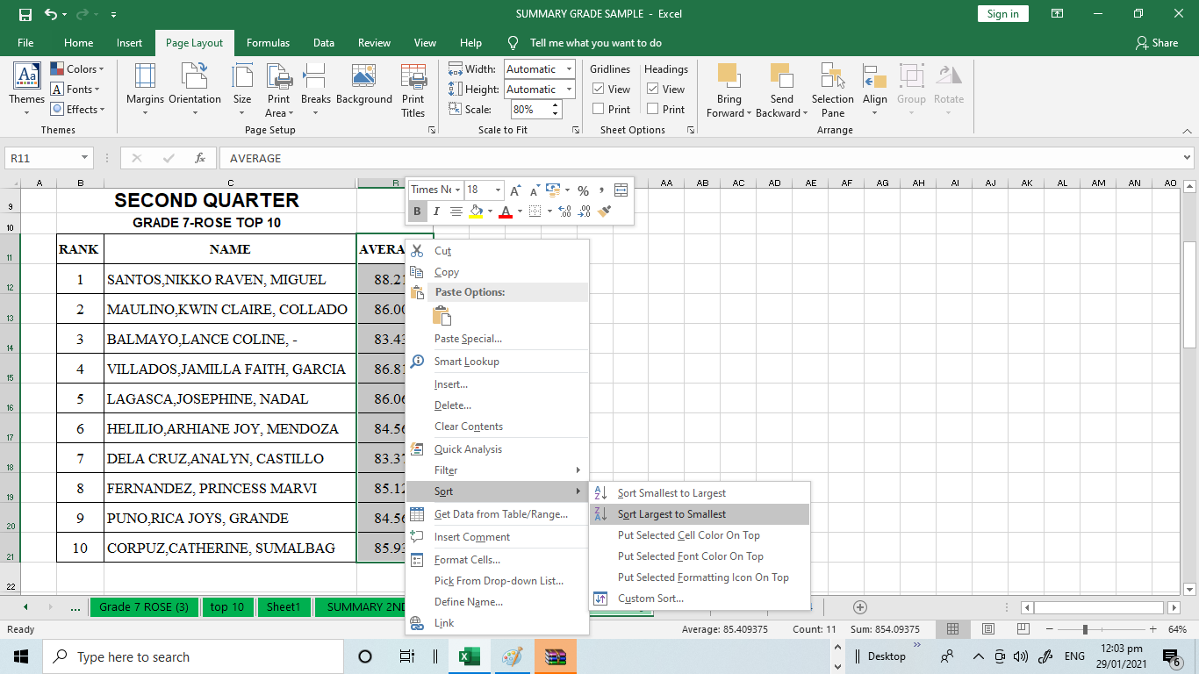

3. Click Custom Sort to set what column to sort. Choose the COLUMN R with the title **“AVERAGE “.** Set the **SORT ON** menu with **“CELL VALUES”** and set the ORDER in to **“LARGEST TO SMALLEST”** then click **“OK”**

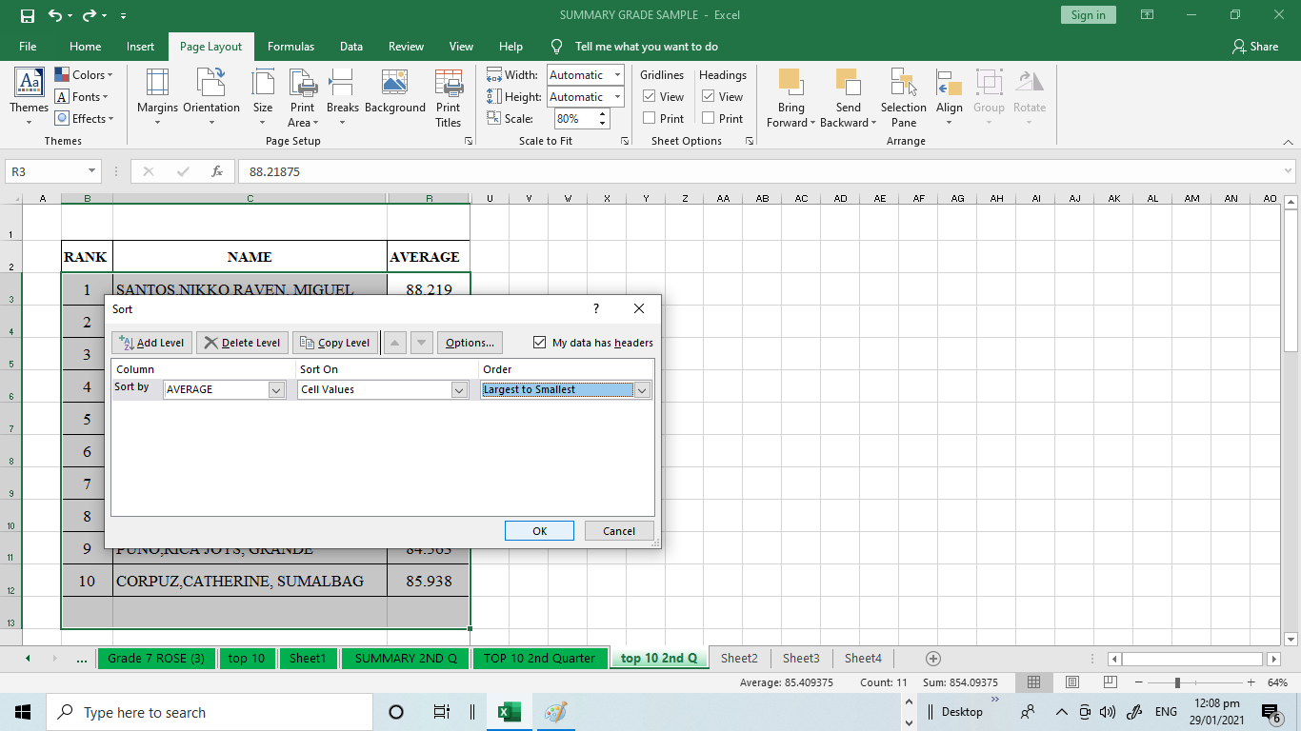

### FILTERING DATA

The **Excel FILTER** function "filters" a range of data based on supplied criteria. The result **Filters c**an be applied in different ways to improve the performance of your worksheet. You can filter text, dates, and numbers. You can even use more than one filter to further narrow your results. When data is filtered, only rows that meet the filter criteria will display and other rows will be hidden. With filtered data, you can then copy, format, print, etc., your data, without having to sort or move it first. To use a filter,

To filter data:

In this example, we'll filter the contents of an equipment log at a technology company. We'll display only the laptops and projectors that are available for checkout.

1. Begin with a worksheet that identifies each column using a header row.

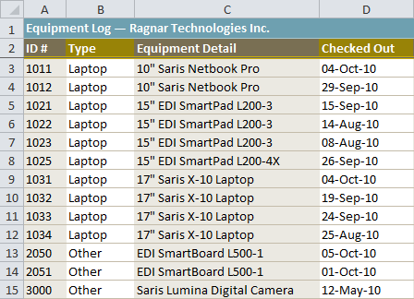

1. Select the **Data** tab, then locate the **Sort & Filter** group.
2. Click the **Filter** command.

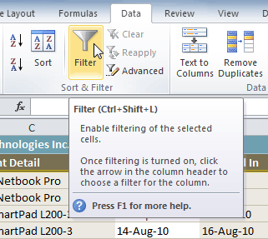

1. Drop-down arrows will appear in the header of each column.
2. Click the **drop-down arrow** for the column you want to filter. In this example, we'll filter the Type column to view only certain types of equipment.

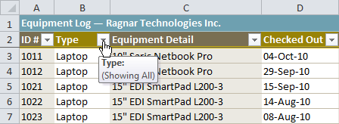

1. The **Filter** menu appears.
2. **Uncheck** the boxes next to the data you don't want to view, or uncheck the box next to **Select All** to quickly uncheck all.
3. **Check** the boxes next to the data you do want to view. In this example, we'll check Laptop and Projector to view only these types of equipment.

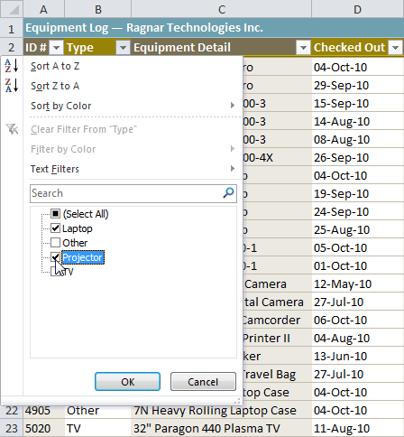

1. Click **OK**. All other data will be filtered, or temporarily hidden. Only laptops and projectors will be visible.

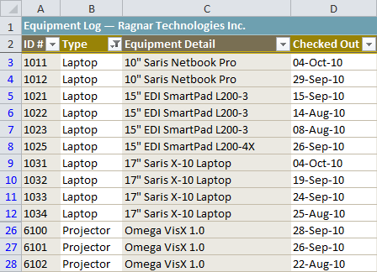

Filtering options can also be found on the Home tab, condensed into the **Sort & Filter** command.

## **WHAT IS A PIVOT TABLE?**

A pivot table is a tool that allows you to quickly summarize and analyze data in your spreadsheet.

You can use a pivot table when:

* You want to arrange and summarize your data.
* The data in your spreadsheet is too large and complex to analyze in its original format.

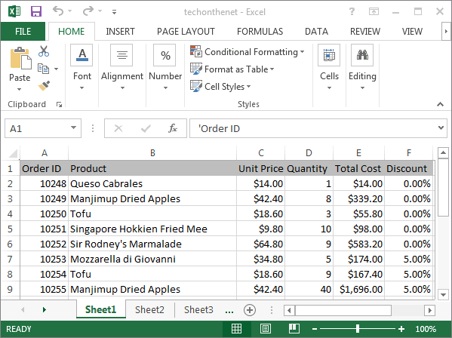

Highlight the cell where you'd like to see the pivot table. In this example, we've selected cell A1 on Sheet2.

Next, select the **INSERT tab** from the toolbar at the top of the screen. In the **Tables group**, click on the Tables button and select PivotTable from the popup menu.

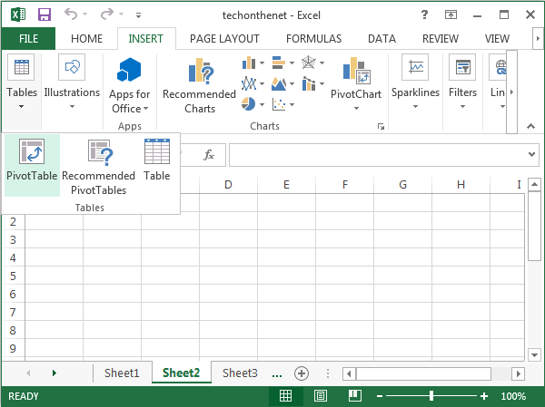

A Create PivotTable window should appear. Select the range of data for the pivot table and click on the OK button. In this example, we've chosen cells A1 to F16 in Sheet1.

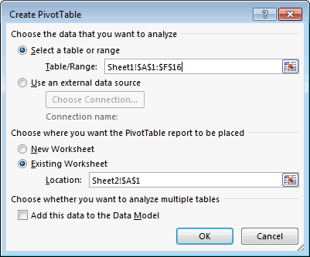

Your pivot table should now appear as follows:

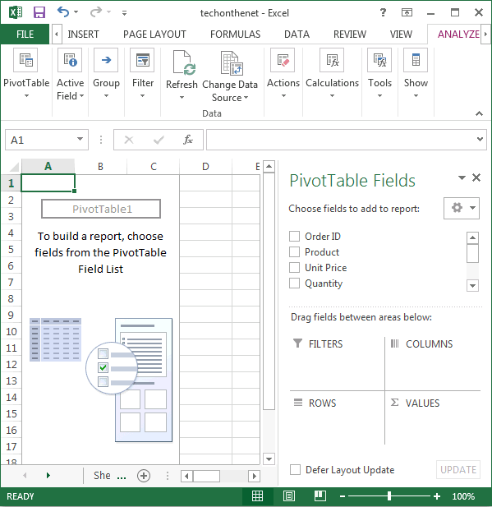

Next, choose the fields to add to the report. In this example, we've selected the checkboxes next to the **Order ID** and **Quantity** fields.

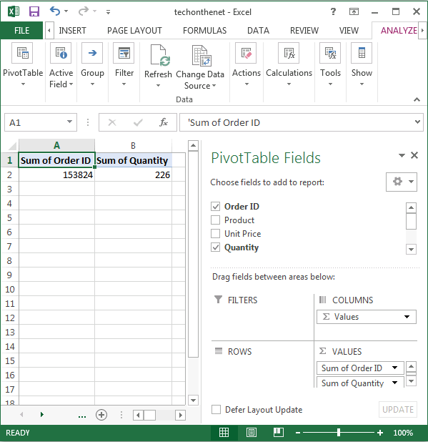

Next in the VALUES section, click on the "Sum of Order ID" and drag it to the ROWS section.

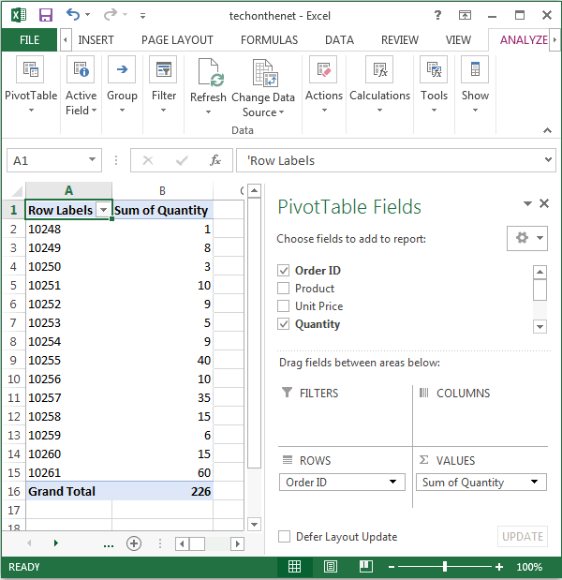

Finally, we want the title in cell A1 to show as "Order ID" instead of "Row Labels". To do this, select cell A1 and type Order ID.

Your pivot table should now display the total quantity for each Order ID as follows:

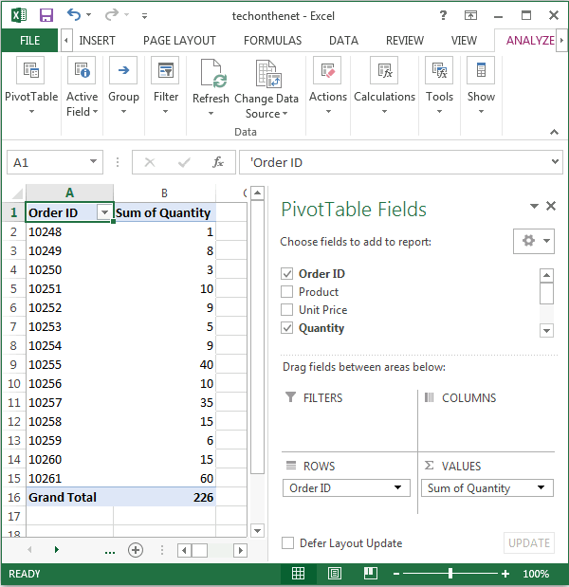

**LEARNING ACTIVITY SHEET**

**SPECIAL PROGRAM IN ICT 7**

**OFFICE PRODUCTIVITY 7**

*Third Quarter, Week 8*

Name of Learner: ____________________________________________________________

Grade Level /Section: __________________________ Date: __________________________

**LEARNING COMPETENCY**

Create functions, sort rows and columns and create Pivot tables?

**ACTIVITY 1**

**Identify the following. Write the correct answer in your answer sheet.**

**1.** A **_______________________** are the ready-made formulas that perform a series of operations on a specific range of values.

2. This function determines the**highest cell value** included in the argument.

3. _______________ contain the information you want to calculate.

4. This function determines the **average o**f the values included in the argument.

5. A ______________is a tool that allows you to quickly summarize and analyze data in your spreadsheet.

**ACTIVITY 2**

1. Find the final grade of Trisha Mae F. Estabillo in all learning areas using the average function.

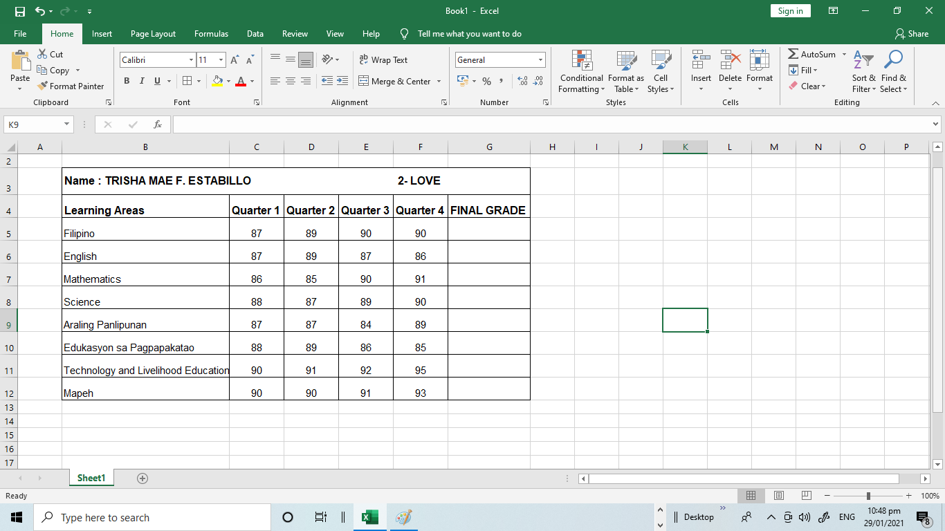

**ACTIVITY 3**

Find the total amount of payment of Edgar Manoloto in Paras Printing Press using the SUM function.

