**

**LEARNING ACTIVITY SHEET**

**SPECIAL PROGRAM IN ICT 7**

**OFFICE PRODUCTIVITY-MICROSOFT EXCEL**

*Third Quarter, Week 9*

**BACKGROUND INFORMATION FOR LEARNERS**

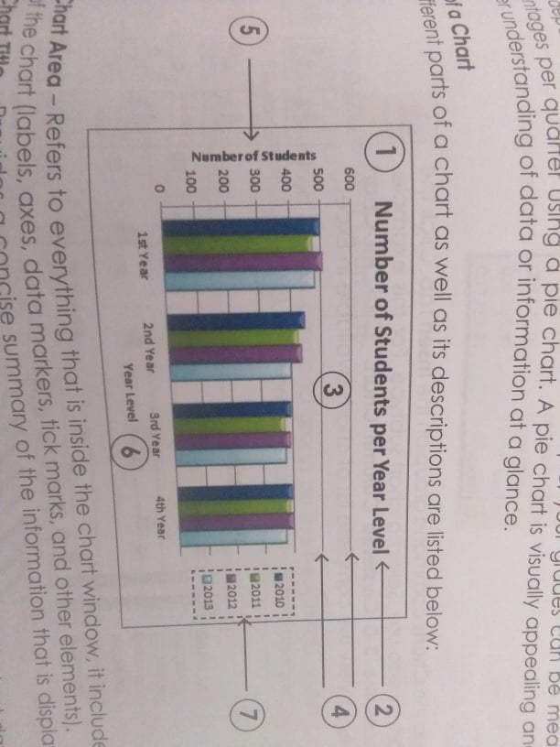**A chart is a visual representative of data in both columns and rows**. Charts are usually used to analyze trends and patterns in data sets. Let's say you have been recording the sales figures in Excel for the past three years. Using charts, you can easily tell which year had the most sales and which year had the least. You can also draw charts to compare set targets against actual achievements.

**Parts of the Chart**

The different parts of the chart as well as its descriptions are listed below:

1. **Chart Area –** Refers to everything that is inside the chart window, it includes all parts of the chart( labels, axes, data markers, tick marks, and other elements).
2. **Chart Title –** Provides a concise summary of the information that is displayed in the chart.
3. **Data Series –** A group of related values that corresponds to the chart data within a single row or column.
4. **Gridlines –** Extending lines across the plot area that makes it easier to view data. The use of gridlines is optional.
5. **Vertical Axis (y-**axis) - Line which serves as a reference for plotting data in the chart. Numbers are typically plotted along the axis.
6. **Horizontal Axis (x-**axis) - Line which serves as a reference for plotting data in the chart. Labels are typically plotted along the axis.
7. **Legend –** Shows the name of the data series that corresponds with a data marker in the chart. Legends usually use patterns, colors, or symbols that are associated with the markers of the chart series.

|  |  |  |
| --- | --- | --- |
| **CHART TYPE** | **WHEN SHOULD I USE IT?** | EXAMPLE |
| 1 | Pie Chart | When you want to quantify items and show them as percentages. | [Visualizing data using charts in Excel](https://www.guru99.com/images/5-2015/050215_0900_Visualizing1.png) |
| 2 | Bar Chart | When you want to compare values across a few categories. The values run horizontally | https://www.guru99.com/images/5-2015/050215_0900_Visualizing2.png |
| 3 | Column chart | When you want to compare values across a few categories. The values run vertically | [Visualizing data using charts in Excel](https://www.guru99.com/images/5-2015/050215_0900_Visualizing3.png) |
| 4 | Line chart | When you want to visualize trends over a period of time i.e. months, days, years, etc. | [Visualizing data using charts in Excel](https://www.guru99.com/images/5-2015/050215_0900_Visualizing4.png) |
| 5 | Combo Chart | When you want to highlight different types of information | [Visualizing data using charts in Excel](https://www.guru99.com/images/5-2015/050215_0900_Visualizing5.png) |

**The importance of charts**

* Allows you to visualize data graphically
* It's easier to analyze trends and patterns in the charts
* Easy to interpret compared to data in cells

**Steps in Creating a Chart**

**To create a line chart, execute the following steps.**

1. Select the range A1:D7.

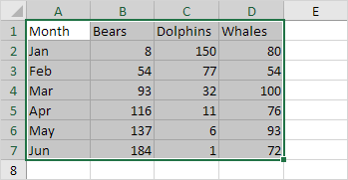

2. On the Insert tab, in the Charts group, click the Line symbol.

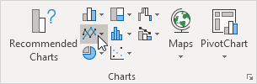

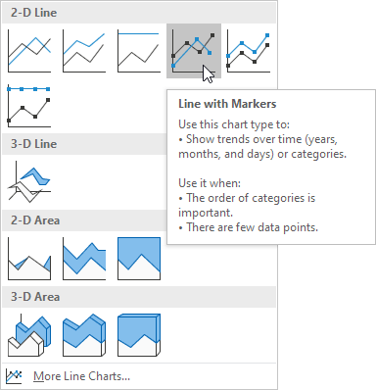3. Click line with Markers.

Result:

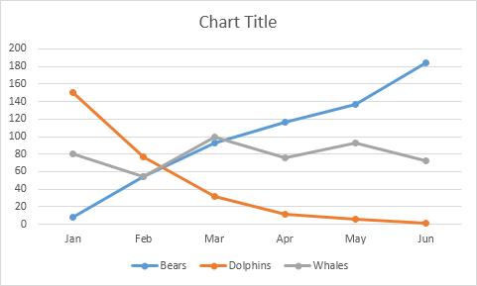

Note: enter a title by clicking on Chart Title. For example, Wildlife Population.

**Change Chart Type**

You can easily change to a different type of chart at any time.

1. Select the chart.

2. On the Design tab, in the Type group, click Change Chart Type.

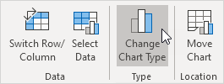

3. On the left side, click Column.

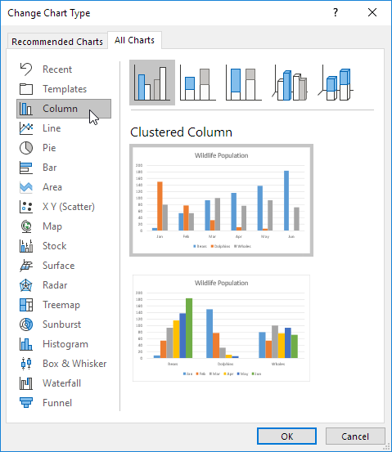

4. Click OK.

Result:

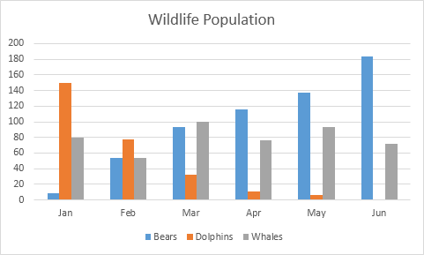

**LEARNING ACTIVITY SHEET**

**SPECIAL PROGRAM IN ICT 7**

**OFFICE PRODUCTIVITY-MICROSOFT EXCEL**

*Third Quarter, Week 9*

Name of Learner: _____________________________ Date: __________________________

Grade Level /Section: __________________________

**LEARNING COMPETENCY**

Create, edit, change, move, layout and resize charts and add, edit titles and labels to these charts.

**ACTIVITIES**

**ACTIVITY 1**

**Directions:** Identify the different parts of the chart. Write the answers on the blanks provided.

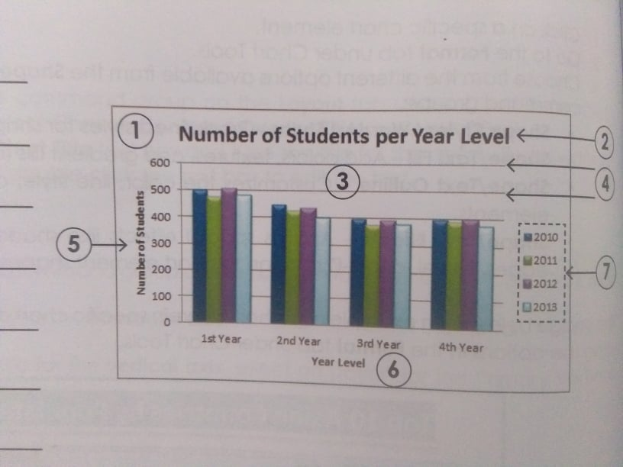**1.** __________________

**2.** __________________

**3.** __________________

**4.** __________________

**5.** __________________

**6.** __________________

**7.** __________________

**Activity 2.**

Direction: Answer the questions based on the given table.

|  |  |  |  |
| --- | --- | --- | --- |
| **PRODUCTS** | **REGION 1** | **REGION 2** | **REGION 3** |
| DOLLS | 4487 | 3546 | 1678 |
| TRUCKS | 2049 | 4057 | 1566 |
| PUZZLES | 1458 | 2354 | 3167 |

1. What is the total number of products sold by region 1? ______________________________
2. How many units of trucks were sold ( Region 1, 2, and 3 combined )? __________________
3. How many products (dolls, trucks, puzzles) were sold by all three regions? ______________
4. Enter the data in MS Excel. Create an appropriate chart based on the given data. Make sure that the chart you create contains the important elements. Think of your own title.
5. Save your work as <student’s name> chart.xlsx. example : “Mark chart.xlsx."