

Assessment Cover Page
Student Full Name | Jhenifer Damasceno Damiski
Student Number | 2026195
Module Title | CA1 Learning Machine
Assessment Title | CA1 Machine Learning
Lecturer/Supervisor | Dr. Muhammad Iqbal
Assessment Due Date | 30/10/2026
Date of Submission | 30/10/2026
Use of AI Tools
I acknowledge the use of ChatGPT as a supporting tool to help me understand some technical aspects of this assessment, particularly the ARIMA and SARIMAX modelling process, including parameter selection, model fitting and convergence warnings.
The implementation of the models, evaluation of their performance and interpretation of the results were carried out as part of my own work.
Declaration
By submitting this assessment, I confirm that I have read the CCT policy on academic misconduct and understand the implications of submitting work that is not my own or does not appropriately reference material taken from a third party or other source.
I declare it to be my own work and that all material from third parties has been appropriately referenced.
I further confirm that this work has not previously been submitted for assessment by myself or someone else in CCT College Dublin or any other higher education institution.

Reflection on the Use of AI
I used ChatGPT AI only as a support tool to better understand the assignment and to help me with some of its more complex parts, especially when I was unsure whether I was applying the techniques correctly.
I mainly used it during the time series analysis, particularly to understand the selection of ARIMA parameters using AIC, the warnings that appeared when fitting the model, and how to apply SARIMAX to investigate seasonality in the hourly bike rental data. It helped me clarify these concepts and understand the purpose of some of the steps involved in the modelling process.
However, I made sure to run the code, check the results and review the model outputs myself. When something was unclear, I used the explanations to improve my understanding rather than relying on the answers without checking them. The implementation, comparison of results and interpretation of the findings remained part of my own work.
In conclusion, I used AI only as a support tool to help me better understand the technical aspects of the assignment, especially when I encountered difficulties with the modelling process, while continuing to apply the concepts and methods covered in class.

Appendix B — Evidence of AI Use

ARIMA Parameter Selection (Cell 42 – 43)

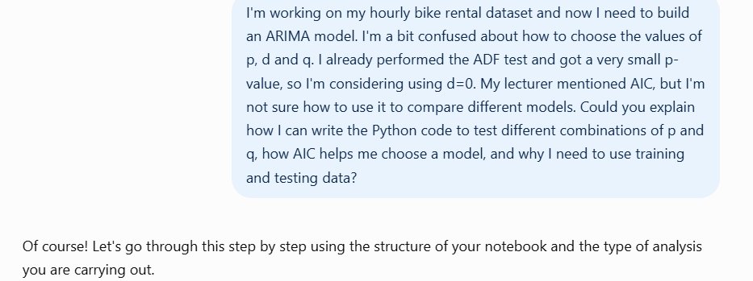
Figure 1.1 – Prompt 1: Selecting ARIMA Parameters Using AIC

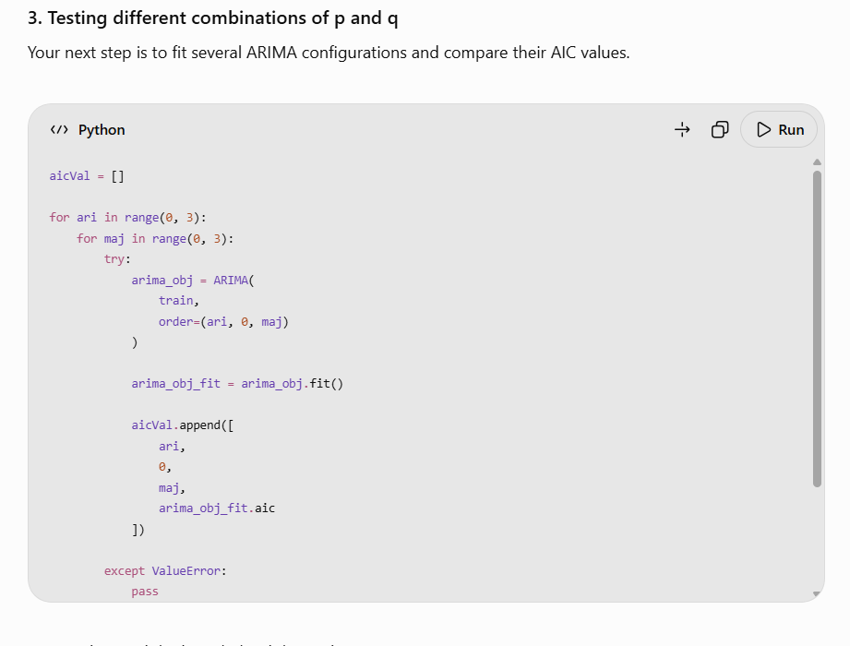
Figure 1.2 – AI Response: Testing ARIMA Parameter Combinations.

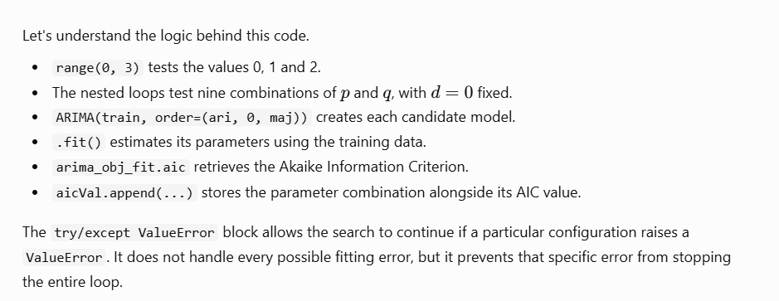
Figure 1.3 – AI Explanation: AIC and Training/Test Data Split.

ARIMA Model Fitting and Convergence (Cell 44 – 46)

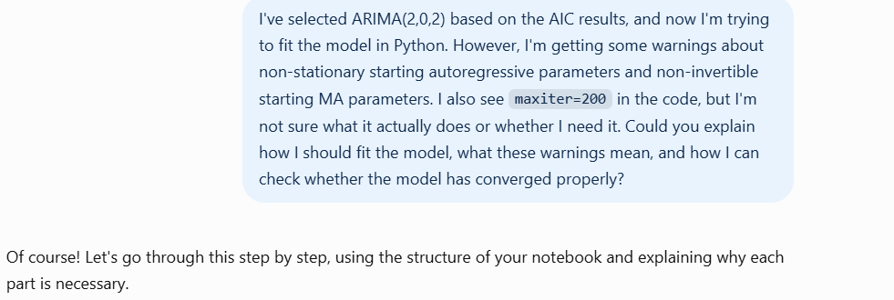
Figure 2.1 – Prompt 2: Fitting the ARIMA (2,0,2) Model.
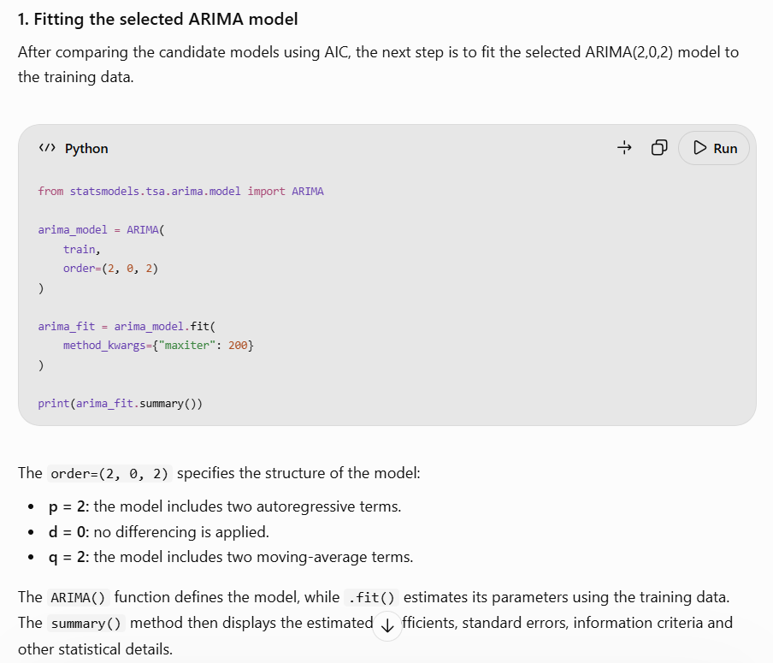
Figure 2.2 – AI Response: Fitting the Selected ARIMA Model.

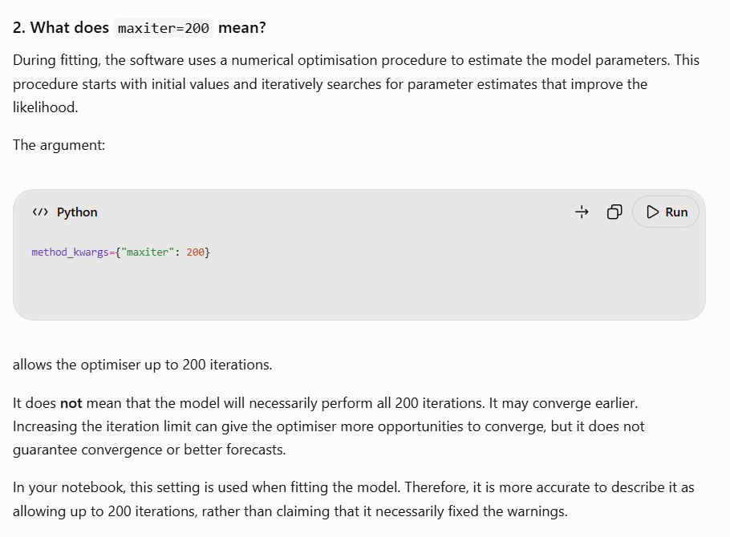
Figure 2.3 – AI Explanation: Understanding maxiter=200.

Seasonal Modelling with SARIMAX (Cell 47)

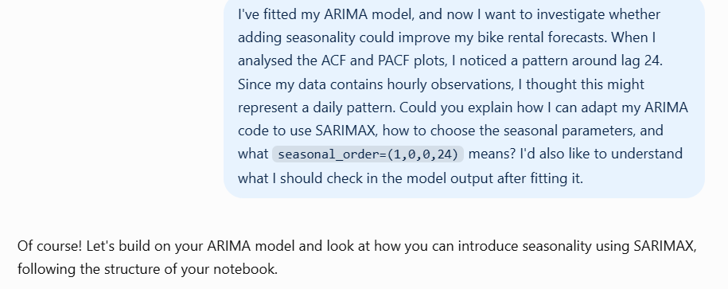
Figure 3.1 – Prompt 3: Investigating Daily Seasonality with SARIMAX.

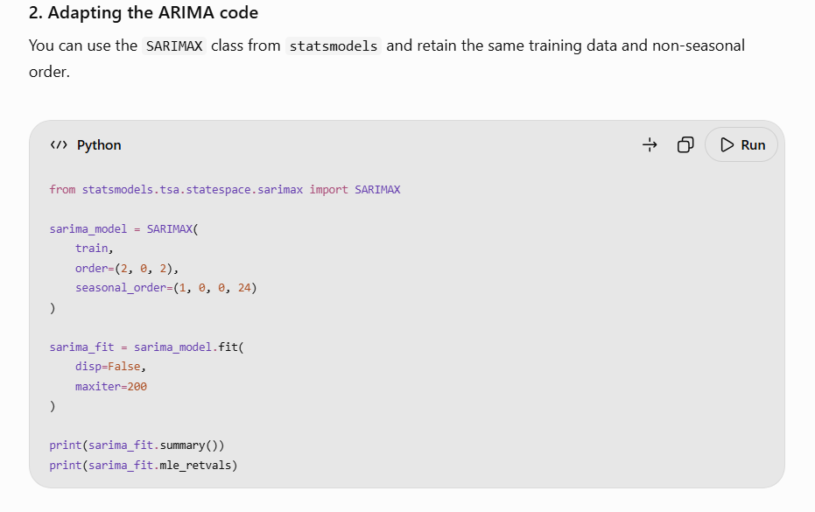
Figure 3.2 -AI Response: Adapting ARIMA Code to SARIMAX.

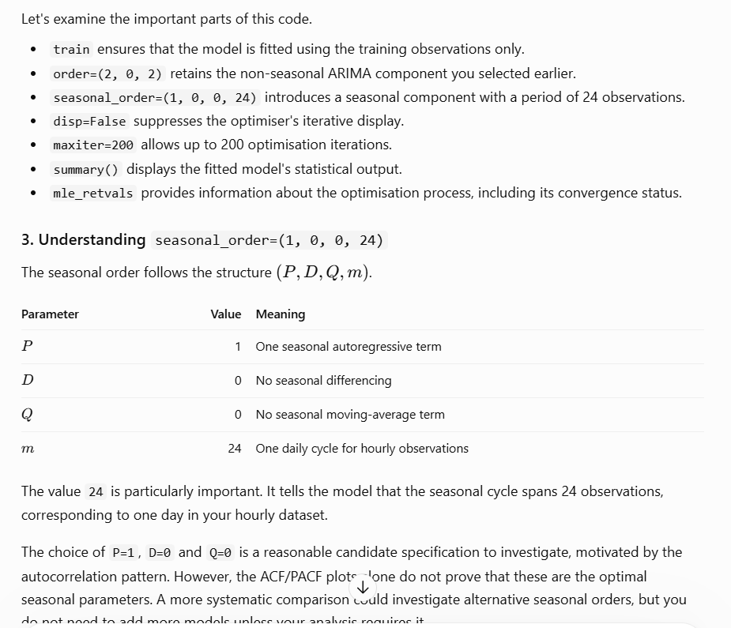
Figure 3.3 – AI Explanation: Understanding Seasonal Parameters.

Main Reflection

For this assignment, I used the Seoul Bike Sharing Demand dataset to understand how the demand for bicycle rentals changes over time. Three different approaches were used, including exploratory data analysis, clustering and time series forecasting. The dataset contained 8,760 hourly observations collected over one year, with information about the number of rented bikes, weather conditions and calendar-related variables. During the initial analysis, some differences in rental demand throughout the year were noticed. Generally, the number of rentals was lower during winter and increased during spring and summer. I also identified two noticeable peaks during the day, around 08:00 and 18:00. These patterns suggest that rental demand is not constant and that factors such as the time of day, the season and weather conditions may play an important role.
For the clustering analysis, the methods compared were K-Means and Agglomerative Clustering, using three clusters and ten numerical variables that were standardised before the models were applied. K-Means achieved a Silhouette Score of 0.2292 and a Davies–Bouldin Index of 1.5133. Agglomerative Clustering, on the other hand, achieved a lower Silhouette Score of 0.1998 and a higher Davies–Bouldin Index of 1.6669. Looking at these results, K-Means performed better, as it achieved a higher Silhouette Score and a lower Davies–Bouldin Index. The PCA visualisations also showed differences between the two methods. The clusters produced by Agglomerative Clustering showed greater overlap, but there was also some overlap in the K-Means results. This is an important point because, although K-Means performed better, the Silhouette Scores were still low. Therefore, I would not consider these clusters to be completely separate groups. Instead, the results provide an initial way of grouping observations with similar characteristics, but the separation between them is not particularly strong.
In the time series forecasting analysis, I checked whether the rental count series was stationary using the ADF test. The results supported treating the series as stationary, so I used d = 0 when building the ARIMA models. I then examined the ACF and PACF plots to investigate how the observations were related over time. After that, I tested nine different combinations of ARIMA parameters and compared their AIC values. Among the non-seasonal models tested, ARIMA(2,0,2) achieved the lowest AIC, at 97,446.127, so I selected it for the forecasting comparison.
I also observed a pattern around lag 24 in the autocorrelation analysis. As the dataset contains hourly observations, this suggests that there could be a daily seasonal pattern in bicycle rental demand. To investigate this possibility, I tested SARIMAX(2,0,2)(1,0,0,24), which includes a seasonal component with a period of 24 hours. Both models were evaluated using the same 1,752 observations from the test dataset. SARIMAX achieved a MAE of 498.557 and a RMSE of 608.334, while ARIMA achieved a MAE of 499.528 and a RMSE of 614.648. These values show that SARIMAX produced more accurate forecasts. However, the improvement was not very significant, especially for MAE. When I compared the forecast graphs with the actual rental demand, I also observed that both models produced smoother forecasts and had difficulty capturing some of the sharp peaks and sudden drops. This shows that, although the seasonal component helped improve the results, it was not enough to capture all the short-term changes in hourly demand.
Throughout the assignment, I was able to observe that using these three approaches provided different ways of understanding the same dataset. The exploratory analysis identified patterns in rental demand, while clustering allowed me to investigate whether observations could be grouped according to similar characteristics. The forecasting models then allowed me to analyse how historical rental demand could be used to predict future observations. K-Means performed better than Agglomerative Clustering, and SARIMAX performed better than ARIMA, but neither approach was able to fully capture the complexity of the data.
In conclusion, this assignment showed why it is important to look beyond numerical results when evaluating a model. A better result for one metric does not necessarily mean that the model can represent all the important patterns in the data. By comparing different methods, analysing the visualisations and considering the limitations, I was able to understand not only which models performed better, but also where they still had difficulties. For me, this was one of the most important parts of the analysis because it demonstrated how model evaluation and interpretation are connected when working with real-world data.

References
- Eren, E. and Uz, V.E. (2020) ‘A review on bike-sharing: The factors affecting bike-sharing demand’, Sustainable Cities and Society, 54, 101882. Available at: https://doi.org/10.1016/j.scs.2019.101882 (Accessed: 15 October 2026). ScienceDirect
- UCI Machine Learning Repository (2020) Seoul Bike Sharing Demand [Dataset]. Available at: https://doi.org/10.24432/C5F62R (Accessed: 15 October 2026).
- Scikit-learn Developers (2026) Scikit-learn: Machine Learning in Python. Available at: https://scikit-learn.org/ (Accessed: 18 October 2026).
- Iqbal, M. (2026) ARIMA and SARIMA Time Series Models. Week 7 lecture material, HDIP in Data Analytics for Business, CCT College Dublin.
- OpenAI (2026) ChatGPT. Available at: https://chatgpt.com/ (Accessed: 18 October 2026).
- Statsmodels Developers (2026) Statsmodels: Statistical Models and Tests. Available at: https://www.statsmodels.org/ (Accessed: 22 October 2026).

