Constellation Worksheet

**Add URL for repl it**

https://replit.com/@Jherlin/The-Aries-Constellation#main.py

Screenshot of Screen 1:

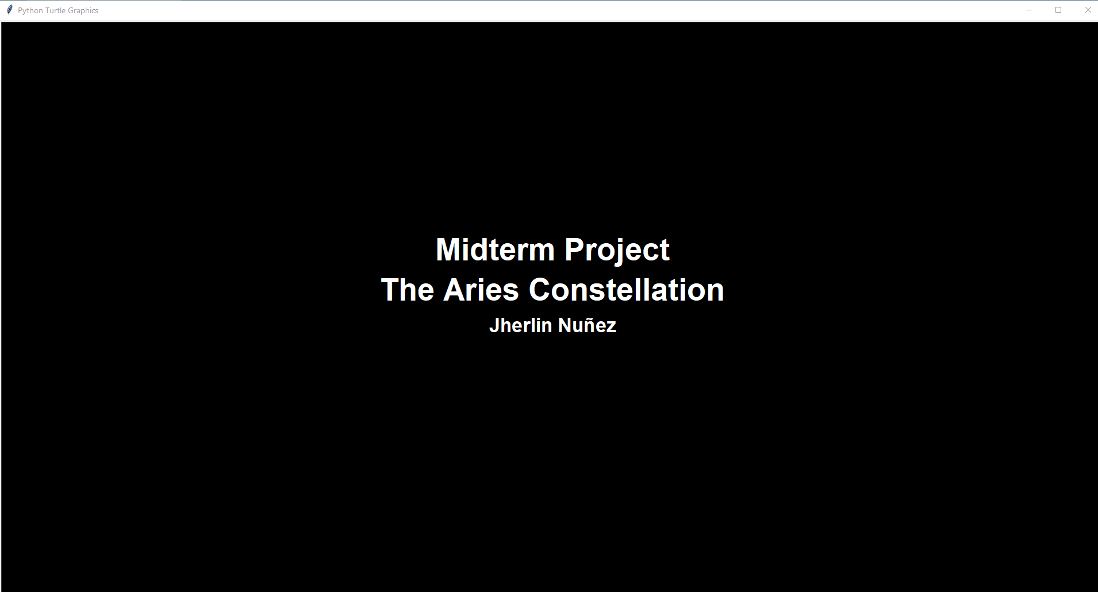

Screenshot of Screen 2:

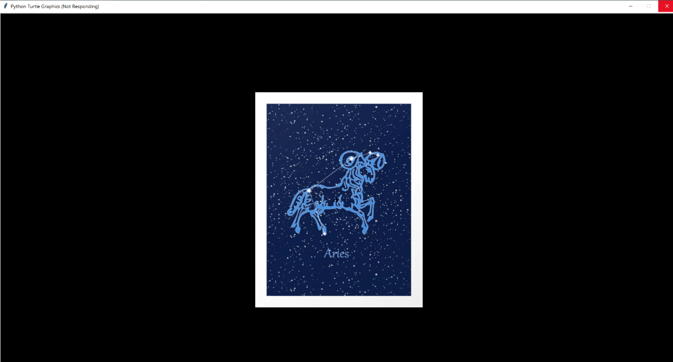

Screenshot of Screen 3:

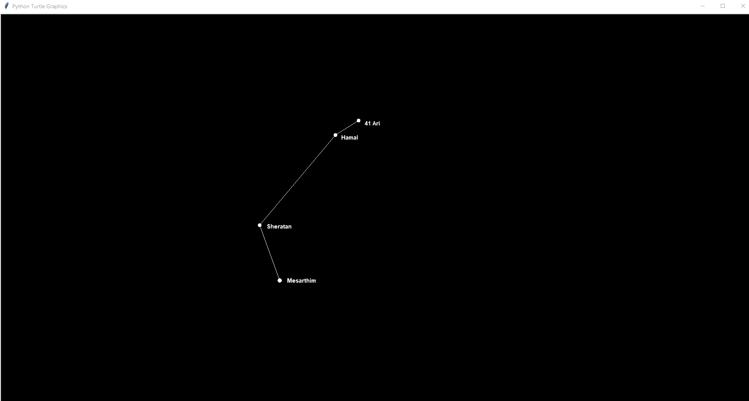

Screenshot of Screen 4:

